

CS4063-Natural Language Processing

Project Proposal

GROUP MEMBERS:
21I-0453 Awais Naeem
21I-0499 M Ejaz Alvi
21I-2532 Qazi Mohib
21I-0547 Haider Rizvi
21I-0720 Saim Mubarak
21I-0457 Abdul Moiz

SUBMITTED TO:
Sir Owais Idrees

Table of Contents
GlutenGuard AI: 3
Introduction 3
Problem Description 3
What Problem Are We Solving? 3
Who Is Facing This Problem (Target Users, Personas)? 3
Why Is This Problem Important? 3
Market Need & Value Proposition 3
Existing Solutions (If Any) 3
What Gap Exists? 4
Why Does Our Product Matter? 4
What Value Does It Create? 4
Use-Case & User Journey 4
Typical User 4
How They Will Interact with the System 4
Clear Example Workflow 4
High-Level System Pipeline 5
Overview of the System 5
Components or Agents Involved 5
Example Flow (Input → RAG/Agents → Output) 5
Agentic AI Design 5
Agent Framework 5
How Many Agents 5
Their Roles 6
Technical Architecture 6
Engineering Plan 6
Feasibility & Risks 7
Technical Risks 7
Data Availability Concerns 7
Model Performance Issues 7
Backup Plans 7
Success Metrics 7
Feasibility Analysis Summary 7
Conclusion 8

GlutenGuard AI:
GlutenGuard AI is an intelligent multi-modal system that accelerates gluten intolerance diagnosis from 6-10 years to just 6 weeks by correlating meals and symptoms using NLP, computer vision, and statistical agents.

Introduction
This proposal outlines our project for the Development Track in CS4063 – Natural Language Processing. We aim to build a production-quality AI product that addresses a real-world health problem using modern agentic AI frameworks. GlutenGuard AI combines NLP for symptom and meal text analysis, computer vision for food photo detection, and statistical agents for pattern correlation. The system will be built with LangChain for agent orchestration, FastAPI for the backend, and Docker for deployment, demonstrating strong product thinking, scalable engineering, and measurable success metrics.

Problem Description

What Problem Are We Solving?
Gluten intolerance diagnosis is notoriously slow, expensive, and unreliable. It often takes 6-10 years for individuals to receive a proper diagnosis due to challenges in manual tracking of meals and symptoms, identifying hidden gluten in processed foods, and correlating symptom patterns with dietary intake. Current methods rely on elimination diets, food diaries, and invasive medical tests, which are tedious, error-prone, and costly.

Who Is Facing This Problem (Target Users, Personas)?
- Primary Persona: "Symptomatic Sarah" (Age 28-45): Experiences bloating, fatigue, and brain fog after meals. Frustrated by undiagnosed symptoms and seeks fast, accurate pattern detection.
- Secondary Persona: "Health-Conscious Henry" (Age 35-55): Suspects gluten sensitivity but wants data-driven proof. Frustrated with manual, unreliable food diaries and needs automated tracking.
- Tertiary Persona: "Diagnosed Dana" (Any age): Already diagnosed with gluten issues and needs tools to avoid hidden gluten in real-time.

Why Is This Problem Important?
Undiagnosed gluten intolerance affects over 20 million Americans, leading to chronic inflammation, nutrient malabsorption, reduced quality of life, and billions in unnecessary medical costs. Early detection can prevent years of suffering and improve health outcomes, making this a critical health and economic issue.

Market Need & Value Proposition

Existing Solutions (If Any)
- Food diary apps (e.g., MyFitnessPal, Cronometer): Offer manual entry but lack intelligent pattern detection, photo recognition, or statistical analysis.
- Symptom trackers (e.g., Migraine Buddy, Bearable): Focus on symptoms but do not integrate with food tracking or provide correlation insights.
- Medical tests (e.g., celiac blood tests, endoscopy): Expensive ($500-$2000), invasive, prone to false negatives, and time-consuming (weeks to months).

What Gap Exists?
The market lacks an integrated system for multi-modal input (text, photos, potentially voice), automated gluten risk assessment using a comprehensive database, and statistically rigorous pattern detection (e.g., correlation with p-values and confidence intervals).

Why Does Our Product Matter?
GlutenGuard AI bridges this gap by combining NLP, computer vision, and agentic AI to provide automated, data-driven insights. It reduces diagnosis time from 6-10 years to 6 weeks (a 50x improvement), empowering users with evidence-based recommendations.

What Value Does It Create?
- For Users: Significant time and cost savings (free vs. expensive tests), peace of mind through data-driven answers, and improved health via faster treatment.
- For Healthcare Providers: Reduces system burden by enabling patients to arrive with pre-analyzed data, leading to better outcomes and cost efficiency.
- Overall: 100% free and open-source, making it accessible and extensible.

Use-Case & User Journey

Typical User
Sarah, a 32-year-old software engineer, experiences post-meal bloating and fatigue. She suspects gluten intolerance but struggles with manual tracking and identifying patterns in elimination diets.

How They Will Interact with the System
- Week 1-2 (Data Collection): Upload food photos for AI detection and gluten risk scoring; log symptoms via text for NLP extraction; view a timeline and dashboard for real-time stats.
- Week 3-4 (Pattern Detection): Generate correlation reports, including time-lag analysis (e.g., symptoms appear 3 hours after gluten exposure) and dose-response insights.
- Week 5-6 (Decision Phase): Receive a final report with statistical evidence (e.g., 87% correlation, p<0.001); get recommendations like a gluten-free trial; share data with doctors.

Clear Example Workflow
- Step 1: Sarah uploads a photo of a pizza slice. The Computer Vision Agent detects "pizza" and assigns a gluten risk of 100/100, automatically logging the meal with a timestamp.
- Step 2: Three hours later, she logs: "Terrible bloating, severity 8/10." The NLP Agent extracts symptom type ("bloating"), severity (8/10), and time context ("3 hours after"), linking it to the meal.
- Step 3: After 2 weeks, the Analysis Agent computes an 85% correlation between high-gluten meals and symptoms (p<0.001), with time-lag patterns (2-4 hours post-exposure).
- Step 4: Output: A report recommending a gluten-free trial, stating "Strong evidence of gluten intolerance."

High-Level System Pipeline

Overview of the System
GlutenGuard AI is a multi-modal AI system with three main pipelines: text processing (NLP), image analysis (computer vision), and pattern detection (statistical analysis). It uses agentic workflows to orchestrate inputs, processing, and outputs.

Components or Agents Involved
- NLP Agent: Handles text inputs for meals and symptoms using LangChain.
- Computer Vision Agent: Processes food photos with OpenCV and HuggingFace models.
- Analysis Agent: Performs statistical correlations on stored data.

Example Flow (Input → RAG/Agents → Output)
- Input: User uploads a photo or logs text.
- Processing: Photo → Computer Vision Agent (preprocessing, detection, gluten mapping); Text → NLP Agent (entity extraction, classification). Data is stored in SQLite; retrieval from a gluten database (with FAISS planned for semantic search) augments processing.
- Output: Structured logs, risk scores, and reports via Analysis Agent (e.g., correlation scores, p-values, recommendations).
(Note: While not a traditional RAG, the system retrieves from historical user data and a food database; FAISS will enhance semantic retrieval in the full implementation.
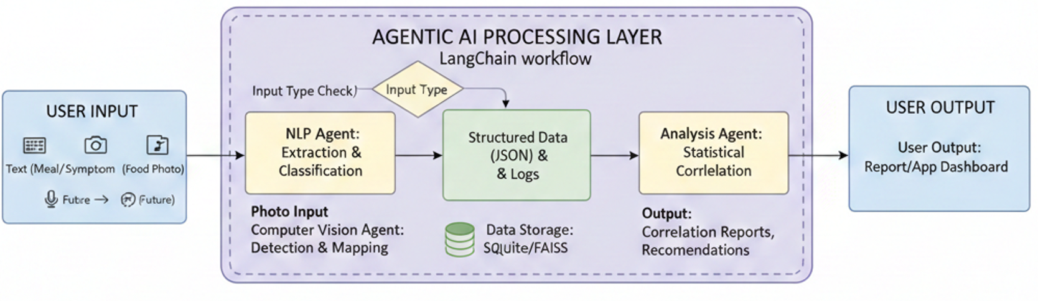

Agentic AI Design

Agent Framework
We will use LangChain (version 0.0.350) for orchestration, chain composition, tool integration (e.g., Groq API, HuggingFace), and memory management. LangChain was chosen for its production-readiness, excellent documentation, and support for multi-agent workflows.

How Many Agents
Three specialized agents.

Their Roles
- NLP Agent (Retriever + Classifier + Generator): Extracts entities (foods, symptoms, times), classifies symptoms, and generates structured JSON. Tools: spaCy (NER), Transformers (sentiment), Groq API (validation).
- Computer Vision Agent (Preprocessor + Detector + Mapper): Applies digital image processing (DIP) techniques, detects foods (2000+ categories), and maps to gluten risks (500+ food database). Tools: OpenCV, HuggingFace nateraw/food, Groq Vision API.
- Analysis Agent (Planner + Evaluator + Generator): Plans analyses (correlation, time-lag), evaluates statistics (Pearson's r, p-values), and generates reports. Tools: SciPy, Pandas, NumPy.
Agents communicate via LangChain:
Inputs → NLP/CV Agents → Database → Analysis Agent → Output.
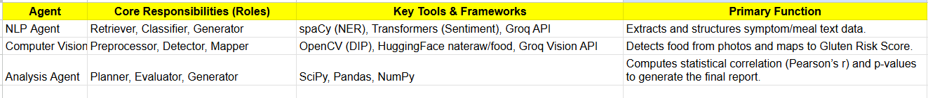

Technical Architecture
- Vector Store: FAISS for semantic search on food embeddings (e.g., handling synonyms like "roti" = "chapati"); current prototype uses SQLite for structured data.
- Model: Primary: Groq Vision API (LLaMA-based) for food detection; Fallback: HuggingFace nateraw/food; NLP: spaCy en_core_web_sm, Transformers distilbert-base-uncased-finetuned-sst-2-english. No fine-tuning required.
- External APIs or Tools Required: Groq API (free tier for vision/text), HuggingFace Hub (free model downloads).
- Backend Framework: FastAPI for its speed, async support, and automatic Swagger documentation.
- How Components Connect: A simple diagram (described): User Input (Text/Photo) → Agents (LangChain-orchestrated) → SQLite/FAISS Storage → Analysis → API Output. Endpoints include /upload_photo, /log_symptom, /analyze.

Engineering Plan
- API Endpoints Planned: /health (monitoring), /upload_photo (detection/logging), /log_symptom (extraction), /analyze (reports), /timeline (data viewing).
- Dockerization Strategy: Docker Compose with multi-stage builds; services for backend (FastAPI) and frontend (React); volumes for uploads, logs, and debug output.
- Logging & Monitoring: Python logging module (DEBUG/INFO levels, rotating files); future Prometheus/Grafana for metrics like latency and error rates.
- Exception Handling: Custom handlers in FastAPI, fallbacks (e.g., HuggingFace if Groq fails), Pydantic for validation, retry logic for transients.
- Repository Structure: backend/ (routers, services, tests), frontend/ (pages, components), docker-compose.yml, README.md.
- Testing Strategy: Pytest for unit tests (70%+ coverage on services) and integration (end-to-end flows like photo upload to report); mocking for external APIs.
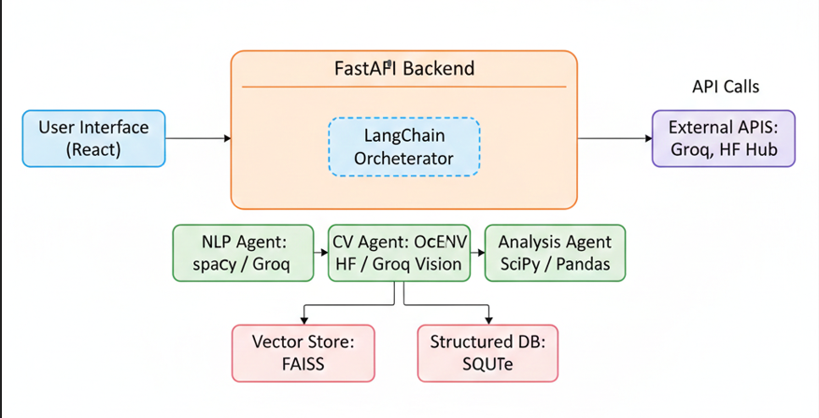

Feasibility & Risks

Technical Risks
- API downtime (e.g., Groq): Mitigated by fallbacks to local HuggingFace models.
- Model accuracy (e.g., food misclassification): Addressed with confidence thresholds (>0.7), user manual corrections, and ensemble methods.

Data Availability Concerns
- Gluten database completeness: Starts at 500+ foods (including regional ones); extensible via user feedback.
- Privacy: Local SQLite ensures data stays on-user; optional encryption.

Model Performance Issues
- Processing speed (>5s): Optimized DIP pipeline and async processing achieve <2s.
- Small data significance: Enforce minimum thresholds (10+ data points); use bootstrap intervals.

Backup Plans
- If Groq fails: Switch to HuggingFace (local).
- If models fail: Rule-based fallbacks.
- If analysis fails: Simple Pearson's r without advanced features.
- Overall: Highly feasible with free tools; no GPU/training needed; MVP in 1-2 weeks, full in 6-8 weeks.

Success Metrics
- Response Accuracy: Food detection >90% (confusion matrix on 100+ images); NLP F1-score >0.85 (200+ texts); Correlation p<0.05 (simulated data).
- Latency: Photo processing <2s; API responses <200ms; Reports <5s.
- Reliability: 99% uptime; <1% error rate; zero data loss (SQLite ACID).
- User Satisfaction: Workflow completion <5 min; feature completeness 100%.
- Evaluation Datasets: Food images (public datasets), synthetic texts, generated correlation data.

Feasibility Analysis Summary
This project is feasible using proven, free tools (LangChain, FastAPI, HuggingFace). It aligns with course requirements for agentic AI, backend engineering, and deployment. Success will look like a deployable system that provides accurate, fast diagnoses, measured by the metrics above. Resources needed: Free APIs, public datasets for testing, in-house gluten database.

Conclusion
GlutenGuard AI addresses a pressing health need with innovative AI, targeting users seeking faster, affordable diagnosis. We are excited to build and demonstrate this product by December 11, 2025.

