PharmaKeep
Micro-Pharmacy Inventory & Expiry Tracking System

Database Systems Lab
ERD & Relational Database Schema Description

Student Name | Awais Qarni
Major | BSSE
Group | B
Project | PharmaKeep
Tool Used | draw.io
Submission Date | Sunday, 26 April 2026

— Awais Qarni | BSSE | Group B —

Part 1 — Entity Relationship Diagram (ERD)

The ERD below represents the complete database design for the PharmaKeep system. It uses Crow's Foot Notation, consistent with draw.io standards, to show all entities, attributes (with PK/FK markers), and the cardinality of each relationship.

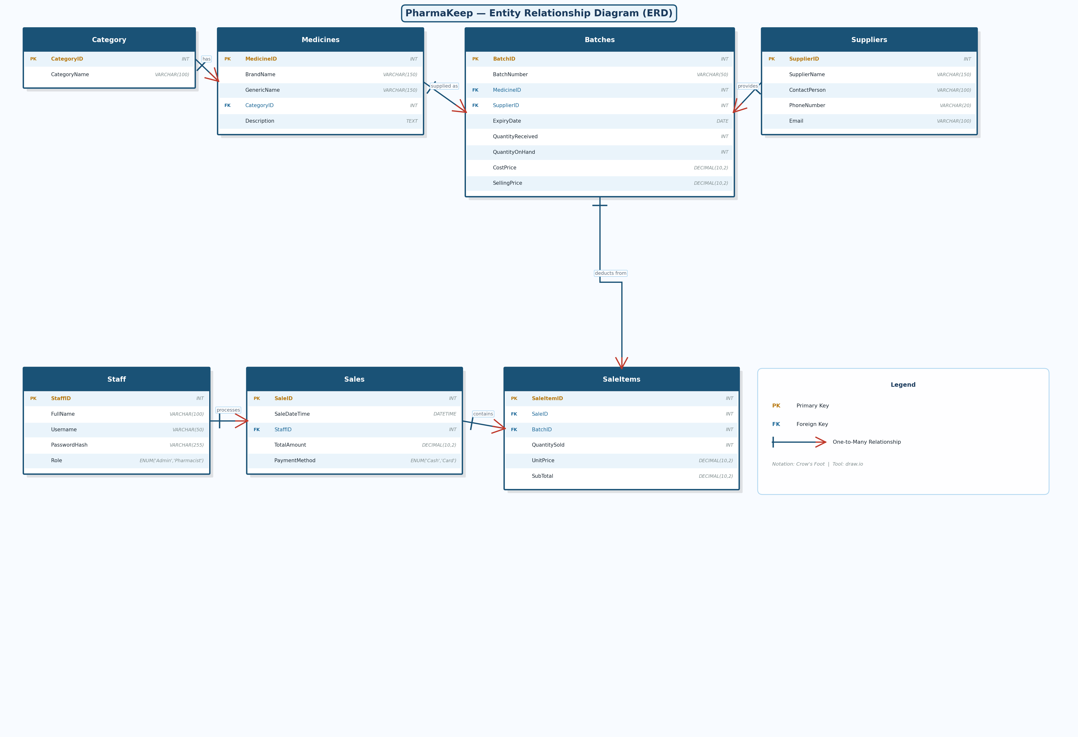

Figure 1: PharmaKeep ERD — Crow's Foot Notation (draw.io) | PK = Primary Key | FK = Foreign Key

ERD Narrative
- Staff → Sales: One staff member can process many sales transactions.
- Category → Medicines: One category classifies many medicine types.
- Medicines → Batches: One medicine can arrive in many batches, each with its own Expiry Date and quantity.
- Suppliers → Batches: One supplier can deliver many different batches.
- Sales → SaleItems: One sale invoice can contain many line items.
- Batches → SaleItems: Each line item references a specific Batch — ensuring correct, expiry-date-aware inventory deduction.

Part 2 — Relational Database Schema Description

This section translates the ERD into fully defined relational database tables. Each table specifies attribute names, data types, primary/foreign keys, and constraints required to enforce data integrity and business rules.

Key Notation
Notation | Meaning
PK | Primary Key — unique identifier for each record in the table
FK | Foreign Key — references a Primary Key in another table
AI | Auto-Increment — value is generated automatically by the database
NN | Not Null — a value must always be provided for this field
U | Unique — the value must be unique across all rows in the table

1. Table: Staff
Stores information about system users — pharmacists and administrators who log into PharmaKeep.

Attribute | Data Type | Constraints | Description
StaffID | INT | PK, AI, NN | Unique identifier for each staff member.
FullName | VARCHAR(100) | NN | Full name of the staff member.
Username | VARCHAR(50) | NN, U | Unique login username.
PasswordHash | VARCHAR(255) | NN | Securely hashed password (never stored in plain text).
Role | ENUM('Admin','Pharmacist') | NN | Permission level: Admin or Pharmacist.

2. Table: Category
Broad classifications for medicines (e.g., Antibiotics, Analgesics, Vitamins & Supplements).

Attribute | Data Type | Constraints | Description
CategoryID | INT | PK, AI, NN | Unique identifier for the category.
CategoryName | VARCHAR(100) | NN, U | Descriptive name of the category (must be unique).

3. Table: Medicines
The core medicine catalogue. Describes what a medicine IS — not how much stock is available. Stock is tracked at the Batch level.

Attribute | Data Type | Constraints | Description
MedicineID | INT | PK, AI, NN | Unique identifier for the medicine type.
BrandName | VARCHAR(150) | NN | Commercial name (e.g., Panadol, Augmentin).
GenericName | VARCHAR(150) | NN | Chemical/generic name (e.g., Paracetamol).
CategoryID | INT | FK, NN | References Category(CategoryID).
Description | TEXT |  | Optional usage notes or details.

4. Table: Suppliers
Stores information about vendors who supply medicine stock to the pharmacy.

Attribute | Data Type | Constraints | Description
SupplierID | INT | PK, AI, NN | Unique identifier for the supplier.
SupplierName | VARCHAR(150) | NN, U | Name of the supplying company (must be unique).
ContactPerson | VARCHAR(100) |  | Main contact person at the supplier.
PhoneNumber | VARCHAR(20) | NN | Primary contact number.
Email | VARCHAR(100) |  | Contact email address (optional).

5. Table: Batches — Core Inventory Table
The heart of the inventory system. Tracks each delivery consignment separately with its own expiry date and current stock quantity.

Attribute | Data Type | Constraints | Description
BatchID | INT | PK, AI, NN | Internal unique ID for this batch record.
BatchNumber | VARCHAR(50) | NN | Manufacturer's batch code printed on packaging.
MedicineID | INT | FK, NN | References Medicines(MedicineID).
SupplierID | INT | FK, NN | References Suppliers(SupplierID).
ExpiryDate | DATE | NN | Critical field: the expiry date of this specific batch.
QuantityReceived | INT | NN, Check > 0 | Total units purchased from supplier initially.
QuantityOnHand | INT | NN, Check >= 0 | Current units remaining available for sale.
CostPrice | DECIMAL(10,2) | NN | Cost per unit paid to the supplier.
SellingPrice | DECIMAL(10,2) | NN | Retail price per unit charged to customer.

Note: BatchNumber must be unique per Medicine (composite unique constraint on BatchNumber + MedicineID).

6. Table: Sales
The master record for each checkout transaction (invoice). Links to the staff member who processed the sale.

Attribute | Data Type | Constraints | Description
SaleID | INT | PK, AI, NN | Unique transaction / invoice number.
SaleDateTime | DATETIME | NN, Default NOW() | Exact date and time of the sale.
StaffID | INT | FK, NN | References Staff(StaffID).
TotalAmount | DECIMAL(10,2) | NN | Total invoice amount (sum of all SaleItems).
PaymentMethod | ENUM('Cash','Card') | NN, Default 'Cash' | Payment method used by the customer.

7. Table: SaleItems
Bridge table listing each line item in a sale. Links to a specific Batch (not just a Medicine) so the correct stock is deducted and expired batches are never sold.

Attribute | Data Type | Constraints | Description
SaleItemID | INT | PK, AI, NN | Unique ID for this line item.
SaleID | INT | FK, NN | References Sales(SaleID).
BatchID | INT | FK, NN | References Batches(BatchID) — ensures correct inventory deduction.
QuantitySold | INT | NN, Check > 0 | Number of units sold in this line.
UnitPrice | DECIMAL(10,2) | NN | Selling price at the time of sale (snapshot for audit).
SubTotal | DECIMAL(10,2) | NN | Calculated: QuantitySold x UnitPrice.

Key Relationships & Business Logic

- The same medicine can have multiple batches with different expiry dates. Stock queries must filter: ExpiryDate > CURRENT_DATE AND QuantityOnHand > 0.Inventory tracked at Batch level:
- Each SaleItem references a specific BatchID, allowing the system to verify the batch is not expired before completing the sale.Expiry-aware selling:
- On every sale, QuantityOnHand on the referenced Batch is decremented by QuantitySold.Automatic stock deduction:
- Sales linked to StaffID creates a full log of who sold what and when — essential for a regulated pharmacy environment.Audit trail:
- UnitPrice is stored in SaleItems at the time of sale, ensuring historical invoices remain accurate even if the selling price changes later.Price snapshot:
- The schema is in Third Normal Form (3NF): no repeating groups, all non-key attributes depend only on their primary key, with no transitive dependencies.Normalization:

Awais Qarni | BSSE | Group B | PharmaKeep | Database Systems Lab | 26 April 2026

