CW2 TESTING DOCUMENT
TEST AND VALIDATION REPORT
NAME: Muhammad Awais
UB NO: 24025960
MODULE NAME: Enterprise Pro
Module Number: COS5019-B
Project Name: BD25 Crowd Engagement Evaluation with ML Web Interface and Secure Access (P8) TEAM 27
Module Leader: Ahmad Zareie
Course Name: BSCS

Table of Contents

• ACCEPTANCE TESTING 3
LOGIN: 4
INVALID LOGIN: 4
Csv upload show Prediction: 5
• INTEGRATION TESTING: 6
• System Testing: 6
• UI TESTING: 7
• TESTING INSPECTION: 7
Python login.py: 7
Python app.py: 8
• GitHub link: 9
Introduction: 9
Project Brief: 9
Introduction of team expertise Rationale of topic choice: 10

ACCEPTANCE TESTING

TEST CASE | INPUT | EXPECTED OUTPUT | RESULT
VALID LOGIN | USERNAME:  Admin  Password: 1234 | Dashboard open | Pass
INVALID LOGIN | Wrong | Invalid login display | Pass
CSV UPLOAD | Data.csv | Prediction show | Pass
Log out | Click log out | Login Page | Pass

LOGIN:
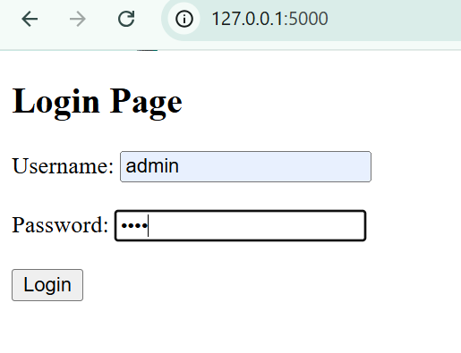



INVALID LOGIN:
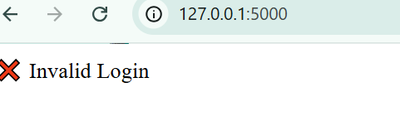

- When I put the correct username and password it shows welcome and it is successfully login but when I put the wrong password and username it shows invalid login.

Csv upload show Prediction:
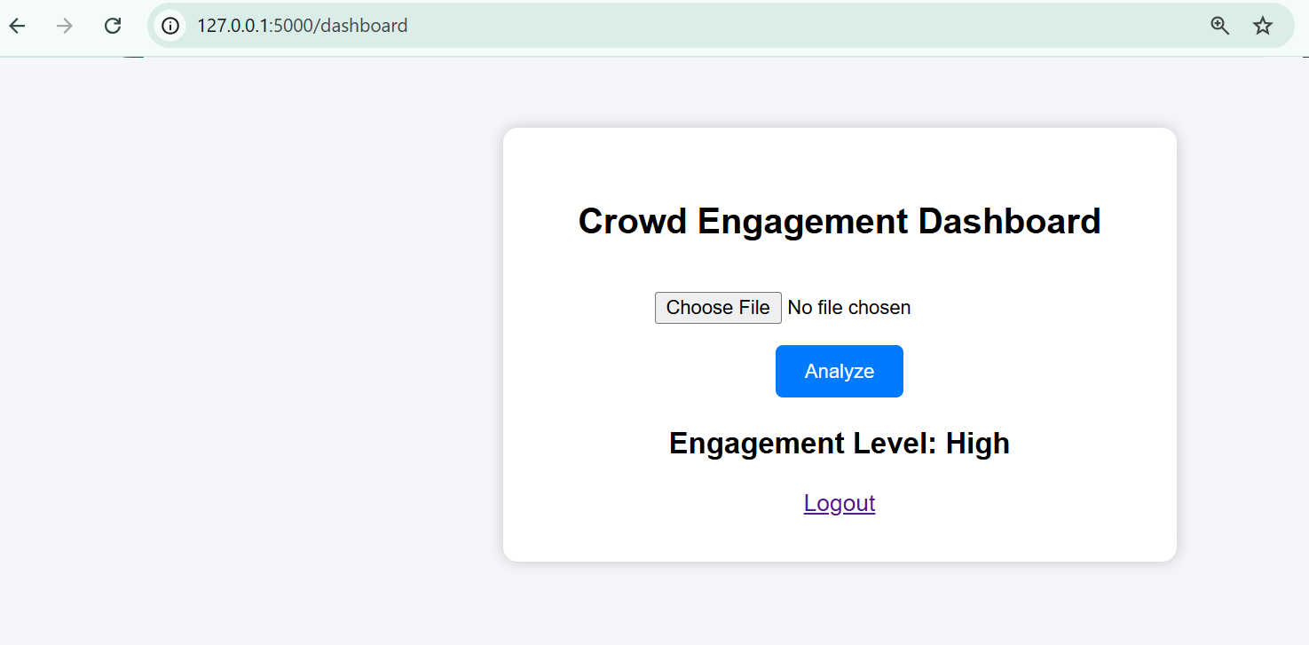

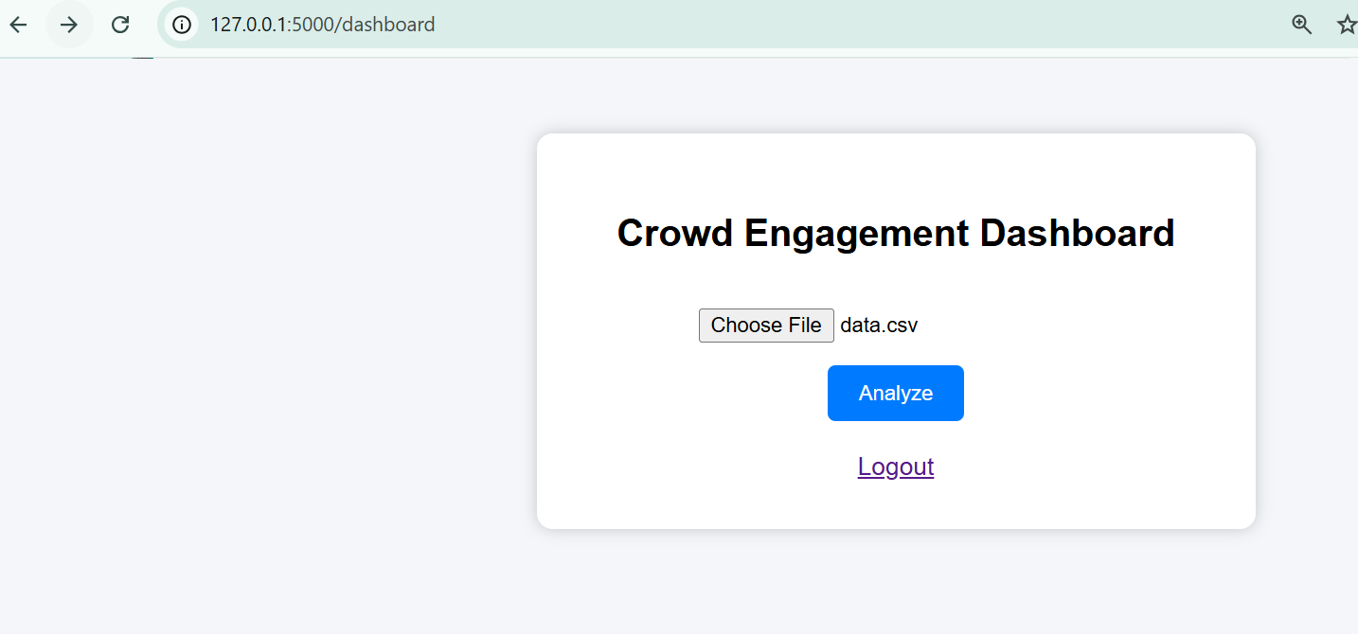

- You see in the first screenshot that when I add the data.csv and then in 2nd screenshot when I enter analyze it shows the prediction level (HIGH) this is shows that csv upload shows the prediction.

INTEGRATION TESTING:
In integration testing it shows that the csv files are successfully upload and the system shows the result (Prediction). There are no error in this so integration pass.

System Testing:
The system we do shows the entire workflow of all the files are working codes are working perfectly. Start from login and then go to prediction. I also add screenshot for the evidence of the workflow of entire project.

UI TESTING:
The project is user friendly and user interface is perfect in the project. The system interface is user-friendly and easy to use and navigate.

TESTING INSPECTION:
I write all the testing and shows that all the codes are working. Login page open and add username and password login successful. The app.py work perfectly it shows the crowd engagement level. It also shows the prediction of csv file. The csv file upload successfully. If anything put wrong, then error shows if put the right thing then alright. I also add the screenshot of the command response to the coding or the result run in the backend and the frontend.

Python login.py:

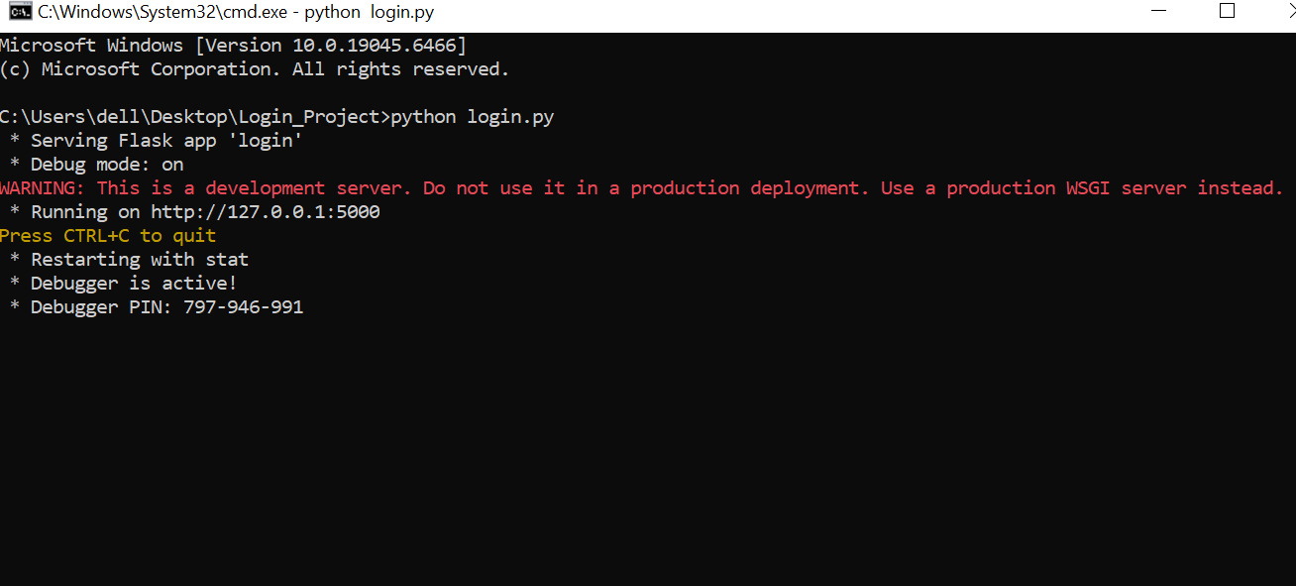

Python app.py:

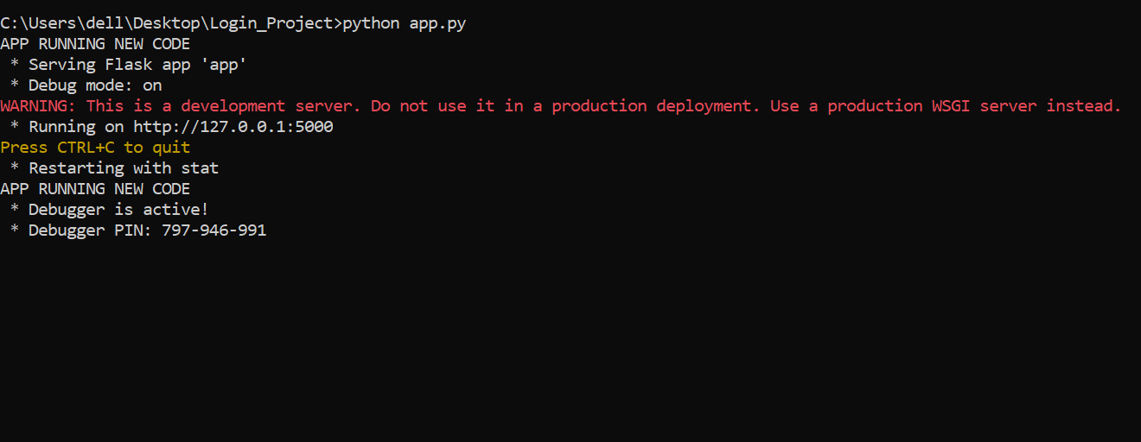

GitHub link:
https://github.com/Awaisriaz17/Enterprise-Pro-Project-P8-.git
https://github.com/Awaisriaz17/Enterprise-Pro-Project-P8-

Introduction:
This project name is BD25 Crowd Engagement Evaluation with ML Web Interface and Secure Access. This project shows the participation of people at event of Bradford in 2025. It shows the city of culture(Bradford) event all the pictures, videos, etc. I do coding in this to make the login page and dashboard page as well that is needed for crowd analysis. In this project a web interface is also made for crowd analysis. It represents the multi data of the people that are in the event. It also tells us the importance of machine learning. Moreover, by using the computer vision we can see the crowd and count them how many they are in the event. The most importantly it provides the secure access to evaluation for stakeholders.

Project Brief:
This project (BD25 Crowd Engagement Evaluation with ML Interface) mainly focus to count the crowd during the cultural event which is organized in UK city of culture(Bradford) in 2025. The system collects and processes the data such as images, videos, audio and footfall during the event. The machine learning techniques are used to measure the crowd size and get the estimate of how many people are there and get the level of engagement. In this project a secure web interface that allow stakeholders to authorized to upload event data and generate the evaluation reports of the event. This system helps the management team to improve the cultural event planning and know how people interact in the event like this. The coding is also used in this project to make the login and dashboard page and make the web interface.

Introduction of team expertise Rationale of topic choice:
The team choice this topic because it combines the important areas of computing including machine learning, data analytics and web application development. Moreover, team members have a strong grip on computer language like Java, Python, Html etc. These things allow team to develop a system to process event data and provide the crowd engagement data. The team choose this topic because it has large cultural data of cultural event by applying the machine learning and computer vision techniques. So these are the main reasons of choose.

