CW2 TESTING DOCUMENT
TEST AND VALIDATION REPORT
NAME: Muhammad Awais
UB NO: 24025960
MODULE NAME: Enterprise Pro

- ACCEPTANCE TESTING
TEST CASE | INPUT | EXPECTED OUTPUT | RESULT
VALID LOGIN | USERNAME:  Admin  Password: 1234 | Dashboard open | Pass
INVALID LOGIN | Wrong | Invalid login display | Pass
CSV UPLOAD | Data.csv | Prediction show | Pass
Log out | Click log out | Login Page | Pass

LOGIN:
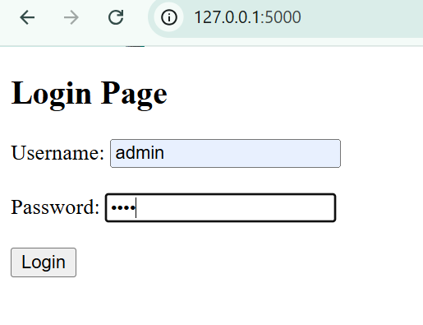

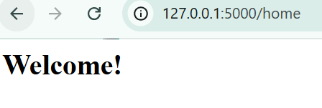

INVALID LOGIN:
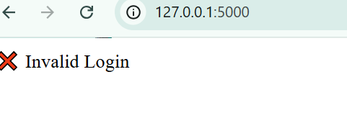

- When I put the correct username and password it shows welcome and it is successfully login but when I put the wrong password and username it shows invalid login.
Csv upload show Prediction:
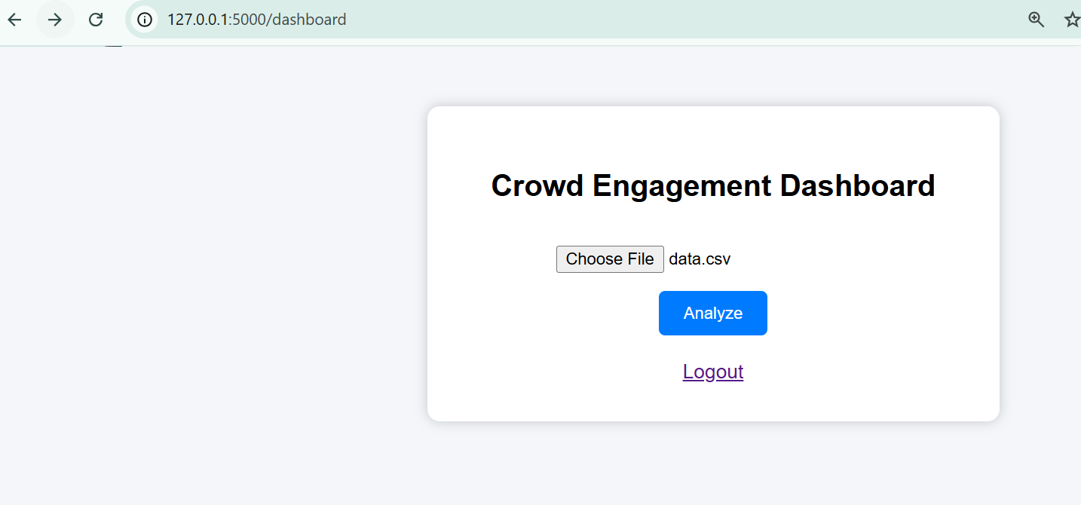

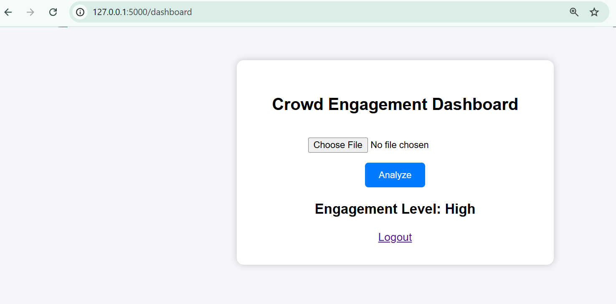

- You see in the first screenshot that when I add the data.csv and then in 2nd screenshot when I enter analyze it shows the prediction level (HIGH) this is shows that csv upload shows the prediction.
INTEGRATION TESTING:
In integration testing it shows that the csv files are successfully upload and the system shows the result (Prediction). There are no error in this so integration pass.

System Testing:
The system we do shows the entire workflow of all the files are working codes are working perfectly. Start from login and then go to prediction. I also add screenshot for the evidence of the workflow of entire project.
UI TESTING:
The project is user friendly and user interface is perfect in the project. The system interface is user-friendly and easy to use and navigate.
TESTING INSPECTION:
I write all the testing and shows that all the codes are working. Login page open and add username and password login successful. The app.py work perfectly it shows the crowd engagement level. It also shows the prediction of csv file. The csv file upload successfully. If anything put wrong, then error shows if put the right thing then alright. I also add the screenshot of the command response to the coding or the result run in the backend and the frontend.

Python login.py:
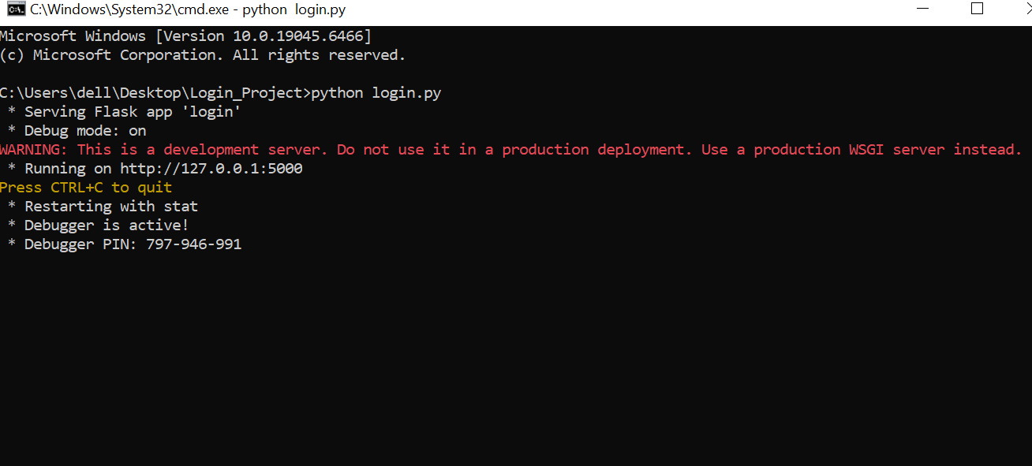

Python app.py:
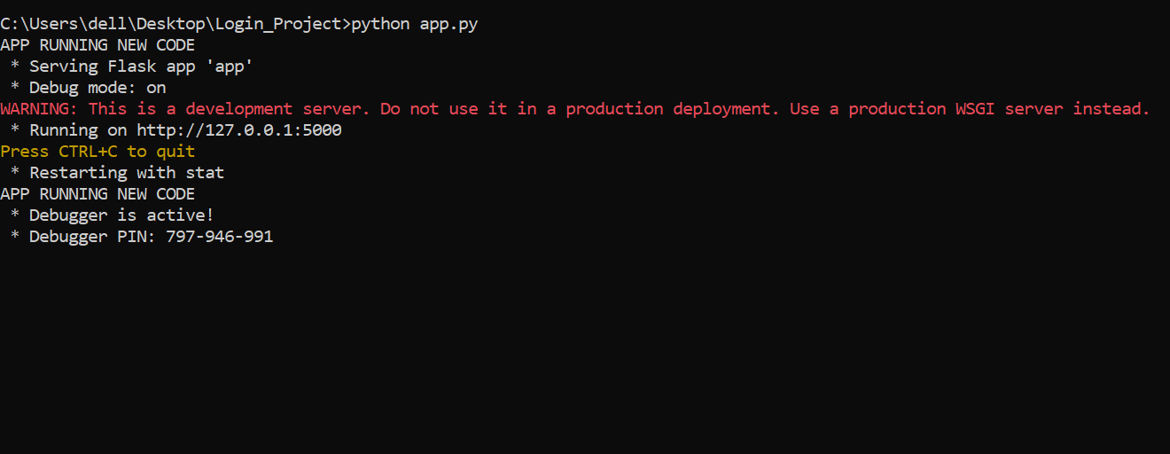

GitHub link:
https://github.com/Awaisriaz17/Enterprise-Pro-Project-P8-.git
https://github.com/Awaisriaz17/Enterprise-Pro-Project-P8-

