**ASSIGNMENT 2**

**Requirement Analysis:**

### KnowSkill: Personal Skill Development Tracker

**Requirements:**

1. **Login and Authentication System**
   * Develop a simple, secure login page where user can sign in using only their email and password.
   * Include basic functionality such as user registration and email-based password reset.
   * Include sign-in if the usser again comes to use the account after again using.
   * Include forget password if the user forget its password.
2. **User Profile Setup**
   * Allow users to create profiles by entering career goals, current skills, and desired skill improvements for personalized recommendations.
3. **Skill Assessment and Tracking**
   * Enable users to assess their current skills and track progress with visual elements like progress bars and milestones.
4. **Goal Setting and Reminders**
   * Allow users to set specific skill-development goals with deadlines and send reminders or notifications to help them stay on track.
5. **Resource Recommendations**
   * Include links to courses, certifications, and workshops from platforms like Coursera, Khan Academy, and Skillshare.
6. **Gamified Progress Rewards**
   * Introduce badges, streaks, or achievements for reaching milestones to keep users motivated.
7. **Community and Peer Support**
   * Provide a community forum or peer support section where users can discuss skill-building strategies, share resources, and seek advice.
8. **Skill Match and Opportunity Notifications**
   * Notify users about internships, job opportunities, or projects matching their assessed skills or skill improvement goals.
9. **Customizable Learning Paths**
   * Allow users to create or customize skill development pathways by selecting multiple skills and defining learning priorities.
10. **Performance Analytics and Reporting**

* Provide detailed analytics showing skill improvement trends, time invested, and comparison with peers (optional for privacy).
* **Non funtional :**

· **Scalability:** Handle up to 50,000 simultaneous users and manage a database with 5 million profiles.

· **Response Time:** Ensure response time for key actions (e.g., loading progress) is under 2 seconds.

· **Security:** Implement encryption protocols (e.g., HTTPS, TLS) and hash passwords securely (e.g., bcrypt).

· **Privacy Compliance:** Adhere to GDPR/CCPA regulations for user data protection.

· **Usability:** Offer an intuitive and user-friendly interface for seamless navigation.

· **Device Compatibility:** Ensure compatibility across Android, iOS, and web platforms.

· **Backup and Recovery:** Enable automated backups and recovery within 6 hours of failure.

· **Third-Party Integration:** Support API integrations for learning platforms (Coursera, LinkedIn Learning, etc.).

**List of Actors:**

**Learner:**

* Creates and manages their profile
* Sets goals and tracks progress
* Consumes learning resources
* Participates in the community
* Receives notifications and reminders
* Accesses performance analytics

**Content Provider:**

* Creates and uploads learning content (courses, articles, videos)
* Manages their content library
* Interacts with learners through comments and forums

1. **Platform Administrator:**
   * Manages the platform's infrastructure and user accounts
   * Monitors user activity and provides technical support
   * Implements new features and updates
   * Analyzes platform usage data
2. **Community Members:**
   * Participate in forums and discussions
   * Share experiences and knowledge
   * Collaborate on projects
3. **Partners:**
   * Provide external resources or services (e.g., job boards, certification providers)
   * Collaborate on marketing and promotion

**List of use cases:**

#### ****.login and Profile Creation and Management:****

* Create a user profile.
* Update personal information.
* Set career goals and skill preferences.

#### ****2. Skill Assessment:****

* Take skill assessments to identify strengths and weaknesses.
* Receive personalized recommendations based on assessment results.

#### ****3. Goal Setting and Tracking:****

* Set specific skill development goals.
* Track progress towards goals using visual aids.
* Receive reminders and notifications to stay on track.

#### ****4. Resource Discovery and Consumption:****

* Search for and discover relevant learning resources (courses, articles, videos).
* Enroll in courses and complete assignments.
* Interact with course content (e.g., watch videos, take quizzes).

#### ****5. Community Engagement:****

* Participate in forums and discussions.
* Connect with other learners and mentors.
* Collaborate on projects.

#### ****6. Performance Tracking and Analytics:****

* View progress reports and analytics.
* Identify areas for improvement.
* Track time spent learning.

#### ****7. Gamified Progress Rewards:****

* Earn badges, achievements, or streaks for skill milestones.
* Showcase rewards on the user profile to boost motivation.
* Track rewards earned over time.

#### ****8. Skill Match and Opportunity Notifications:****

* Notify users of job opportunities or internships matching their skills.
* Provide notifications about relevant projects or certifications.
* Allow users to set preferences for the type of opportunities they want to receive.

#### ****9. Customizable Learning Paths:****

* Let users select multiple skills and prioritize learning paths.
* Allow modifications to learning paths over time based on progress.
* Offer system-suggested paths based on user goals and preferences.

**Prottypes:**

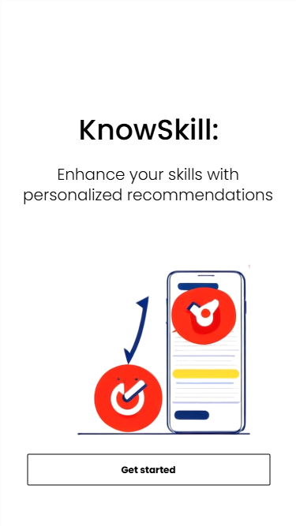

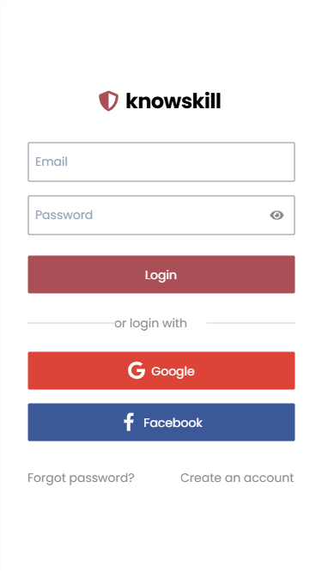

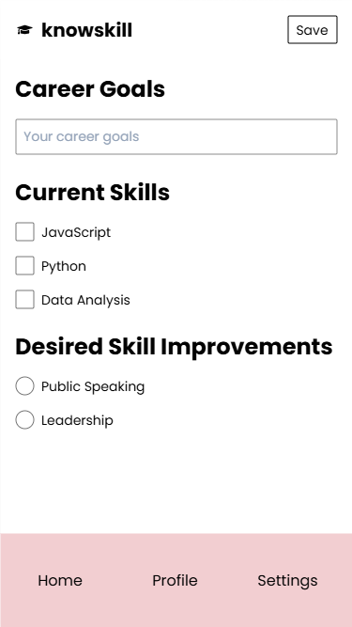



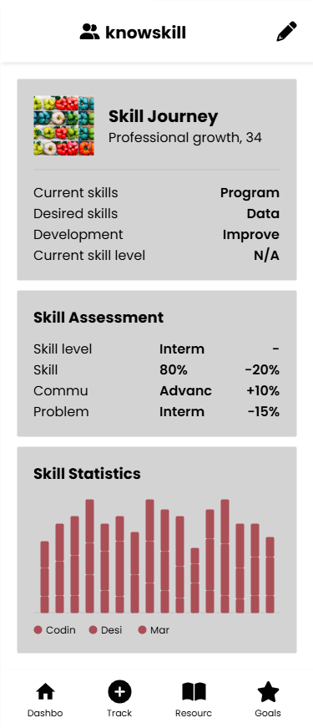

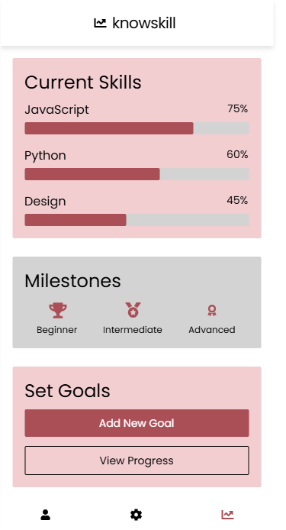

**System use case diagram**

Knowskill

system

User

**Login:**

Knowskill

system

User

**Forget Password:**

Knowskill

system

**User**

**Use-case Table:**

**Use Case Table for Login Process**

|  |  |
| --- | --- |
| **Field** | **Details** |
| **Use Case Name** | Login |
| **Created By** | Awais tabaruk |
| **Date Created** | 24-05-24 |
| **Last Updated By** | 03-06-24 |
| **Last Revision Date** | 24-06-24 |
| **Actors** | |  | | --- | | Users, System Administrator | |
| **Description** | |  |  | | --- | --- | |  | Provides a secure login system where users can sign in using email/password or social media accounts like Google and Facebook. | |
| **Trigger** | |  |  | | --- | --- | |  | User navigates to the login page. | |
| **Preconditions** | |  |  | | --- | --- | |  | - User has a valid account.  - Social media accounts (e.g., Google, Facebook) are set up for OAuth authentication. | |
| **Post conditions** | |  |  | | --- | --- | |  | - User is logged in successfully and directed to the dashboard.  - Authentication token/session is created. | |
| **Normal Flow** | |  |  | | --- | --- | |  | 1. User navigates to the login page.  2. User enters email and password or selects a social media login option.  3. System validates the credentials.  4. On successful validation, user is redirected to the dashboard. | |
| **Alternative Flows** | |  |  | | --- | --- | |  | - User opts for "Forgot Password":  1. User selects the "Forgot Password" link.  2. System sends a password reset link via email.  3. User resets the password and logs in.  - User registers for a new account (if sign-up option is integrated). | |
| **Exceptions** | |  |  | | --- | --- | |  | - Invalid email/password combination: Display an error message.  - Social media authentication fails: Display a relevant error.  - Network failure: Display a connection error. | |
| **Includes** | |  |  | | --- | --- | |  | - Email/password authentication  - Social media login integration (OAuth)  - Error handling mechanisms | |
| **Frequency of Use** | |  |  | | --- | --- | |  | Multiple times daily by users. | |
| **Special Requirements** | |  |  | | --- | --- | |  | - Compliance with security standards (e.g., encryption, secure connections).  - Use of CAPTCHA or similar mechanisms to prevent automated logins. | |
| **Assumptions** | |  | | --- | | - Users have access to the internet.  - Users have a valid email or social media account. | |
| **Notes and Issues** | |  |  | | --- | --- | |  | - Ensure accessibility for all users (e.g., ADA compliance).  - Monitor for and mitigate security vulnerabilities like brute force attacks. | |
| **Use Case ID** | |  |  | | --- | --- | |  | UC-1 | |

**Profile setup:**

Knowskill

system

User

**Use Case Table for Profile setup**

|  |  |
| --- | --- |
| **Field** | **Details** |
| **Use Case Name** | Profile setup |
| **Created By** | Awais tabaruk |
| **Date Created** | 24-05-24 |
| **Last Updated By** | 03-06-24 |
| **Last Revision Date** | 24-06-24 |
| **Actors** | |  | | --- | | Users | |
| **Description** | |  |  | | --- | --- | |  | Enables users to create or update their profiles by entering career goals, current skills, and desired skill improvements. This information is used to provide personalized recommendations. | |
| **Trigger** | |  |  | | --- | --- | |  | User selects the profile setup or edit option. | |
| **Preconditions** | |  |  | | --- | --- | |  | - User is logged in.  - User has access to the profile setup page. | |
| **Post conditions** | |  |  | | --- | --- | |  | - Profile information is saved successfully.  - System updates personalized recommendations based on the profile data. | |
| **Normal Flow** | |  |  | | --- | --- | |  | 1. User navigates to the profile setup page.  2. User enters career goals, current skills, and desired skill improvements.  3. User submits the information.  4. System validates and saves the data.  5. User receives confirmation that the profile was updated successfully. | |
| **Alternative Flows** | |  |  | | --- | --- | |  | - User skips some fields: System saves partial data and prompts the user to complete it later. | |
| **Exceptions** | |  |  | | --- | --- | |  | - Validation error (e.g., invalid input): System displays an error message and highlights the fields requiring correction.  - Network failure: System notifies the user that changes could not be saved and prompts to retry. | |
| **Includes** | |  |  | | --- | --- | |  | - Profile data validation.  - Data persistence in the database.  - Real-time suggestions (optional). | |
| **Frequency of Use** | |  | | --- | | Occasional: When the user creates a profile for the first time or updates it. | |
| **Special Requirements** | |  |  | | --- | --- | |  | - Interface should be user-friendly and responsive.  - Ensure data security and privacy. | |
| **Assumptions** | |  |  | | --- | --- | |  | - Users are motivated to provide accurate and complete information.  - Users have access to the required fields and options. | |
| **Notes and Issues** | |  | | --- | | - Consider integrating progress indicators to show profile completion percentage.  - Ensure accessibility for diverse user groups. | |
| **Use Case ID** | |  |  | | --- | --- | |  | UC-2 | |

**Skill Assessment and Tracking:**

Knowskill

system

User

**Use Case Table for Skill Assessment and Tracking**

|  |  |
| --- | --- |
| **Field** | **Details** |
| **Use Case Name** | Skill Assesment and Tracking |
| **Created By** | Awais tabaruk |
| **Date Created** | 24-05-24 |
| **Last Updated By** | 03-06-24 |
| **Last Revision Date** | 24-06-24 |
| **Actors** | |  |  | | --- | --- | |  | Users | |
| **Description** | |  |  | | --- | --- | |  | Enables users to assess their current skills and track their progress through visual elements such as progress bars and milestones. | |
| **Trigger** | |  |  | | --- | --- | |  | User selects the skill assessment or progress tracking option. | |
| **Preconditions** | |  |  | | --- | --- | |  | - User is logged in.  - User has access to the skill assessment page. | |
| **Post conditions** | |  |  | | --- | --- | |  | - User’s skills are assessed and saved.  - Progress is tracked and displayed with visual elements. | |
| **Normal Flow** | |  |  | | --- | --- | |  | 1. User navigates to the skill assessment page.  2. User completes a skill assessment (e.g., questionnaire, quiz).  3. System evaluates the results and displays the user’s current skill level.  4. System updates and displays progress in visual elements like progress bars and milestones.  5. User receives confirmation and an option to review or set goals. | |
| **Alternative Flows** | |  |  | | --- | --- | |  | - User skips certain sections: System saves partial data and prompts the user to complete it later.  - User fails to meet assessment criteria: System provides feedback and suggests areas of improvement. | |
| **Exceptions** | |  |  | | --- | --- | |  | - Validation error (e.g., invalid input): System displays an error message and highlights the fields requiring correction.  - Network failure: System notifies the user that changes could not be saved and prompts to retry. | |
| **Includes** | |  |  | | --- | --- | |  | - Skill assessment validation.  - Data persistence in the database.  - Progress tracking and visual representation. | |
| **Frequency of Use** | |  |  | | --- | --- | |  | Occasional: When users assess their skills or track progress periodically. | |
| **Special Requirements** | |  |  | | --- | --- | |  | - Visual elements (progress bars, milestones) should be clear and interactive.  - Ensure data security and privacy. | |
| **Assumptions** | |  |  | | --- | --- | |  | - Users will take skill assessments periodically.  - Users have access to necessary tools for tracking progress. | |
| **Notes and Issues** | |  |  | | --- | --- | |  | - Consider adding a goal-setting feature based on assessment results.  - Ensure accessibility for users with visual impairments. | |
| **Use Case ID** | |  |  | | --- | --- | |  | UC-003 | |

**Goal Setting and Reminders:**

Knowskill

system

User

**Use Case Table forgoalsetting and remainder**

|  |  |
| --- | --- |
| **Field** | **Details** |
| **Use Case Name** | Goal seeting and remainder |
| **Created By** | Awais tabaruk |
| **Date Created** | 24-05-24 |
| **Last Updated By** | 03-06-24 |
| **Last Revision Date** | 24-06-24 |
| **Actors** | |  |  | | --- | --- | |  | Users | |
| **Description** | |  |  | | --- | --- | |  | Allows users to set specific skill-development goals with deadlines and sends reminders or notifications to help them stay on track with their progress. | |
| **Trigger** | |  |  | | --- | --- | |  | User selects the goal-setting option. | |
| **Preconditions** | |  |  | | --- | --- | |  | - User is logged in.  - User has access to the goal-setting page. | |
| **Post conditions** | |  |  | | --- | --- | |  | - User's goals are set with deadlines.  - Reminders and notifications are activated for goal tracking. | |
| **Normal Flow** | |  |  | | --- | --- | |  | 1. User navigates to the goal-setting page.  2. User defines specific skill-development goals with deadlines.  3. User submits the goals.  4. System saves the goals and sets up reminders/notifications.  5. User receives confirmation that goals are set and reminders are active. | |
| **Alternative Flows** | |  |  | | --- | --- | |  | - User skips setting a deadline: System saves the goal without a deadline and prompts the user to set one later.  - User enters incomplete goals: System prompts the user to complete the missing fields before submission. | |
| **Exceptions** | |  |  | | --- | --- | |  | - Invalid goal input (e.g., unrealistic deadline): System displays an error message and suggests alternative options.  - Network failure: System notifies the user that goals couldn’t be saved and prompts to retry. | |
| **Includes** | |  |  | | --- | --- | |  | - Goal data validation.  - Data persistence in the database.  - Notification setup for reminders. | |
| **Frequency of Use** | |  |  | | --- | --- | |  | Occasional: When users set new goals or update existing ones. | |
| **Special Requirements** | |  |  | | --- | --- | |  | - Reminders should be customizable (e.g., frequency, timing).  - Ensure data security and privacy for user goals. | |
| **Assumptions** | |  |  | | --- | --- | |  | - Users are motivated to set and follow through with goals.  - Users have access to notifications or reminders through the platform. | |
| **Notes and Issues** | |  |  | | --- | --- | |  | - Consider adding goal tracking visualization or progress indicators.  - Ensure the reminder system works across different devices/platforms. | |
| **Use Case ID** | |  |  | | --- | --- | |  | UC-004 | |

**Resource Recommendations:**

Knowskill

system

System

**Use Case Table for recourse recommendation**

|  |  |
| --- | --- |
| **Field** | **Details** |
| **Use Case Name** | Recource recommendation |
| **Created By** | Awais tabaruk |
| **Date Created** | 24-05-24 |
| **Last Updated By** | 03-06-24 |
| **Last Revision Date** | 24-06-24 |
| **Actors** | |  | | --- | | User | |
| **Description** | |  |  | | --- | --- | |  | Provides users with links to courses, certifications, and workshops from platforms like Coursera, Khan Academy, and Skillshare based on their skills and goals. | |
| **Trigger** | |  |  | | --- | --- | |  | User accesses the recommendations page or completes a skill assessment/goal setup. | |
| **Preconditions** | |  |  | | --- | --- | |  | - User is logged in.  - User has completed skill assessment or goal setup (optional). | |
| **Post conditions** | |  |  | | --- | --- | |  | - System displays relevant resources tailored to the user’s profile.  - User can access the recommended resources via provided links. | |
| **Normal Flow** | |  |  | | --- | --- | |  | 1. User navigates to the resource recommendations page.  2. System analyzes the user’s profile (skills, goals, and progress).  3. System displays a list of recommended resources with links to external platforms.  4. User selects and accesses the resources as needed. | |
| **Alternative Flows** | |  |  | | --- | --- | |  | - User profile is incomplete: System provides generic recommendations and prompts the user to complete their profile for better suggestions. | |
| **Exceptions** | |  |  | | --- | --- | |  | - External resource link is broken or unavailable: System notifies the user and removes the resource from the list.  - Network failure: System notifies the user that recommendations could not be loaded and prompts to retry. | |
| **Includes** | |  |  | | --- | --- | |  | - Analysis of user data to generate recommendations.  - Display of resource links. | |
| **Frequency of Use** | |  |  | | --- | --- | |  | Frequent: Users may revisit this feature to explore updated recommendations. | |
| **Special Requirements** | |  |  | | --- | --- | |  | - Recommendations should be relevant, up-to-date, and categorized by skill type or goal.  - Ensure third-party resource links are accurate and functional. | |
| **Assumptions** | |  |  | | --- | --- | |  | - Users are open to exploring external learning platforms.  - External platforms provide accessible content for users. | |
| **Notes and Issues** | |  |  | | --- | --- | |  | - Consider user feedback to improve recommendation accuracy.  - Ensure resources are accessible to diverse user groups and skill levels. | |
| **Use Case ID** | |  |  | | --- | --- | |  | UC-005 | |

**Gamified Progress Rewards:**

Knowskill

system

System

**Use Case Table for Gamified progress reward**

|  |  |
| --- | --- |
| **Field** | **Details** |
| **Use Case Name** | Gamified Progress Reward |
| **Created By** | Awais tabaruk |
| **Date Created** | 24-05-24 |
| **Last Updated By** | 03-06-24 |
| **Last Revision Date** | 24-06-24 |
| **Actors** | |  |  | | --- | --- | |  | Users | |
| **Description** | |  | | --- | | Introduces badges, streaks, or achievements for reaching milestones to keep users motivated and engaged. | |
| **Trigger** | |  |  | | --- | --- | |  | User achieves a milestone or reaches a predefined goal. | |
| **Preconditions** | |  |  | | --- | --- | |  | - User is logged in.  - System tracks user progress and milestones. | |
| **Post conditions** | |  |  | | --- | --- | |  | - User earns a badge, streak, or achievement.  - Rewards are displayed on the user’s profile or dashboard. | |
| **Normal Flow** | |  |  | | --- | --- | |  | 1. User completes a task or reaches a milestone (e.g., completing a course, maintaining a streak).  2. System identifies the achievement and awards the corresponding badge, streak, or milestone.  3. User is notified of the reward.  4. Reward is displayed on the user’s profile/dashboard for visibility. | |
| **Alternative Flows** | |  |  | | --- | --- | |  | - User misses a streak (e.g., fails to log in for a set time): System notifies the user and suggests ways to regain motivation. | |
| **Exceptions** | |  |  | | --- | --- | |  | - Progress tracking error: System apologizes, recalculates, and reassigns rewards if necessary.  - Network failure: System notifies the user that rewards cannot be updated and prompts to retry later. | |
| **Includes** | |  |  | | --- | --- | |  | - Milestone tracking.  - Reward assignment and display. | |
| **Frequency of Use** | |  |  | | --- | --- | |  | Frequent: Rewards are triggered as users achieve milestones or maintain progress. | |
| **Special Requirements** | |  |  | | --- | --- | |  | - Rewards should be visually appealing and varied to maintain user interest.  - System should notify users of upcoming milestones to encourage engagement. | |
| **Assumptions** | |  |  | | --- | --- | |  | - Users are motivated by gamification and visible achievements.  - System can accurately track user progress and milestones. | |
| **Notes and Issues** | |  |  | | --- | --- | |  | - Consider offering customizable rewards (e.g., selecting a badge style).  - Ensure fair criteria for earning rewards to avoid user frustration. | |
| **Use Case ID** | |  |  | | --- | --- | |  | UC-006 | |

**Community and Peer Support:**

Knowskill

system

User

**Use Case Table for Community and peer support**

|  |  |
| --- | --- |
| **Field** | **Details** |
| **Use Case Name** | Community and peer support |
| **Created By** | Awais tabaruk |
| **Date Created** | 24-05-24 |
| **Last Updated By** | 03-06-24 |
| **Last Revision Date** | 24-06-24 |
| **Actors** | |  | | --- | | Userr | |
| **Description** | |  |  | | --- | --- | |  | Provides a community forum or peer support section where users can discuss skill-building strategies, share resources, and seek advice from others. | |
| **Trigger** | |  |  | | --- | --- | |  | User accesses the community forum or peer support section. | |
| **Preconditions** | |  |  | | --- | --- | |  | - User is logged in.  - Forum or peer support section is accessible. | |
| **Post conditions** | |  |  | | --- | --- | |  | - User successfully posts a question, shares a resource, or participates in a discussion.  - Other users can view and interact with the content. | |
| **Normal Flow** | |  |  | | --- | --- | |  | 1. User navigates to the community forum or peer support section.  2. User browses existing discussions or starts a new thread.  3. User submits their post (e.g., question, resource, or advice).  4. System saves and displays the post for others to interact with.  5. Other users can respond or react to the post, facilitating discussion and support. | |
| **Alternative Flows** | |  |  | | --- | --- | |  | - User searches for existing discussions: System displays relevant threads for the user to join.  - User edits or deletes their post: System updates or removes the post accordingly. | |
| **Exceptions** | |  |  | | --- | --- | |  | - Inappropriate content detected: System flags the post and notifies moderators for review.  - Network failure: System notifies the user that the post could not be submitted and prompts to retry. | |
| **Includes** | |  |  | | --- | --- | |  | - Post creation, editing, and deletion.  - Moderation tools for content review.  - Notification system for post replies or interactions. | |
| **Frequency of Use** | |  |  | | --- | --- | |  | Frequent: Users may participate in discussions or seek advice regularly. | |
| **Special Requirements** | |  |  | | --- | --- | |  | - Interface should be user-friendly and encourage interaction.  - Moderation tools should ensure a safe and respectful environment. | |
| **Assumptions** | |  |  | | --- | --- | |  | - Users are interested in sharing and seeking advice within the community.  - Community guidelines are clearly defined and enforced. | |
| **Notes and Issues** | |  |  | | --- | --- | |  | - Consider integrating a rating or upvote system for useful posts.  - Ensure accessibility for users with diverse needs. | |
| **Use Case ID** | |  |  | | --- | --- | |  | UC-007 | |

**Skill Match and Opportunity Notifications:**

Knowskill

system

System

**Use Case Table for Skill match and opprotunity notifications**

|  |  |
| --- | --- |
| **Field** | **Details** |
| **Use Case Name** | Skill match and opprotunity notifications |
| **Created By** | Awais tabaruk |
| **Date Created** | 24-05-24 |
| **Last Updated By** | 03-06-24 |
| **Last Revision Date** | 24-06-24 |
| **Actors** | |  |  | | --- | --- | |  | Users | |
| **Description** | |  |  | | --- | --- | |  | Notifies users about internships, job opportunities, or projects that match their assessed skills or skill improvement goals. | |
| **Trigger** | |  |  | | --- | --- | |  | System identifies a match between user skills/goals and available opportunities. | |
| **Preconditions** | |  |  | | --- | --- | |  | - User is logged in.  - System has access to user skill data and improvement goals.  - Opportunity data is available in the system. | |
| **Post conditions** | |  |  | | --- | --- | |  | - User is notified about relevant opportunities.  - User can view details and take action on the opportunities. | |
| **Normal Flow** | |  |  | | --- | --- | |  | 1. System periodically analyzes user data (skills, goals) and available opportunities.  2. System identifies matching opportunities.  3. System sends a notification to the user about the match.  4. User views the notification and accesses opportunity details.  5. User takes action (e.g., applies for a job, joins a project). | |
| **Alternative Flows** | |  |  | | --- | --- | |  | - User dismisses a notification: System marks the opportunity as seen and no further notifications are sent for it.  - User updates their profile to refine matches: System recalibrates and sends more tailored notifications. | |
| **Exceptions** | |  |  | | --- | --- | |  | - No matching opportunities: System notifies the user and suggests ways to enhance their profile for better matches.  - Network failure: System retries sending the notification and logs the failure for review. | |
| **Includes** | |  |  | | --- | --- | |  | - Matching algorithm for skills and opportunities.  - Notification system for sending alerts.  - Opportunity detail display. | |
| **Frequency of Use** | |  |  | | --- | --- | |  | Frequent: Notifications are sent whenever matching opportunities are found. | |
| **Special Requirements** | |  |  | | --- | --- | |  | - Notifications should be timely and concise.  - Users should have the ability to customize notification preferences. | |
| **Assumptions** | |  |  | | --- | --- | |  | - Users are interested in opportunities aligned with their skills and goals.  - Opportunity data is regularly updated in the system. | |
| **Notes and Issues** | |  |  | | --- | --- | |  | - Consider integrating filters to allow users to prioritize certain types of opportunities.  - Ensure notifications are not overwhelming or intrusive. | |
| **Use Case ID** | |  |  | | --- | --- | |  | UC-008 | |

**Customizable Learning Paths:**

Knowskill

system

User

**Use Case Table for Customisable learning path**

|  |  |
| --- | --- |
| **Field** | **Details** |
| **Use Case Name** | Customisable learning path |
| **Created By** | Awais tabaruk |
| **Date Created** | 24-05-24 |
| **Last Updated By** | 03-06-24 |
| **Last Revision Date** | 24-06-24 |
| **Actors** | |  | | --- | | Users | |
| **Description** | |  |  | | --- | --- | |  | Allows users to create or customize skill development pathways by selecting multiple skills and defining learning priorities. | |
| **Trigger** | |  |  | | --- | --- | |  | User selects the option to create or customize a learning path. | |
| **Preconditions** | |  |  | | --- | --- | |  | - User is logged in.  - System has access to the user's skill data and goals (optional). | |
| **Post conditions** | |  |  | | --- | --- | |  | - User's customized learning path is saved.  - System provides recommendations or progress tracking for the selected learning path. | |
| **Normal Flow** | |  |  | | --- | --- | |  | 1. User navigates to the customizable learning path page.  2. User selects skills they want to develop.  3. User defines learning priorities (e.g., importance, order of focus).  4. System validates and saves the learning path.  5. User receives confirmation and can begin tracking progress along the path. | |
| **Alternative Flows** | |  |  | | --- | --- | |  | - User skips some selections: System saves the incomplete path and prompts the user to complete it later.  - User selects a predefined learning template: System customizes it based on the user’s input. | |
| **Exceptions** | |  |  | | --- | --- | |  | - Validation error (e.g., conflicting priorities): System notifies the user and prompts for corrections.  - Network failure: System notifies the user that changes couldn’t be saved and prompts to retry. | |
| **Includes** | |  |  | | --- | --- | |  | - Skill selection and prioritization interface.  - Path validation and saving.  - Integration with progress tracking. | |
| **Frequency of Use** | |  |  | | --- | --- | |  | Occasional: When users create or update their learning paths. | |
| **Special Requirements** | |  |  | | --- | --- | |  | - Interface should be user-friendly, with clear options for skill selection and prioritization.  - Ensure data security and privacy. | |
| **Assumptions** | |  |  | | --- | --- | |  | - Users are motivated to plan their learning journey.  - Users have an understanding of the skills they want to develop. | |
| **Notes and Issues** | |  |  | | --- | --- | |  | - Consider offering predefined learning paths as templates for beginners.  - Ensure flexibility to accommodate diverse user needs. | |
| **Use Case ID** | |  |  | | --- | --- | |  | UC-009 | |

**Performance Analytics and Reporting:**

Knowskill

system

User

**Use Case Table forPerformance analytics and reporting**

|  |  |
| --- | --- |
| **Field** | **Details** |
| **Use Case Name** | Performance analytics and reporting |
| **Created By** | Awais tabaruk |
| **Date Created** | 24-05-24 |
| **Last Updated By** | 03-06-24 |
| **Last Revision Date** | 24-06-24 |
| **Actors** | |  |  | | --- | --- | |  | Users | |
| **Description** | |  |  | | --- | --- | |  | Provides detailed analytics showing skill improvement trends, time invested, and optional comparisons with peers while maintaining privacy. | |
| **Trigger** | |  |  | | --- | --- | |  | User accesses the performance analytics page. | |
| **Preconditions** | |  |  | | --- | --- | |  | - User is logged in.  - System has tracked user progress data. | |
| **Post conditions** | |  |  | | --- | --- | |  | - User views detailed analytics and reports on their skill development progress.  - Insights help users identify areas for improvement or celebrate achievements. | |
| **Normal Flow** | |  |  | | --- | --- | |  | 1. User navigates to the performance analytics page.  2. System retrieves and processes user data (e.g., skills, progress, time invested).  3. System displays analytics, including trends, achievements, and optional peer comparisons.  4. User explores the analytics and identifies actionable insights. | |
| **Alternative Flows** | |  |  | | --- | --- | |  | - User customizes the analytics view: System filters or adjusts the data display according to user preferences. | |
| **Exceptions** | |  |  | | --- | --- | |  | - Insufficient data: System notifies the user and provides suggestions to start tracking progress.  - Network failure: System notifies the user that analytics could not be loaded and prompts to retry. | |
| **Includes** | |  |  | | --- | --- | |  | - Data retrieval and processing.  - Visualization of trends and metrics.  - Optional peer comparison with privacy safeguards. | |
| **Frequency of Use** | |  |  | | --- | --- | |  | Frequent: Users may regularly review analytics to track progress. | |
| **Special Requirements** | |  |  | | --- | --- | |  | - Visualizations should be clear, intuitive, and responsive.  - Ensure privacy and security, especially for peer comparison data. | |
| **Assumptions** | |  |  | | --- | --- | |  | - Users are interested in monitoring their progress and identifying improvement areas.  - System has accurate and up-to-date progress data. | |
| **Notes and Issues** | |  |  | | --- | --- | |  | - Consider integrating recommendations or tips based on analytics.  - Ensure accessibility for users with diverse needs. | |
| **Use Case ID** | |  |  | | --- | --- | |  | UC-010 | |

**Extend use case:**

<<extend>>

<<extend>>

<<extend>>

<<extend>>

<<extend>>

User

<<extend>>

<<extend>>

**Activity diagram :**

**Class diagram:**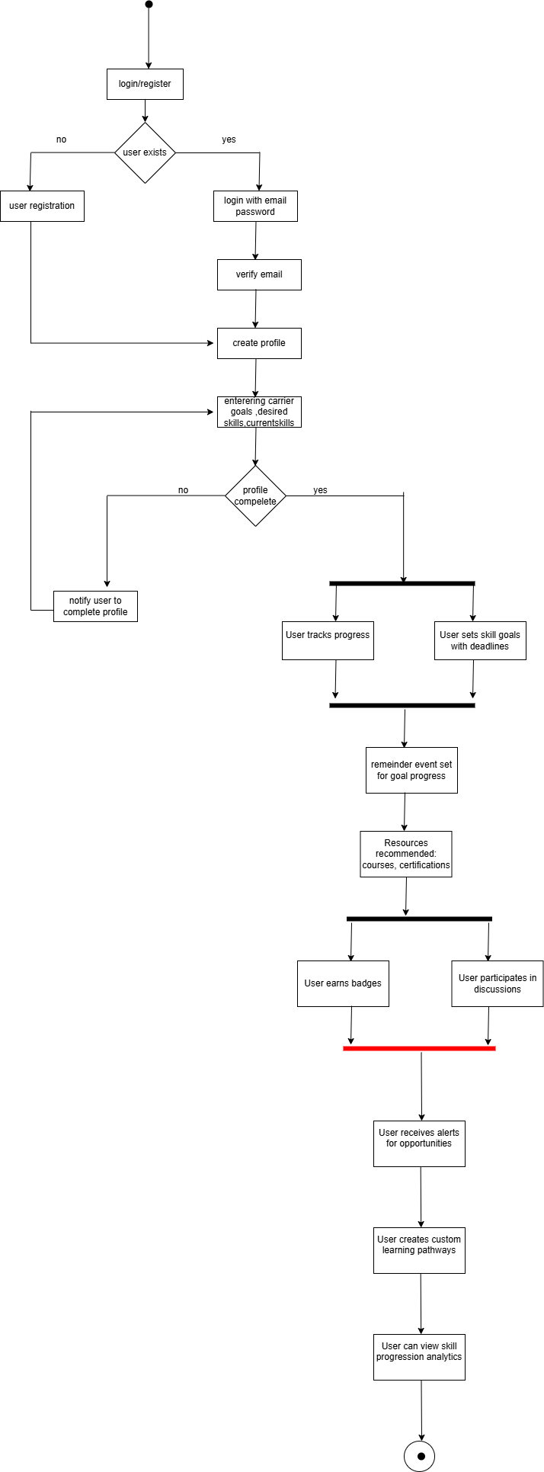

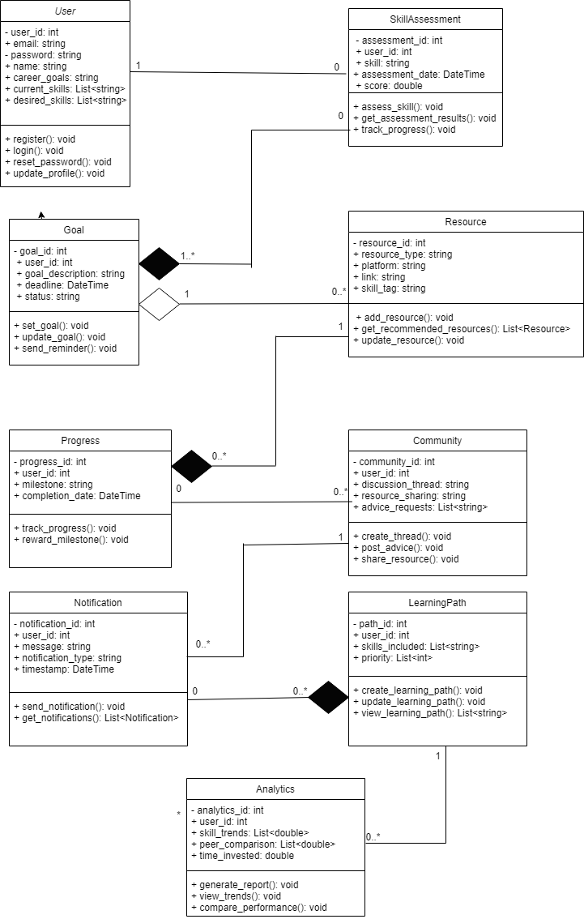

**Sequence diagram:**

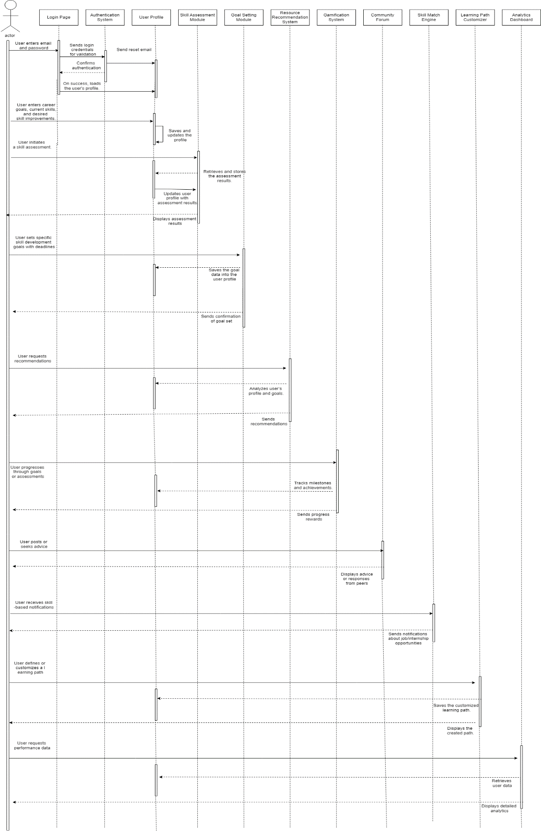

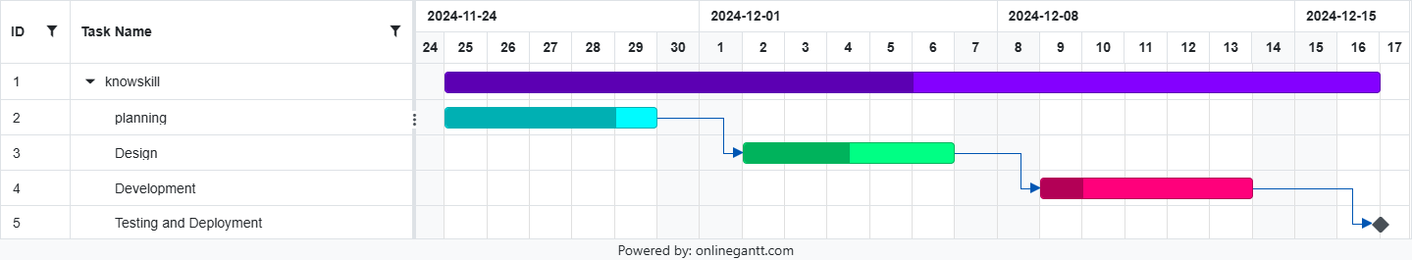

**Dfd lvl 0**

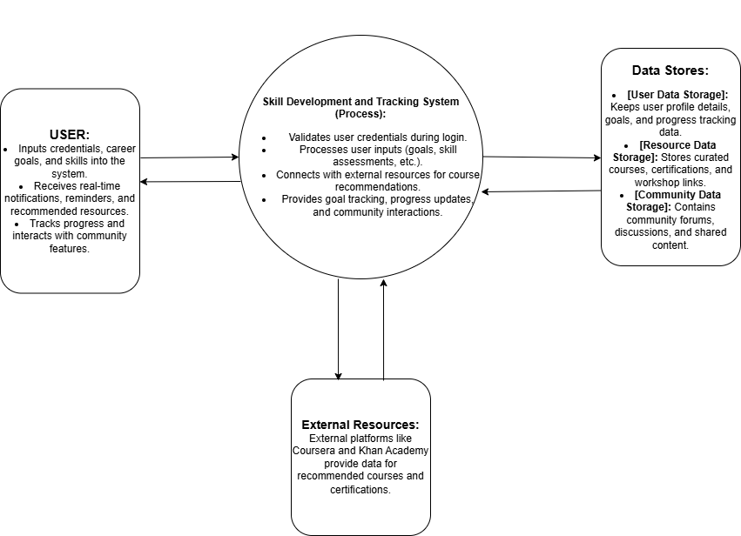

**Dfd lvl 1**

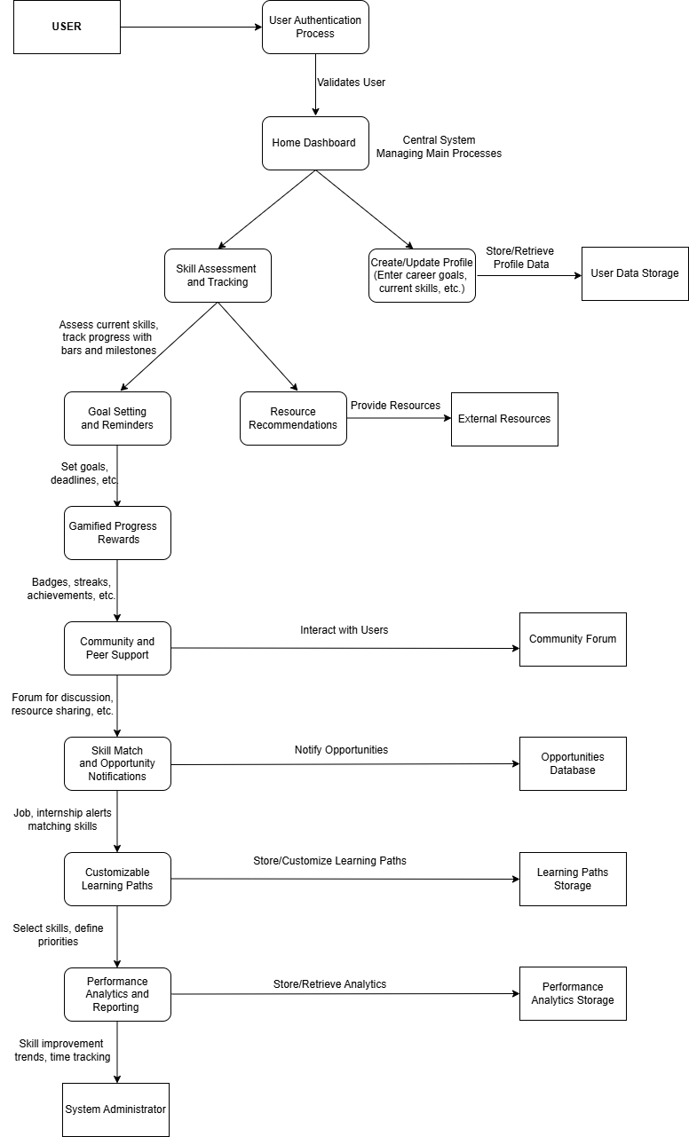

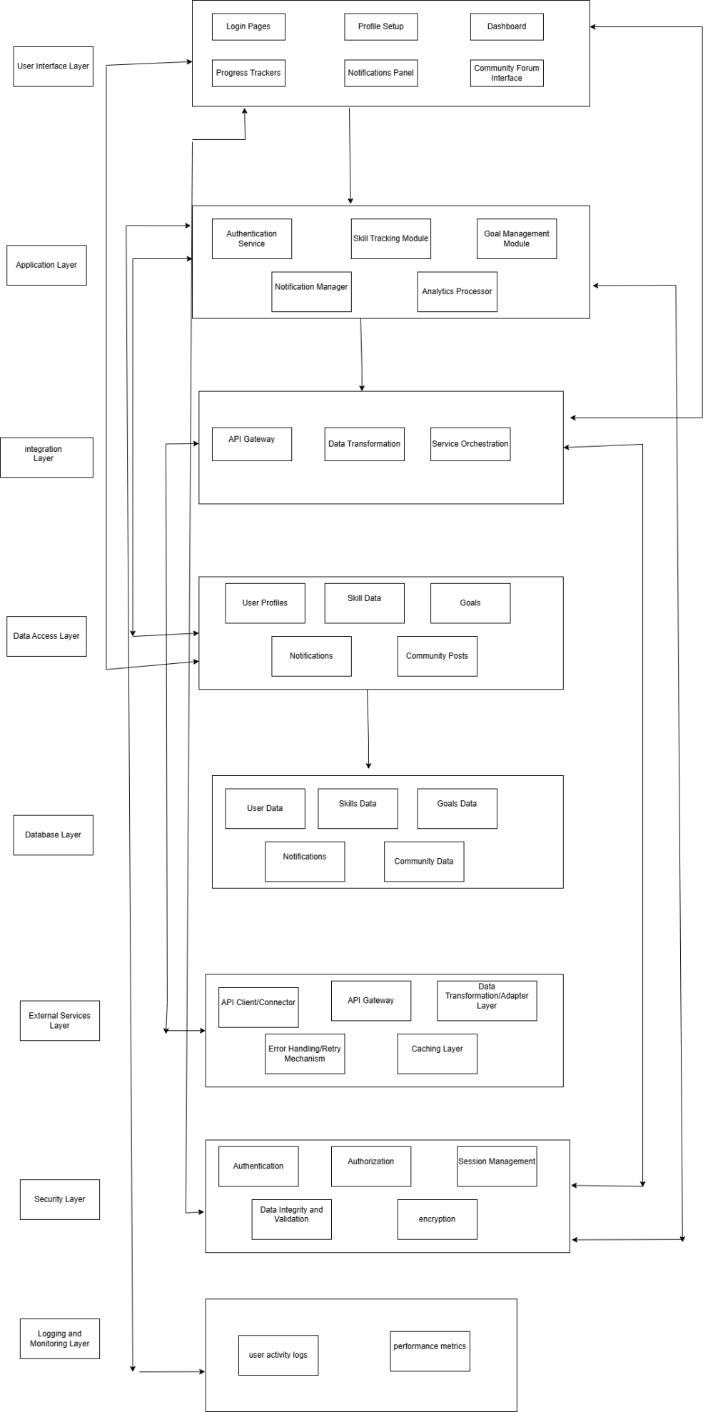

**TESTING**

### ****Login and Authentication System****

| **Module Name** | **Secure Data Storage** |
| --- | --- |
| **Test Case ID** | 1 |
| **Test Case Description** | Verify the functionality of login, registration, password reset, and secure data storage. |
| **Prerequisites** | Application must be deployed with a database connection. User account exists for login and password reset scenarios. |
| **Tester Name** | [Tester Name] |
| **Environmental Information** | [Environment Details: e.g., OS, browser, version] |
| **Test Scenario** | 1. Verify that a student can register for the first time with a valid email and password. |
|  | 2. Verify that a registered user can log in with valid credentials. |
|  | 3. Verify the "Forgot Password" functionality allows password reset via email. |
|  | 4. Verify that login fails when incorrect credentials are provided. |
|  | 5. Verify that users can log in again after a session ends. |
|  | 6. Verify that passwords are securely stored in the database (e.g., encrypted). |

|  |  |  |  |  |  |
| --- | --- | --- | --- | --- | --- |
| **Test Case ID** | **Test Steps** | **Expected Results** | **Actual Results** | **Status** | **Comments** |
| 1.1 | 1. Open login page.  2. Enter valid email and password.  3. Click "Login." | User should be logged in successfully. | User logged in successfully. | Pass | Ensure secure session management after login. |
| **1.2** | 1. Click "Forgot Password."  2. Enter registered email.  3. Submit request. | Password reset email is sent to the registered email address. | Password reset email sent. | Pass | Check if the email contains a functional reset link. |
| 1.3 | 1. Enter an invalid email or password.  2. Click "Login." | An error message is displayed for invalid credentials. | Error message displayed. | Pass | Ensure error messages do not disclose sensitive information. |
| 1.4 | 1. Register a new account using email and password.  2. Verify email. | Account is created, and the user can log in after verification. | Account created successfully. | Pass | Ensure duplicate registrations with the same email are restricted. |

Profile setup :

### ****User Profile Creation****

| **Module Name** | **User Profile Setup** |
| --- | --- |
| **Test Case ID** | 2 |
| **Test Case Description** | Verify that users can create and update profiles by entering required details. |
| **Prerequisites** | Application must be deployed. |
| **Tester Name** | [Tester Name] |
| **Environmental Information** | [Environment Details: e.g., OS, browser, version] |
| **Test Scenario** | 1. Verify that a new user can create a profile by entering personal information, academic scores, and preferences. |
|  | 2. Verify that profile details are saved correctly in the database. |
|  | 3. Verify that users can update existing profile information. |
|  | 4. Verify validation for required fields (e.g., GPA, date of birth). |

|  |  |  |  |  |  |  |  |  |  |  |  |  |  |
| --- | --- | --- | --- | --- | --- | --- | --- | --- | --- | --- | --- | --- | --- |
| |  | | --- | | **Test Case ID** | | |  | | --- | | **Test Steps** | | |  |  |  | | --- | --- | --- | | |  | | --- | | **Expected Results** |  |  | | --- | |  | | | |  | | --- | | **Actual Results** | | |  | | --- | | **Status** | | |  | | --- | | **Comments** | |
| 2.1 | 1. Navigate to profile creation page.  2. Enter career goals, current skills, and desired improvements. | Profile data is saved and displayed correctly. | Profile saved successfully. | Pass | Validate that all input fields accept valid data in correct formats. |
| 2.2 | 1. Edit existing profile details.  2. Save changes. | Profile updates should be saved and displayed correctly. | Changes saved successfully. | Pass | Check if updated fields reflect immediately in the UI. |

### ****Skill Assessment and Tracking****

| **Module Name** | **Skill Assessment** |
| --- | --- |
| **Test Case ID** | 3 |
| **Test Case Description** | Verify the functionality of assessing and tracking skills with visual progress. |
| **Prerequisites** | Skill assessment feature must be implemented and connected to the database. |
| **Tester Name** | [Tester Name] |
| **Environmental Information** | [Environment Details: e.g., OS, browser, version] |
| **Test Scenario** | 1. Verify users can take a skill assessment quiz and view results. |
|  | 2. Verify progress tracking updates dynamically based on completed milestones. |
|  | 3. Verify that users can view detailed skill improvement analytics. |

|  |  |  |  |  |  |  |  |  |  |  |  |  |  |
| --- | --- | --- | --- | --- | --- | --- | --- | --- | --- | --- | --- | --- | --- |
| |  | | --- | | **Test Case ID** | | |  | | --- | | **Test Steps** | | |  |  |  | | --- | --- | --- | | |  | | --- | | **Expected Results** |  |  | | --- | |  | | | |  | | --- | | **Actual Results** | | |  | | --- | | **Status** | | |  | | --- | | **Comments** | |
| 3.1 | 1. Start a skill assessment quiz.  2. Submit answers. | Skill levels are calculated and displayed visually. | Assessment results displayed. | Pass | Ensure accurate evaluation and proper visual representation. |
| 3.2 | 1. Track progress by completing skill milestones. | Progress bar updatesdynamically based on completed milestones. | Progress bar updated. | Pass | Validate visual accuracy of progress bars.. |

### ****Goal Setting and Reminders****

| **Module Name** | **Goal Setting** |
| --- | --- |
| **Test Case ID** | 4 |
| **Test Case Description** | Verify users can set goals and receive reminders. |
| **Prerequisites** | Goal-setting functionality must be implemented with notification integration. |
| **Tester Name** | [Tester Name] |
| **Environmental Information** | [Environment Details: e.g., OS, browser, version] |
| **Test Scenario** | 1. Verify users can set goals with deadlines. |
|  | 2. Verify reminders are sent before deadlines via notifications. |
|  | 3. Verify users can view and update goal details. |

|  |  |  |  |  |  |  |  |  |  |  |  |  |  |
| --- | --- | --- | --- | --- | --- | --- | --- | --- | --- | --- | --- | --- | --- |
| |  | | --- | | **Test Case ID** | | |  | | --- | | **Test Steps** | | |  |  |  | | --- | --- | --- | | |  | | --- | | **Expected Results** |  |  | | --- | |  | | | |  | | --- | | **Actual Results** | | |  | | --- | | **Status** | | |  | | --- | | **Comments** | |
| 4.1 | 1. Set a skill-development goal with a deadline. | Goal is saved and displayed in the user's dashboard. | Goal saved successfully. | Pass | Ensure goal deadlines accept valid date inputs. |
| 4.2 | 1. Wait for a reminder notification. | Reminder notification is received before the deadline. | Notification received. | Pass | Check the timing and relevance of the reminder.. |

### ****Resource Recommendations****

| **Module Name** | **Resource Recommendations** |
| --- | --- |
| **Test Case ID** | 5 |
| **Test Case Description** | Verify that users receive relevant course and resource recommendations based on their profile and preferences. |
| **Prerequisites** | Resource recommendation engine must be implemented and connected to an external database of resources. |
| **Tester Name** | [Tester Name] |
| **Environmental Information** | [Environment Details: e.g., OS, browser, version] |
| **Test Scenario** | 1. Verify that users can view recommendations for courses, certifications, and workshops. |
|  | 2. Verify recommendations match user-entered skills and career goals. |
|  | 3. Verify links to external resources are functional and lead to valid destinations. |

| **Test Case ID** | **Test Steps** | **Expected Results** | **Actual Results** | **Status** | **Comments** |
| --- | --- | --- | --- | --- | --- |
| 5.1 | 1. View resource recommendations based on career goals. | Relevant courses and resources are displayed. | Recommendations displayed. | Pass | Ensure links are functional and lead to the correct resources. |
| 5.2 | 1. Search for specific resources. | Resources related to the search term are displayed. | Search results displayed. | Pass | Test if search functionality returns accurate and relevant results. |

### ****Gamified Progress Rewards****

| **Module Name** | **Gamified Rewards** |
| --- | --- |
| **Test Case ID** | 6 |
| **Test Case Description** | Verify that users receive badges, streaks, or achievements for completing skill-building milestones. |
| **Prerequisites** | Gamification feature must be implemented and integrated with skill-tracking. |
| **Tester Name** | [Tester Name] |
| **Environmental Information** | [Environment Details: e.g., OS, browser, version] |
| **Test Scenario** | 1. Verify that users earn badges upon completing specific milestones. |
|  | 2. Verify streaks are tracked and displayed correctly for continuous activity. |
|  | 3. Verify badges and rewards are visually appealing and displayed in the user profile. |

|  |  |  |  |  |  |  |  |  |  |  |  |  |  |
| --- | --- | --- | --- | --- | --- | --- | --- | --- | --- | --- | --- | --- | --- |
| |  | | --- | | **Test Case ID** | | |  | | --- | | **Test Steps** | | |  |  |  | | --- | --- | --- | | |  | | --- | | **Expected Results** |  |  | | --- | |  | | | |  | | --- | | **Actual Results** | | |  | | --- | | **Status** | | |  | | --- | | **Comments** | |
| 6.1 | 1. Complete a milestone or skill assessment. | A badge or achievement is awarded and displayed. | Badge awarded successfully. | Pass | Validate badge or achievement displays correctly in the user profile. |

### ****Community and Peer Support****

| **Module Name** | **Community and Peer Support** |
| --- | --- |
| **Test Case ID** | 7 |
| **Test Case Description** | Verify that users can interact with peers, post questions, and share resources in a community forum. |
| **Prerequisites** | Community forum must be implemented and accessible to registered users. |
| **Tester Name** | [Tester Name] |
| **Environmental Information** | [Environment Details: e.g., OS, browser, version] |
| **Test Scenario** | 1. Verify users can post a new question or discussion. |
|  | 2. Verify peers can reply to questions and discussions. |
|  | 3. Verify users can upvote or mark helpful replies. |

|  |  |  |  |  |  |  |  |  |  |  |  |  |  |
| --- | --- | --- | --- | --- | --- | --- | --- | --- | --- | --- | --- | --- | --- |
| |  | | --- | | **Test Case ID** | | |  | | --- | | **Test Steps** | | |  |  |  | | --- | --- | --- | | |  | | --- | | **Expected Results** |  |  | | --- | |  | | | |  | | --- | | **Actual Results** | | |  | | --- | | **Status** | | |  | | --- | | **Comments** | |
| 7.1 | 1. Post a question or discussion in the community forum. | The post is visible to other users for discussion or advice. | Post displayed successfully. | Pass | Ensure the post visibility aligns with privacy settings. |

### ****Skill Match and Opportunity Notifications****

| **Module Name** | **Skill Match Notifications** |
| --- | --- |
| **Test Case ID** | 8 |
| **Test Case Description** | Verify that users receive notifications about relevant internships, jobs, or projects matching their skills. |
| **Prerequisites** | Notification system must be implemented and integrated with skill assessment data. |
| **Tester Name** | [Tester Name] |
| **Environmental Information** | [Environment Details: e.g., OS, browser, version] |
| **Test Scenario** | 1. Verify notifications are sent when a relevant opportunity matches a user's skillset. |
|  | 2. Verify notifications are timely and provide accurate details about the opportunity. |
|  | 3. Verify users can disable or customize notifications. |

| **Test Case ID** | **Test Steps** | **Expected Results** | **Actual Results** | **Status** | **Comments** |
| --- | --- | --- | --- | --- | --- |
| 8.1 | 1. View skill-based opportunity notifications. | Relevant notifications appear for internships or jobs. | Notifications displayed. | Pass | Ensure all notifications are relevant and not redundant. |

### ****Customizable Learning Paths****

| **Module Name** | **Learning Path Customization** |
| --- | --- |
| **Test Case ID** | 9 |
| **Test Case Description** | Verify that users can create and customize skill development pathways. |
| **Prerequisites** | Learning path customization feature must be implemented and connected to the database. |
| **Tester Name** | [Tester Name] |
| **Environmental Information** | [Environment Details: e.g., OS, browser, version] |
| **Test Scenario** | 1. Verify users can select multiple skills to include in a learning path. |
|  | 2. Verify users can reorder skills or update priorities in the path. |
|  | 3. Verify the saved learning path is accurately displayed in the user's profile. |

| **Test Case ID** | **Test Steps** | **Expected Results** | **Actual Results** | **Status** | **Comments** |
| --- | --- | --- | --- | --- | --- |
| 9.1 | 1. Create a learning path by selecting multiple skills. | Learning path is saved and displayed correctly. | Learning path created. | Pass | Verify the flexibility to reorder or update skills in the path. |

### ****Performance Analytics and Reporting****

| **Module Name** | **Performance Analytics** |
| --- | --- |
| **Test Case ID** | 10 |
| **Test Case Description** | Verify that users can view detailed analytics of their skill improvement trends and performance. |
| **Prerequisites** | Analytics and reporting feature must be implemented and connected to the database. |
| **Tester Name** | [Tester Name] |
| **Environmental Information** | [Environment Details: e.g., OS, browser, version] |
| **Test Scenario** | 1. Verify detailed skill improvement trends are displayed with graphs or charts. |
|  | 2. Verify time spent on each skill is accurately calculated and reported. |
|  | 3. Verify privacy settings allow users to enable or disable peer comparisons. |

| **Test Case ID** | **Test Steps** | **Expected Results** | **Actual Results** | **Status** | **Comments** |
| --- | --- | --- | --- | --- | --- |
| 10.1 | 1. View analytics for skill improvement trends. | Trends are displayed visually with graphs or charts. | Trends displayed successfully. | Pass | Ensure data accuracy and meaningful visualization of trends. |