Mess & Café Automation Platform
Project Command Board
  - Updated Version-1 scope, future roadmap, architecture view, and maintenance review framework
Project Owner: Dr. Humayun Shahzad
Date: 14-Mar-2026
Platform baseline: Flutter + Firebase + Google Cloud
Printable control document for development sequencing, verification tracking, and roadmap governance.

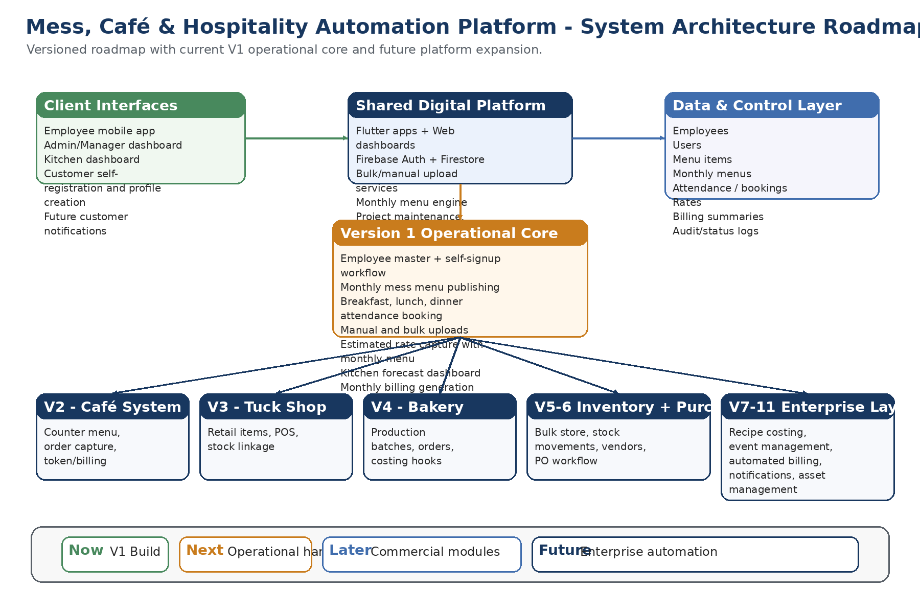
Figure 1. Full platform architecture roadmap from Version 1 operational core to future hospitality modules.

1. Executive Summary
Version 1 is now defined as a mess operations platform rather than only a daily menu viewer. It will manage breakfast, lunch, and dinner attendance, monthly menu publishing, monthly billing based on manually uploaded estimated rates, and dedicated interfaces for employees, managers/admin, and kitchen operations.
The menu is not intended to change randomly every day. The primary operating model is a monthly menu that remains active until management publishes the next revision. Rates may be attached to menu items during monthly menu setup until a later costing engine is introduced.
The build must include two input modes throughout the operational masters: manual data entry/editing and bulk upload. Customer or employee phone number is a mandatory profile field. Self-signup must be available for users not already present in the database, with a controlled profile-creation flow.
2. Updated Version-1 Requirements
Area | Requirement | Status
Operational coverage | Mess system only in V1: breakfast, lunch, dinner | Locked
Menu model | Monthly menu publishing; active until revised | Locked
Attendance model | Employee-wise meal booking/attendance capture | Locked
Billing model | Monthly billing from manually uploaded estimated rates | Locked
User registration | Self-signup and profile creation if not already in database | Added
Input methods | Manual entry/editing + bulk upload for core masters | Locked
Mandatory profile data | Phone number required for customer/employee profile | Added
Interfaces | Employee app, manager/admin dashboard, kitchen dashboard | Locked
3. Current Verified Baseline
Module | Verified capability | State
Foundation | Flutter environment, tablet deployment, Git repository, cloud project | Complete
Firebase integration | Auth + Firestore connected to app | Complete
Authentication | Login and logout working | Complete
Menu retrieval | Firestore menu read and breakfast menu display | Complete
Maintenance baseline | NAS backup, Git push workflow, updated markdown saving | Complete
4. Project Command Board - Sequenced Work Plan
The sequence below is designed for step-by-step development with verification after each milestone.
Step | Work package | Deliverables | Verification checkpoint | State
1 | Admin dashboard shell | Navigation for employee, menu item, monthly menu, rates, upload modules | App builds and dashboard opens on device | Pending
2 | Employee master - manual | Add/edit/search/deactivate employee form including phone number | Firestore employee record visible and editable | Pending
3 | Employee master - bulk | Template import for employee records | Uploaded file populates employees correctly | Pending
4 | Menu item master - manual | Add/edit/disable menu items with estimated rate support | Menu item saved and updated | Pending
5 | Menu item master - bulk | Bulk menu item import/update | Rows validated and written correctly | Pending
6 | Monthly menu management - manual | Create/edit month menu with breakfast/lunch/dinner line-up and validity period | Monthly menu stored and retrieved correctly | Pending
7 | Monthly menu management - bulk | Upload month menu from template | Month menu preview and import verified | Pending
8 | Self-signup/profile flow | Customer/employee account creation if not yet in database | Profile creation works with approval/flag logic | Pending
9 | Attendance/booking engine | Employee-wise booking for breakfast, lunch, dinner with duplicate/deadline checks | Booking record appears in correct path | Pending
10 | Kitchen dashboard | Meal counts and preparation forecast | Counts match bookings | Pending
11 | Manager/admin dashboard | Attendance summaries, menu publishing controls, bulk import controls | Counts and controls accessible by role | Pending
12 | Monthly billing generation | Billing summaries based on attendance and uploaded estimated rates | Monthly bill output verified for test users | Pending
5. Version-1 Functional Breakdown
Employee / customer profiles
- Self-signup if not present in the database
- Manual admin add/edit and bulk upload
- Mandatory phone number
- Employee number, department, role, cost center, status, eligibility
Monthly menu engine
- Menu published monthly rather than random daily changes
- Breakfast, lunch, dinner structure
- Valid until revised or replaced
- Estimated rates captured during monthly menu creation
Attendance and booking
- Employee-wise booking per meal
- Duplicate prevention and booking rules
- History available on employee side
- Forecast data available to kitchen and manager
Billing
- Monthly bill generation
- Rates uploaded manually until recipe/purchase costing is introduced
- Employee-wise summaries ready for deduction or export
Interfaces
- Employee mobile app
- Manager/admin dashboard
- Kitchen dashboard
6. Future Version Roadmap
Version | Module | Indicative scope
V2 | Café management system | Counter ordering, café menu, billing/token workflow
V3 | Tuck shop management system | Retail item sales, POS controls, stock linkage
V4 | Bakery management system | Bakery production planning, order handling, future costing hooks
V5 | Bulk store and inventory management | Stock levels, stock movements, warehouse controls
V6 | Purchase management system | Vendor management, purchase requests, purchase orders, approvals
V7 | Costing system | Recipe-based and service-based costing
V8 | Event management system | Bookings, catering planning, event billing
V9 | Automated billing management | Invoice generation, salary deduction integration, digital statements
V10 | Customer communication | Email/WhatsApp push messages for transactions and alerts
V11 | Asset management system | Kitchen and hospitality asset registry, maintenance tracking
7. Maintenance and Progress Review Feature
A linked live status markdown file should remain part of the project repository so the team can review completed work, ongoing work, upcoming steps, and parked ideas without scanning chat history.
Because NAS backup, Git upload/push, and updated markdown saving scripts already exist in the project ecosystem, the command board should be integrated as another maintained state file rather than as an isolated note.
Recommended included files:
- project_command_board_status.md - live board for completed / ongoing / next / future ideas
- update_project_status.sh - simple append helper for structured update entries
- Printable command board document (this DOCX/PDF) for policy and roadmap control
8. Suggested Repository Placement
Suggested path: ~/projects/mess_cafe_automation_v1/project_state/
9. Architecture Map

Figure 2. Shared platform architecture with Version-1 operational core and future expansion layers.
10. Immediate Decision Notes
- Use monthly menu documents rather than daily random menus as the dominant data model.
- Allow self-signup/profile creation with controlled reconciliation against employee data.
- Capture estimated rates during menu planning until later costing modules are built.
- Retain both manual and bulk input paths for all master data that operations staff will maintain.

