**ST. XAVIER’S COLLEGE**

**Maitighar, Kathmandu**

**(Affiliated to Tribhuvan University)**



**Lab Assignment 5**

**Advance Java**

**Submitted By:**

Rohin Awale

015BIM042

BIM 5th semester

**Submitted To**

**Mr. Bal Krishna Subedi**

Lecturer

Department of Computer Science

St. Xavier’s College

Maitighar, Kathmandu

***Applet to draw Star***

import java.awt.*;

import java.applet.*;

public class Test extends Applet{

public void paint(Graphics g){

g.drawLine(20,100,100,100);

g.drawLine(20,140,100,140);

g.drawLine(20,100,60,160);

g.drawLine(60,160,100,100);

g.drawLine(60,80,20,140);

g.drawLine(100,140,60,80);

}

}

***Output***

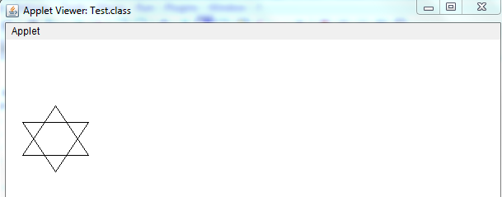

***Applet to draw ovals***

import java.awt.*;

import java.applet.*;

public class Test6 extends Applet{

public void paint(Graphics g){

g.drawOval(30,50,200,100);

g.drawOval(80,0,100,200);

}

}

***Output***

