NATIONAL UNIVERSITY OF COMPUTER AND EMERGING SCIENCES
CS3005 — Data Mining



Smart Discount Targeting System

A Data Mining Project Report
for Customer Discount Sensitivity Analysis in E-Commerce

Submitted by:
Rabbi Awan — 23L-2554
Emad Rafique — 23L-2604
Usaid Chaudhry — 23L-2538

April 2026

1. Introduction & Project Overview

In modern e-commerce, discount strategies are a powerful tool for driving customer engagement and revenue growth. However, applying uniform discounts across all customers is inefficient while some customers are highly responsive to promotional offers, others purchase regardless of any discount incentive. This indiscriminate approach erodes profit margins without providing proportional business value.
This project develops a Smart Discount Targeting System using data mining techniques applied to the publicly available Olist Brazilian E-Commerce dataset. The system identifies customer discount sensitivity through behavioral analysis and classifies customers into actionable discount tiers enabling data-driven, personalized promotional strategies.

Research Problem
"How can data mining techniques be used to identify customer discount sensitivity and recommend suitable discount tiers based on purchasing behaviour?"

Project Objectives
- Analyze customer purchasing behaviour from multi-table transactional e-commerce data.
- Engineer meaningful customer-level behavioral features capturing price sensitivity, recency, and payment patterns.
- Segment customers into discount sensitivity groups using K-Means clustering.
- Apply association rule mining to discover product co-purchase patterns.
- Build a predictive classification model to assign new customers to discount tiers.
- Develop an interactive Streamlit dashboard for real-time discount tier prediction.

Dataset — Olist E-Commerce
Table | Records | Key Information
Customers | 99,441 | Customer IDs and location details
Orders | 99,441 | Order status and timestamps
Order Items | 112,650 | Product-level price and quantity
Products | 32,951 | Category metadata
Payments | 103,886 | Payment type and transaction values

2. Data Mining Pipeline & Methodology

The project follows a structured data mining pipeline covering data integration, preprocessing, feature engineering, unsupervised segmentation, association rule mining, and supervised classification. The full pipeline is illustrated below.

2.1 Data Preprocessing & Integration
Five relational tables were merged into a single unified transactional dataset using customer_id, order_id, and product_id as join keys. Post-merge cleaning steps included:
- Retaining only delivered orders to ensure completed transaction records.
- Parsing and converting all timestamp columns to datetime format.
- Filling missing product category names with the placeholder 'unknown'.
- Removing duplicate records and dropping rows with missing payment information.
- Imputing remaining numerical missing values with column medians.
The cleaned dataset was saved as an intermediate CSV for downstream processing.

2.2 Feature Engineering
The transaction-level dataset was aggregated to one row per customer, producing 25+ behavioral features spanning five dimensions:
Feature Group | Examples | Relevance
Recency / Frequency | recency (days), total_orders, orders_per_month | Purchase activity patterns
Monetary | total_spent, avg_order_value, avg_item_price | Spending behavior
Price Sensitivity | cheap_order_ratio, avg_installments, high_installment_ratio | Discount responsiveness proxies
Promotional Behavior | promo_month_order_ratio (Nov/Dec) | Seasonal discount activity
Payment Preferences | preferred_payment_type (one-hot encoded) | Payment method tendencies

2.3 Customer Segmentation — K-Means Clustering
All numerical features were standardized using StandardScaler before clustering. The Elbow Method and Silhouette Score analysis were used to determine the optimal number of clusters.

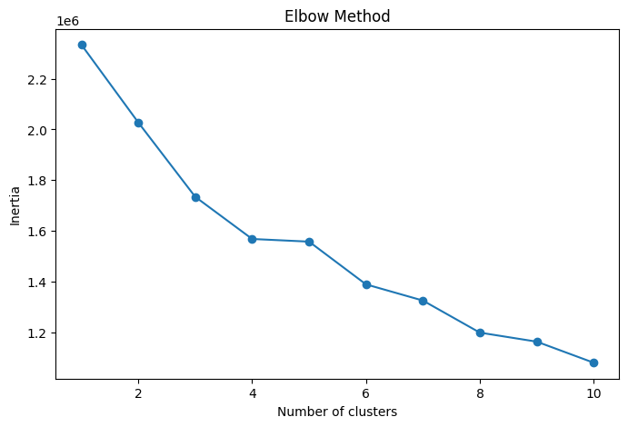  Figure 1 : Elbow Method (Inertia vs. k) | 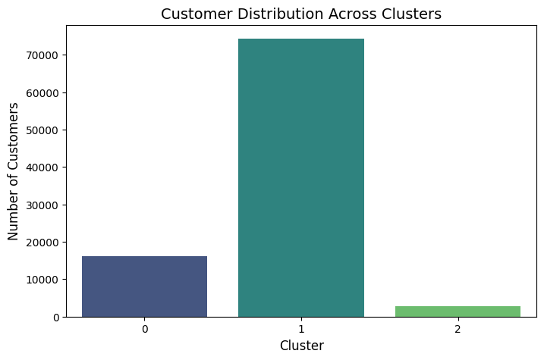  Figure 2 : Customer Distribution Across Clusters

Silhouette scores across k values: k=2 (0.373), k=3 (0.350), k=4 (0.310), k=5–9 (<0.25). While k=2 achieves the highest statistical separation, k=3 was selected as the optimal value, offering a practical balance between cluster quality and business interpretability enabling three distinct discount tiers.

2.4 Cluster Interpretation & Discount Tier Mapping
Cluster | Customers | Discount Tier | Key Characteristics
Cluster 1 | 74,308 (79.5%) | High Discount | Low spenders, frequent budget purchases, high cheap_order_ratio
Cluster 0 | 16,172 (17.3%) | Medium Discount | Moderate spenders, mixed payment behavior
Cluster 2 | 2,855 (3.1%) | Low Discount | High value, low promo dependency, premium buyers

The majority of customers (79.5%) fall into the High Discount sensitivity tier, confirming that targeted discounting rather than blanket promotions is essential to preserve margins.

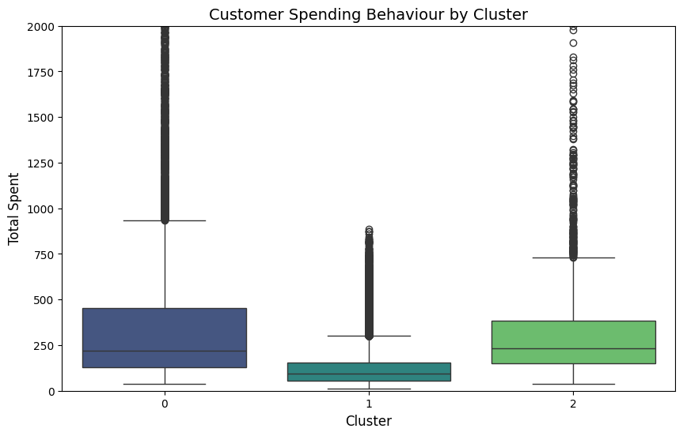  Figure 3 : Spending Behavior by Cluster | 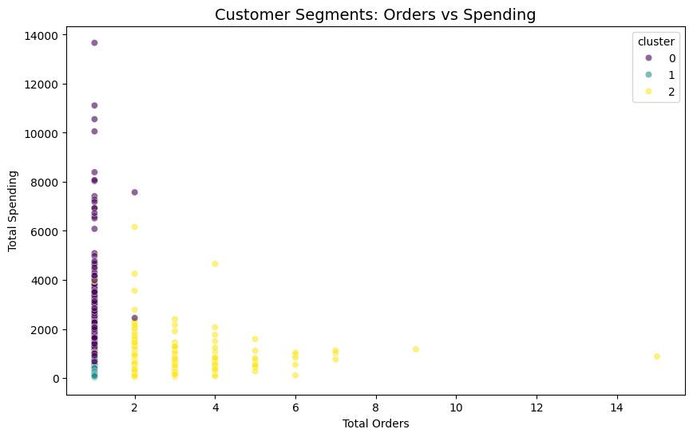  Figure 4 : Orders vs. Total Spending (Cluster Scatter)

2.5 PCA Visualization
Principal Component Analysis reduced the high-dimensional feature space to two components for visual inspection. The PCA scatter plot confirms visible cluster separation, validating that the engineered features capture meaningful behavioral differences across segments.
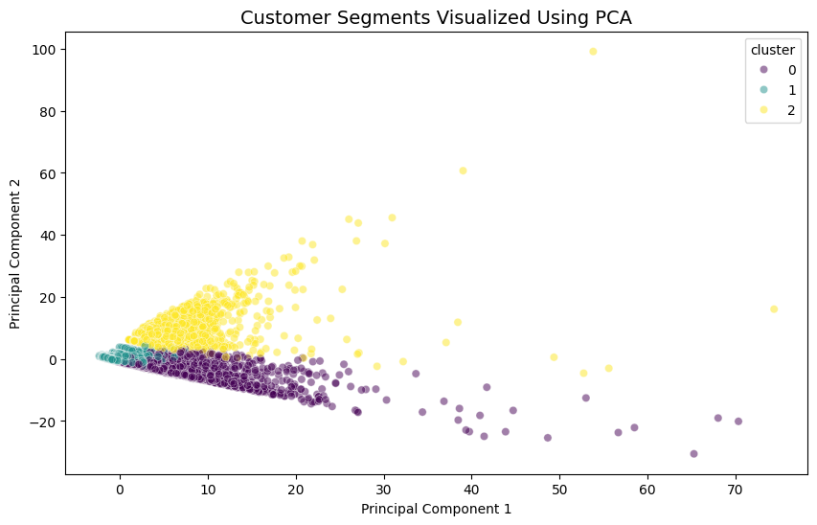
Figure 5 : PCA Visualization of Customer Segments

3. Association Rule Mining

The Apriori algorithm was applied to an order-category basket matrix to identify frequently co-purchased product categories. Each row represented one order; each column represented a product category (in English, using the provided translation table).

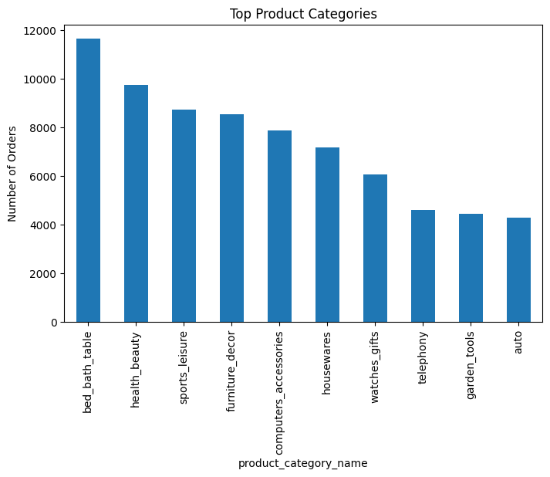
Figure 6 : Top 10 Product Categories by Order Volume

Analysis revealed that over 98% of orders contained products from a single category, resulting in highly sparse baskets. While single-item frequent itemsets were generated (bed_bath_table, health_beauty, and sports_leisure being the dominant categories), no meaningful multi-category association rules emerged.
This finding is itself a significant insight: the dataset's purchasing structure does not support cross-category bundling strategies. Discount campaigns are therefore better targeted at individual high-demand categories rather than product bundle offers.

4. Predictive Modelling

4.1 Behaviour-Based Discount Sensitivity Score
Rather than directly predicting cluster labels, a novel behaviour-based discount sensitivity score was designed. This score is a weighted composite of five normalized behavioral indicators:
Feature | Weight | Rationale
Promotional month order ratio | 0.30 | Strongest signal of price responsiveness
High installment ratio | 0.25 | Indicates financial price sensitivity
Average installments | 0.20 | Reflects payment flexibility preference
Recency (inverted) | 0.15 | Inactive customers more likely to need discounts
Average order value (inverted) | 0.10 | Lower AOV correlates with price-conscious behavior

Customers were divided into Low, Medium, and High Discount tiers using quantile-based thresholds on this composite score, producing a balanced three-class target for the classification model.

4.2 Feature Selection & Model Training
Random Forest feature importance was used to select the top 5 predictive features. A Decision Tree classifier (max_depth=5) was then trained on an 80/20 stratified split using these selected features.
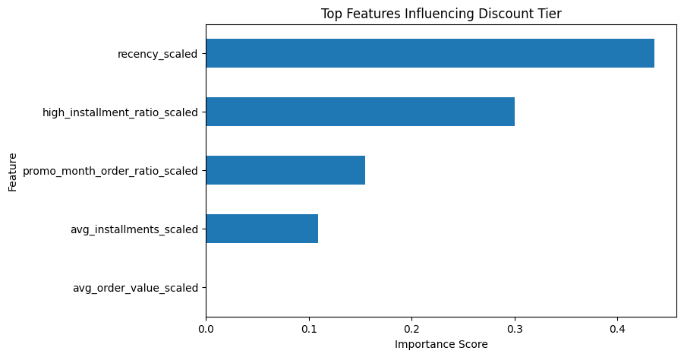  Figure 7 : Feature Importance (Decision Tree) | 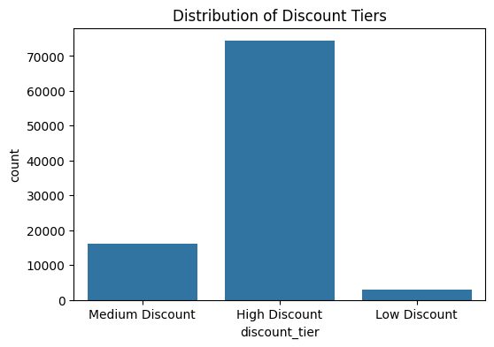  Figure 8 : Discount Tier Distribution

Recency emerged as the single most important predictor, followed by high installment usage and promotional purchase ratio. Average order value had minimal impact, confirming that spending amount alone is insufficient to characterize discount sensitivity.

4.3 Model Performance
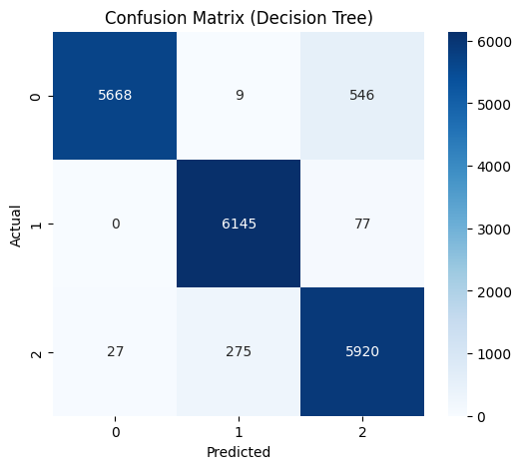
Figure 9 : Confusion Matrix (Decision Tree Classifier)
Metric | Value
Overall Accuracy | ~High (validated via classification report)
Low Discount Tier | Highest precision, minimal misclassifications
High Discount Tier | Minor overlap with Medium Discount
Medium Discount Tier | Some boundary confusion with adjacent tiers

Prediction errors occur primarily between adjacent tiers (Medium ↔ High or Medium ↔ Low), which is expected given the continuous nature of discount sensitivity. The model successfully captures the key behavioral boundaries separating discount tiers.

5. Results & Discussion

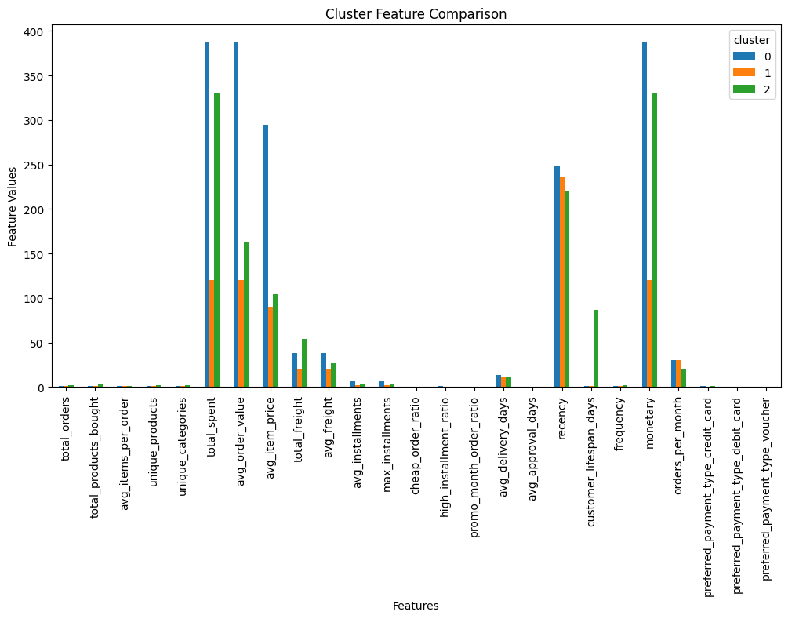
Figure 10 : Cluster Feature Comparison Across Segments

The cluster feature comparison chart confirms that the three segments exhibit distinctly different behavioral profiles. High-discount customers show elevated cheap_order_ratio and promo_month_order_ratio, while Low-discount customers (Cluster 2) exhibit higher total spending and lower price-sensitivity indicators.

Key Findings
- 79.5% of e-commerce customers exhibit high discount sensitivity, validating the need for targeted rather than uniform discounting.
- Recency is the most powerful predictor of discount sensitivity, suggesting that re-engagement campaigns should be the primary use case for discount targeting.
- Payment behavior (installment usage) is a reliable proxy for financial price sensitivity, second only to recency.
- Promotional purchase patterns during November–December confirm that seasonal discount behavior is a meaningful segmentation signal.
- Association rule mining confirmed that cross-category bundling is not viable for this dataset, focused category-level discounts are recommended.

Limitations
- Discount tiers are derived from engineered behavioral proxies, not actual campaign response data (click-through rates, coupon redemption).
- The Olist dataset is from the Brazilian market (2016–2018), which may limit generalizability to other geographies or time periods.
- Sparse basket data prevented meaningful multi-category association rules from being generated.

Future Directions
- Incorporate actual discount campaign response data (A/B test results, coupon usage) for ground-truth-based model training.
- Extend the Streamlit dashboard with a live customer data ingestion pipeline for real-time discount recommendations.
- Explore deep learning-based approaches (e.g., customer embeddings) to capture latent behavioral patterns.
- Apply temporal analysis to track how discount sensitivity evolves across a customer's lifecycle.

6. Conclusion

This project presents a complete end-to-end data mining pipeline for a Smart Discount Targeting System applied to real-world e-commerce data. Starting from raw multi-table relational data, the system engineers meaningful customer behavioral features, applies unsupervised clustering to discover natural discount sensitivity segments, and trains a predictive model to classify new customers into actionable discount tiers.
The integration of K-Means clustering, behavior-based scoring, association rule mining, and Decision Tree classification demonstrates how a combination of data mining techniques can address a practical business problem more effectively than any single technique alone. The developed Streamlit dashboard further bridges the gap between analysis and deployment, providing a ready-to-use interface for discount tier prediction.
Ultimately, the system enables businesses to move from wasteful blanket discount campaigns toward precision-targeted promotions directing offers to customers most likely to respond, while preserving margins for loyal, price-insensitive buyers.

Technology Stack
Component | Technologies Used
Data Processing | Python, Pandas, NumPy
Machine Learning | Scikit-learn (KMeans, PCA, DecisionTree, RandomForest), XGBoost
Association Mining | mlxtend (Apriori, association_rules)
Visualization | Matplotlib, Seaborn
Dashboard | Streamlit
Dataset | Olist Brazilian E-Commerce (Kaggle)

