National University of Computer and Emerging Sciences



CS3005: Mid Semester Project Report

Project Title: Smart Discount Targeting System Using Data Mining Techniques

NAME | ROLL NO.
Rabbi Awan | 23L-2554
Emad Rafique | 23L-2604
Usaid Chaudhary | 23L-2538

1. Project Idea
In modern e-commerce platforms, businesses aim to maximize profitability while maintaining customer satisfaction through personalized marketing strategies. One of the key challenges is determining the optimal discount for different customers, as applying uniform discounts can lead to revenue loss and inefficient promotional decisions. This project proposes a “Smart Discount Targeting System” that analyzes customer purchasing behavior to enable data-driven discount allocation.
The system is designed to use data mining techniques to identify meaningful customer segments based on behavioral patterns. By distinguishing between price-sensitive and high-value customers, the system aims to support targeted discount strategies that improve both customer engagement and business efficiency. The system is implemented using the Brazilian E-Commerce Public Dataset (Olist dataset) which provides detailed information on customers, orders, products, and payments.

2. Methodology Overview
The project follows a structured traditional data mining pipeline consisting of the following stages:
- Data Integration
  - Merge datasets such as customers, orders, order items, products, and payments.
  - Align and join datasets using common keys (e.g., customer_id, order_id) to ensure consistency

- Data Preprocessing
  - Handle missing values
  - Remove invalid records
  - Standardize data formats

- Feature Engineering
  - Create customer behavior features.
  - Transform transactional data into customer-level aggregated features for analysis

- Customer Segmentation
  - Apply K-Means clustering to group customers based on behavior.
  - Evaluate optimal number of clusters using the Elbow Method

- Future Modeling
  - Association rule mining
  - Predictive modeling for discount recommendation.

3. Milestones Achieved So Far
3.1 Data Preprocessing
The first phase focused on creating a clean, consistent dataset by merging multiple datasets. Key steps included handling missing values and inconsistencies, removing invalid or incomplete records, and standardizing data formats.
Output: cleaned_transactional_data.csv – each row represents a purchase instance with product, order, and payment information.
3.2 Feature Engineering
Transactional data was transformed into a customer-level dataset where each row represents one customer.
Features created include:
- Total number of orders
- Total spending
- Average order value
- Purchase frequency
- Recency (time since last purchase)
- Indicators capturing price sensitivity
Output: customer_level_features.csv – one row per customer, used as input for clustering.
3.3 Customer Segmentation
Clustering techniques were applied to group customers based on their behavioral features. K-Means clustering was used, and different values of k were explored to identify suitable segmentation.

The preliminary clustering results indicate:

- Clear separation of customers into distinct groups
- Presence of segments corresponding to:
- Price-sensitive customers
- Moderate customers
- High-value customers

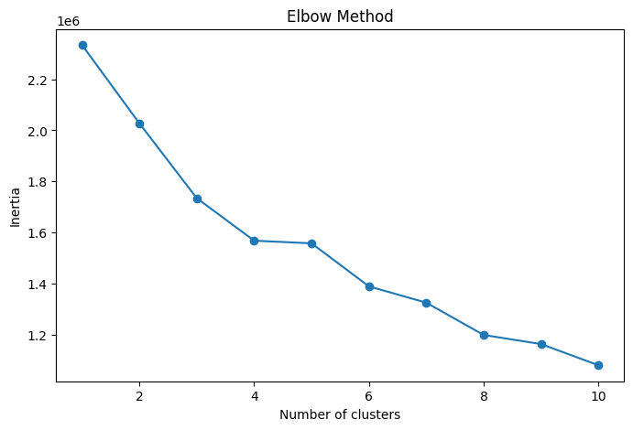
Figure 1: Elbow Method for determining the optimal number of clusters in K-Means

At this stage, further analysis of these clusters is ongoing, particularly to better understand feature distributions and validate the quality of segmentation.

4. Work in Progress and Future Plan
The next phase of the project focuses on enhancing analysis and extending the system toward decision-making.
Ongoing Work
- Visualization of clusters using techniques such as PCA
- Comparative analysis of features across clusters
- Validation and interpretation of clustering results

Planned Work
- Association Rule Mining
- Applying Apriori algorithm to identify co-purchase patterns
- Predictive Modeling
- Building classification models (e.g., Decision Trees, Random Forest)
- Predicting discount tiers based on customer features
- Visualization & Insights
- Cluster visualization (PCA plots)
- Feature distribution analysis (boxplots, comparisons)
- Business Mapping
- Mapping customer segments to appropriate discount strategies
- Interpreting results for practical application
- Development of an Interface
- Implementing a Streamlit-based dashboard to allow users to input customer features and obtain real-time discount recommendations.

5. Conclusion
Therefore, the project has established a solid analytical foundation by constructing both transactional and customer-level datasets and applying clustering techniques to uncover distinct customer behavioral patterns. The results highlight clear variations in customer purchasing patterns, which can be useful for data driven segmentation and targeted decision making.
Building on this foundation, the next stages will focus on enhancing interpretability through visualization, finding deeper transactional patterns using association rule mining and developing predictive models to automate discount allocation. Together, these components aim to evolve the system into a comprehensive and practical solution for intelligent discount targeting in e-commerce environments.

