Muhammad Awais Adnan

207701

BSCS-7b

Lab 08

**Task 1:**

**Code:**

import React from 'react';

class Welcome extends React.Component {

constructor(){

super()

this.state={message:"welcome visitor"}

}

  render(){

  return( <h1>{this.state.message}</h1>

  )

}

}

export default Welcome;

**Output:**



**Code:**

import React from 'react';

class Welcome extends React.Component {

  constructor(){

    super()

    this.state={message:"welcome visitor"}

    }

    changeMessage(){

    this.setState({

    message: "Thank you for subscribing"

    })

    }

      render(){

      return (

    <div>

    <h1>{this.state.message}</h1>

    <button onClick={()=>this.changeMessage()}>Subscribe</button>

    </div>

      )

    }

  }

export default Welcome;

**Output:**

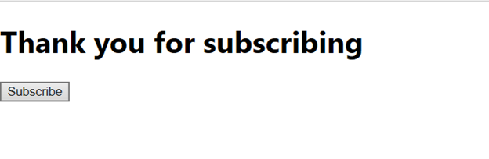

**Task 2:**

**Code:**

import React from 'react';

class Timer extends React.Component{

constructor(props){

super(props);

this.state = {

minutes: 0,

seconds: 0,

clicked: false

}

this.setTimer = this.setTimer.bind(this)

this.runClock = this.runClock.bind(this)

this.changeTime = this.changeTime.bind(this)

}

setTimer(event){

this.setState({

minutes: event.target.value

})

}

runClock(){

if(this.state.minutes >=1){

this.setState({seconds: 59, minutes: this.state.minutes-1, clicked: true });

this.intervalID = setInterval(()=>this.changeTime() ,1000);}

}

changeTime(){

if(this.state.minutes ===0 && this.state.seconds===0)

{

clearInterval(this.intervalID);

}

else if(this.state.seconds === 0 ) {

this.setState({

seconds: 59,

minutes: this.state.minutes-1 })

}

else this.setState({seconds: this.state.seconds-1 })

}

render(){

if (this.state.clicked) {

return(

<div style = {{marginLeft:600, marginTop:30}}>

<h1>Time Remaining</h1>

<div><h1 style = {{fontSize:'60px', color:'red'}}>{this.state.minutes}:{this.state.seconds < 10 ? `0${this.state.seconds}` : this.state.seconds}</h1></div>

</div>

)

}else{

return(

<div style = {{marginLeft:600}}>

<h2>Set Timer </h2>

<input type="number" onChange={this.setTimer}/><div></div>

<div><h1 style = {{fontSize:'60px'}}>0{this.state.minutes}:0{this.state.seconds}</h1></div>

<button style= {{marginLeft:30}}onClick={this.runClock}>Start</button>

</div>

)

}

}

}

export default Timer;

**Output:**

