Muhammad Awais Adnan
207701
BSCS-7b
Lab 06
TASK 1:

var MongoClient = require('mongodb').MongoClient;
var url = "mongodb://localhost:27017/";
MongoClient.connect(url, function(err, db){
if (err) throw err;
var dbo=db.db("mydb");
db.close();
});

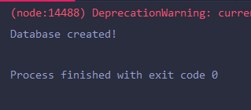
TASK 2:

var MongoClient = require('mongodb').MongoClient;
var url = "mongodb://localhost:27017/";
MongoClient.connect(url, function(err, db){
if (err) throw err;
var dbo=db.db("mydb");
dbo.createCollection("customers",function(err,res){
if (err) throw err;
console.log("Collection created!");
db.close();
})
});
});

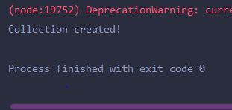

TASK 3:

var MongoClient = require('mongodb').MongoClient;
var url = "mongodb://localhost:27017/";
MongoClient.connect(url, function(err, db){
if (err) throw err;
var dbo=db.db("mydb");
var data={name:"Humayun", address:"Razi Hostel"};
dbo.collection("customer").insertOne(data,function(data,res){
if (err) throw err;
console.log("Document successfully added")
});
});

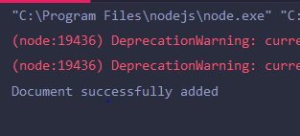

TASK 4:

var MongoClient = require('mongodb').MongoClient;
var url = "mongodb://localhost:27017/";
MongoClient.connect(url, function(err, db){
if (err) throw err;
var dbo=db.db("mydb");
var data=[{name:"Hurarah", address:"Razi Hostel"},
{name:"Asad", address:"Attar Hostel"},
{name:"Awais", address:"Sector G13"}];
dbo.collection("customers").insertMany(data,function(err,res){
if(err) throw err;
console.log("Documents inserted!");
db.close();
});
});

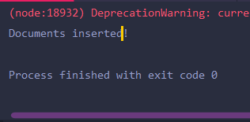

TASK 5:

var MongoClient = require('mongodb').MongoClient;
var url = "mongodb://localhost:27017/";
MongoClient.connect(url, function(err, db) {
if (err) throw err;
var dbo = db.db("mydb");
var data=[{_id:1, item: "apple"},
{_id:2, item: "banana"},
{_id:3, item: "mango"}];
dbo.createCollection("products", function(err,res){
if(err) throw err;
});
dbo.collection("products").insertMany(data, function(err,res){
if (err) throw err;
console.log("Records added!");
db.close();
});
});

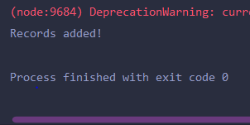

TASK 6:

var MongoClient = require('mongodb').MongoClient;
var url = "mongodb://localhost:27017/";
MongoClient.connect(url, function(err, db) {
if (err) throw err;
var dbo = db.db("mydb");
dbo.collection("customers").findOne({},function(err, result) {
if (err) throw err;
console.log(result);
db.close();
});
});

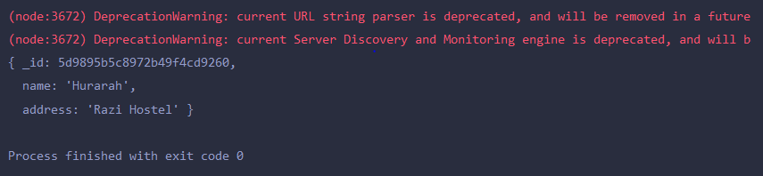

TASK 7:

var MongoClient = require('mongodb').MongoClient;
var url = "mongodb://localhost:27017/";
MongoClient.connect(url, function(err, db) {
if (err) throw err;
var dbo = db.db("mydb");
dbo.collection("customers").find({}).toArray(function(err, result) {
if (err) throw err;
console.log(result);
db.close();
});
});

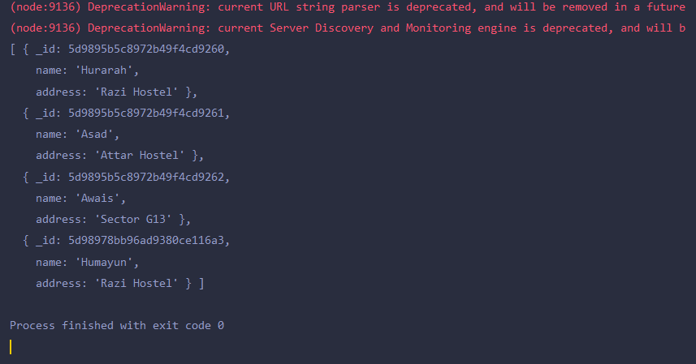

TASK 8:

var MongoClient = require('mongodb').MongoClient;
var url = "mongodb://localhost:27017/";
MongoClient.connect(url, function(err, db) {
if (err) throw err;
var dbo = db.db("mydb");
var query = { address: "Park Lane 38" };
dbo.collection("customers").find(query).toArray(function(err,res){
if (err) throw err;
console.log(res);
})
});

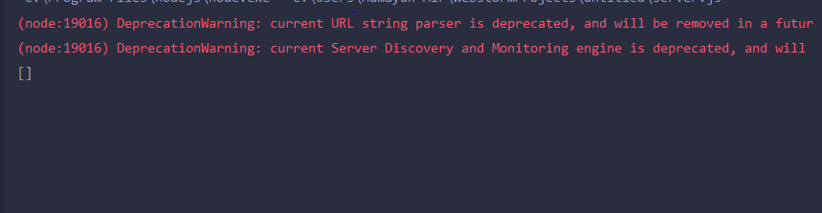

TASK 9:

var MongoClient = require('mongodb').MongoClient;
var url = "mongodb://localhost:27017/";
MongoClient.connect(url, function(err, db) {
if (err) throw err;
var dbo = db.db("mydb");
var ascending={name:1};
dbo.collection("customers").find().sort(ascending).toArray(function(err,result){
if (err) throw err;
console.log(result);
});
});

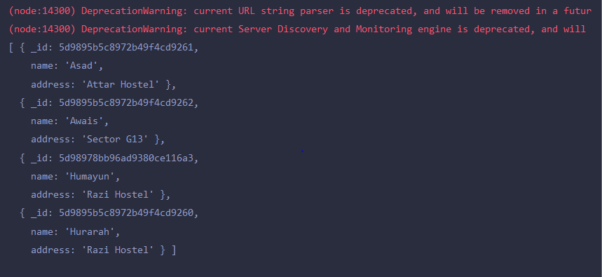

TASK10:

var MongoClient = require('mongodb').MongoClient;
var url = "mongodb://localhost:27017/";
MongoClient.connect(url, function(err, db) {
if (err) throw err;
var dbo = db.db("mydb");
var query = { address: 'Mountain 21' };
dbo.collection("customers").deleteOne(query,function(err,res){
if (err) throw err;
console.log(res);
});
});

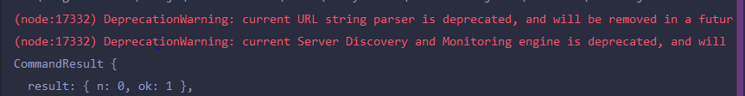

TASK11:

var MongoClient = require('mongodb').MongoClient;
var url = "mongodb://localhost:27017/";
MongoClient.connect(url, function(err, db) {
if (err) throw err;
var dbo = db.db("mydb");
var query = { address: /^O/ };
dbo.collection("customers").deleteMany(query,function(err,obj){
if (err) throw err;
console.log(obj.result.n + " document(s) deleted");
});
});

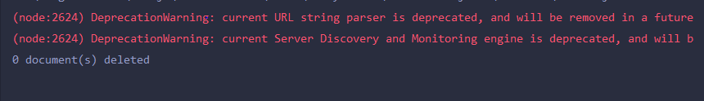

TASK12:

var MongoClient = require('mongodb').MongoClient;
var url = "mongodb://localhost:27017/";
MongoClient.connect(url, function(err, db) {
if (err) throw err;
var dbo = db.db("mydb");
dbo.collection("customers").drop(function(err, delOK) {
if (err) throw err;
if (delOK) console.log("Collection deleted");
db.close();
});
});

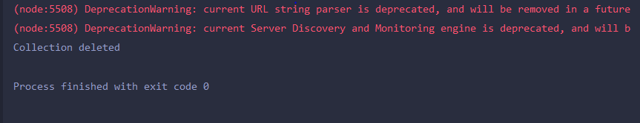

TASK13:

//First populating the collection ‘customers’ with the appropriate field

var MongoClient = require('mongodb').MongoClient;
var url = "mongodb://localhost:27017/";
MongoClient.connect(url, function(err, db) {
if (err) throw err;
var dbo = db.db("mydb");
var data = [
{ name: 'John', address: 'Highway 71'},
{ name: 'Peter', address: 'Lowstreet 4'},
{ name: 'Amy', address: 'Apple st 652'},
{ name: 'Chuck', address: 'Main Road 989'},
{ name: 'Viola', address: 'Valley 345'}
];
dbo.collection("customers").insertMany(data, function(err,res){
if (err) throw err;
console.log("Document inserted!");
})
});

//Now updating the field ‘Valley 345’

var MongoClient = require('mongodb').MongoClient;
var url = "mongodb://localhost:27017/";
MongoClient.connect(url, function(err, db) {
if (err) throw err;
var dbo = db.db("mydb");
var org={address: "Valley 345"};
var new_q={$set:{name:"Mickey", address:"Canyon 123"}};
dbo.collection("customers").updateOne(org,new_q, function(err,res){
if (err) throw err;
console.log("Document updated!");
})
});

//once added now searching for the required document

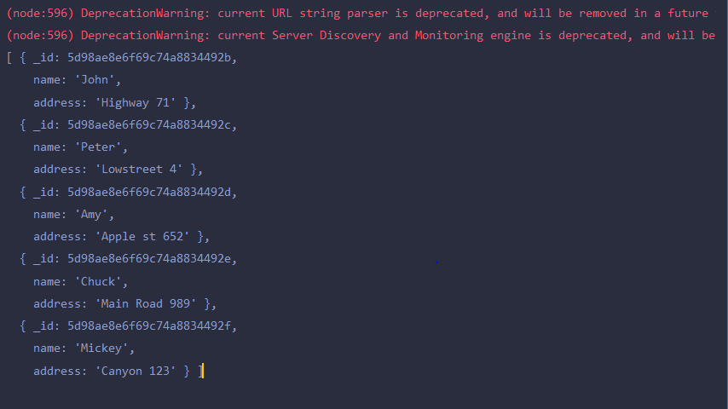

TASK14:

var MongoClient = require('mongodb').MongoClient;
var url = "mongodb://localhost:27017/";
MongoClient.connect(url, function(err, db) {
if (err) throw err;
var dbo = db.db("mydb");
dbo.collection("customers").find().limit(5).toArray(function(err,result){
if (err) throw err;
console.log(result);
});
});

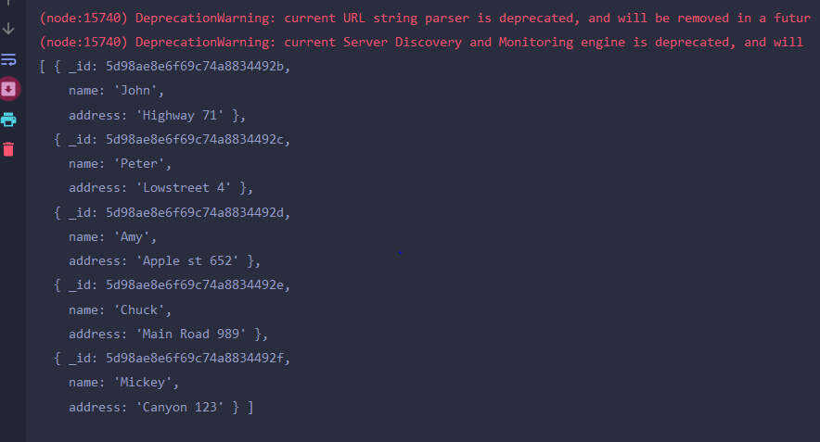

TASK15:

var MongoClient = require('mongodb').MongoClient;
var url = "mongodb://localhost:27017/";
MongoClient.connect(url, function(err, db) {
if (err) throw err;
var dbo = db.db("mydb");
dbo.collection("customers").aggregate([
{
$lookup:
{
from:"products",
localField:"_id",
foreignField:"name",
as:"details"
}
}
]).toArray(function(err,res){
if(err) throw err;
console.log(JSON.stringify(res));
db.close();
});
});

