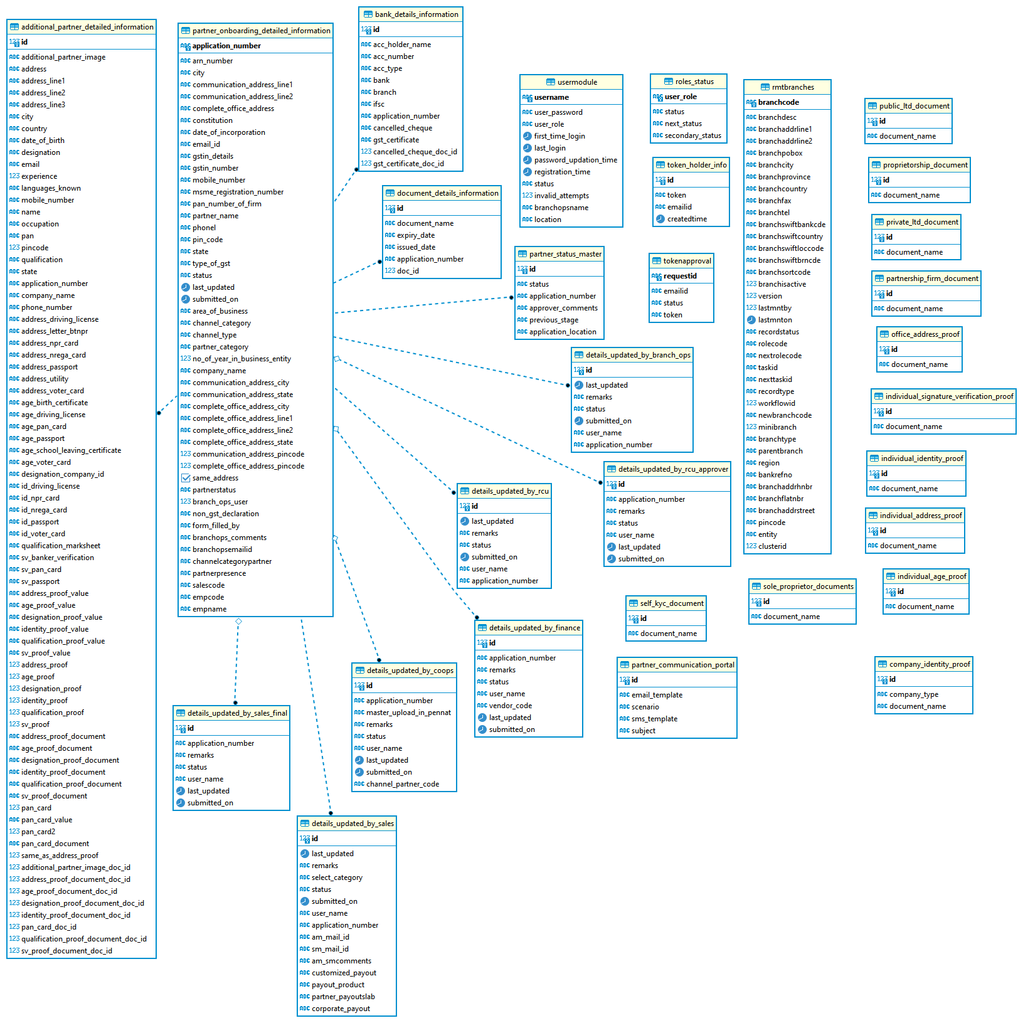

**usermodule:** The data which gets stored after sign up is stored in this table.

**role_status:** to know how an application current status and next status will be changed.

**partner_onboarding_detailed_info:** details of company is stored here.

**additional_partner_detailed_info:** applicant details stored here.

**bank_details_information:** Bank Details stored in this.

**document_details_information:** documents details stored here.

**partner_status_master:** contains current and priveous stage status of an application.

**partner_communication_portal:** contains template for communication.

Note: Rest table are not so critical details can be covered in dev-to-dev KT.