<https://www.atlassian.com/git/tutorials/git-bash>

<https://opensource.com/article/22/5/essential-linux-commands>

## What is Linux?

The Unix operating system is a set of programs that act as a link between the computer and the user.

The computer programs that allocate the system resources and coordinate all the details of the computer's internals is called the **operating system** or the **kernel**.

Users communicate with the kernel through a program known as the **shell**. The shell is a command line interpreter; it translates commands entered by the user and converts them into a language that is understood by the kernel.

* Several people can use a Linux computer at the same time; hence Linux is called a multiuser system.
* A user can also run multiple programs at the same time; hence Linux is a multitasking environment.

## Linux Architecture

Here is a basic block diagram of a Unix system –

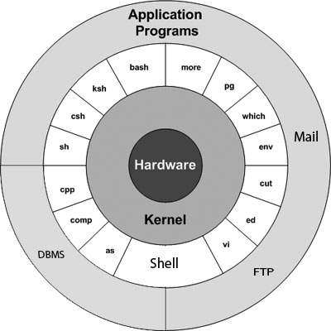

The main concept that unites Linux is the following four basics −

* **Kernel** − The kernel is the heart of the operating system. It interacts with the hardware and most of the tasks like memory management, task scheduling and file management.
* **Shell** − The shell is the utility that processes your requests. When you type in a command at your terminal, the shell interprets the command and calls the program that you want. The shell uses standard syntax for all commands. C Shell, Bourne Shell and Korn Shell are the most famous shells which are available with most of the Unix variants.
* **Commands and Utilities** − There are various commands and utilities which you can make use of in your day to day activities. **cp**, **mv**, **cat** and **grep**, etc. are few examples of commands and utilities. There are over 250 standard commands plus numerous others provided through 3rd party software. All the commands come along with various options.
* **Files and Directories** − All the data of Unix is organized into files. All files are then organized into directories. These directories are further organized into a tree-like structure called the **filesystem**.

# **What Is Linux**

Linux is an open-source operating system like other operating systems such as Microsoft [Windows](https://www.javatpoint.com/windows), Apple Mac OS, iOS, Google android, etc. An operating system is a software that enables the communication between computer hardware and software. It conveys input to get processed by the processor and brings output to the hardware to display it. This is the basic function of an operating system. Although it performs many other important tasks, let's not talk about that.

Linux is around us since the mid-90s. It can be used from wristwatches to supercomputers. It is everywhere in our phones, laptops, PCs, cars and even in refrigerators. It is very much famous among developers and normal computer users.

### **Evolution of Linux OS**

The [Linux OS](https://www.javatpoint.com/linux-tutorial) was developed by **Linus Torvalds** in **1991**, which sprouted as an idea to improve the UNIX OS. He suggested improvements but was rejected by UNIX designers. Therefore, he thought of launching an OS, designed in a way that could be modified by its users.

Nowadays, Linux is the fastest-growing OS. It is used from phones to supercomputers by almost all major hardware devices.

## Structure Of Linux Operating System

An operating system is a collection of software, each designed for a specific function.

Linux OS has following components:

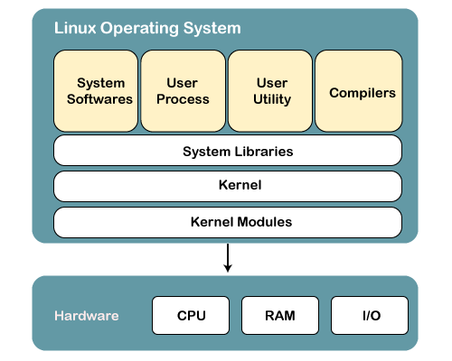

## 1) Kernel

Linux kernel is the core part of the operating system. It establishes communication between devices and software. Moreover, it manages system resources. It has four responsibilities:

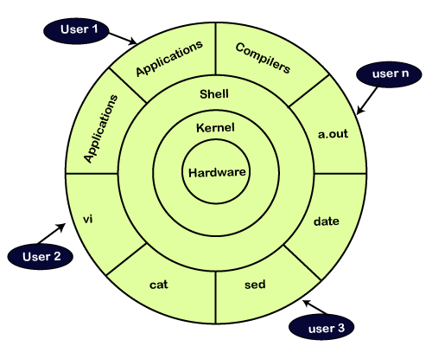

1. pwd – prints current working directory

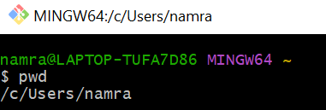

1. ls - is used to 'list' contents of the current working directory.
2. ls -R - shows all the files not only in directories but also subdirectories
3. ls -al - gives detailed information of the files. The command provides information in a columnar format.

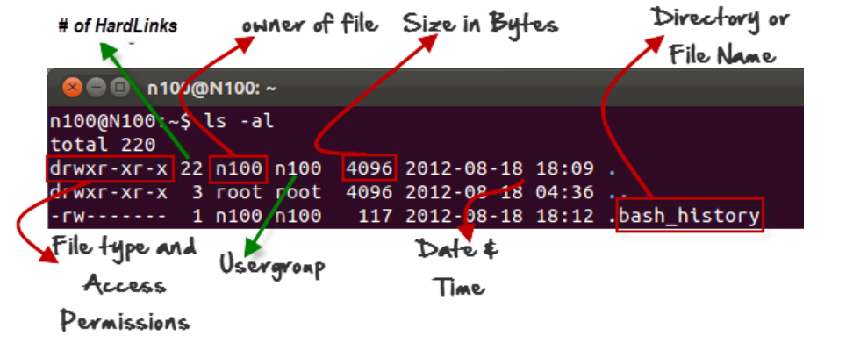

1. ls -a - Listing Hidden Files - Hidden items in UNIX/Linux begin with . or period symbol at the start, of the file or directory. Any Directory/file starting with a ‘.’ will not be seen unless you request for it. To view hidden files, use the command.
2. Creating & Viewing Files:- The ‘cat’ server command is used to display text files. It can also be used for copying, combining and creating new text files. Let’s see how it works.

To create a new file, use the command

1. cat > filename
2. Add content
3. Press ‘ctrl + d’ to return to command prompt.
4. To view a file, use the command –

cat filename

1. The syntax to combine 2 files is –

cat file1 file2 > newfilename

1. Deleting Files - The ‘rm’ command removes files from the system without confirmation.

To remove a file use syntax – rm filename

1. Moving and Re-naming files - To move a file, use the command.

mv filename new_file_location

Suppose we want to move the file “sample2” to location /home/guru99/Documents. Executing the command

***mv sample2 /home/guru99/Documents***

1. mv command needs super user permission. Currently, we are executing the command as a standard user. Hence, we get the above error. To overcome the error use command.

sudo command_you_want_to_execute

Sudo program allows regular users to run programs with the security privileges of the superuser or root.

Sudo command will ask for password authentication. Though, you do not need to know the root password. You can supply your own password. After authentication, the system will invoke the requested command.

Sudo maintains a log of each command run. System administrators can trackback the person responsible for undesirable changes in the system.

sudo mv sample2 c:/tempp

[sudo] password for guru99: ****

For renaming file: mv filename newfilename

**NOTE**: By default, the password you entered for sudo is retained for 15 minutes per terminal. This eliminates the need of entering the password time and again.

You only need root/sudo privileges, only if the command involves files or directories not owned by the user or group running the commands

1. Directory Manipulations: - Creating Directories

Directories can be created on a Linux operating system using the following command

mkdir directoryname

## Removing a directory - To remove a directory, use the command –

rmdir directoryname

**Tip**: Ensure that there is no file / sub-directory under the directory that you want to delete. Delete the files/sub-directory first before deleting the parent directory.

## Renaming Directory

The ‘mv’ (move) command (covered earlier) can also be used for renaming directories. Use the below-given format:

mv directoryname newdirectoryname

## ****Other Important Commands****

## The ‘Man’ command

Man stands for manual which is a reference book of a [Linux operating system](https://www.guru99.com/introduction-linux.html). It is similar to HELP file found in popular software.

To get help on any command that you do not understand, you can type

man

The terminal would open the manual page for that command.

For an example, if we type man man and hit enter; terminal would give us information on man command

## The History Command

History command shows all the basic commands in Linux that you have used in the past for the current terminal session. This can help you refer to the old commands you have entered and re-used them in your operations again.

## The clear command

This command clears all the clutter on the terminal and gives you a clean window to work on, just like when you launch the terminal.

1. Pasting commands into the terminal:

For copying, the text from a source, you would use **Ctrl + c,** but for pasting it on the Terminal, you need to use **Ctrl + Shift + p**. You can also try **Shift + Insert or select Edit>Paste on the menu**