# STATISTICS FOR ENGINEERS EXPERIMENT 1

**NAME – TANMAY DAGA REG. NO. – 18BME0829**

# Write the R programming code for computing the mean, median, mode, quartile deviation, variance, standard deviation, co-efficient of variation, first four moments about the mean and Pearson’s co- efficients for the following frequency distribution.

|  |  |  |  |  |  |  |  |  |
| --- | --- | --- | --- | --- | --- | --- | --- | --- |
| **Wages (in Rs.)** | **170-**  **180** | **180-**  **190** | **190-**  **200** | **200-**  **210** | **210-**  **220** | **220-**  **230** | **230-**  **240** | **240-**  **250** |
| **No. of Persons** | **52** | **68** | **85** | **92** | **100** | **95** | **70** | **28** |

Ans –

mid=seq(175,245,10)

* mid

[1] 175 185 195 205 215 225 235 245

> f=c(52,68,85,92,100,95,70,28)

* f

[1] 52 68 85 92 100 95 70 28

## Mean –

mean=(sum(mid*f))/sum(f)

> mean

[1] 208.9831

## Median-

cl=cumsum(f)

* cl

[1] 52 120 205 297 397 492 562 590

* ml=min(which(cl>=n/2))

Error in which(cl >= n/2) : object 'n' not found

* n=sum(f)
* ml=min(which(cl>=n/2))
* ml

[1] 4

* h=4
* c=cl[ml-1]
* c

[1] 205

* l=mid[ml]-h/2
* l

[1] 203

* median=l+(((n/2)-c)/f)*h

> median

[1] 209.9231

## Mode –

m=which(f==max(f))

* m

[1] 5

* fm=f[m]
* fm [1] 100
* f1=f[m-1]
* f2=f[m+1]
* l=mid[m]-h/2
* l

[1] 213

* mode=l+((fm-f1)/(2*fm-f1-f2))*h

> median

[1] 209.9231

Variance – v=var(f)

> v

[1] 601.9286

## Standard Deviation -

* sd=sqrt(v)

> sd

[1] 24.53423

## Quartile Deviation -

* summary(f)

Min. 1st Qu. Median Mean 3rd Qu. Max. 28.00 64.00 77.50 73.75 92.75 100.00

## Coefficient of Variance -

* cv=sd/mean

> sd

[1] 24.53423

## Pearson’s Coeffecient

> cor(mid,f)

[1] -0.1426281

# Create your own (Student Record) dataset and do the summary statistics and graphs with interpretation. Use at least 25 observations with five variables.

Ans –

* id=c(11,12,13,14,15,16,17,18,19,20,21,22,23,24,25,26,27,28,29,30,31,32,33,34,35)

>age=c(19,19,22,20,24,18,17,21,20,19,23,24,19,18,21,20,18,19,22,21,19,24,19,21,24)

* branch=c(1,1,3,2,3,3,1,2,1,1,3,2,2,3,2,3,1,1,1,2,2,1,1,1,2)
* gender=c(0,1,0,1,1,0,1,1,1,0,0,1,1,1,0,0,0,1,0,0,0,0,0,0,0)
* extracurricular=c(0,1,2,3,2,0,2,4,0,3,2,3,4,0,4,2,0,1,2,1,2,0,3,2,4)
* data=data.frame(id,age,gender,branch,extracurrcular)
* data$gender=factor(data$gender,labels=c("male","female"))
* data$branch=factor(stuinfo$status,labels=c("B.Tech","B.Sc."))
* data$extracurricular=factor(data$extracurricular,labels=c("Football","Basketball","Sketching","Debate","Acting"))
* data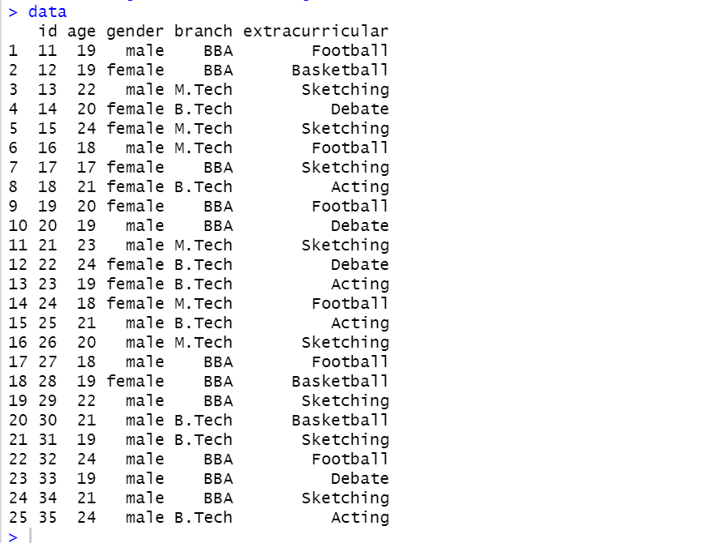

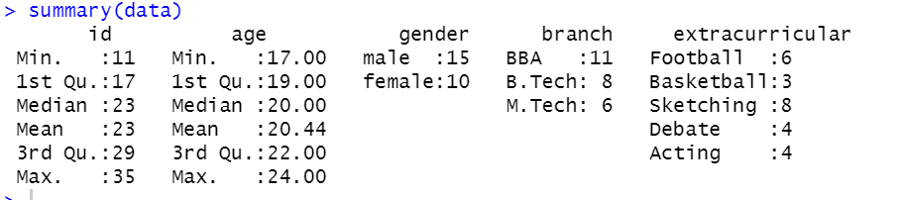

plot(data$age,type="l",main="age of students",xlab="id",ylab="age in years",col="blue")

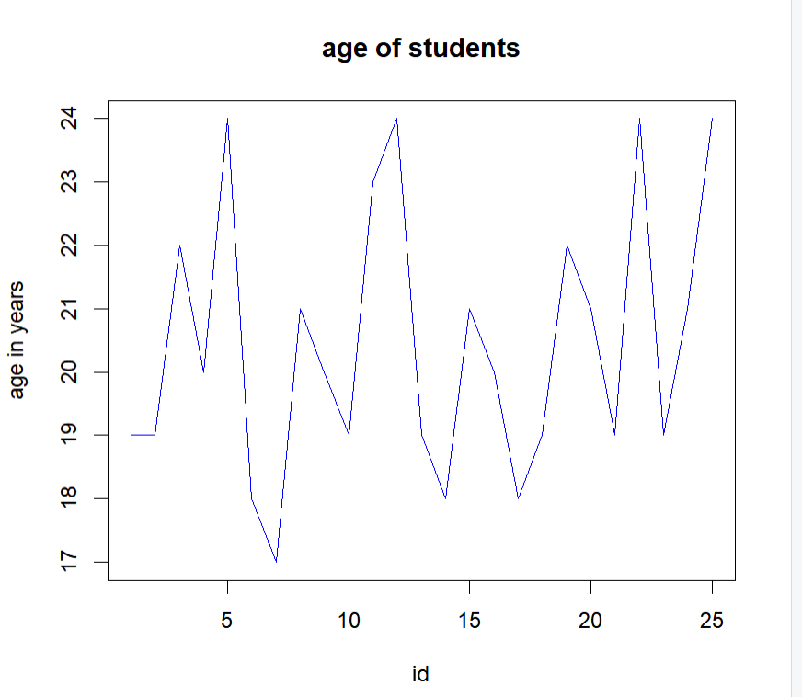

* table4<-table(data$extracurricular)
* pie(table4)

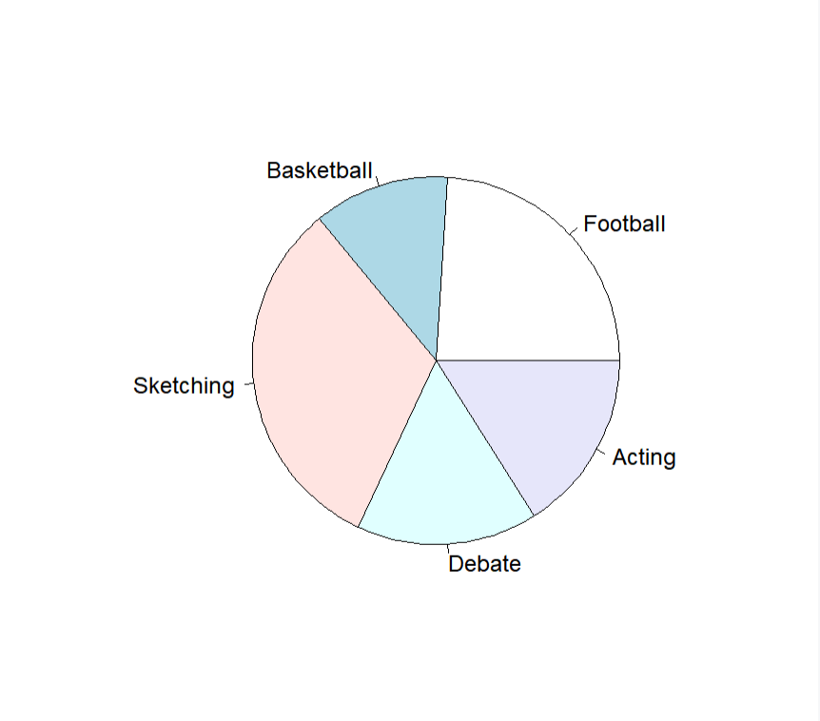

table5=table(data$gender,data$branch)

* barplot(table5,beside=T,xlim=c(1,15),ylim=c(0,8))
* 