*Welcome to*



*LazerTag* is a new, revolutionary, high-adrenaline, high-octane, high-intensity, open-source, top-down shooter from the brilliant minds of Zhenyang Cai and Daniel Su. For reasons unbeknownst to you, you find yourself trapped in a futuristic gladiator arena where contestants compete not only for their freedom, but for their lives. Armed with nothing but an alien laser rifle, can you fight your way out of certain doom?

…

Probably not, but the story doesn’t matter (or even exist in the first place) here. We don’t bother with convoluted storylines or character building. We know what GamersTM really want, and we promise to deliver. The top-down shooter, a trope as old as time, perfected for the 21st century. *Zero* filler, *zero* timewasters, and *zero* dumb stuff. Mindlessly gun down waves of enemies, without having to read tedious dialogues between your character and Mr. whats-his-name-again.

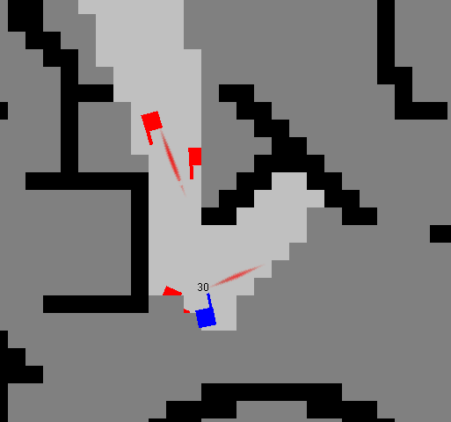

*LaserTag* is the first VideoGameTM ever to offer players complete choice and freedom. Everything, from the number of enemies to the maps themselves, can be easily[1] be customized to your liking. Want to storm a heavily defended enemy base? Sure![2] Feel like sneakily infiltrating a hostile country and assassinating a ruthless tribal warlord? Of course![3]

How to Play:

W – Move up

A – Move left

S – Move down

D – Move Right

Shift – Sprint

Mouse - Aim

Left Click (LMB) – Shoot

Right Click (RMB) – Shoot

Middle Click (MMB) – Shoot

*Insert Any Other Mouse Button Here* – Shoot

How to Win:

You can’t *really* win, but you *can* try to get a higher score than last time.

¯\_(ツ)_/¯

Community:

[Here](https://github.com/Awedtan/LaserTag) is our Github repo, if reading the detailed history of a train wreck in slo-mo is how you like to spend your Saturday night.

We don’t judge.

Credits:

Zhenyang Cai: Part of the code

Daniel Su: Other part of the code

1. Depending on your willingness to put up with crappy code
2. Imagination recommended
3. Imagination required