**1 BACKGROUND**

**1.1 Mismatch Repair (MMR) System**

The MMR system is one of the many evolutionarily conserved pathways involved in the repair and maintenance of DNA. Specifically, MMR recognizes mismatched bases and insertion/deletion (indel) loops in newly synthesized DNA, for example during DNA replication or recombination. It acts in a strand-specific manner, triggering the degradation of the error-containing region in the daughter strand, allowing the cell to ”try again” by resynthesizing the degraded DNA.

In humans, the protein MSH2 pairs with MSH6 to form the primary error-recognition complex of the MMR system. Similarly, MLH1 partners with PMS2 to create an endonuclease complex. Once an error is identified, the MLH1-PMS2 complex is recruited and activated by the MSH2-MSH6 complex, with additional assistance from cofactors such as PCNA and RFC. Upon activation, MLH1-PMS2 introduces multiple nicks on the 5’ side of the error in the daughter strand. Exo1 is then recruited to these nicks, where it degrades the strand in the direction of the error. Subsequently, DNA polymerase δ or ε resynthesizes the excised segment, and the repair process is completed by DNA ligase I, which seals the strand.

Why does interest focus on the mlh and msh homologs? What about POLD / LIGI/ POLE/EXO1 defficiencies?

The MMR system involves numerous other proteins, including alternative heterodimer combinations (Figure 1). While these heterodimers are less well-characterized, they are generally less active and exhibit overlapping functionality with the primary complexes described above, making them largely redundant.

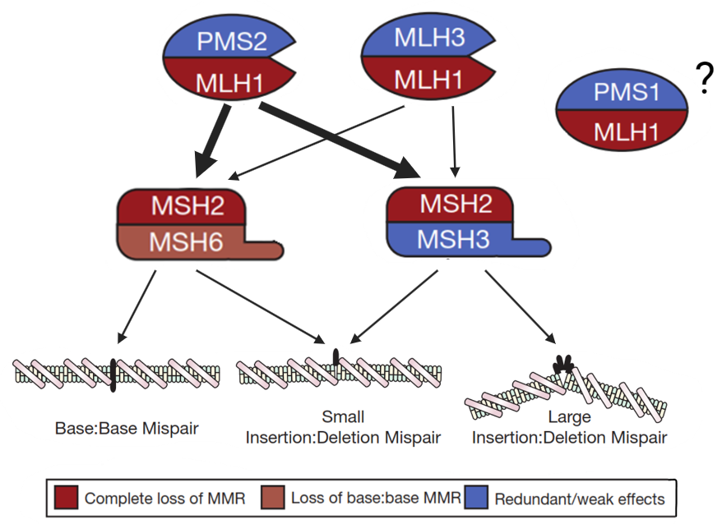

**Figure 1.** Overview of the human MMR system. MSH2 can also dimerize with MSH3 to form a separate

error-recognition unit. These two units differ in terms of their binding affinities to different types of errors. Similarly, MLH1 can also dimerize with MLH3 and PMS1. MLH1-MLH3 can substitute for MLH1-PMS2 but plays a more minor role. On the other hand, not much is known about PMS1-MLH1. Color indicates effect of protein loss.

What happens with an overactive MMR (e.g. overexpression models)

**1.1.1 Anti-mutagenic effect of MMR**

If left unrepaired, mismatches and indel loops may develop into base and indel mutations respectively during the next cell cycle. Thus, MMR minimizes the frequency of these mutations by preventing the formation of its precursors. Mutation or inactivation of key MMR genes (MLH1, MSH2, MSH6, PMS2) lead to an MMR deficient (MMRd) phenotype, which is characterized by elevated mutation rates. Indeed, MMRd mice had a significantly higher indel mutation rate (up to ∼72 fold in MLH1−/− ) compared to WT, MMR proficient (MMRp) mice, as determined by a supFG1 reporter assay.

[MMR in apoptotic response to mutagens, MMR in homeologous recombination]

**1.1.2 Pro-mutagenic effect of MMR There are several categories of promutagenic effects should be listed separately (you have two , add a third)**

Although the primary role of MMR is anti-mutagenic, there are instances where it can contribute to mutagenesis, particularly in the context of trinucleotide repeat (TNR) expansions. For example, studies in Huntington’s disease (HD) transgenic mice revealed that the expansion of CAG repeats (correlated with a more severe HD phenotype) was reduced in MSH2-deficient mice compared to wild-type counterparts.

Where is associati0n with genomic instability? The is pretty critticial

Additionally, MMR overexpression was frequently observed in late-stage prostate cancer, where it correlated with poor prognosis and genomic instability phenotypes such as large-scale deletions. While this alone does not confirm a causal role for MMR function in driving genomic instability, experiments in yeast showing that co-overexpression of MSH2 and MSH6 induced similar genomic instability phenotypes may support this hypothesis.

**1.1.3 MMR in Cancer Etiology**

An increased mutational burden is a key driver of cancer initiation and progression, contributing to tumor heterogeneity and therapy resistance. Unsurprisingly, changes in MMR expression, in particular MMRd, can be seen across various tumor types. This is because MMRd cells are more prone to mutations, increasing their likelihood of becoming cancerous. The prevalence of MMRd varies widely across cancers, ranging from as low as ∼1% (prostate, bladder, etc..) to as high as

∼15% in colorectal (CRC) and ∼30% in endometrial cancer (EC).

[MMRd can be sporadic or inherited (Lynch)] [Differences MMRd tumors vs MMRp tumors] [CMMRD]

**1.2 Lynch Syndrome**

1.2 MMR deficiency in human disease

1.2.1 MMRD in cancer

1.2..1.1. MMRD in sporadic tumours

1.2.1.1 Germline MMR defects

1.2.1.1.1 Lynch syndrome

Germline mutations in one of : MLH1, MSH2, MSH6, PMS2 (or more rarely a deletion in EPCAM which causes epigenetic silencing of MSH2) characterizes a heritable cancer predisposition disease known as Lynch syndrome (LS). LS patients are more susceptible to the MMRd phenotype since additional events, such as somatic mutations or promoter hypermethylation, can inactivate the remaining functional allele of the affected gene, an example of a mechanism known as the ”two-hit hypothesis.” MLH1 and MSH2 defects are the most common in LS, accounting for 60-80% of cases. Defects in these genes comes with the lifetime risk (by age 70) of ∼50% for CRC and ∼40% for EC. While other mutations are milder in effect (∼10-20% risk), it is still much higher than the general population risk of 2% and 1% respectively.

LS is one of the most common hereditary cause of CRC predisposition, it has an estimated population prevalence of 0.3%. Due to its hereditary nature, genetic counselling is relevant in LS. It is important to identify LS patients early on since preventative measures can be taken to reduce cancer incidence and mortality. For example, positive results have been shown for intensive colonoscopic surveillance and chemoprevention with aspirin. Furthermore, identifying LS patients facilitates cascade genetic testing in relatives, enabling early detection and intervention.

122.1.1.2 CMMRD

**1.3 MMRd detection**

MMRd detection in tumors is important since it serves as the initial step towards identifying LS patients. More generally, due to their distinct biological behavior, distinguishing between MMRd and MMRp tumors allows care-providers to make informed clinical decisions, for instance in the choice of therapy, and predicting prognosis, ultimately improving patient outcomes.

Traditionally, there are two ways to detect MMRd :

1. Immunohistochemistry (IHC), which uses antibodies against the 4 major MMR proteins to measure their expression, a lack of which would suggest MMRd. However, mutations in MMR genes can lead to the production of nonfunctional proteins that remain antigenic, potentially resulting in false negatives. It is estimated that around 6% of MMRd cases, particularly those related to MLH1, escape IHC detection due to this issue.

2. Microsatellite instability testing. Microsatellites are genomic regions composed of short sequence motifs (1–6 bp) repeated in tandem. These regions are particularly prone to indel loop formations caused by strand slippage during DNA replication, resulting in an increased occurrence of mutant-length alleles—a phenomenon known as microsatellite instability (MSI). Normally, MSI is kept at low levels by the MMR system, but without it, indel mutations accumulate unchecked, leading to a significant increase in MSI. This sensitivity of microsatellites to MMR function forms the basis of MSI testing (see section 1.4)

3. Sequencing is missing

MSI testing and IHC are highly concordant (92-99%). Using both tests in conjunction, almost 100% of MMRd tumors can be identified. MMRd tumors can be further classified by their origin—either sporadic or hereditary (LS). This is done through germline sequencing of the MMR genes.

[BRAF and MLH1 methylation analysis?] [Functional MMR assays?]

**1.4 MSI testing**

MSI testing involves PCR amplification and sequencing of specific microsatellite markers. The frequencies of the various length alleles are then compared between paired normal/tumor samples from the same individual. Alternatively, quasi- monomorphic microsatellite markers may be used. These are microsatellites whose major (also known as reference) allele is present with frequency ≥ 95% in the population. This means that PCR on normal tissues is unnecessary since the reference allele is assumed to be the same as seen in a human reference genome library (hg19).

One significant challenge with MSI testing is that the PCR amplification step introduces additional indel mutations through the same ”slippage” process that causes indels to occur naturally in vivo. This introduces a degree of noise in the PCR

products, which is particularly concerning for data analysis involving rare (¡1% frequency) allelic variants, as it becomes difficult to distinguish true in vivo mutations from artefacts introduced during amplification.

The error rate per PCR cycle increases linearly with the number of repeat units in a microsatellite, making longer repeats more susceptible to errors. There is also a threshold repeat size, typically around 4–5 units depending on the sequence motif, below which PCR-induced errors are undetectable. Based on these observations, models of microsatellite mutation have been developed to predict and correct errors introduced during PCR amplification.

A more straight-forward approach to account for these errors is the use of unique molecular identifiers (UMIs)—short, nucleotide sequences attached to individual DNA molecules prior to amplification. After sequencing, reads are grouped into ”UMI families” based on their shared origin from the same template molecule. A consensus sequence is then derived for each family, typically by selecting the most common sequence, to represent the true allele. While this method effectively eliminates the majority of PCR-induced errors, it significantly reduces the number of reads available for analysis, and thus requires a high sequencing depth to be effective. Despite this, it has been explored as a reliable technique for more accurate microsatellite genotyping, particularly in forensic applications.

**2 ALLELE FREQUENCY ANALYSIS**

In an earlier study, we investigated differences in the frequency of different length alleles in MMRp and MMRd samples in CRC and EC (cite previous work?). In particular, the frequency of length alleles corresponding to deletions (-1, -2) are significantly higher in the MMRd group than the MMRp group as expected. Crucially, this pattern was not observed for the insertions, moreover our results seemed to suggest that the +1 allele is more frequent in the MMRp group instead. While this pattern was observed in both CRC and EC datasets, it was more clearly observed in CRC, which suggests tissue-specific differences.

Present an example here. Introduce terminoly.

The differing behaviour of insertion and deletion alleles in MMRp and MMRd samples challenges the assumption that the MMRd phenotype universally increases the frequency of all types of length mutations, including insertions. There are two possible explanations for this discrepancy :

1. PCR errors. The observed +1 alleles may simply result from PCR sequencing artifacts, particularly given their low frequencies (¡1%), which make them difficult to differentiate from PCR-induced noise. Furthermore, the larger initial ”pool” of reference (zero-length) alleles in the MMRp samples could serve as a source for +1 allele generation through during the PCR process. This could explain the higher frequency of +1 alleles observed in the MMRp samples.

2. A normal function of MMR. As previously discussed, MMR has pro-mutagenic effects, particularly in the context of TNR expansion. Thus, it is possible that MMR activity directly contributes to the higher +1 allele frequency observed in the MMRp samples.

Assuming the first hypothesis is true, then the +1 allele frequency could potentially be used to estimate the PCR error rate, this can help further normalize the dataset. Assuming the second hypothesis is true, then the +1 allele frequency can be used as a predictor for the level of MMR function.

**2.1 Replication of Previous Results**

To reconfirm our previous observation, that the +1 allele frequencies are higher in MMRp than MMRd samples, we checked to see if this result can be replicated in other datasets as well, these include : 2 new CRC datasets (CRC1, CRC2) and a CMMRD dataset. Importantly, the CMMRD dataset gives us a look into how MMRd affects MSI in a non-tumor environment, free from effects such as homogeneity from clonal expansion, etc...

To achieve this, frequencies of the +1 allele were compared between the MMRp and MMRd groups for each marker using a two-tailed Mann-Whitney U test, crucially this allows us to check for marker-specific differences, something that was not done in the previous study. Additionally, a directional AUC was calculated, where higher AUC values indicate greater frequencies in the MMRd group, and lower values suggest higher frequencies in the MMRp group. This analysis was repeated for the -2, -1, and 0 length alleles (Figure 2).

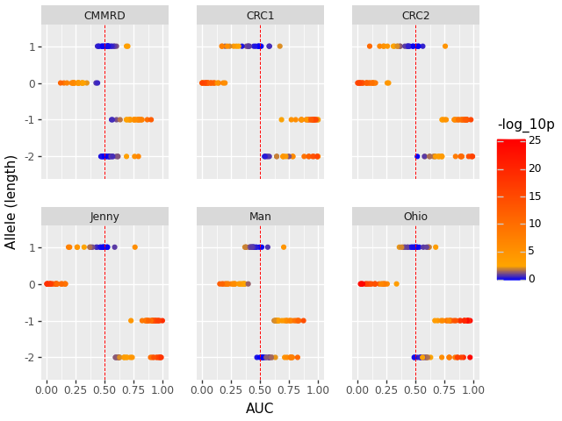

**Figure 2.** b Differences between allele frequencies between MMRp and MMRd samples in 6 datasets. Each marker is represented as a point, with color to indicate significance (blue : no significance, yellow : slight significance, red : very significant), and AUC to indicate directionality (AUC < 0.5 : frequencies are higher in MMRp group, AUC > 0.5

These results are in general agreement with our previous observation. The same pattern was observedreplicated in the new CRC datasets, but not in the CMMRD dataset. The behaviour of each allele is, in general, consistent between datasets with exception to the +1 allele which has a strong MMRp tendency in the CRC datasets, with this tendency being weaker in the EC datasets, and nonexistent in the CMMRD dataset.

It is also interesting to note that for 1 particular marker (DEPDC2), the +1 allele has the same behaviour as the deletion alleles, ti.e, it is more frequent in the MMRd group. This is the sole significant (yellow) marker in the ”right” (AUC>0.5) direction for the +1 allele in all of the datasets.

Since datasets of the same condition (i.e <list conditions) behave similarly, this justifies their merging in future analysis.

**2.2 Analysis using UMI for error correction and duplicate exclusion.**

Next, we performed the same analysis using consensus sequence obtained from UMI groupings (D1, D2) to check if PCR

error correction has any effect on the patterns observed in the raw data, which still contains PCR noise (Figure 3)

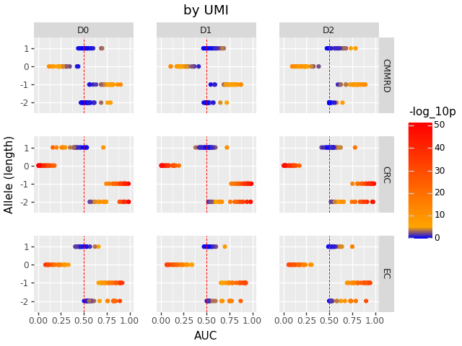

**Figure 3.** Placeholder

The allele that is most significantly affected by the grouping process is the +1 allele. This is unsurprising as, being a rare variant, the +1 allele is more likely to be affected by PCR noise. While this observation supports the PCR error hypothesis, it remains to be shown why this pattern is more readily observed in some datasets (CRC) but not others (CMMRD). (different tumor/tissue type have different PCR error rates??)

Markers in the +1 allele shifted to the right when UMI correction was used, reversing the previously observed pattern. This indicates that the ”true” behavior of the +1 allele is closer to that of the deletion alleles than our initial results suggests.

Explain results in D0

Explain why not observed in normal blood