# TYPES OF SOFTWARE

Darío Fernández 2ºB ESO

Technology

# TYPES OF SOFTWARE

1-Transparency and Control-

Free Software: Proportion all the transparency when it allows anyone to access or modify the source code as it is needed. The users have more control of the software and they can modify so it can adapt to their specifics needs.

Proprietary: The source code is protected and controlled by the developing company. The users have a limited access to it and they depend on the updates given by the company

2-Cost-

Free Software: In general free software is download use and modify for free. The costs associated can include technical support or personal modification, but the software on its own has free access.

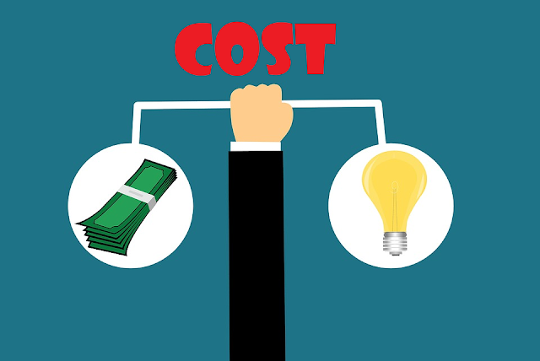

Proprietary Software: In general it implies initial licence costs and they can include recurring costs. The total cost of the property can be significative over time, especially for companies or users with multiple licences.

3-Quality and Support-

Free Software: The quality of free software can vary depending on the maintenance community. Nowadays many well mantained and supported open source projects still exist; others may lack sources, attention, which affects the quality of the software



Proprietary Software: The developers of the proprietary software usually offer quality guaranty and technical software. The users can trust in regular updates, security fixes and client attention services for keeping the software running without any trouble.

4-Flexibility and personalization-

Free Software: Gives a high flexibility and the capacity of personalization. The users can adapt the software by their specific needs, add some new characteristics and contribute the general developing of the software

Proprietary Software: The personalization can have a limited power, due to the fact that users depend on the developer of the software to implement changes. The options of personalization are just allowed to predefined configurations or specific complements.

5-Community and Collaboration

Free Software: It is based on the collaboration and the community, it fosters the participation of developers all over the world. The open debates, the code revision and the active contribution are needed for success and the evolution of the project.

Proprietary Software: The collaboration is limited to the company’s developing group and in these cases, to selected developers. The updates mostly depend on the decisions and resources of the developing company.

6-Security-

Free Software: The transparency of the code allows a greater detection and correction of security vulnerabilities. With a wide community of developers reviewing constantly the code, the security troubles can be fixed very quickly and efficiently.

Proprietary Software: The security depends most on pentesting activities inside the corporation. The vulnerabilities can last more to be detected and get fixed due to the need of public access to the source code.

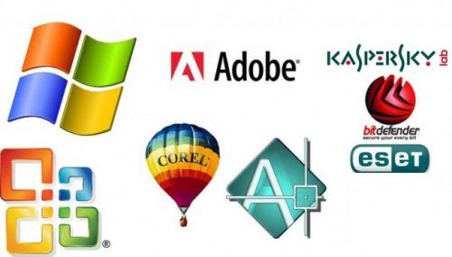7-Conclusion-

Both software types have their own strengths and weaknesses, and the choice between them mostly depends on the needs and priorities of the user. However, open source software is transparent and gives the user freedom and flexibility.

Commercial software gives quality, support and security. The best software depends on the specific context of the user or company.

In my opinion, if you like more powerful software with added functions, you should opt for free software, but if you prefer a more secure and guaranteed quality software, you should choose commercial software.

[A dev’s guide to open source software licensing · GitHub](https://github.com/readme/guides/open-source-licensing#What_Is_Open_Source?)

<https://www.bing.com/ck/a?!&&p=f242160c9b73f526JmltdHM9MTcxNDg2NzIwMCZpZ3VpZD0wMThiOWIyMy05Mjg1LTY3MWItMTcwYS04OGY3OTNhZTY2OTUmaW5zaWQ9NTIyMA&ptn=3&ver=2&hsh=3&fclid=018b9b23-9285-671b-170a-88f793ae6695&psq=what+is+a+comercial+software&u=a1aHR0cHM6Ly93d3cudGVjaG9wZWRpYS5jb20vZGVmaW5pdGlvbi80MjQ1L2NvbW1lcmNpYWwtc29mdHdhcmU&ntb=1>

Darío Fernández 2ºESO B 05/05/

2024