Investing Wisdom Around The Web

Created: 10 August 2013

Updated: See first article

Author: Mark Carter

**Abstract** A collection of interesting articles from the internet.

# ROTA

Added: 10-Feb-2015

Link: csinvesting http://is.gd/OdfJvR

Source date: 05-Feb-2015

This is how John Chew calculated ROTA in “Enron Case Study Analysis. Ask Why? Why?”

ROTA = EBIT/TA

EBIT = Net Income + Interest Expense + Taxes

TA is Total Assets

# The Superinvestors of Graham and Doddesville

Added: 09-Feb-2015

Link: csinvesting/Kopernik PDF [http://goo.gl/rbdxyT /](http://goo.gl/rbdxyT%20/) http://is.gd/ZSJg1s

Source date: 28-jan-2015

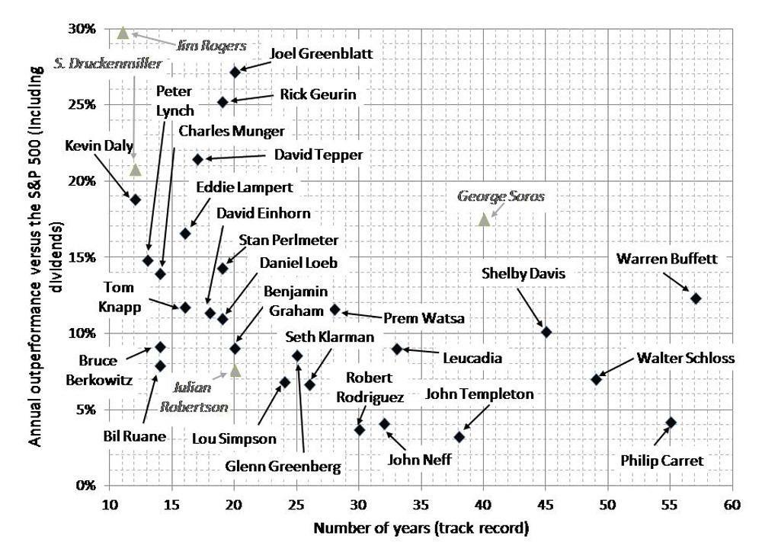

# Why spinoffs outperform the market by 22% year after year

Added: 09-Feb-2015

Link: stephanmanos http://www.stephanemanos.com/spinoff-investing/

Source date: 01-Apr-2014

The spinoff is usually a “bad” asset, dragging down the performance of the parent. Sometimes a jewel is spun off. Spinoffs outperform the S&P500 by 22% in the first year. In the second year, spinoffs return another 15%. Lots of volatility occurs in the first 3-6 months, as the company seeks for a new investor base.

Reasons for opportunities to exist:

1. The spinoff is unwanted
2. Insiders want them. Read the **Form 10**, where you will see the percentage that the insiders will own. Also read **forms 3s** and **4s** to see management options.
3. Lack of information makes investment difficult. Potential analyst coverage is a huge catalyst. A small company of 50m mkt cap will most likely never get coverage.

# Jim Slater – Frequently Asked Questions

Added: 06-Feb-2015

Link: jimslater http://is.gd/quU4WB

Source date: unknown

Tell-tale signs of an impending bear market:

1. Cash is trash
2. Value is hard to find. The average PEG will be 1.5 or more
3. Dividend yields will be at historically low levels
4. Interest rates will be about to rise
5. Investment advisers will be bullish
6. New issues will be rampant of deteriorating quality
7. Ration of director buying selling will be low
8. Shares fail to respond to good results
9. The number of stocks standing above their long-term averages falls below 75%
10. Broad money supply contracting
11. Cyclical usually do well near the top of bull markets

Poor RS3m is a cause for concern

# What should you do when a stock plummets?

Added: 05-Feb-2015

Link: Stockopedia <http://is.gd/RGFQK0>

Source date: 05-Feb-2015

Mauboussin creates a decision tree for what to do when a stock declines 10% or more on a single day. He has a detailed chart. I drew my own little table which vastly simplifies things, without losing too much detail.

|  |  |  |  |
| --- | --- | --- | --- |
| V  M | Cheap | Neutral | Expensive |
| Strong | Keep | Sell | Sell |
| Neutral | Keep | Keep | Sell |
| Weak | Buy | Keep | Buy |

M is momentum, V is value. It may be surprising to learn that expensive stocks can be a buy. Weak, cheap and good quality provide the best returns for a 90-day holding period.

Begin table

MVQ

Level 1

+** -1.6% -14.9% 408 -1.5% -1.9% -0.6%

0** -2.8% -14.7% 434 0.8% 2.4% 4.0%

-** -1.0% -14.9% 600 2.7% 5.1% 8.4%

Level 2

++* -2.6% -14.4% 123 -0.6% 1.4% 3.6%

+0* -1.0% -14.6% 118 -1.3% -1.6% -1.4%

+-* -1.2% -15.4% 157 -2.4% -4.5% -3.2%

0+* -4.6% -15.2% 162 2.9% 5.0% 7.1%

00* -1.8% -14.4% 146 0.8% 2.4% 4.8%

0-* -1.7% -14.4% 126 -1.7% -1.0% -0.9%

-+* -3.4% -15.1% 299 3.7% 5.5% 10.9%

-0* 0.8% -14.8% 177 0.5% 3.3% 3.5%

--* 2.3% -14.7% 124 3.5% 6.8% 9.4%

Level 3

+++ -4.2% -14.2% 42 -1.1% 0.8% 4.6%

++0 -0.9% -14.6% 23 -3.1% 3.2% 4.5%

++- -2.2% -14.5% 58 0.7% 1.1% 2.5%

+0+ -2.4% -15.9% 44 -0.2% 3.4% 3.5%

+00 -1.2% -13.5% 29 -1.7% -4.0% -5.0%

+0- 0.6% -14.1% 45 -2.3% -5.0% -4.0%

+-+ 0.4% -14.8% 62 -3.2% -3.5% -3.1%

+-0 -3.1% -17.0% 49 -0.7% -3.7% -5.3%

+-- -1.3% -14.6% 56 -2.9% -6.3% -1.4%

End table

# 9 Insights from George Soros

An article appeared in ST50 on 28 July 2013. Author: Ivanoff. <http://stocktwits50.com/2013/07/28/9-insights-from-george-soros/?utm_source=buffer&utm_campaign=Buffer&utm_content=bufferfa225&utm_medium=twitter> This section is a digest, added on 25 August 2013

Sentiment changes slowly in trending markets and extremely fast in choppy, range-bound markets.

When a long-term trend loses its momentum, short-term volatility tends to rise. It is easy to see why that should be so: the trend-following crowd is disoriented. A surprising countertrend pop or drop reminds investors of the risks involved and all of a sudden the fear of losing (giving back gains) becomes bigger than the fear of missing out. This is the beginning of the end of an established trend. It doesn't end here, but it is a damn good spot to consider closing positions and moving to something else. The distribution/accumulation stage is in full force.

Markets constantly discount events that haven't happened yet. As a result they will often discount events that will never happen and over-discount identified risks.

# 3 Reasons not to trade range breakouts

An article appeared on Investopedia on 3 March 2010. Author: Corey Mitchell. <http://www.investopedia.com/articles/trading/10/3-reasons-not-to-trade-range-breakouts.asp> This section is a digest, added on 18 August 2013.

The reasons:

1. **false breakouts**. This is when a price moves beyond the previously established range, but retreats back within it. These happen frequently.
2. **Corrections to breakout point**. Roughly half of breakouts that occue from trading ranges retrace back to the breakout point. Combine this by the high rate of false breakouts and most novice traders lose money on gyrations and end up missing the big move when it occurs.
3. **Explosions are rare.**

Alternative strategies:

1. If the breakout pulls back to the breakout price, and then starts to move back in the breakout direction, then you can enter a trade in that direction.
2. A pullback to the breakout may not occur. Therefore a trend may develop. In this, use a trend strategy.

# Doing less

An article appeared on *Capital Observer* on 3 March 2013. Author: Tsachy Mishal. <http://capitalobserver.com/?p=7842&utm_source=feedburner&utm_medium=feed&utm_campaign=Feed%3A+capitalobserver%2FGqqN+%28Capital+Observer%29> This section is a digest, added on 17 August 2013.

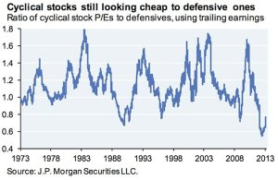

# This is how upside momentum often ends

An article appeared on *Ivanhoff Capital* on 21 June 2012. Author: Ivanhoff. <http://ivanhoff.com/2012/06/21/this-is-how-upside-momentum-often-ends/> This section is a digest, added on 12 August 2013.

Sooner or later, all trends end. To protect gains, you have to exit at some point. Here are the typical four stages near the end of a momentum move:

1. **Price goes parabolic and extends significantly above its “relevant” moving average**.
2. **There is a major, high-volume move in the opposite direction of the trend.** It might last anywhere from a day to two weeks. This is a major tipping point.
3. The trend may re-assert itself. **The bounce however will carry very little volume behind it or it will be less that the volume during the pullback**. This is due to “Johnny-come-latelys” entering near, say, a 20dma or 50dma who have been sitting on the sidelines the whole time thinking they see an opportunity to buy in.
4. **The previous high will not be reached or if it is, it will be on low volume**. That snapback bounce should be used to liquidate your position. There is usually a high-volume move lower.

# When is a Stock Considered Broken

An article appeared on *Ivanhoff Capital* on 7 August 2013. Author: Ivanhoff. <http://ivanhoff.com/2013/08/07/when-is-a-stock-considered-broken/> This section is a digest, added on 12 August 2013

A stock is “broken” when either:

* **it makes a 52-week low during a bull markets**. Stock that do this usually do so for a good reason, and should be avoided. They don't switch from being in down-trend to recovery mode without long periods of accumulation beforehand.
* **a momentum high-flier breaks its up-trend**. It is then in a place where momentum investors are gone or short, and value investors are not yet interested. So there is nobody to buy. When a momentum leader closes below its 50-week moving average, consider it a big warning sign.

# Looking for Ten-Baggers is a Losing Strategy

The following article appeared on *The Motley Fool* on 7 July 2013. Author: CockneyRebel. [<http://boards.fool.co.uk/i-think-investing-for-10-baggers-is-an-excellent-12844144.aspx>]. This section was added on 10 August 2013.

I think investing for 10 baggers is an excellent idea as long as you look for the right stocks and don't look for 10 baggers - you need to get your 10 baggers by accident imo.

**I'd say the real 10 baggers are the stocks you buy that you weren't looking to 10 bag but become 10 baggers.** This is usually because you look for a stock that is screamingly undervalued in a market where shares are being shunned imo.

Hornby was a real boring stock when I bought it at circa 140p in 2000. Everyone said 'what, the model trains?' like I was crazy. I sold out a few years later at £10 having also bagged a packet in sizeable divis too. **The thing was it was a boring share, people were totally uninterested.** The press never even covered it until it hit £5. At £7 a share they were enthusiastic and at £10 they were having multiple orgasms about the co. That's the time to sell imo.

JDG was a classic. A market where everyone was scared, but directors buying and a fwd PE of about 3 when I bought at £1 a share. Did I think I t was a bargain when I bought it? Yes. Did I think it would 10 bag when I bought it? No.

That's the difference imo. **When you buy stock that you think is a potential 10 bagger most have done it on hype, press speculation and bulletin board sizzle.** Most will be AIM miners or dreamer stocks, foreign based and full of directors with dubious intent imo. The risk outweighs the illusory potential reward.

TCG - did that look a 10 bagger in October? No, but as soon as the new CEO came out and said she had made even greater savings than forecast and then bough 500K shares I think that said they were going up from there out. They've nearly 10 bagged in about 8 months but nobody seemed interested here when I put them in the shares competition. Just seemed so ironic that once they were well over £1 Motley Fool ran an article asking were these a buy now? **You need to be contrarian but you need not be reckless.**

Which sort of sums 10 baggers up for me. **If you buy genuine undervaluation when others are uninterested then often the 10 baggers come to you by accident.** If you look for something that looks like a 10 bagger then you're probably missing something fundamental imo.

**Buying several AIM miners and the like that look like 10 baggers looks like the route to disaster** imo. You're just increasing your chances of buying some real duff dogs imo. Yep, you might get lucky with one that out performs all the rest that go bust but why have one 10 bagger and 7 others that go bust? It might sound like you're up on the deal but far better to pick 7-8 solidly undervalued stocks and find they nearly all go up and one becomes a 10 bagger by accident imo