Technische Universität München - ShaderKurs WS 2018/19

Wumpus World

Game Design Document

Akbar Suriaganda, Jana, Marco

Structure

# Mission Statement

# Sprints

## Core Features

* + 1. Game Loop
    2. Player
    3. Maze
    4. Instant Deaths
    5. Artefacts
    6. Wumpus
  1. Secondary Obstacles
     1. Sword
     2. Mobs
     3. Switches
     4. Bow and Arrows
  2. Story
     1. Companion
     2. Intro
     3. Tutorial
     4. Bosses
     5. Epilogue

# Mission Statement

Wumpus World is a Top-Down-Shooter game where the player has to go through a maze to get an artefact and defeat the final boss.

# Sprints

## Core Features

### Game Loop

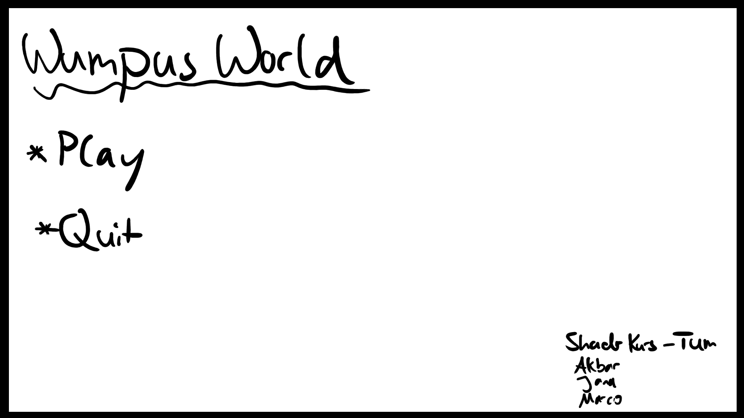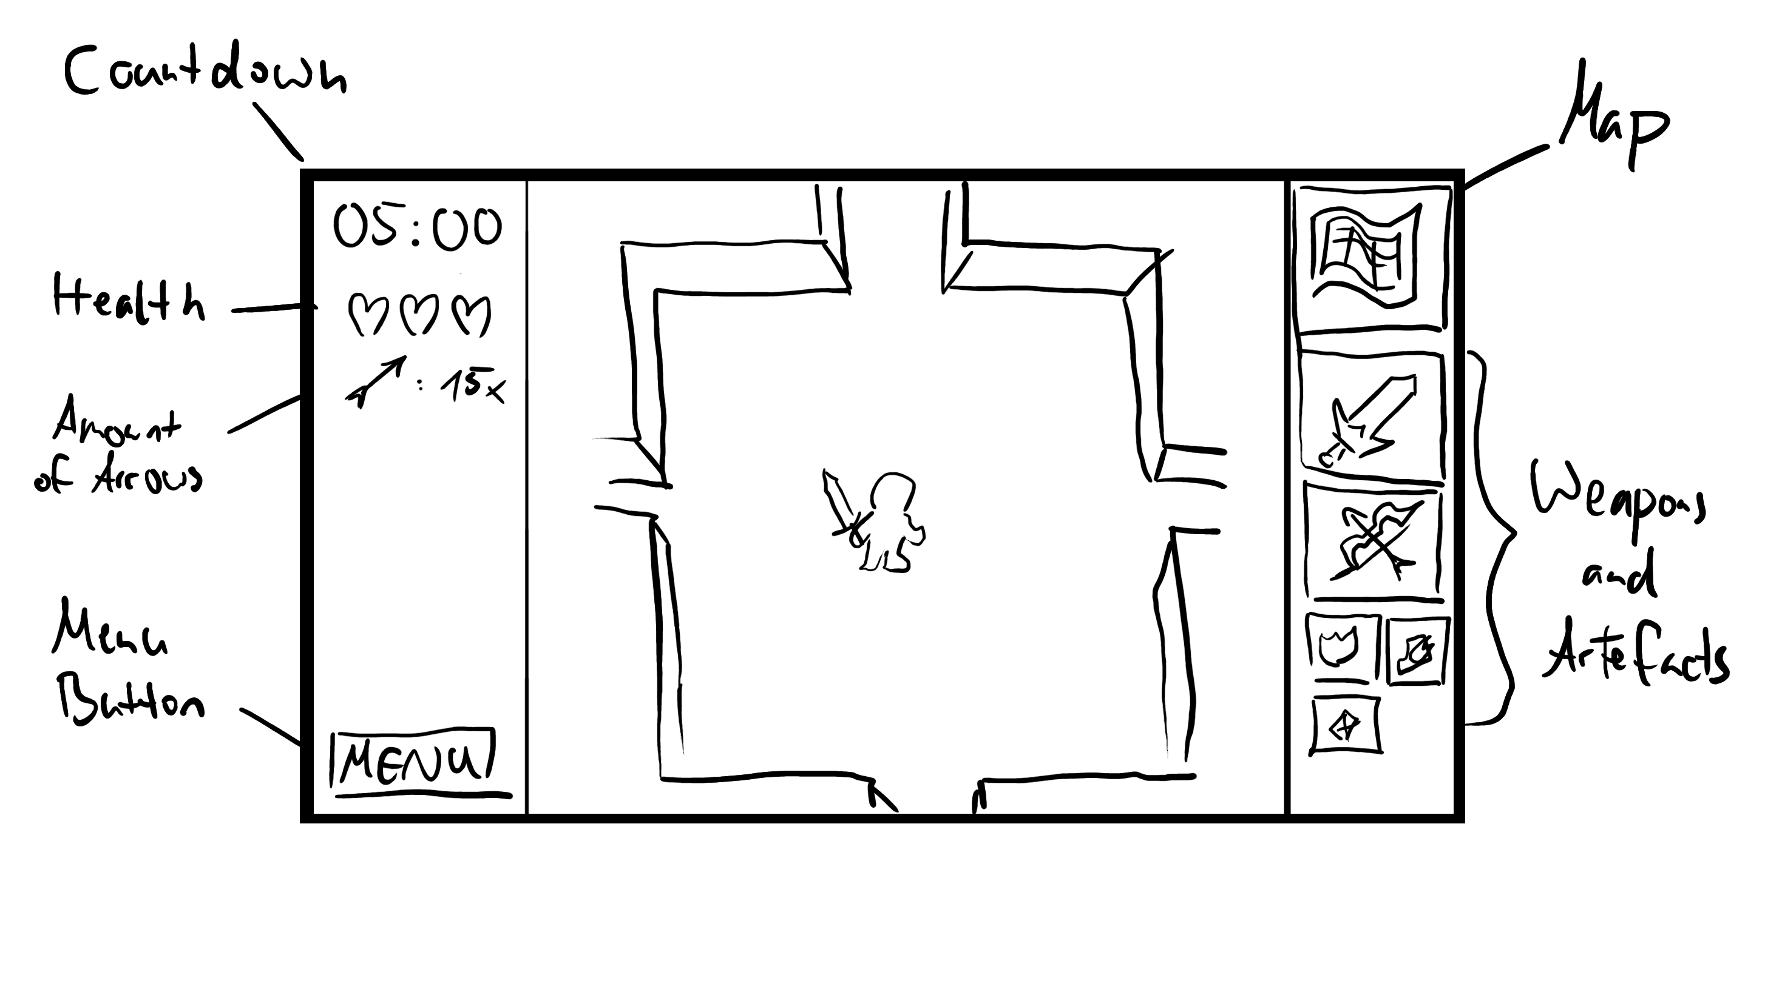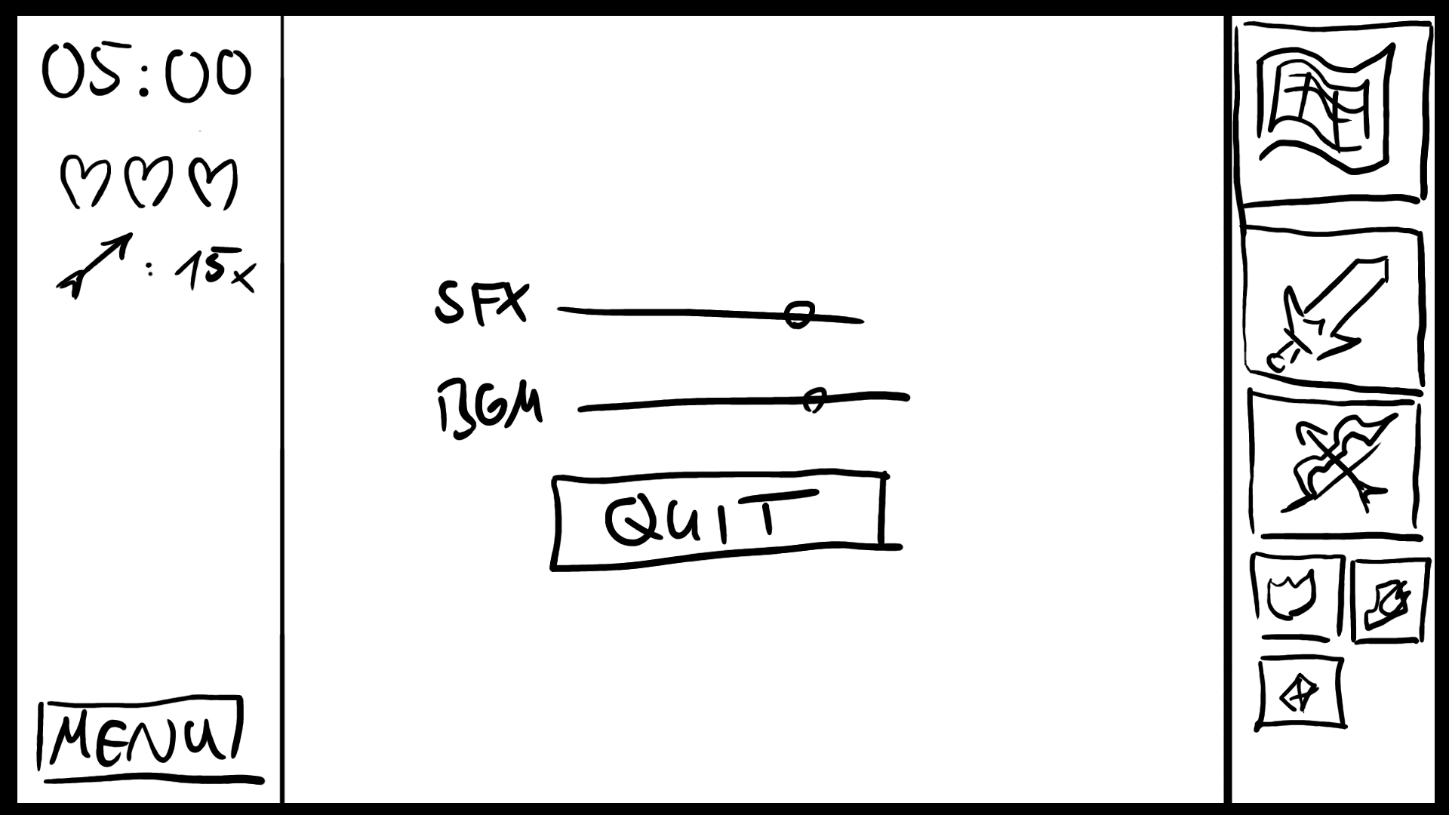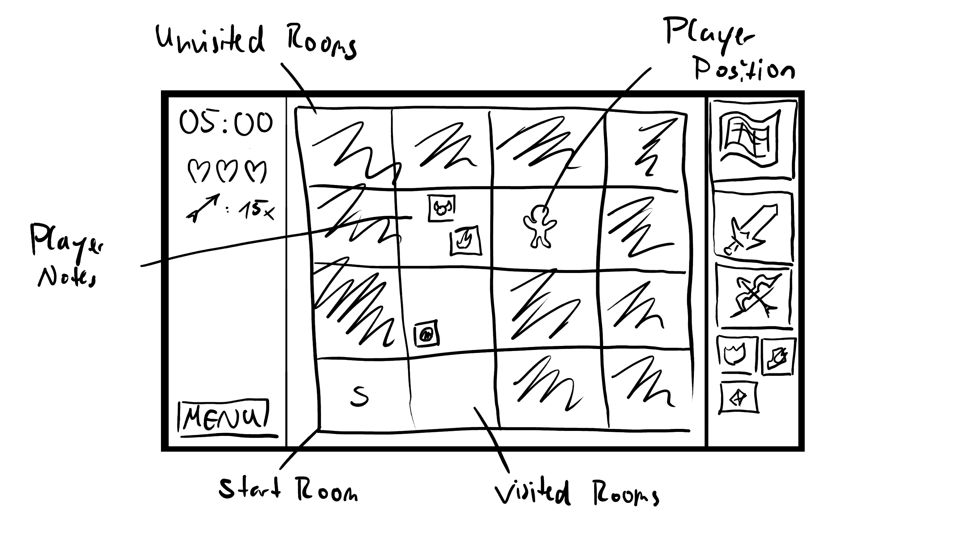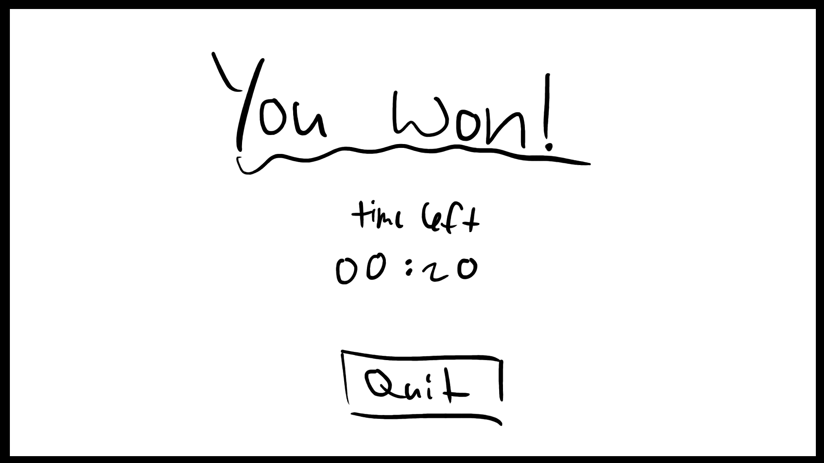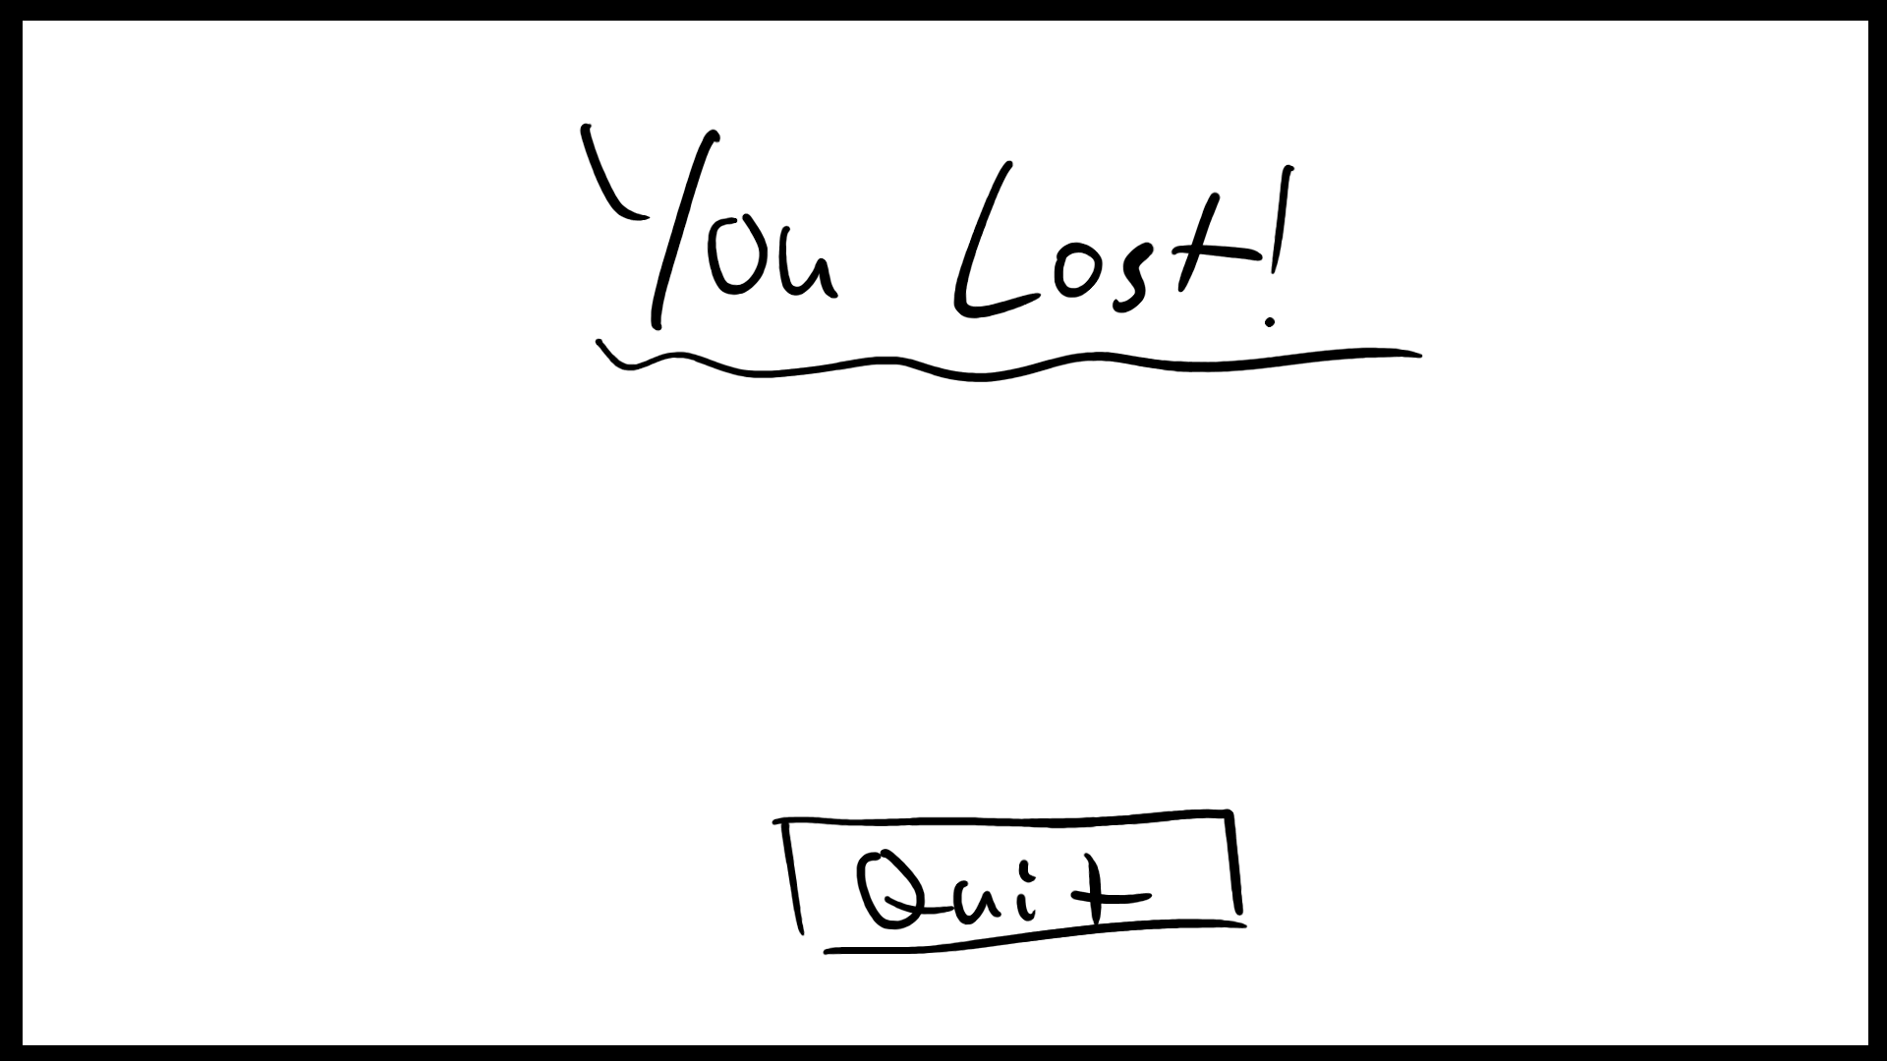

### 

### Player

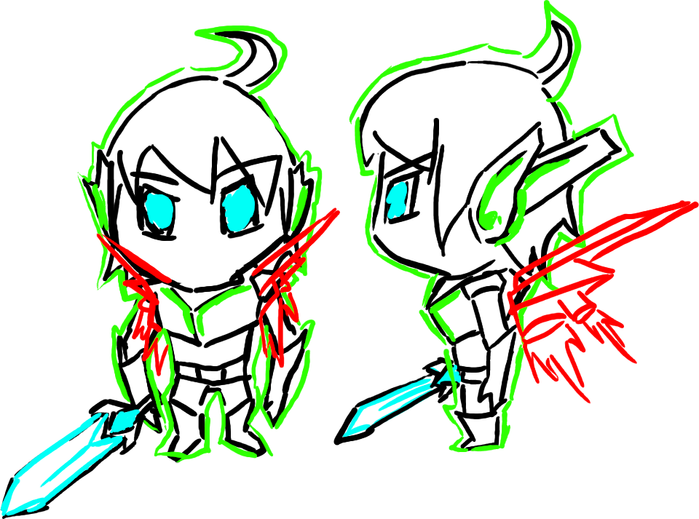

Design:

* Matthias Althoff lol
* Male
* Chibi Style
* Black: Idle state with sword [Sprint 2]
* Red: Wing artefact
* Green: Anti heat barrier artefact
* Blue: Wumpus slayer artefact

Movement:

* WASD: Walk
* Right Mouse Button: Run
* Left Mouse Button: Attack  
   When clicking/holding, player looks at mouse

Animation:

* Idle
* Walk: forward, sideways, diagonal left and right; each one plays backwards  
   when going to the opposite direction; speed duplicates when running
* Attack: sword swing, looks at mouse while swinging [Sprint 2]
* Aim: holds bow, looks at mouse [Sprint 2]
* Dying

Shader: (Pls add more ideas)

* Body: diffuse  
   dissolve vertically when dying  
   glow eyes when Wumpus slayer is active   
   glow ears when anti heat is active
* Body Aura: wireframe when anti heat is active  
   dissolve vertically when dying
* Sword: diffuse  
   dissolve vertically when dying  
   glow edge when Wumpus slayer is active
* Bow: diffuse  
   dissolve vertically when dying
* Wings: diffuse  
   dissolve vertically when dying  
   particle system (not shader) for fire

### Maze



* Start: Bottom left corner  
   Respawns there when dying  
   Neighbor rooms are no instant death rooms
* Instant Death: Wumpus, Pit or Lava  
   Neighbor Rooms indicate its location with shading effects on the wall
* Treasure Room: Contains artefacts to overcome Instant death

On map menu, the player can select a block and mark it with the three symbols. So the player can remember which effects are in which rooms.

Shading: (Pls add more ideas)

* Indicators: Color waves  
   Pulsing  
   Shaking with geometric shader  
    
   Effect-Death pairs are randomized -> on demoday more people can play without  
   cheating  
   Alternatively: for each death an effect that fits (What do you think?)
* Visibility: Dissolve, only active room is visible -> dissolve effect when going to next room
* Pit: Dissolve, is actually the same with visibility but in y coordinate

Animation:

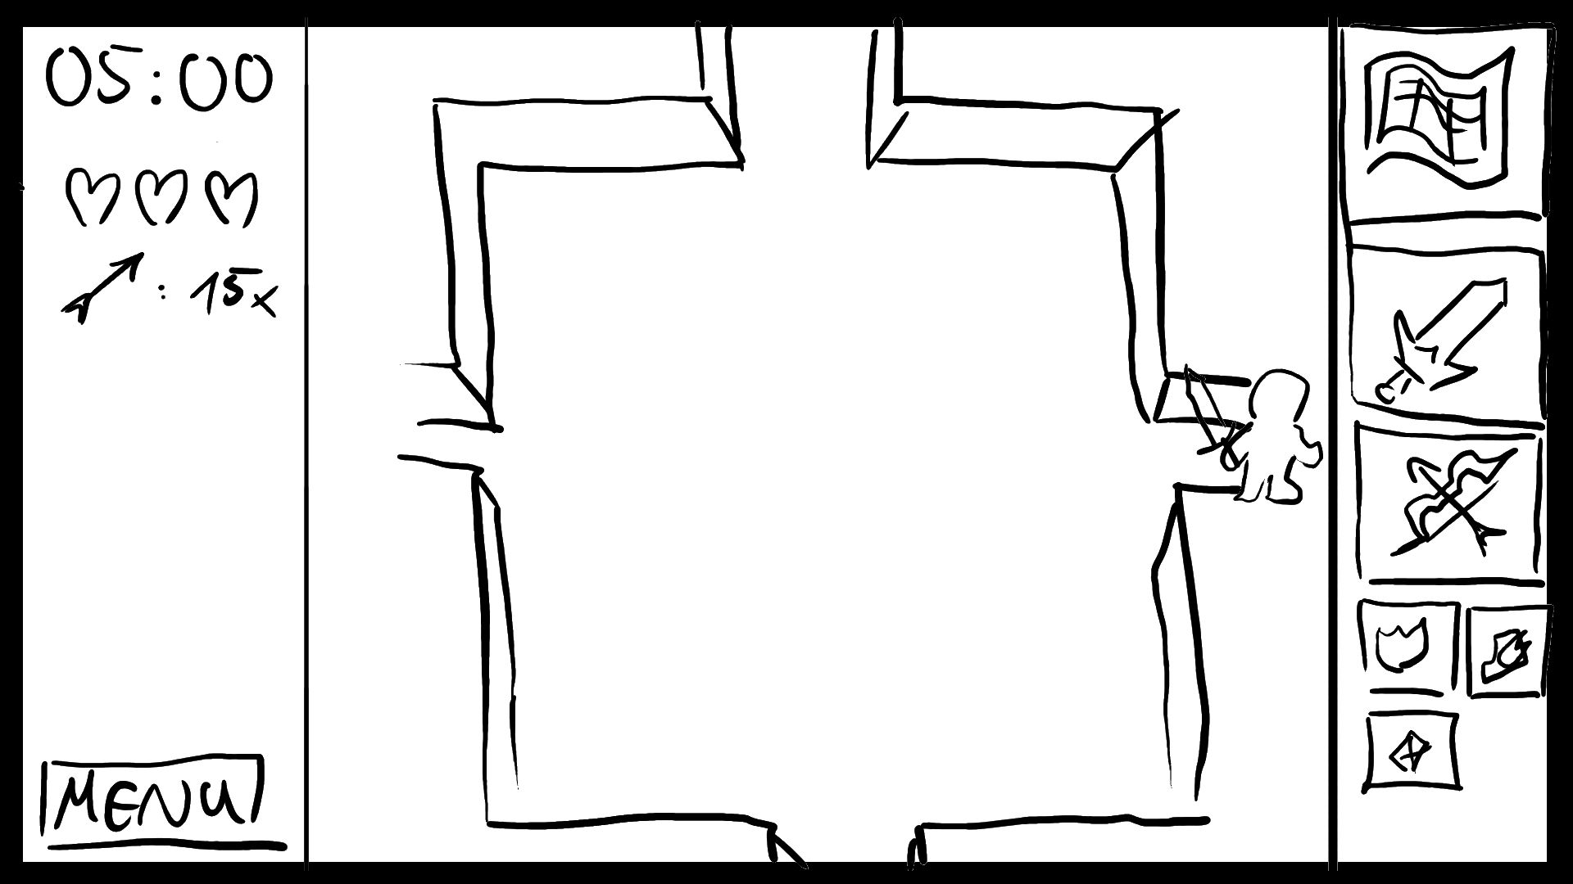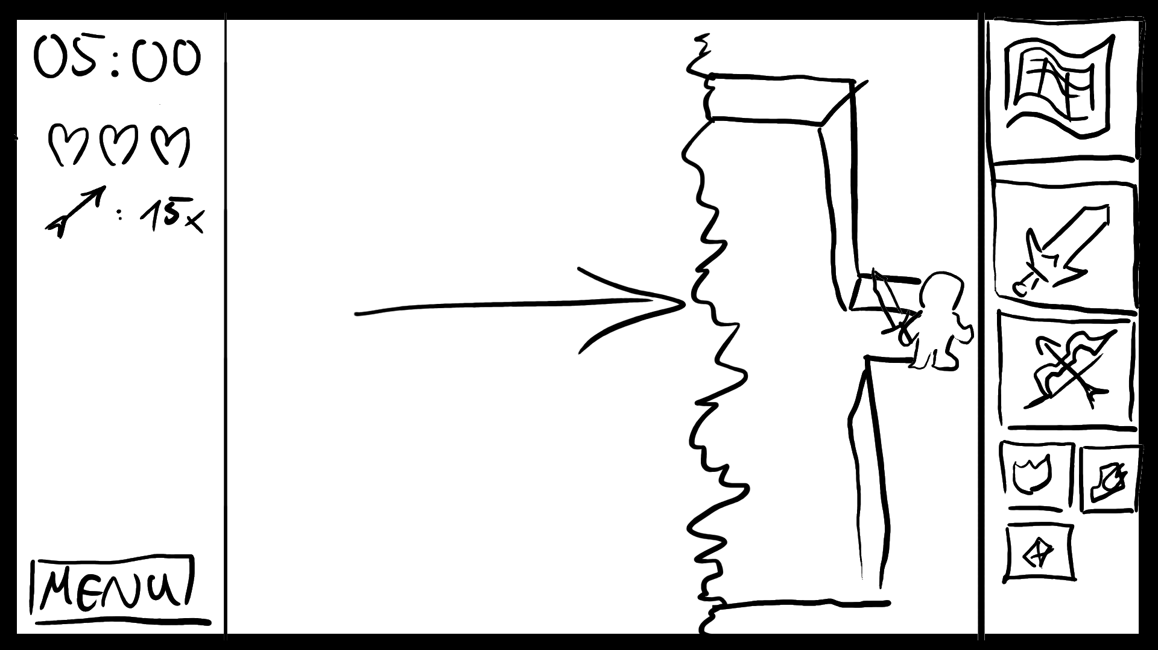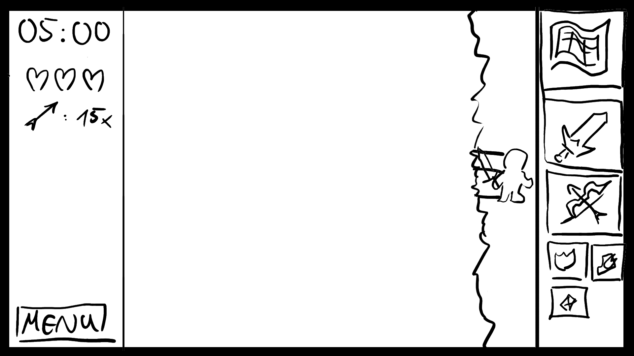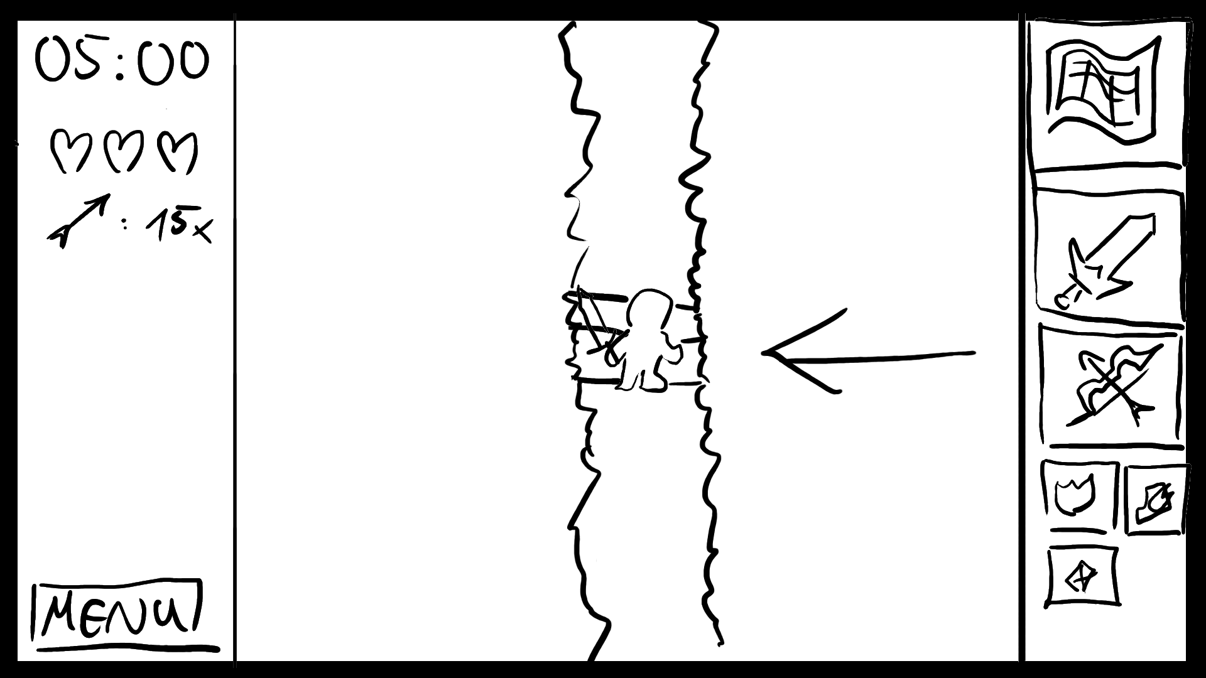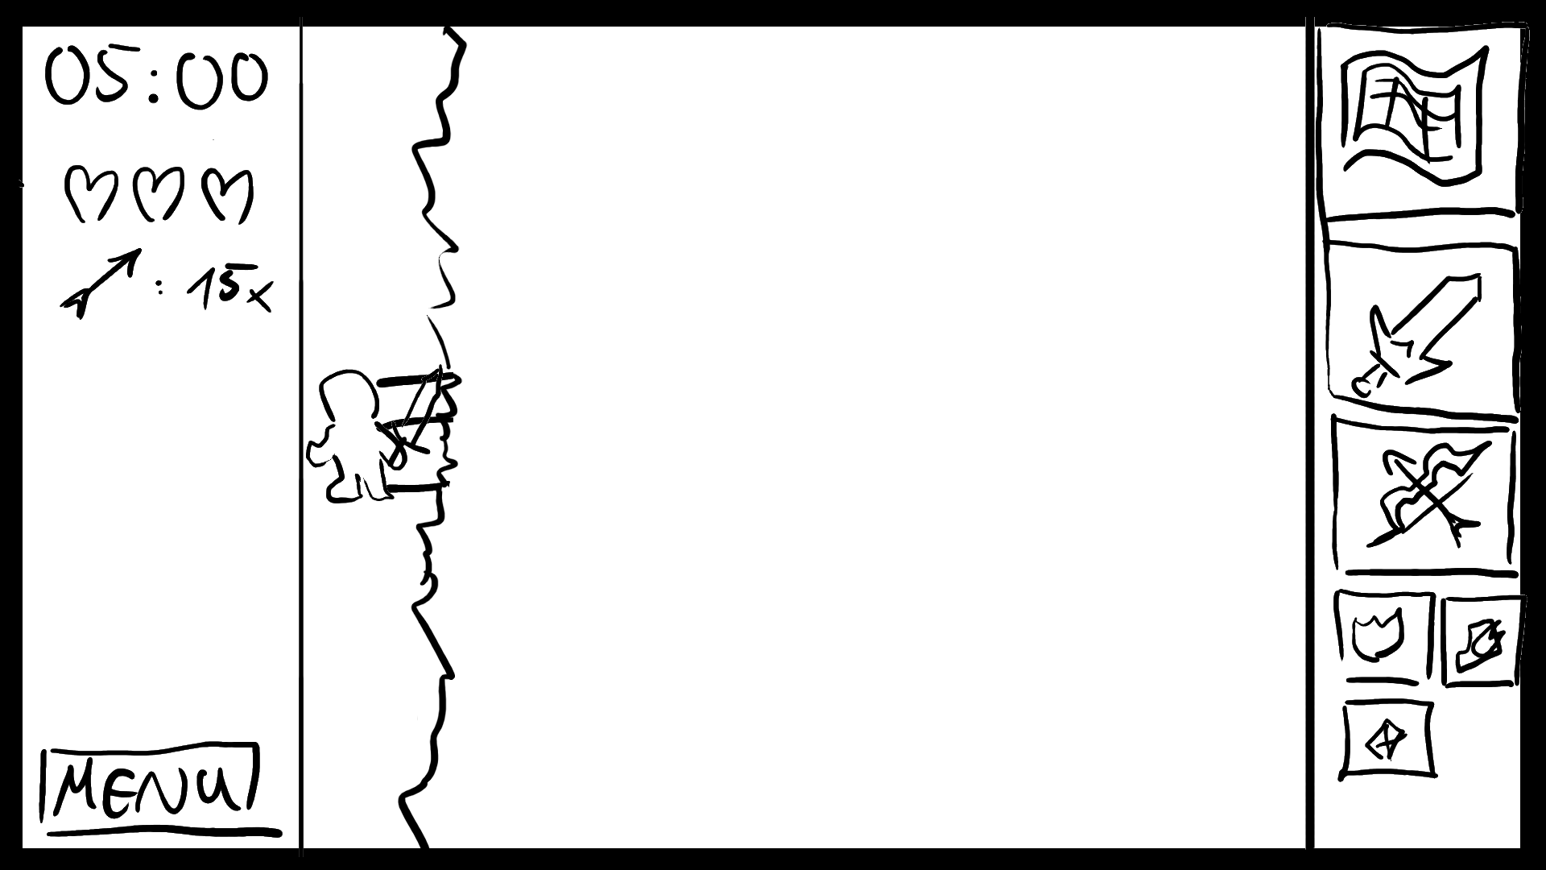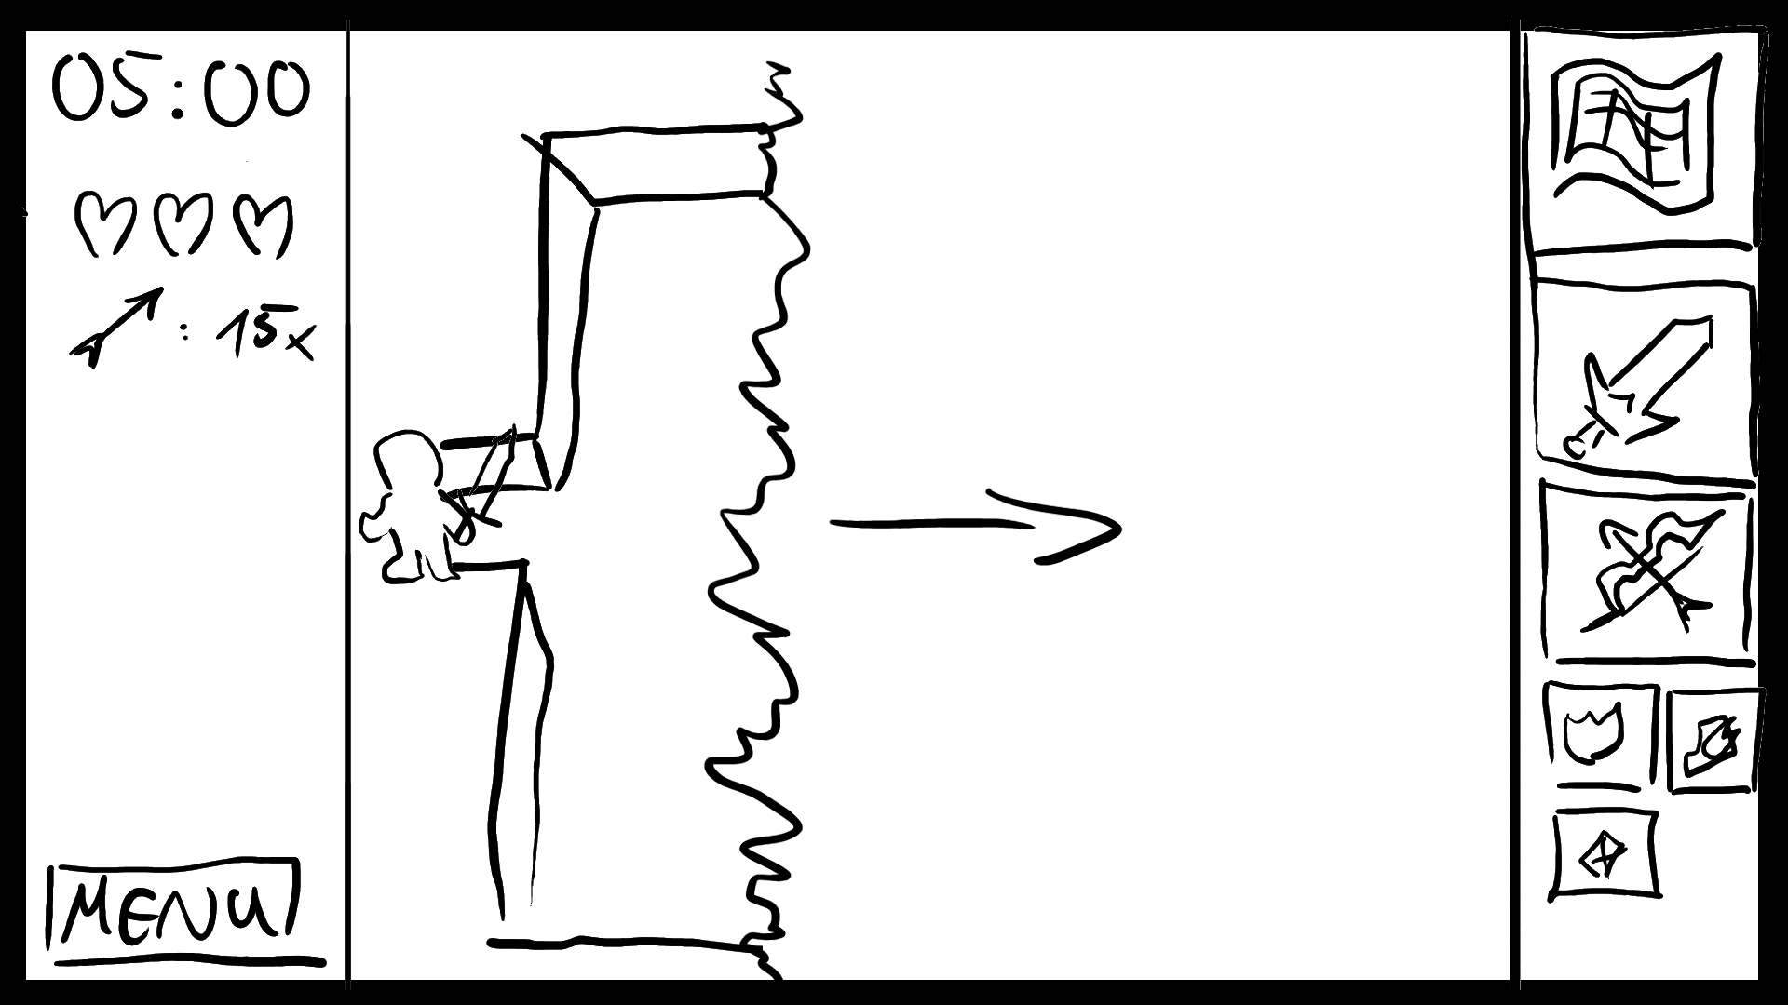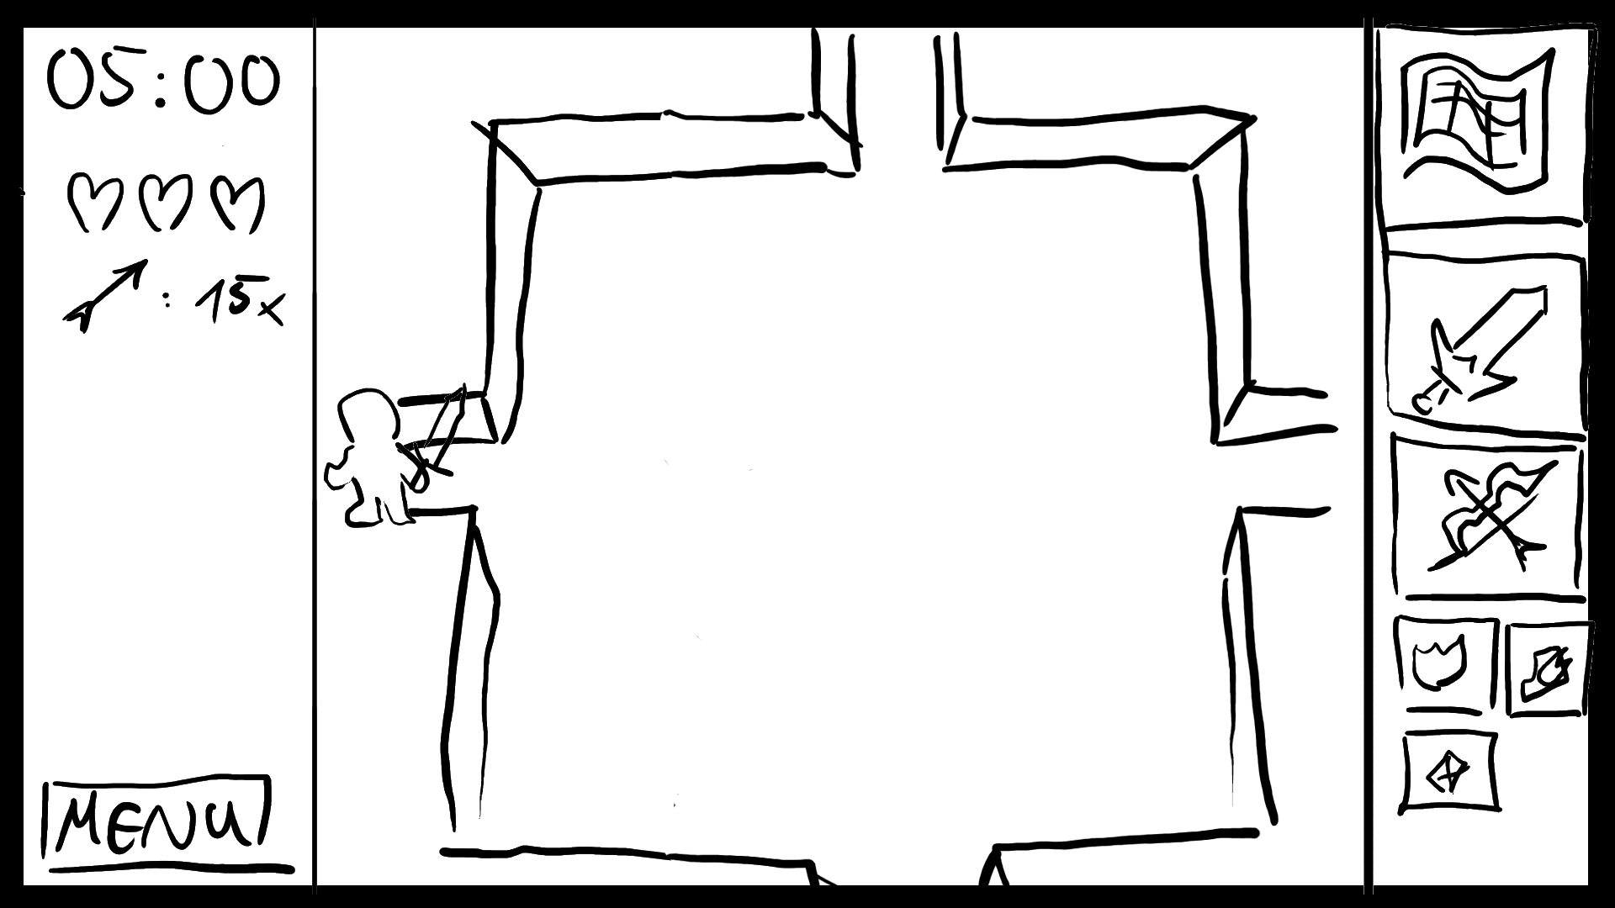

Meanwhile, the player cannot move. In that way the player sees first if the room is safe or not. Then the player instantly dies before he can move again lol.

### Instant Deaths

* Pit: Player falls
* Lava: Player burns and dies instantly  
   Shader: pulsing glow  
   Particle System for fire
* Wumpus: Laser Vision kills the player  
   Shader: Laser as particles with compute shader

### Artefacts

* Wings: Fly over pit
* Anti-Heat: Walk through lava
* Wumpus slayer: Immune to Wumpus laser

Even though wings and anti-heat are passive, they cannot be used at the same time with other items. The Wumpus slayer is fully passive and always active once achieved.

### Wumpus

Reference picture from the AI lecture:

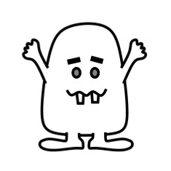

[Sprint 1] With the Wumpus Slayer, the player shines so bright that Wumpus dissolves. -> Win

[Sprint 3] More boss fight.