Seong-Jun Kang, Ph.D.  Experimental and computational biomedical scientist: multiplexed molecular imaging, single-cell and spatial biology, quantitative image analysis  Postdoctoral Associate applicant · Bathe Lab, MIT Department of Biological Engineering | 101 Canal Street  Boston, MA 02114  (551) 239-0341  sjkang89@gmail.com

RESEARCH PROFILE
I am an immunologist working with primary mammalian cells, multiplexed protein and RNA measurements, and quantitative imaging. My hands-on experience includes end-to-end GeoMx DSP, MACSima cyclic immunofluorescence, confocal microscopy, and automated single-cell library preparation. I would apply donor-aware analysis and held-out evaluation to PRISM assay validation, imaging automation, and drug-response studies in human iPSC-derived neurons.
RESEARCH & TECHNICAL EXPERTISE
- Single-cell and multimodal profiling. 10x single-cell workflows, end-to-end GeoMx DSP, Visium spatial transcriptomics, MACSima multiplexed imaging, high-parameter flow cytometry, and Olink targeted proteomics.
- Computational analysis and AI-driven drug discovery. Sequencing-data analysis in Python and R using statistical and machine-learning tools; multimodal integration and donor- or case-level evaluation. AI-driven drug discovery workflows spanning target discovery, binding prediction, virtual screening, and lead optimization.
- Cellular and molecular assays. Primary-cell culture and immune-cell functional assays; DNA, RNA, and protein workflows, including qRT-PCR, cloning, and Western blotting; Biacore SPR and ELISA binding assays.
- Animal models and immune monitoring. EAE and Alzheimer's disease models; skin- and islet-transplantation studies; animal breeding, non-human-primate sampling, and longitudinal immune monitoring.
- Research coordination and grant writing. Multi-site sample QC, project coordination across academia and industry, and contributions to grant proposals for programs with combined budgets of approximately $3 million.
EDUCATION
Ph.D.  2014–2023 | Seoul National University, Seoul, Republic of Korea  Department of Biomedical Sciences  Thesis: Exploration of the Role of Regulatory T cells in Various Pathogenic Contexts  Advisor: Chung-Gyu Park, M.D., Ph.D.
M.S.  2012–2014 | Seoul National University, Seoul, Republic of Korea  Department of Biomedical Sciences  Thesis: Enhanced LPS-Induced Monocyte Activation by Recombinant Human Soluble CD14  Advisor: Chung-Gyu Park, M.D., Ph.D.
B.S.  2008–2012 | Sungkyunkwan University, Suwon, Republic of Korea  Department of Genetic Engineering
RESEARCH & PROFESSIONAL EXPERIENCE
Researcher  (postdoctoral)  2025–present | Yonsei University Wonju College of Medicine · Dept. of Physiology / Organelle Medicine Research Center, Wonju, Republic of Korea  Contributed to a project examining associations between skin immunity and Alzheimer's disease using public transcriptomic and clinical datasets.
Associate Director  Sep 2023–Aug 2025 | PB Immune Therapeutics Inc. · Dept. of Basic Research, Seoul, Republic of Korea  Led anti-CD40 candidate evaluation, including primate studies, external-study coordination, advancement decisions, and single-cell/spatial workflow development.
Manager  May 2021–Aug 2023 | PB Immune Therapeutics Inc. · Dept. of Basic Research, Seoul, Republic of Korea  Led KDDF-funded anti-CD40 lead-selection work and wrote proposals for multiple-sclerosis and pemphigus-vulgaris programs.
Researcher  Sep 2019–Apr 2021 | Xenotransplantation Research Center, Seoul National University, Seoul, Republic of Korea  Rhesus tissue processing and transplant immune monitoring.
Military Service  Sep 2016–Aug 2019 | Research Personnel, Transplantation Research Institute, Seoul National University MRC, Seoul, Republic of Korea
Teaching Assistant  Sep 2014–Aug 2016 | Seoul National University College of Medicine · Dept. of Microbiology and Immunology, Seoul, Republic of Korea
BK21 Research Student  Mar 2012–Aug 2014 | BK21 Plus Biomedical Science Project, Seoul National University, Seoul, Republic of Korea
PUBLICATIONS
20 Total | 17 Published | 1 In revision | 2 In preparation | 6 First / Co-first Published & in revision
Google Scholar · Full Profile, Citations & h-index ↗
First / Co-first Author
2026 | Woogil Song*, Seong-Jun Kang*, Taehee Stella Kim*, Seyoung Jung, Sung Hee Kim, Su Chan Park, Sung Hae Chang, Eun Young Lee, Tae-Gyun Kim, Hyun Je Kim, Jeong Seok Lee. "Conserved PDE4D short-isoform bias defines pathogenic Th1.17 state across human inflammatory diseases." Nature Immunology. in revision
2025 | Seong-Jun Kang*, Yong-Hee Kim*, Thuy Nguyen-Phuong*, Yijoon Kim, Jin-Mi Oh, Jae-chun Go, DaeSik Kim, Chung-Gyu Park, Hyunsu Lee, Hyun Je Kim. "Immune cell-enriched single-cell RNA sequencing unveils the interplay between infiltrated CD8⁺ T resident memory cells and choroid plexus epithelial cells in Alzheimer's disease." Journal of Neuroimmunology. Download PDF
2025 | Seong-Jun Kang*, Jeong-Ryeol Gong*, Seon-Pil Jin, Jin-Mi Oh, Hyunjin Jin, Yuji Lee, Yewon Moon, Dongjun Kim, Hyo Jeong Nam, Hyun Seung Choi, Sanha Hwang, Yun Jung Huh, Kyung Yeon Han, Jihwan Moon, Jongsuk Chung, Woong-Yang Park, Chung-Gyu Park, Hyun Je Kim, Jeong Eun Kim. "Deciphering Dysfunctional Regulatory T Cells in Atopic Dermatitis." Allergy. Download PDF  Co-first author. Single-cell and functional dissection of skin-homing regulatory T cells in atopic dermatitis, with OX40 up-regulated alongside impaired suppressive function.
2024 | Jong-Min Kim*, Seong-Jun Kang*, So-Hee Hong*, Hyunwoo Chung, Jun-Seop Shin, Byoung-Hoon Min, Hyun Je Kim, Jongwon Ha, Chung-Gyu Park. "Long-term control of diabetes by tofacitinib-based immunosuppressive regimen after allo-islet transplantation in diabetic rhesus monkeys that rejected previously transplanted porcine islets." Xenotransplantation. Download PDF  Co-first author. Long-term diabetes control with a tofacitinib-based regimen after allo-islet transplantation in rhesus macaques, with longitudinal immune monitoring.
2022 | Youngkyoung Lim*, Seong-Jun Kang*, Beom Keun Cho, Hyun Je Kim, … Chong Hyun Won, Chung-Gyu Park. "Intra-tumoral heterogeneity and immune escape of melanoma arising from congenital melanocytic nevus revealed by spatial gene expression profiling." JEADV. Download PDF
2019 | Jong-Min Kim*, Jun-Seop Shin*, Byoung-Hoon Min*, Seong-Jun Kang*, Il-Hee Yoon, Hyunwoo Chung, Jiyeon Kim, Eung-Soo Hwang, Jongwon Ha, Chung-Gyu Park. "JAK3 inhibitor-based immunosuppression in allogeneic islet transplantation in cynomolgus monkeys." Islets. Download PDF  Co-first author, one of four authors contributing equally. JAK3-inhibitor-based immunosuppression in allogeneic islet transplantation in cynomolgus macaques.
Contributing Author
2026 | Jung Ho Lee*, Sung Ha Lim*, Hyungdon Kook, Seong-Jun Kang, Geon Lee, Brian Hyohyoung Lee, Hyunsung Nam, YongJun Kim, Christine Suh-Yun Joh, Soyoung Jeong, Dongryeol Shin, Hyun Je Kim, Jiyoung Ahn. "Mycosis Fungoides-like Atopic Dermatitis Represents a Th22-dominant Inflammatory Endotype." Allergy.
2024 | Brian Hyohyoung Lee*, Yoon Ji Bang*, Sung Ha Lim*, Seong-Jun Kang, Sung Hee Kim, Seunghee Kim-Schulze, Chung-Gyu Park, Hyun Je Kim, Tae-Gyun Kim. "High-dimensional profiling of regulatory T cells in psoriasis reveals an impaired skin-trafficking property." eBioMedicine. Download PDF
2024 | Youngkyoung Lim*, Beom Keun Cho*, Seong-Jun Kang, Soyoung Jeong, Hyun Je Kim, Jiyoon Baek, Ji Hwan Moon, Cheol Lee, Chan-Sik Park, Je-Ho Mun, Chong Hyun Won, Chung-Gyu Park. "Spatial transcriptomic analysis of tumour–immune cell interactions in melanoma arising from congenital melanocytic nevus." JEADV. Download PDF
2023 | Sunyoung Jung*, Sunho Lee, Hyun Je Kim, Sueon Kim, Ji Hwan Moon, Hyunwoo Chung, Seong-Jun Kang, Chung-Gyu Park. "Mesenchymal stem cell-derived extracellular vesicles subvert Th17 cells by destabilizing RORγt through posttranslational modification." Experimental & Molecular Medicine.
2022 | Sangho Lee, Han-Teo Lee, Young Ah Kim, Il-Hwan Lee, Seong-Jun Kang, Kyeongpyo Sim, Chung-Gyu Park, Kyungho Choi, Hong-Duk Youn. "The optimized core peptide derived from CABIN1 efficiently inhibits calcineurin-mediated T-cell activation." Experimental & Molecular Medicine.
2021 | So Hee Hong, Hyun Je Kim, Seong-Jun Kang, Chung-Gyu Park. "Novel Immunomodulatory Approaches for Porcine Islet Xenotransplantation." Current Diabetes Reports. Download PDF
2020 | Sunho Lee, Sueon Kim, Hyunwoo Chung, Ji Hwan Moon, Seong-Jun Kang, Chung-Gyu Park. "Mesenchymal stem cell-derived exosomes suppress proliferation of T cells by inducing cell cycle arrest through p27kip1/Cdk2 signaling." Immunology Letters.
2019 | Hyun Je Kim, Ji Hwan Moon, Hyunwoo Chung, Jun-Seop Shin, Bongi Kim, Jong Min Kim, Jung-Sik Kim, Il-Hee Yoon, Byoung-Hoon Min, Seong-Jun Kang, Yong-Hee Kim, Kyuri Jo, Joungmin Choi, Heejoon Chae, Won Woo Lee, Sun Kim, Chung-Gyu Park. "Bioinformatic analysis of peripheral blood RNA-sequencing sensitively detects the cause of late graft loss following overt hyperglycemia in pig-to-non-human primate islet xenotransplantation." Scientific Reports.
2018 | Byoung-Hoon Min, Jun-Seop Shin, Jong-Min Kim, Seong-Jun Kang, Hyun-Je Kim, Il-Hee Yoon, Su-Kyoung Park, Ji-won Choi, Min-Suk Lee, Chung-Gyu Park. "Delayed revascularization of islets after transplantation by IL-6 blockade in pig-to-non-human primate islet xenotransplantation model." Xenotransplantation.
2018 | Jun-Seop Shin, Jong-Min Kim, Byoung-Hoon Min, Il Hee Yoon, Hyun Je Kim, Jung-Sik Kim, Yong-Hee Kim, Seong-Jun Kang, Jiyeon Kim, Hee-Jung Kang, Dong-Gyun Lim, Eung-Soo Hwang, Jongwon Ha, Sang-Joon Kim, Wan Beom Park, Chung-Gyu Park. "Pre-clinical results in pig-to-non-human primate islet xenotransplantation using anti-CD40 antibody (2C10R4)-based immunosuppression." Xenotransplantation.
2018 | Jong-Min Kim, Jun-Seop Shin, Byoung-Hoon Min, Il Hee Yoon, Seong-Jun Kang, Won-Young Jeong, Sang-Joon Kim, Chung-Gyu Park. "Pre-Clinical Results of Islet Allo-Transplantation Using JAK Inhibitor as Replacement for Tacrolimus in Cynomolgus Monkeys." Transplantation.
2018 | Jung-Sik Kim, Hyunwoo Chung, Nari Byun, Seong-Jun Kang, Sunho Lee, Jun-Seop Shin, Chung-Gyu Park. "Construction of EMSC-islet co-localizing composites for xenogeneic porcine islet transplantation." Biochemical and Biophysical Research Communications.
Manuscripts in Preparation
2026 | Kangsan Roh*, Sabyasachi Das*, Seong-Jun Kang, Olga Barreiro, Rodrigo Javier Gonzalez, Timothy P. Padera, Shraddha Shirguppe, Ahlim Lee, Youngju Song, Pazhanichamy Kalailingam, Claire E. Fong, Aarushi Gandhi, Meehyun Kim, Diana Tambala, Adam Vernon Crain, Casey A. Maguire, Ulrich H. Von Andrian, Christian L. Lino Cardenas, Sekeun Kim, Benjamin P. Kleinstiver, Mark E. Lindsay, Patricia L. Musolino, Rajeev Malhotra. "In-vivo base editing of ACTA2 R179H restores lymphatic function and immune cell homeostasis in a murine model of Multisystemic Smooth Muscle Dysfunction Syndrome (MSMDS)." in preparation  Co-author (immunology). Ran the Olink plasma proteomics across 12 patients and 6 controls and the flow-cytometry immunophenotyping of lymph-node leukocytes.
2026 | Sung Ha Lim*, Jiyeon Oh*, Kyu-Hee Hwang, Taesic Lee, Seong-Jun Kang, Eung Ho Choi, Seung-Kuy Cha. "Skin-brain transcriptomic convergence: an integrative framework for predicting Alzheimer's disease from cutaneous aging signatures." in preparation  Co-author (methodology, single-cell analysis). Built the method that turns a meta-analysis of 8 skin-aging transcriptome datasets into gene sets and uses them to classify Alzheimer's disease in human brain transcriptomes. Reanalyzed 4 public skin and brain single-cell cohorts (295,243 cells and nuclei) with donor-level pseudobulk to map the candidate genes to specific cell types.
TECHNICAL EXPERTISE
Multiplexed in situ  detection and imaging | GeoMx DSP run end to end — slide preparation, oligonucleotide-barcoded probe hybridisation, immunofluorescence staining, fluorescence-guided ROI selection, instrument operation, UV cleavage and barcode collection. MACSima cyclic multiplexed immunofluorescence, iterative stain–image–erase rounds on one section. Olink targeted plasma proteomics; Visium spatial transcriptomics. High-parameter fluorescence panel design up to 24 markers. Spinning-disk confocal (Nikon CSU-W1 SORA) with quantitative image analysis.
High-content image  and data analysis | Segmentation, feature extraction and model scoring on public iPSC-neuron imaging screens. Batch- and donor-aware modelling, held-out evaluation, calibrated confidence. Automated library preparation on 10x Chromium Connect.
Single-cell /  spatial / multi-omic | scRNA-seq, scTCR-seq, snRNA/snATAC; 10x 5′/3′ library generation and 10x Chromium Connect automated preparation. Single-cell sequencing data analysis and interpretation in Python and R. Spatial: GeoMx DSP run end to end, Visium, MACSima cyclic multiplexed immunofluorescence.
Computational | Python, R, Linux, and Git; scikit-learn, XGBoost/LightGBM/CatBoost, and PyTorch. Donor- or case-level validation and multimodal analysis of imaging, transcriptomic, and clinical data.
Cell, tissue &  immunological assays | Primary human T-cell isolation, expansion and functional assays; monocyte and dendritic-cell differentiation; mesenchymal stem cell culture. Enzymatic tissue digestion, Percoll enrichment, cell and nucleus isolation. High-dimensional flow cytometry (panels up to 24 markers); multiplex panel design; 10-color 6-way FACS. Olink targeted plasma proteomics (immune & neurology panels).
Microscopy &  animal models | Spinning-disk confocal (Nikon CSU-W1 SORA), point-scanning confocal (Leica SP8), two-photon; IHC/IF (frozen & FFPE) with quantitative image analysis. Non-human primates across three species (rhesus, cynomolgus, marmoset), including EAE and islet-transplantation studies; mouse immune profiling.
Study execution &  collaboration | Study design, external-study coordination, multi-site sample QC, milestone tracking, regulatory documentation, and data review.
BOOKS
Seong-Jun Kang, Do-gyun Kim, Jin-seon Han. AI Drug Discovery: A Practical Guide for Biomedical Researchers (title translated). PanmunEducation. September 21, 2026. 548 pages. ISBN 979-11-5943-583-6. YES24 Global
The book covers molecular and protein data preparation, QSAR, ChemBERTa, graph neural networks, docking, virtual screening, candidate optimization, and follow-up experimental validation.
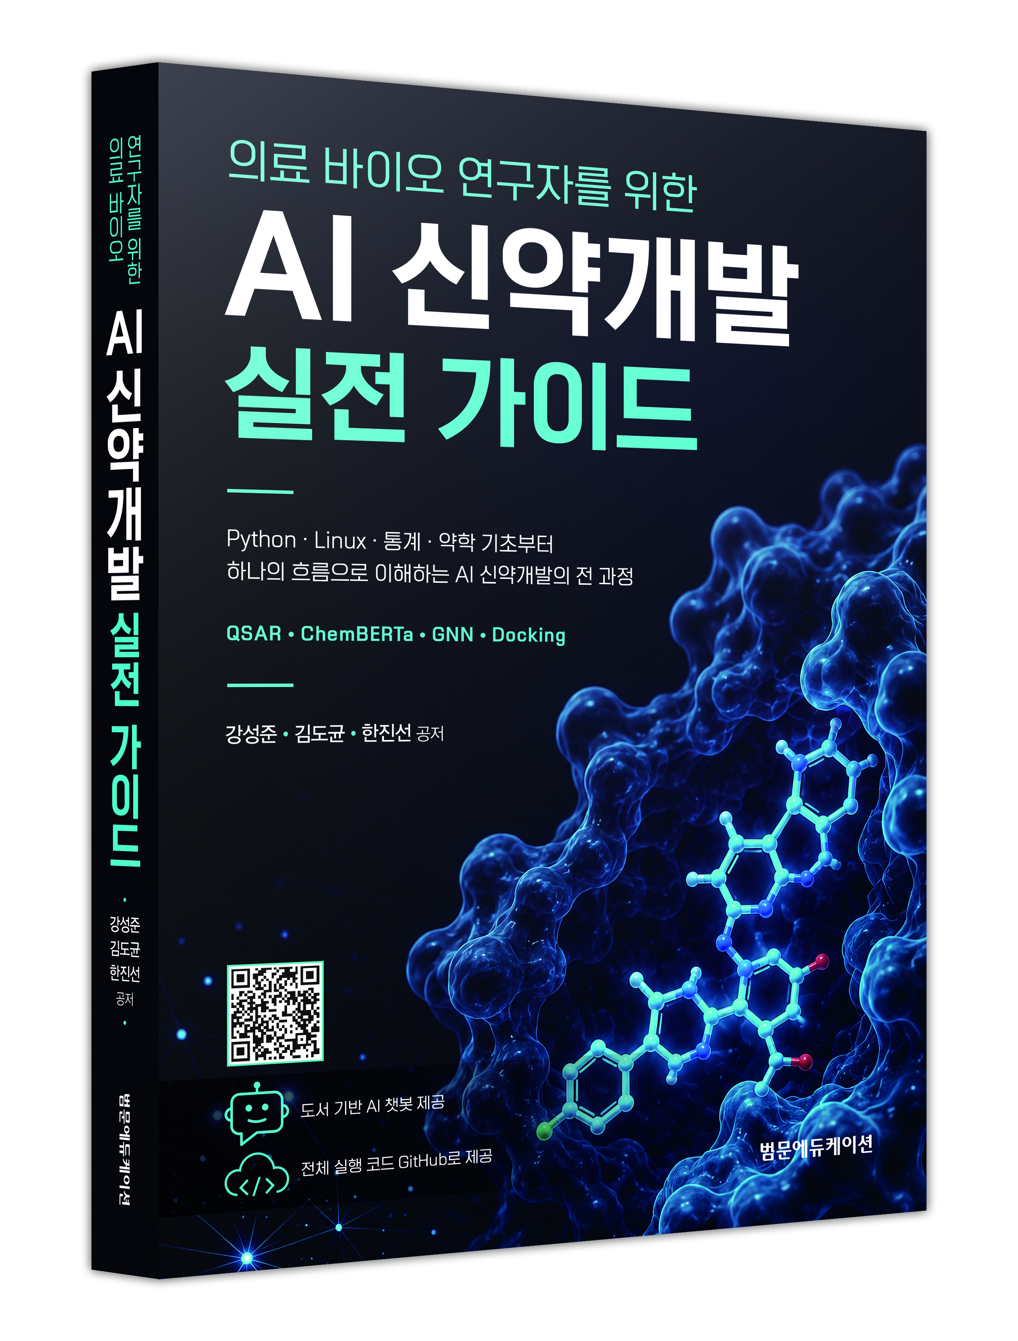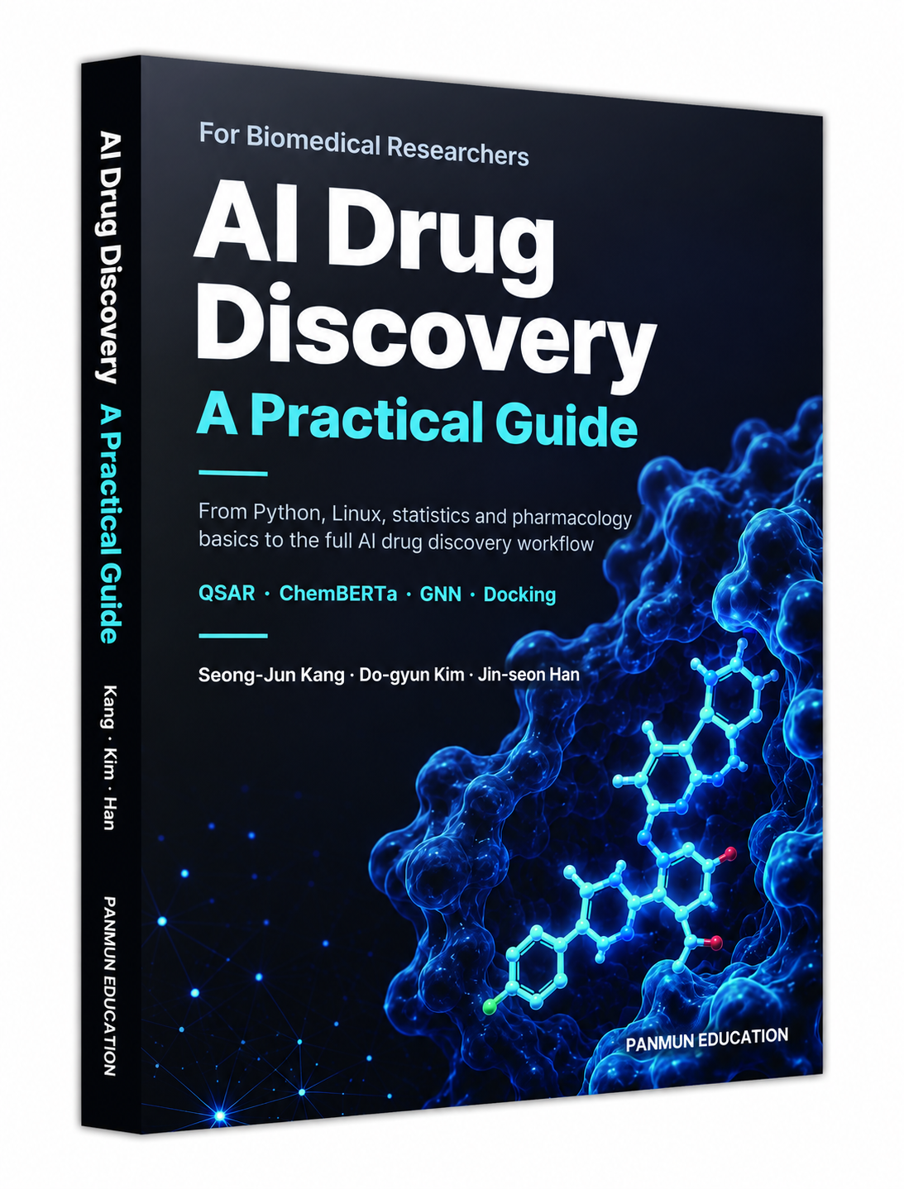
PATENTS
2024 | Antagonistic Anti-CD40 Humanized Antibody. Republic of Korea, Appl. No. 10-2024-0085972; registered 2024-07-01. Co-inventor.
2019 | Immunosuppression Composition Comprising JAK Inhibitor. Republic of Korea, Appl. No. 10-2014-3490000; registered 2019-08-20.
AWARDS & SCHOLARSHIPS
Awards
Jun 2024 | Grand Prize, 2024 GPTers AI Hackathon (Project GAIA Team)
Dec 2023 | Grand Prize, SBA Smart Workathon for Work Process Innovation
Dec 2021 | Excellence Award (Poster Presentation), 2021 Research Safety Contest, Seoul National University College of Medicine
Dec 2020 | Excellence Award (Poster Presentation), 2020 Research Safety Contest, Seoul National University College of Medicine
Dec 2017 | Best Research Award, 2017 Infection and Immunity Research Festival, Department of Microbiology and Immunology, Seoul National University College of Medicine
Nov 2017 | Best Presentation Award (Poster Presentation), 2017 Annual Meeting of the Korean Association of Immunologists
May 2017 | Best Poster in Congress Award, 2017 American Transplant Congress, Chicago
Scholarships
Sep 2019–Aug 2020 | Research Scholarship for Ph.D. Candidates, National Research Foundation of Korea (NRF)
Sep 2014–Aug 2016 | Lecture and Research Support Scholarship, Dean of Seoul National University College of Medicine
Mar 2012–Aug 2014 | BK21 Research Scholarship, BK21 Plus Biomedical Science Project, Seoul National University
Selected Presentations
Poster | KAI Annual Meeting, Incheon (2022) · Cytokine, Hawaii (2022) · American Transplant Congress, Chicago (2017) · The Transplantation Society, Hong Kong (2016) · IPITA/IXA/CTS, Melbourne (2015) · TREG, Shanghai (2012)
SELECTED GRANT WRITING & PROGRAM FUNDING
Industry · PB Immune Therapeutics (Manager → Associate Director)
Funding Agency / Sponsor | Project | Period | Budget (USD) | Role / Contribution
Korea Drug Development Fund (KDDF) | Anti-CD40 antibody lead selection and optimization (multiple sclerosis) | 2021–2023 | ~$571,000 | Lead proposal writer (>90% of proposal & execution)
Korea Drug Development Fund (KDDF) | Anti-CD40 lead compound (PB101): efficacy and pharmacodynamic biomarkers (pemphigus vulgaris) | 2022–2024 | ~$321,000 | Lead proposal writer (>90% of proposal & execution)
Ministry of SMEs and Startups (MSS) | Scale-up Funding for Tech Commercialization | 2022–2023 | ~$222,000 | Lead proposal writer; managed >90% of execution
Ministry of SMEs and Startups (MSS) | Early-stage startup R&D: anti-CD40 biologic (PB-40N) to prevent anti-drug antibodies | 2021–2022 | ~$74,000 | Lead proposal writer & core researcher
NAVER Corporation | Engineered regulatory T cells for immune-mediated diseases (PB20X_Treg) | 2023–2026 | ~$128,000 | Proposal & study design (~50%)
Doctoral training · Seoul National University
Funding Agency / Sponsor | Project | Period | Budget (USD) | Role / Contribution
Ministry of Science and ICT (MSIT) | Multi-layered immune-disease single-cell map for molecular target discovery (SCAID, A9-22-1-05) | 2022–2028 (3+3) | ~$1.6M | Participated in proposal writing (>30%)
Ministry of Education (MOE) & Ministry of Science and ICT (MSIT) | Laboratory-Specialized Tech-Transfer & R&BD Grant | 2020–2021 | ~$40,000 | Grant writing, experimental design & technical validation
All grants were held by the institutional Principal Investigator (Ph.D. advisor at SNU; company CEO/CSO at PB Immune Therapeutics); the listed roles reflect the applicant's contribution to proposal writing and project execution, not as PI. Budgets converted at ≈ ₩1,400 / USD.
MENTORING AND RESEARCH TRAINING
Year | Mentee / role at time | Current affiliation | Research training
2013 | Sung Ha Lim, M.D., Ph.D.Student intern | Postdoctoral Fellow; Laboratory of Shadmehr Demehri, M.D., Ph.D.; Department of Dermatology, Massachusetts General Hospital; Harvard Medical School, Boston, MA, USA | Cell culture, Western blotting, flow cytometry, and C57BL/6 mouse breeding.
2014 | Soyoung Jeong, Ph.D.Student intern | Postdoctoral Associate; Medical Research Center, Seoul National University, Seoul, Republic of Korea | Cell culture, flow cytometry, and in vivo mouse experiments.
2016 | Sowon Choi, M.S.Incoming graduate student | Ph.D. Candidate; Department of Biomedical Sciences; Seoul National University Graduate School, Seoul, Republic of Korea | Mouse pancreatic islet isolation, pancreatic islet beta-cell functional assays, and ion channel assays.
2021 | Hyo Jeong Nam, M.S.Incoming graduate student | Associate Researcher, Human Immune Monitoring Center, Icahn School of Medicine at Mount Sinai, New York, NY, USA | GeoMx DSP, T-cell functional assays, and single-cell RNA sequencing (scRNA-seq) data analysis using R.
2021 | Beom Keun Cho, M.S.Incoming graduate student | Ph.D. Candidate; Department of Biomedical Sciences; Seoul National University Graduate School, Seoul, Republic of Korea | GeoMx DSP, mouse breeding, cell culture, T-cell functional assays, and scRNA-seq data analysis using R.
2021 | Minji Kang, Ph.D.Incoming graduate student | Postdoctoral Associate; Transplantation Research Institute; Seoul National University Medical Research Center, Seoul, Republic of Korea | GeoMx DSP spatial transcriptomics data analysis and T-cell functional assays.
2021 | Jung Ho Lee, M.S.Incoming graduate student | Visiting Scholar; Laboratory of Ulrich von Andrian, M.D., Ph.D.; Department of Immunology, Harvard Medical School, Boston, MA, USA; Ph.D. Candidate; Department of Biomedical Sciences; Seoul National University Graduate School, Seoul, Republic of Korea | scRNA-seq data analysis using R.
2021 | Hyun Seung Choi, M.S.Incoming graduate student | Ph.D. Candidate; Department of Biomedical Sciences; Seoul National University Graduate School, Seoul, Republic of Korea | scRNA-seq data analysis using R.
2022 | Yuji Lee, M.S.Incoming graduate student | Ph.D. Candidate; Department of Biomedical Sciences; Seoul National University Graduate School, Seoul, Republic of Korea | Regulatory T-cell suppression assays and scRNA-seq data analysis using R and machine-learning models.
2022 | Sanha Hwang, M.S.Incoming graduate student | Ph.D. Candidate; Department of Biomedical Sciences; Seoul National University Graduate School, Seoul, Republic of Korea | Regulatory T-cell suppression assays and scRNA-seq data analysis using R and machine-learning models.
2022 | Dongjun Kim, M.S.Incoming graduate student | Ph.D. Candidate; Department of Biomedical Sciences; Seoul National University Graduate School, Seoul, Republic of Korea | Regulatory T-cell suppression assays and scRNA-seq data analysis using R and machine-learning models.
2022 | Yewon Moon, M.S.Incoming graduate student | Ph.D. Candidate; Department of Biomedical Sciences; Seoul National University Graduate School, Seoul, Republic of Korea | Regulatory T-cell suppression assays and scRNA-seq data analysis using R and machine-learning models.
2022 | Karoliina Eliisa Ruhno, M.S.Incoming graduate student | Senior Researcher; IMBiologics, Seoul, Republic of Korea | Regulatory T-cell suppression assays.
2023 | Moonki Chae, M.S.Student intern | Ph.D. Student; Department of Pathology; Johns Hopkins University, Baltimore, MD, USA | Immune-cell culture, flow cytometry, and scRNA-seq data analysis using machine-learning models and AI tools.
2023 | Sung Bin Bae, M.S.Incoming graduate student | Staff, Biologics CMC Team, Yuhan Corporation, Seoul, Republic of Korea | Cell culture, flow cytometry, and GeoMx DSP spatial transcriptomics data analysis.
2024 | Mi Jeong Oh, M.S.Manager, PB Immune Therapeutics | Manager; PB Immune Therapeutics, Seoul, Republic of Korea | Experimental design for animal sample collection, ELISA and SPR assay design, and 10x Genomics scRNA-seq.
2024 | Eun Sol Jo, B.S.Assistant Manager, PB Immune Therapeutics | Assistant Manager; PB Immune Therapeutics, Seoul, Republic of Korea | Animal experiment design and evaluation of a mouse model of experimental autoimmune encephalomyelitis (EAE).
REFERENCES
Chung-Gyu Park, M.D., Ph.D.  Professor, Microbiology & Immunology / Biomedical Sciences, SNU College of Medicine; CEO/CSO, PB Immune Therapeutics · chgpark@snu.ac.kr  Doctoral advisor and industry supervisor; directed the anti-CD40 antibody program. | Hyun Je Kim, M.D., Ph.D.  Assistant Professor, Microbiology & Immunology / Biomedical Sciences; Interdisciplinary Program in Artificial Intelligence (IPAI), SNU · tte9801@snu.ac.kr  Corresponding on the several single-cell studies; supervised the computational work.
Seung-Kuy Cha, Ph.D.  Professor, Dept. of Physiology & Global Medical Science, Yonsei University Wonju College of Medicine · skcha@yonsei.ac.kr  Most recent research supervisor (2025–2026). | Jeong Seok Lee, M.D., Ph.D.  Associate Professor, Graduate School of Medical Science & Engineering, KAIST, Daejeon · chemami@kaist.ac.kr  Corresponding author, PDE4D / Nature Immunology study.

