Enhancing CHIM-XPT: A Geochemical Modeling Tool for Mars Research
Nikaansh Singh
Institute of Computing and Research

Background
There have long been speculations of water on other celestial bodies in our solar system. Mars, one of the four solid planets and located inside of the asteroid belt, was one of these bodies where water was suspected to be. Early telescopic observations hinted at the presence of water. These observations led scientists to speculate about the existence of water in liquid form on Mars. With the advance of space missions, we were finally able to confirm this theory. The Mariner 9 mission, launched in 1971, provided the first clear images of the Martian surface, showing features such as river valleys, water outflow channels, and dried lake beds. These formations suggested that liquid water had once existed on the planet. In the 1990s, data from the Mars Global Surveyor and Mars Odyssey missions further confirmed the presence of ice, primarily located on the poles. The Mars Phoenix Lander in 2008, directly sampled water ice from the Martian soil at high latitudes.
Mars hosts water in several forms. The most well known features are the polar ice caps, which consist of water ice in the north (Planum Boreum) and a mixture of water ice and dry ice (solid carbon dioxide) in the south (Planum Australe). Significant amounts of underground ice have been detected, usually at high latitudes located closer to the poles. This discovery was made possible by instruments like the Gamma Ray Spectrometer aboard the Mars Odyssey spacecraft. Additionally, Mars has a thin atmosphere containing small amounts of water vapor. This atmospheric water indicates signs of a Martian water cycle, involving the exchange of water between the atmosphere, the surface, and subsurface ice.
The presence of water on Mars is significant for several reasons. It provides insights into the planet's geological history. The evidence of river valleys, delta formations, and lake beds indicates that Mars once had a thicker atmosphere and was capable of sustaining liquid water on its surface. This also may mean that Mars may have been warmer and wetter in the past, conditions that are strikingly similar to Earth. Secondly, the discovery of water shows that the planet may have been habitable. Water is a fundamental ingredient for life as we know it (alongside carbon and other such elements), and its presence raises the possibility that Mars may have supported microbial life in the past. Missions like the Mars Science Laboratory's Curiosity rover and the Perseverance rover are focusing on the search for biosignatures in Martian rocks and soil. Finally, the existence of water resources on Mars is important for human exploration. Water can be used for drinking, growing food, and producing oxygen and hydrogen for life support and fuel.
One of the most important aspects of studying Mars' history and its potential for life is the analysis of mineral composition in rocks, soils, and minerals. Water-rock interactions often lead to the formation of specific minerals, such as clays (normal pH), sulfates (much higher and more acidic pHs), and carbonates, which give us clues about the environment at that time. As mentioned, phyllosilicates (clay minerals) indicate the presence of water with a neutral to slightly alkaline pH, conditions that are generally considered favorable for life. Sulfates, on the other hand, form in more acidic conditions, suggesting that the water chemistry varied significantly across different regions and times. Carbonates are equally as important because they can form in the presence of water and a thicker carbon dioxide atmosphere, which signifies the fact that there may have been periods of a warmer and wetter Mars.
What is CHIM-XPT
CHIM-XPT is a geochemical modeling software used to simulate water-rock interactions, usually in the context of planetary geology. Geochemical Analysis: It helps in understanding the chemical processes that occur during the interaction between water and rocks, such as mineral dissolution, precipitation, and ion exchange. This is particularly useful for the mineralogy and chemistry of rocks that have been altered by water. Planetary Science: CHIM-XPT is often used in the study of planetary surfaces, such as Mars, where the presence of water has been a key factor in shaping the planet's geological history. Resource Exploration: The software can also be used in the exploration of mineral resources.
How Does CHIM-XPT Work

1. Input Data
To run a simulation with CHIM-XPT, several types of input data are required. Initial Chemical Composition: This includes the initial concentrations of dissolved species in the water and the composition of the rock minerals involved in the interaction. This is usually given in the CHIMRUN.DAT file that is provided and modified by the user. Thermodynamic Data: The software requires thermodynamic properties of minerals and aqueous species. This is usually provided in the SOLTHERM file that is modified by the user based of required run conditions. Environmental Conditions: Parameters like temperature, pressure, and the presence of gasses (e.g., CO₂) are specified. This is included in the MINOX files which is once again modified by the user

2. Thermodynamic Calculations
CHIM-XPT uses thermodynamic models to predict the equilibrium state of a chemical system. The core of this process involves. Speciation: Determining the distribution of chemical species in solution, including complex ions, free ions, and neutral molecules. Mineral Solubility: Calculating the solubility of minerals under given conditions, which determines whether minerals will dissolve or precipitate. Reaction Balancing: Balancing chemical reactions to maintain mass and charge balance in the system.

3. Output Data
The results of the simulation provide detailed information on. Aqueous Chemistry: The concentrations of various dissolved species in the water. This is provided in the CHIMOUT.DAT file. Mineralogy: The phases of minerals that are stable under the given conditions, including which minerals precipitate or dissolve. This is provided in the CHIMOUT.DAT file. pH and Redox Conditions: The pH of the solution and redox potential, which are critical for understanding the environmental conditions. This output is provided in the terminal/command line interface
Issues with CHIM-XPT
CHIM-XPT is typically run in a command-line interface. A command-line interface (CLI) and requiring extensive user analysis and interaction can introduce several challenges:

1. User Error

Manual Data Entry: Users often need to manually input data, which can lead to mistakes such as typos, incorrect values, or formatting errors. These mistakes can result in incorrect simulations or software crashes. File Handling: Manually copying and modifying files increases the risk of errors, such as overwriting important files, misplacing files, or using outdated versions.

2. Complex Workflow

Multiple Steps: Running CHIM-XPT typically involves multiple steps, including preparing input files, running simulations, and analyzing output. This process can be time-consuming and prone to errors. Interdependency: Steps in the workflow are often interdependent. An error in one step can persist through the process. This makes it extremely hard to trace back error and often results in restarting the entire process

3. Inefficiency

Repetitive Tasks: Many tasks, such as copying files, modifying parameters, and running simulations, are repetitive. Performing these tasks manually is inefficient and can consume a significant amount of time. Automated Recovery: Handling errors and implementing automated recovery from errors (such as retrying failed operations) can be more challenging without a GUI.

4. Integration and Extensibility

Third-Party Tools: Integrating CHIM-XPT with other software tools (e.g., for data analysis or visualization) can be more cumbersome without a GUI that supports drag-and-drop operations or easy API access. Extending Functionality: Extending or customizing the functionality of CHIM-XPT often requires advanced scripting or programming skills, which may not be available to all users.

Solutions to Address These Issues

Through the use of a GUI and python subprocess, a more refined way of running CHIM-XPT was created. This contains four main files, chimxpt_gui.py, run_chimxpt.py, csv_create.py, graph_gui.py.

Running CHIM-XPT

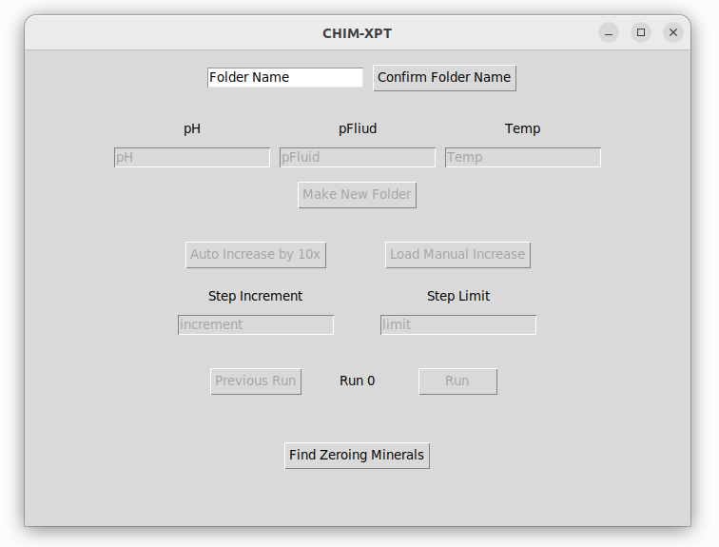

This is the GUI interface for running CHIM-XPT with whatever conditions that you want. This would require a CHIMRUN.DAT file provided by the user to be placed in the directory with the rest of the CHIM-XPT files and the .py files.

Folder Creation and Start
Folder Name Text Box: Enter the name of the folder that you want to create, all other folders created will be based on this too. The rest of the GUI will be locked until this is set.
Confirm Folder Name: This locks in the file name. By using os.mkdir and shutil.copy functionalities, a folder is created with the name provided in the entry

New Conditions and RUN Files
pH Entry: In order to create a new RUN file that will be run along with the original, then use this field to change pH.
pFluid: Use this to change the pFluid in the new RUN file.
Temp: Use this to change the Temp in the new RUN file.
Make New Folder: Use to to create a new RUN file using the values from entries from above as the modification values. By reading in the original RUN files and using shutil.copy, the original file is read into an array where the values are then modified. Because CHIM-XPT was written in FORTRAN, it uses whitespace as a separator. By using inbuilt string functionality of .split and .strip, a copy of the files is made with the edited values. A new folder is created and once the new RUN file is ran using CHIM-XPT, files are copied directly into that folder

Running and Increasing Step Increments and Limits
Auto Increase by 10x: Increase the step increment and step limit of all RUN files by 10x. Uses the same logic as creating a new RUN files above
Step Increment: Shows current step increment for all RUN files, can be used to create a new Step Increment.
Step Limit: Shows current step limit for all RUN files, can be used to create new Step Limit.
Load Manual Increase: Loads the Step Increment and the Step Limit from the entries into all RUN files.
Run: Runs all RUN files and saves OUT, PLOT, RUN-pre, RUN-post, and terminal output into the proper folder.
Previous Run: Changes all current RUN files to the way they were right before last Run. Locks Auto increase by 10 and Previous Run buttons until the program is Run again. Goes into all folders and copies the previous RUN file into the ones in the main directory.

Graphing CHIM-XPT
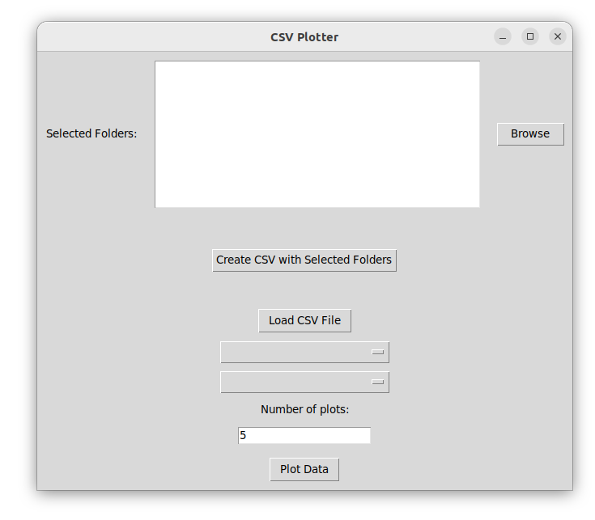

Browsing for Folders:
The user clicks a "Browse" button which opens a dialog to select a directory. The selected folder path is displayed in a Listbox widget for easy viewing.

Adding Folders and Creating CSVs:
The user clicks "Create CSV with Selected Folders", which collects all the folder paths from the Listbox. These folder paths are stored in a global list selected_folders. This list is then passed to a function main_call which processes the files in these folders to generate CSV files.

Loading a CSV File:
The user clicks "Load CSV File" which opens a file dialog to select a CSV file. The selected CSV file is read into a Pandas DataFrame df.The column names from the CSV file are extracted and used to update dropdown menus for selecting columns to plot.

Selecting Columns and Plotting:
The user selects which columns from the CSV to use for the x and y axes of a plot.The user can also specify the number of unique plots (based on a specific column like 'Name') they want to generate. When the "Plot Data" button is clicked, the selected columns are used to generate a plot using Matplotlib.

File Pairing Logic:
For each selected folder, the script looks for pairs of files: one ending in CHIMOUT.DAT and the other in CHIMTERMINAL.DAT. These pairs are matched based on a number pattern in the filename, ensuring that the corresponding files are processed together.

Reading Files: For each pair of files, the CHIMTERMINAL.DAT file is read to extract the pH value. The CHIMOUT.DAT file is read to extract temperature, pressure, fluid composition, and weight percentages or aqueous moles of minerals.

Data Storage:

The extracted data is stored in custom class instances (item_weight and item_mole), each representing a mineral with its associated properties. These instances are collected in global lists for further processing. During the extraction process, if the water/rock ratio (logwr) is found, it is updated for each mineral instance. Minerals with significant weight percentages (greater than 1%) are added to a final list for CSV output. The collected data for minerals is written to two CSV files: one for weight percentages and one for aqueous moles. The data in these CSV files is sorted by mineral name before being saved to ensure easy readability and further analysis.

Sources
- Carr, M. H. (2006). The Surface of Mars. Cambridge University Press.
- Jakosky, B. M., & Phillips, R. J. (2001). Mars’ volatile and climate history. Nature, 412(6843), 237-244.
- Boynton, W. V., et al. (2002). Distribution of hydrogen in the near surface of Mars: Evidence for subsurface ice deposits. Science, 297(5578), 81-85.
- Smith, P. H., et al. (2009). H2O at the Phoenix landing site. Science, 325(5936), 58-61.
- Ehlmann, B. L., et al. (2008). Orbital identification of carbonate-bearing rocks on Mars. Science, 322(5909), 1828-1832.
- Grotzinger, J. P., et al. (2014). A habitable fluvio-lacustrine environment at Yellowknife Bay, Gale Crater, Mars. Science, 343(6169), 1242777.
- Bibring, J. P., et al. (2006). Global mineralogical and aqueous Mars history derived from OMEGA/Mars Express data. Science, 312(5772), 400-404.

