北京梓熙生物科技有限公司
Special focus on oligo
CERTIFICATE OF ANALYSIS


Primer Name ：TAM-F1-BJ
Sequence(5’to 3’) ：CCCTGGGCTCTGTAAAGAATAGTG
Lot No. : | X03313120 |  | Length : | 24
Purification : | HPLC |  | Modification(5’to3’) : | 5‘TAMRA
ODs : | 5 |  | OD/tube : | 5
nmoles: | 25 |  | TM(℃) : | 62.0
GC(%) : | 50.0 |  | Purity（HPLC）: | 98.06%
MW (target): | 7985.4 |  | MW(observed): | 7984.4
Add water to[100pmole/ul ]: |  | 50

ESI - MS
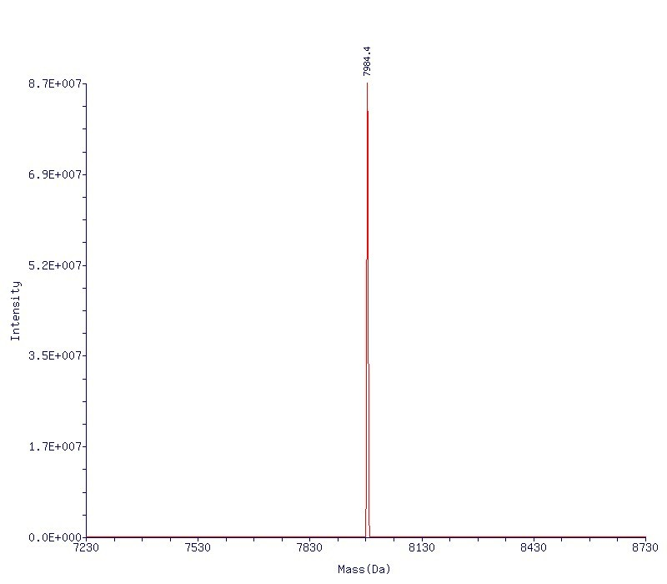

Beijing ZiXi Biotechnology 1st Xisha idustrial park,Beiqijia Town, Changping district, Beijing, China
www.zixibio.com Phone: +86 10 61734155 E-mail: oligo@zixibio.com

PLC TRACE
