北京梓熙生物科技有限公司
Special focus on oligo
CERTIFICATE OF ANALYSIS


Primer Name ：HFF05
Sequence(5’to 3’) ：TAAGTGCATTTTATCCCATTTACTCTG
Lot No. : | x05212150 |  | Length : | 27
Purification : | HPLC |  | Modification(5’to3’) : | FAM
ODs : | 47.2 |  | OD/tube : | 47.2
nmoles: |  |  | TM(℃) : | 57.4
GC(%) : | 33.3 |  | Purity（HPLC）:
MW (target): | 8728.0 |  | MW(observed):
Add water to[100pmole/ul ]: |  | 1800

ESI - MS
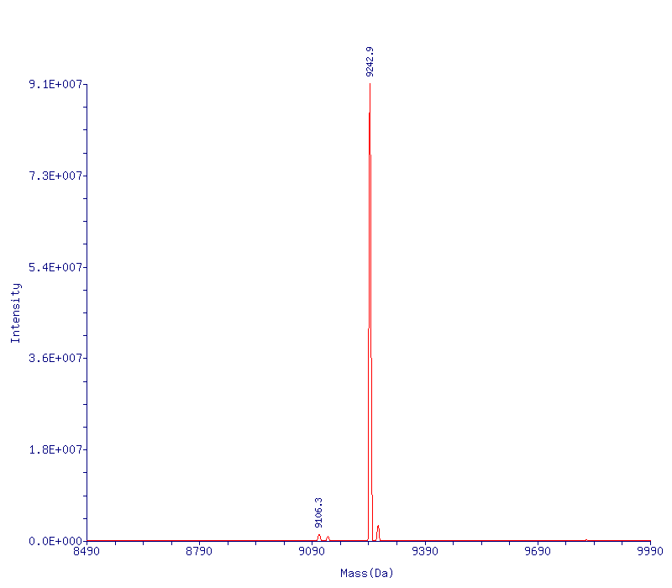

HPLC
