Winter
2026
<GROUP NAME> | Group #1
<united transit>

Software Requirements Specification

Scott Denby
Xena Illarionov
Dillon Kwak
Avery Lyu
Alex Protuc
Eric Wong
https://github.com/Awestruck3/PRJ566NBB_2261_Group1

Executive Summary

Background

Description

Company Value Add

End-User Value Add

Scope

What is Included

What is Not Included

Justification

Table of Contents
Background 1
Description 1
Company Value Add 1
End-User Value Add 1
Scope 1
What is Included 1
What is Not Included 1
Justification 1
1.1 Document Authors: 4
1.2 Document Revision History 4
1.3 Document Purpose 5
1.4 Audience 5
1.5 Group Agreement 5
Team name: Group 1 5
Project Title: United Transit 5
Project Time Frame 5
Team Members 5
Team Leadership 5
Team Functions/Roles 5
Team Meetings 6
Team Problems 6
Team Commitment 6
2.1 Project Proposal 6
2.1.1 Project Background (research) 6
2.1.2 Problem Statement (1pg) 8
2.1.3 Product Vision (1pg) 9
2.2 Stakeholders and Users 9
2.3 Project Scope 10
2.4 System Risks 11
2.5 Operating Environment 13
2.6 Functional Requirements 14
2.6.1 User Story Interviews 14
2.6.2 Core Functionalities 17
2.7 Nonfunctional Requirements 18
2.8 UI/UX Interface Mock-ups 19
3.1 Data Flow Diagrams 23
3.2 User Stories and related Use Case Scenarios 24
3.3 Activity Diagrams 26
3.4 Business Rules 31
6.1 Work Breakdown Structure 41
6.2 Milestones & Acceptance Criteria 42

Section 1

1.1 Document Authors:
Scott Denby - 118823244
Dillon Kwak - 135389203
Avery Lyu - 183244235
Alex Protuc - 185936234
Eric Wong - 037250081
Xena Illarionov - 170037212

1.2 Document Revision History

WEEK | DATE | Revisions
1 | Jan 19, 2026 | - Updated title page, completed: section 1, 2.1
2 | Jan 31, 2026 | - Completed sections 2.2-2.5
3 | Feb 7, 2026 | - Completed sections 2.6-2.7
4 | Feb 15, 2026 | - Completed sections 3.1-3.4
5 | Mar 1,2026 | - Completed sections 2.8
6 | Mar 15, 2026 | - Completed sections 4 and 5
7 | Mar 22, 2026 | - Completed section 6
8
9
11
12
13
14

1.3 Document Purpose
This document aims to be a master document for tracking the development of United Transit. This living document will be updated and expanded upon as new use cases, requirements, and business rules are created for the project.
This document’s progress will be tracked in the following sections (Section 2-8, 1.2) allowing readers to easily keep track of these updates as they are implemented.

1.4 Audience
Intended for users who rely on map-based apps with public transit. The primary audience includes daily commuters (such as students) who depend on buses, trains, subways, and other forms of public transit to reach multiple destinations which requires efficient transit planning.

1.5 Group Agreement

Team name: Group 1

Project Title: United Transit

Project Time Frame
Jan 19, 2026 - Aug 14, 2026

Team Members
- Scott Denby
- Xena Illarionov
- Dillon Kwak
- Avery Lyu
- Alex Protuc
- Eric Wong

Team Leadership
Scott Denby

Team Functions/Roles
- Scott Denby: Project Manager
- Xena Illarionov: UI/UX Designer
- Dillon Kwak: QA
- Avery Lyu: System Developer
- Alex Protuc: System Developer
- Eric Wong: Data Analyst

Team Meetings
- Every Monday 13:30 - 15:15 in person
- Every Thursday 11:40 - 13:25 online

Team Problems
In the event a problem does occur, it will be listed here along with all respective proposed/functional solutions.

Team Commitment

The undersigned members agree to work together on the project until the end of the PRJ666 next Semester. They recognize that as a team and individually they are equally responsible for the quality of all deliverables.

Name | Date | Signature
Scott Denby | 1/19/2026 | Scott Denby
Xena Illarionov | 1/19/2026 | Xena Illarionov
Dillon Kwak | 1/19/2026 | Dillon Kwak
Avery Lyu | 1/19/2026 | Avery Lyu
Alex Protuc | 1/19/2026 | Alex Protuc
Eric Wong | 1/19/2026 | Eric Wong

Section 2

2.1 Project Proposal

2.1.1 Project Background (research)

Features | Google Maps | Apple Maps | Transit App | United Transit (Ours)
Point A to B Transit Routing | ✔ | ✔ | ✔ | ✔
Real-time Vehicle Locations | ✔ | ✔ | ✔ | ✔
Multi-Stop Transit Planning | ✘ | ✘ | ✘ | ✔
Proactive Delay Alerts | ✘ | ✘ | ✔ | ✔
Trip Bookmarking/Saving | ✔ | ✔ | ✘ | ✔
Historical Reliability Data | ✘ | ✘ | ✘ | ✔
Multi-destination ETA | ✘ | ✘ | ✘ | ✔

Statistics
She would like to know the background story (reasoning) behind our selection
But for transit the answer to "What's the best route from A to B" depends on the moment you ask it (or the moment you say you want to depart/arrive if you use those options). The transit routes occurring at that time are analyzed and the best option is provided. You might be told to take two busses to get from A to B, but if you wait 10 minutes and it's now too late to get that first bus then the same search might tell you to take a train instead.
This is the reason that transit doesn't have a multi-stop option; because the answer to "What's the best route from B to C" varies depending on how long you spend at B, rather than being the constant answer available should you be driving. (https://www.reddit.com/r/GoogleMaps/comments/jcf94v/google_maps_doesnt_support_planning_a/)
Existing solutions:
- Google Maps: Google Maps is the most widely used navigation engine globally. While it excels in visualizing routes and provides real-time data for public transit, its transit feature is strictly limited to single-destination queries. Users can add stops while driving or walking, but the "Add Stop" button disappears once the transit mode is selected. Furthermore, its arrival estimates often suffer from latency issues because distributed servers do not always update instantly when transit commissions (like the TTC) push service alerts.
https://www.google.com/maps
- Apple Maps: As the native navigation app for the iOS ecosystem, Apple Maps provides a seamless user interface and deep integration with mobile hardware. However, it mirrors the limitations of Google Maps regarding transit. It lacks the logic to calculate how a 15-minute delay at an intermediate stop will impact the connecting legs of a journey, forcing users to manually restart their search for every segment of a trip.
https://maps.apple.com/
- Transit App: Transit App is a specialized platform that utilizes crowdsourced data to provide high-accuracy vehicle tracking. While it is superior to general-purpose maps in providing real-time "Go" directions and multimodal options, it is still built around a single-destination architecture. It does not allow a student, for example, to plan a route from Seneca to a grocery store and then to their home as one continuous, tracked itinerary.
https://transitapp.com/
- United Transit: United Transit leverages a custom routing API designed to handle complex, user-defined constraints. Unlike existing solutions, our platform treats a "trip" as a sequence of multiple events. By integrating real-time GTFS data with predictive arrival intervals, we provide a total-journey ETA that accounts for the time spent at each stop. Our solution seeks to eliminate the "uncertainty gap" that transit users face when trying to run errands during their daily commute

2.1.2 Problem Statement (1pg)
The problem addressed by this project is the lack of multi-stop trip planning and unreliable real-time accuracy for public transit users in existing mapping applications. This issue affects commuters, students, and urban residents who rely on public transit and mapping tools to plan efficient daily travel, especially those without access to private vehicles. From their perspective, the inability to add intermediate stops forces users to manually replan routes after each destination, increasing travel time, uncertainty, and the risk of missed connections due to delays or inaccurate arrival predictions. The impact of this problem is reduced efficiency, increased stress, and decreased trust in public transit systems, which can discourage transit use altogether. A successful solution would provide an optimized public transit routing system that supports multiple stops in a single journey, incorporates accurate real-time service updates, offers alternative routes during disruptions, and ultimately improves reliability, convenience, and user confidence in public transit travel.

This issue mainly affects daily commuters who solely rely on public transportation to travel throughout the day.

2.1.3 Product Vision (1pg)
Those of us who want to streamline their trip, any visitors or day to day commuters. The United Transit that allows users to optimize the travel time unlike Google Map, Apple Map, Our product will provide optimal solution for multi trip planning when using public transit.

2.2 Stakeholders and Users
Internal:
Stakeholder | Description | Influence | Interest
Project manager | Manages the project and team to ensure the project quality and ensure deadlines are met | High | High
UI/UX Designer | Design the UI/UX for the software or other platforms developed in the future. | Med | High
System Developer | Developer of the project software based on requirements | High | High
Data Analyst | Analyzes the data to uphold proper database structure and quality | Med | Med
QA | Tests the software quality before launching/updating | High | Med

External:
Stakeholder | Description | Influence | Interest
End-User | Commuters who use this service | High | High
Google Maps Development Team | Integration team for this project | High | Med
Google Maps Marketing Team | Team responsible for getting service to end users | High | Low

2.3 Project Scope

In scope features:
- Multi stop trip planning using transit: Allows users to plan a trip with multiple stops estimated durations at each stop.
- Trips with Multiple forms of transit: Includes buses, walking and alternatives for bikers that also use transit.
- Accurate real time transit updates: Using a combination of real time data from the buses using the Next Vehicle Arrival System (NVAS) and location data from users
- Alternate routes: When there are system interruptions or multiple routes available
- Route optimization: Find fastest way to get to the destination when the user has single or multiple stops
- Redirection optimization: When having to redirect during the travel, it will consider the changed time of travel, location and time of travel (rush hour, holidays etc) to reflect the most optimal way to redirect via public transit.
- Recent visits: Able to set recently visited places and retrieve in convenience
- Landmarks: Will identify “Landmark” or any other commonly visited / identified places (this will be based on more established maps such as google or apple maps)
- Compass: Identify which direction the user is located (it will show users current location and identify the “North or N” and will reformat the map so the upper part of the phone will be directed to the “N” when this feature is enabled)
Out of scope features:
- Directions for private vehicles: Other existing solutions already
- Long distance travel: Long distance trains, flights and buses that travel between cities and countries.
- Offline navigation: A connection is required for the real time data and other solutions already provide options to download maps.
- Taxi/ride share services: Integration with taxis or ride share services such as uber or lyft.
- User Profiles: User authentication or profile management
- Guide features: Recommended restaurants or destination for the region
- Advertisements: Any advertisements of products will not be featured
- 3D map viewing: 3D display, or real image of the actual location will not be displayed
- Share my location: Share my location to other users
- Library / Bookmarks: Ways to save certain locations under a criteria (e.g. Save restaurant under “food”)
- Search with camera: Access camera for the app to detect which location you are in
- Voice search: Access microphone to enter the location
- Set destination as “your” locations: setting certain addresses to be your: home, work, school, or any other frequently visited place.
- Rating: Rate a destination (place, restaurant, museum, historical site etc.)
- Review: Write a review of the destination.

2.4 System Risks
- Market
  - Limited user adoption if accuracy is not significantly better than Google Maps
- Financial
  - Cost of maintaining access to real-time data sources in the future
- Technology
  - Real-time transit data is inaccurate or delayed
  - API integration failure with third-party data sources
  - Algorithm complexity for multi-stop transit routing
  - Scalability issues when expanding beyond Seneca area
- People
  - Limited experience with transit data standards (GTFS, real-time feeds)
  - Uneven workload distribution among developers
- Structure / Process
  - Poor system architecture design affecting maintainability (not modular enough)
  - Incomplete or unclear system requirements early in development

Risk ID | Category | Risk Description | Probability | Impact
T1 | Technology | Real-time transit data may be inaccurate or delayed due to unreliable updates from external data providers (e.g., TTC, GTFS). | High | High
T2 | Technology | Failure or instability in integrating third-party APIs may disrupt routing and trip planning features. | Medium | High
T3 | Technology | Increased algorithm complexity for multi-stop transit routing may cause performance or optimization issues. | Medium | High
T4 | Technology | Scalability limitations when expanding beyond the Seneca area to larger transit networks. | Low | Medium
P1 | Structure / Process | Poor initial system architecture design may reduce maintainability and future extensibility. | Medium | Medium
P2 | Structure / Process | Unclear or evolving system requirements may lead to rework and delays. | Medium | Medium
R1 | People | Limited team experience with real-time transit data standards (e.g., GTFS) may slow development. | Medium | Medium
R2 | People | Uneven workload distribution among developers may impact schedule and quality. | Medium | Medium
M1 | Market | Users may not adopt the system if routing accuracy does not significantly outperform existing mapping applications. | Medium | Medium
F1 | Financial | Future costs related to accessing or maintaining real-time transit data sources. | Low | Low–Medium

 | High |  |  | T1
 | Medium |  | P1 P2 R1 R2 M1 | T2 T3
 | Low | F1 | T4
 |  | Low | Medium | High
Probability

Impact

2.5 Operating Environment
Hardware/Devices Supported
The system will support a wide range of devices, including:
- Desktop and laptop computers (Windows, macOS, Linux-based systems)
- Smartphones and tablets (Android, iOS systems)
End users will interact with the system through a demonstration app accessed via the web or downloaded from a device’s app store.

Operating System
While United Transit may be accessed through the web or mobile application, the system itself is still web-based and is built on an API. As such, compatibility mostly depends on the operating system’s ability to run modern web browsers, including:
- Windows 10 or later
- macOS 11 or later
- Linux distributions with modern browser support
- Android OS 10 or later
- iOS 15 or later
Ideally, support for older devices should align closely to the minimum standards of established transit apps as well.

Software Dependencies
- A backend server running a RESTful routing API (such as Node.js with Express)
- Database for storing transit data and route logs (such as PostgreSQL or MongoDB)
- Integration with external transit data sources and real-time transit APIs (such as TTC data feeds)
- Modern web browser for system access (such as Chrome, Firefox, or Edge) or compatible mobile device with an app store
- Frontend frameworks for improved mobile app usability (such as React)

Internet Connection
Since the system relies on real-time transit data, an active internet connection is required at all times to ensure accurate routing and up-to-date estimates. Offline functionality is not supported as static data is insufficient for reliable multi-stop transit planning.

2.6 Functional Requirements

2.6.1 User Story Interviews

User Interview
- Name: Tom Smith
- Age: 20
- Occupation: Student
- Status: Studying at college while working part time
- Financial Situation: Majority of income used to pay for living expenses with a small amount of savings
- Transit Situation: Relies on transit for the majority of their travel

How often do you use public transit, and for what kind of trips?
"I use public transit almost every day, mostly between Monday and Friday. On weekdays, I usually travel from home to school, then to my part-time job, and sometimes to a couple of stores before heading home. On weekends, I mostly use public transit for visiting friends or to complete other miscellaneous tasks which require travel."

How do you currently plan trips that involve multiple stops on existing apps?
"I can't exactly plan everything at once with what I currently have. I search how to get from home to school first, then once I arrive or have to go elsewhere, I search again for the next place. If I'm running late or a bus ends up being delayed, I have to redo everything and wait for the next available option. It's especially annoying when I'm short on time."

What other problems do you experience with current transit apps?
"The most recurring issue is delays not updating quick enough. Sometimes the app says the bus is arriving soon, then it ends up arriving 10 minutes later and I’m left waiting in the freezing cold. I also can't see how a delay affects my travel for the rest of my day unless I manually replan each trip."

How important do you find real-time vehicle locations and accurate arrival times?
"I believe it's very important, as it would make me feel more confident whether I should wait, walk, or look for another route if I could see where the bus actually is. Arrival times without live tracking just aren't that reliable anymore. I also believe that alerting users of possible delays during a trip is also highly needed."

Would you use a feature that allows you to plan a full trip with multiple stops?
"Yes, I really would, as that's exactly what I need. If I could plan my whole day at once and see the total travel time, it would make scheduling work shifts much easier, as I wouldn't feel like I'm guessing all the time. I would also like to bookmark routes that I often take to avoid having to retype everything over and over, as it would save a lot of time."

When offered multiple routes how do you decide which one to pick?
“I usually try to pick the route that has the shortest travel time but other factors include the amount of transfers and the time spent waiting between buses. I would rather take 2 buses for a 1 hour trip then 3 buses for a 45 minute trip”

How would you like to be notified about potential delays or changes?
“I would prefer push notifications so that I can quickly read it and can adjust my schedule if needed. But I only want to be notified if the change will actually affect my trip. If the bus I'm on will be 5 minutes late to my 2nd bus stop but I need to wait at the 2nd stop for 15 minutes anyway there's no need to notify me since I need to wait anyway.”

Business owner interview
- Name: Harvey Douglas
- Age: 45
- Occupation: Business Owner
- Status: Owner of a mid-sized retail and service business
- Financial Situation: Financially stable with steady business revenue
- Transit Situation: Previously relied on a personal vehicle. However, recently began using public transit to better understand customer accessibility and challenges in newly expanded business locations

How often do you use public transit, and for what kind of trips?
“I am not used to the public transit system. I grew up from the suburbs and got my drivers license when I was 16. From then on, I've never really thought of not owning a car. However, now that I'm expanding my business locations, I've been intentionally using it several times a week. I mainly take it to travel between my home, my main office, and newer business locations just to understand our new customer base. Because our new expansion will be near schools, we expect a lot of our customer base and I find the importance in knowing that as a business owner.”

How do you currently plan trips that involve multiple stops on existing apps?
“I find that it’ll be extremely inconvenient for our customers. I’ve downloaded several transit apps that are clearly popular amongst people in their 20’s thanks to my daughter. However, most transit apps are clearly designed for single trips. If I need to visit multiple locations in one day, I must plan each segment separately. I can only imagine this adds to the difficulty to my customers as the delays or route changes will affect my potential customer’s schedule, especially when they have to run on tight timelines.”

What other problems do you experience with current transit apps?
“The biggest issue is the lack of clarity around reliability. Delays are often communicated too late, and there’s very little context on how those delays affect the rest of my trip. From a business standpoint, uncertainty is frustrating because it directly impacts punctuality and productivity.”

How important do you find real-time vehicle locations and accurate arrival times?
“They are extremely important. As a business owner, thinking from a busy customer’s schedule where their day is tightly planned, even small delays can have a ripple effect throughout their day. Being able to see real-time vehicle locations would help me make informed decisions, such as whether to stay on a route or switch to an alternative. I can only imagine how helpful this would be to my customer base.”

Would you use a feature that allows you to plan a full trip with multiple stops?
“Yes, I think my customers will really enjoy the multiple stops feature. A feature like that would be very useful, especially when my customers have multiple locations to stop. This feature will help them to time their day perfectly and add a stop to my business location. Being able to see total travel time upfront would help them plan their day more efficiently and reduce uncertainty when scheduling appointments.”

When offered multiple routes how do you decide which one to pick?
“I prioritize reliability and predictability over the absolute shortest travel time. I prefer routes with fewer transfers and longer buffer times, as they reduce the risk of missing connections. A slightly longer but more dependable route is often the better option for me. This is because I have a really busy schedule. Now I cannot speak for every customer base, but I think my customers may feel similar to me as they are likely to have a very busy schedule.”

How would you like to be notified about potential delays or changes?
“From the experience I had, I would prefer push notifications, but only when the delay meaningfully impacts my trip. The notifications should be actionable. If a delay doesn’t affect my arrival time or next connection, it’s unnecessary. However, if it risks making me late to a meeting, I’d want to know immediately so I can adjust.”

2.6.2 Core Functionalities
- The system must add multiple stops on a commute using public transit.
- The system must provide digital representation of vehicle live location across the whole trip (within a reasonable timeframe).
- The system must be able to bookmark trips (it will save all the destinations that are added to the trip).
- Alert any delay that occurs prior to the user's bookmarked trip, users will be alerted prior to the traveltime.
- The system must be able to provide API data from anyone who calls.
- The system must provide estimated arrival time (including individual stops).
- The system must provide the nearest two previous vehicles before the search time.

2.7 Nonfunctional Requirements
Performance
- The system must be able to handle at least 100 concurrent users at the same time
- The system should maintain 99% uptime during operating hours
Usability
- Real-time vehicle data and service alerts must be refreshed from the source (e.g., GTFS-Realtime) every 30 seconds.
- The system must be able to handle map scalability
- The system architecture must be modular to allow for the future integration of new regions and transit operators beyond the initial Seneca area.
Security
- User location information will remain confidential
- The system must not share personally identifiable information (PII) or user movement patterns with third-party transit commissions or advertisers.
Portability
- The system must run on mobile devices
- The system should be able to be easily ported to browsers
Accessibility
- Must comply to AODA standards
- Must meet WCAG2.0 Level AA standards
- The UI must be optimized for mobile devices, as the primary use case is commuters in transit.
- The map interface must allow for smooth scaling and panning across the Greater Toronto Area (GTA).
Maintainability
- The system must be built using a modular microservices approach to allow individual transit feeds (e.g., TTC, York Region Transit) to be updated or added without system downtime.

2.8 UI/UX Interface Mock-ups
https://www.figma.com/design/7p2fYC2Tw2YP1IpqhfHFRY/Untitled?node-id=0-1&t=zuxSLEFf93Ys2xr9-1
UI1: Mock-up of the trip planning UI
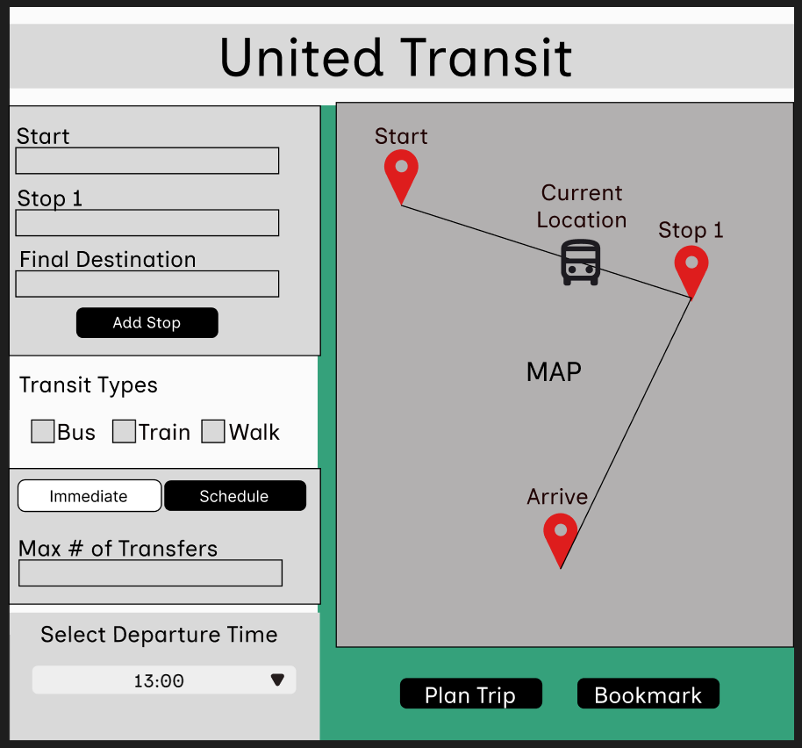

UI2: Service disruptions
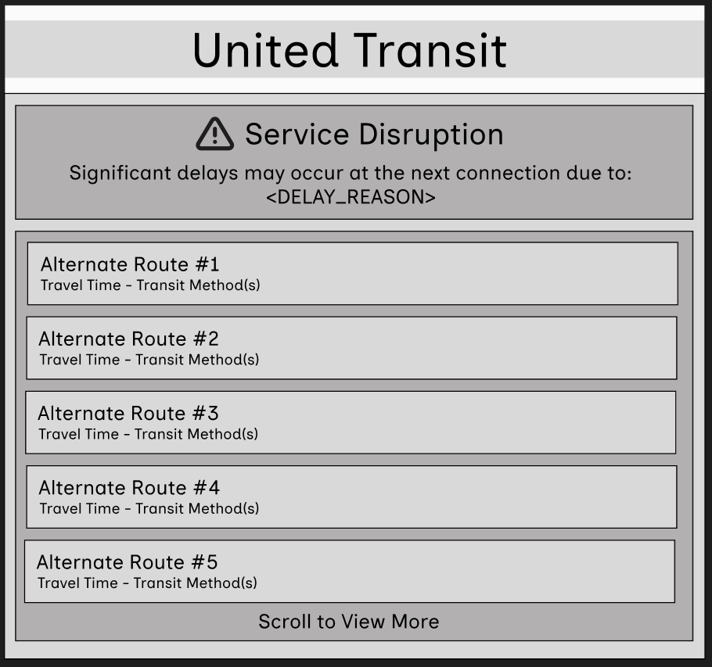

UI3: Bookmarked trips
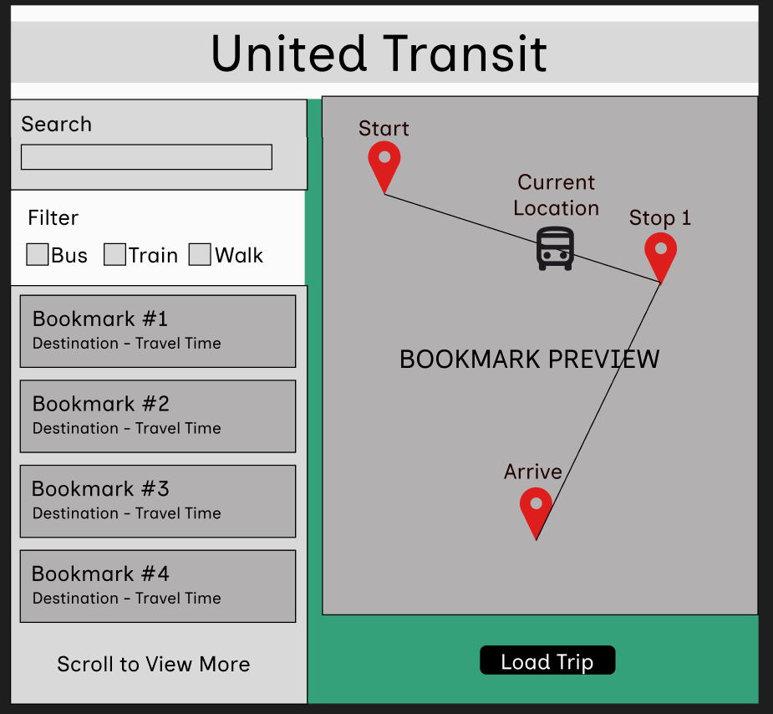

UI4: List of available routes
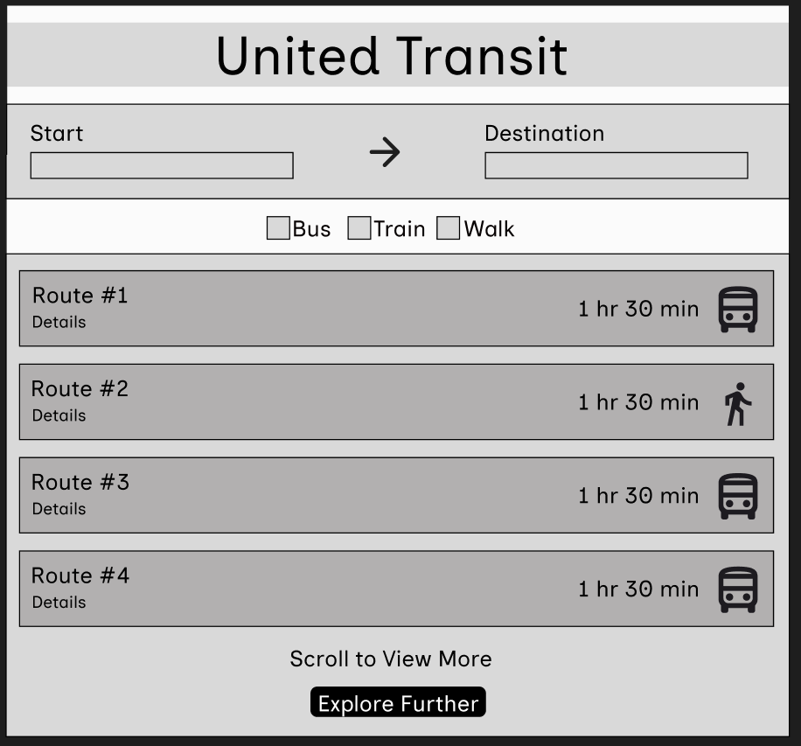

Section 3

3.1 Data Flow Diagrams
DFD: 0
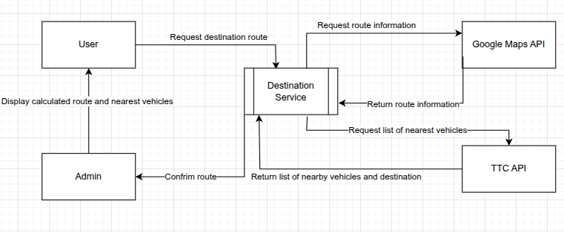
DFD: 1
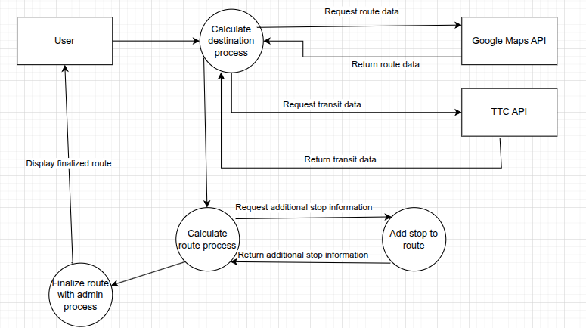

3.2 User Stories and related Use Case Scenarios
Use Case 1: Multi- Stop Planning Engine
User Story: As a public transit user, I want to plan a multi stop trip in a single search so that I can see the total travel time, possible routes/transfers, transit types and stop information.
Description:
- Allows the input of multiple destinations and the order of arrival.
- Calculates the optimal route plus alternatives
- User can add estimated time between stops
- User can choose preferred transit types
Actor: Commuter
Trigger: User enters a trip including starting location, multiple destinations, time at each destination and time.
Outcome: Engine provides possible routes for the trip and detailed information for each stop.
Priority: High

Use Case 2: Trip management System
User Story: As a regular commuter, I want to save my usual trips so that I don’t have to input the same destinations all the time.
Description:
- Saves trips that the user choses
- Stores locally (not tied to a user account)
- Uses alert management system to notify about disruptions for saved trips
Actor: Commuter
Trigger: User previously entered a trip and chose to save the route.
Outcome: Trip is saved by the system so that it can be retrieved later.
Priority: Medium

Use Case 3: Alert management System
User Story: As a transit user, I want to receive meaningful notifications about my current or saved trips so that I can adjust my schedule accordingly.
Description:
- Detects service interruptions or delays
- Decides if the delay will affect the current/saved trips
- Sends notifications only when impact is meaningful
- Provides alternate routes to avoid the impacted area
Actor: System
Trigger: There is a service delay for a current/saved trip.
Outcome: System checks if the delay will meaningfully impact the trip and if so sends a push notification to the user with the delay information and possible route alternatives.
Priority: High

Use Case 4: Real-Time Transit Monitoring System
User Story: As a transit user, I want to be able to see the real time locations of buses and updated schedules so that I can remain informed about my trip.
Description:
- Uses NVAS and user location data for real time bus positions
- Displays vehicles on the map
- Dynamically updates schedules and arrival times
Actor: System
Trigger: Real time data shows a change in the arrival of the current bus.
Outcome: Compares real time data with the transit schedule and updates current trip times shown to the user.
Priority: High

Use Case 5: External Routing API
User Story: As a third-party developer , I want to call the United Transit API to get structured transit data so that I can integrate multi-stop routing features into my own local community applications.
Description:
- Provides API endpoints for developers
- Returns information in JSON format
- Uses real time data if available
Actor: Developer
Trigger: External system calls the United Transit API.
Outcome: Returns structured routing and real time data
Privority: Low

3.3 Activity Diagrams
UC 1:
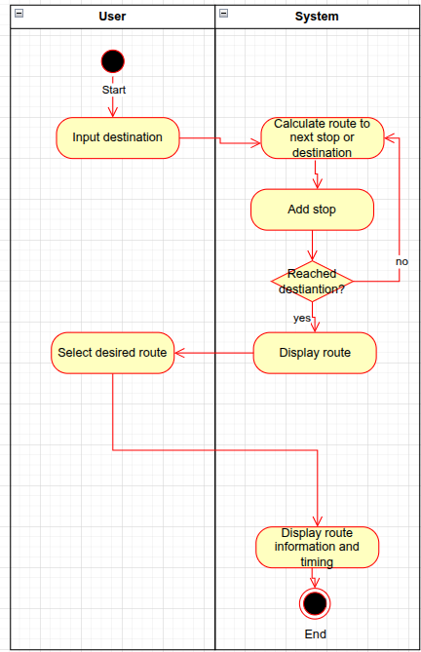

UC 2:
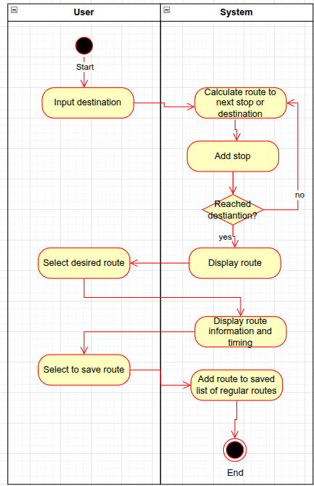

UC 3:
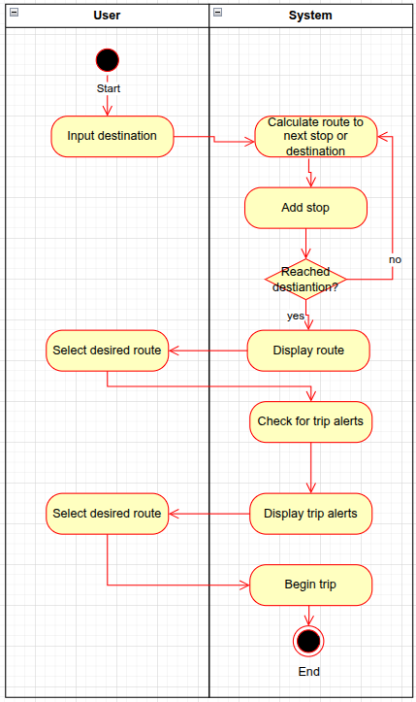

UC 4:
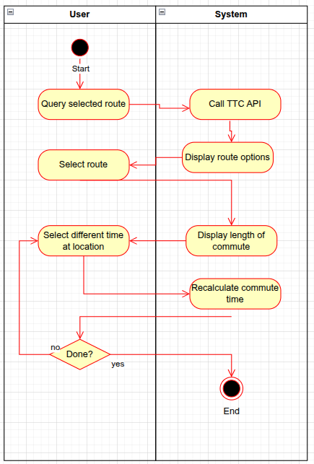

UC 5:
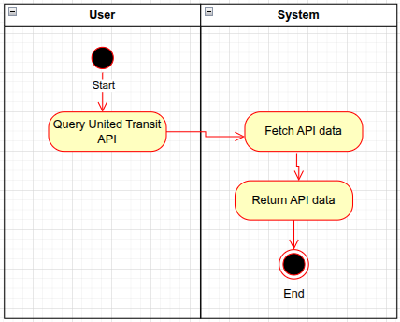

3.4 Business Rules

Fewer stop options (like if the travel to a destination requires 2+ stops, users can select how many stops they want for the trip) for public transit.
Type of transit selection (bus, train, tram, combined or limit the type etc)

Business Rule # | Description | Activity Diagram | Related UCS | UI  Mock-up
BR1 | System should allow users to filter routes by transit type(s) (bus, train, walking, etc.) |  | UC1 | UI1
BR2 | System should allow users to specify a maximum number of transit stops (transfers) for a trip |  | UC1 | UI1
BR3 | System should notify users when significant delays occur that affect connections or arrival time |  | UC3 | UI2
BR4 | System should display real-time vehicle locations when supported |  | UC4 | UI1, UI3
BR5 | System should recalculate routes using real-time transit data when available or fallback to scheduled data |  | UC4 | UI1, UI3
BR6 | System should prioritize routes with fewer transfers if total travel time is similar |  | UC1 | UI1
BR7 | System should allow users to save routes which are frequently used without requiring an account |  | UC2 | UI3
BR8 | System should alert users in advance if a saved trip is affected by service disruptions |  | UC2, UC3 | UI2
BR9 | System should present alternative routes when service disruptions occur during travel |  | UC1, UC4 | UI2
BR10 | System should calculate and display total travel time for an entire multi-stop trip |  | UC1 | UI4
BR11 | System should calculate and display arrival times for each individual stop in a multi-stop trip |  | UC1 | UI4
BR12 | System shows users the previous and upcoming stops for a route or the buses for a stop |  | UC1 | UI4
BR13 | The demonstration app will display data provided by the United transit API |  | UC5 | UI1,UI2,UI3
BR14 | Customers must be within 1km vicinity of the stop to make alterations of the stop |  | UC2,4 | UI1
BR15 | Alternative routes when service disruptions occur during travel must be fastest route |  | UC2 | UI2
BR16 | System should have the option to alter routes when user doesn’t want to proceed with the presented route |  | UC1 | Ui4
BR17 | Reported disruption must be unavailable until it is confirmed to be stable |  | UC4 | UI2
BR18 | User should save the trip |  | UC2 | Ui3
BR19 | User should get notified of any changes that may occur on their saved trip x minutes prior to the destination arrival |  | UC3 | UI2
BR20 | Report from user should be considered yet not overridden |  | UC4 | UI4
BR21 | Any updates to the transit system must override the trip |  | UC3, UC4 | UI2
BR22 | App must streamline when there has been an update to the transit system |  | UC5 | Ui2
BR23 | If the app is affected by disrupted API, it must warn / alert user for any inaccuracies |  | UC5 | UI2
BR24 | App should be able to cater both Android and IOS devices |  | UC4, UC5 | UI1,UI2,Ui3<UI4

Section 4 – Domain Class

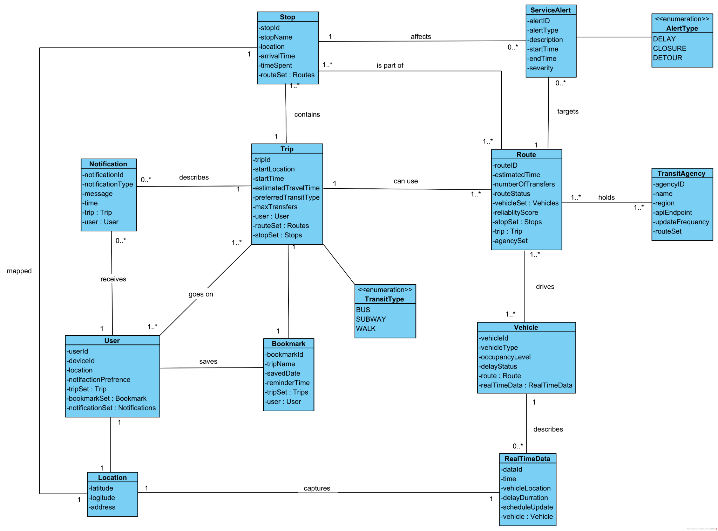

Section 5 – Database

5.1 ERD Diagram

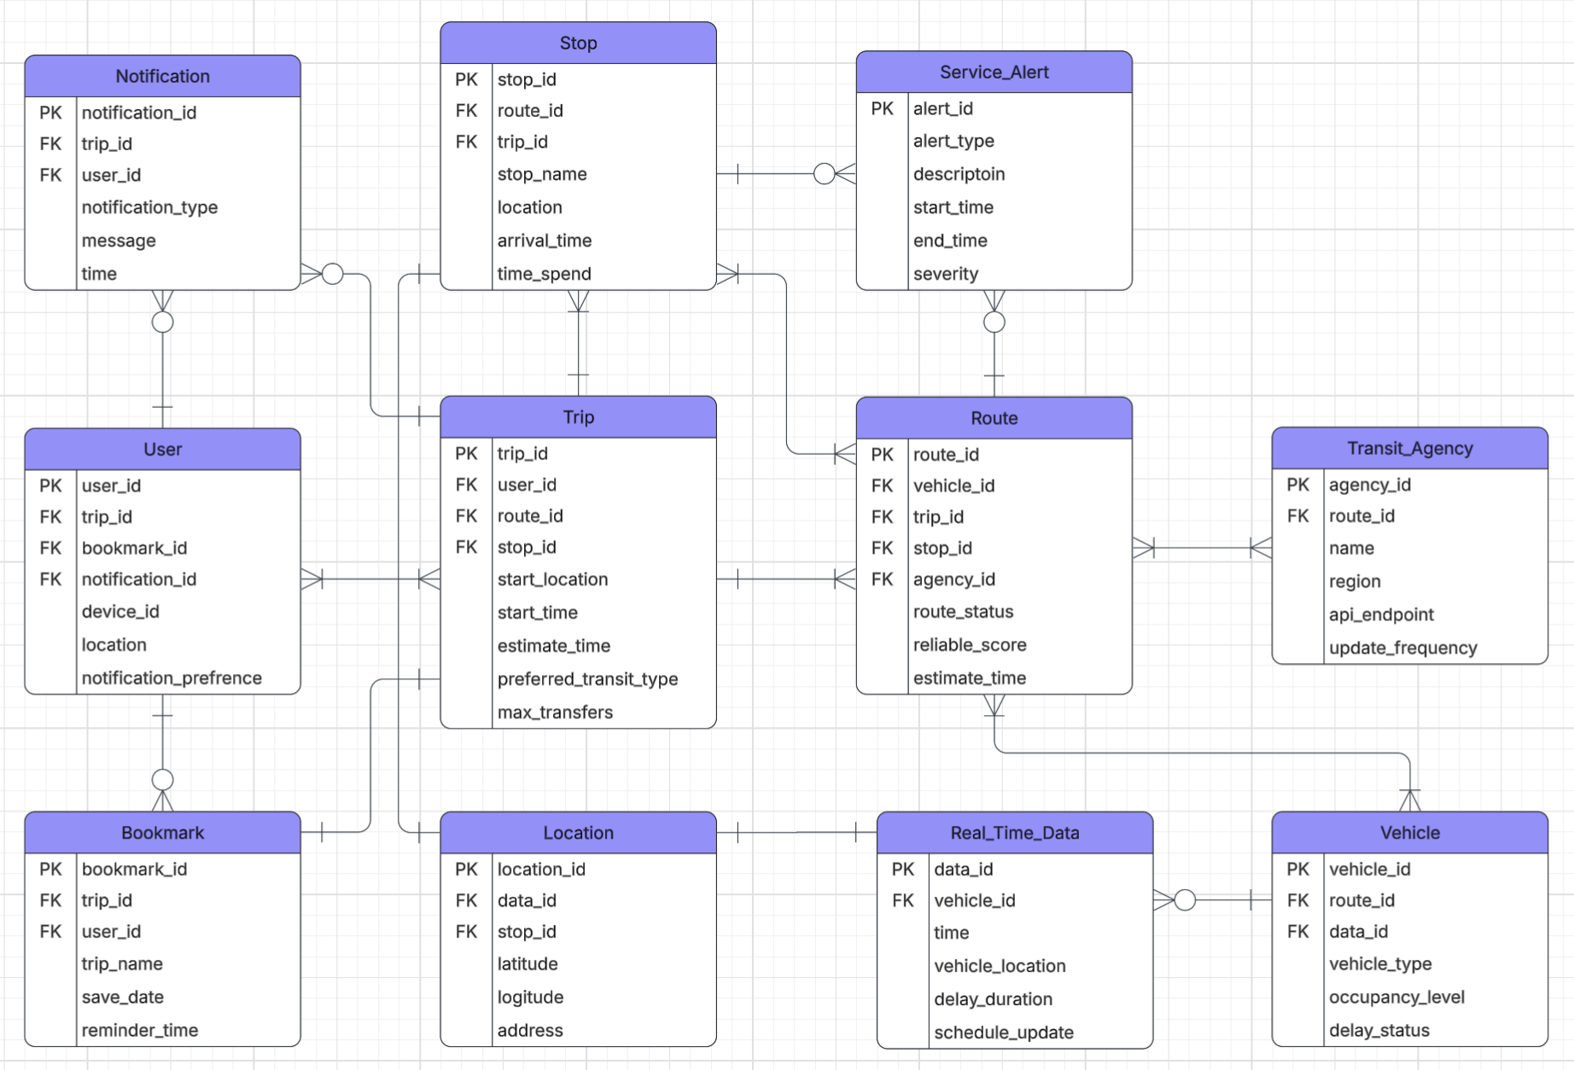

5.2 Data Dictionary

Data Dictionary: User
Data Item | Data Type | Data Format | Num Bytes for Storage | Size for Display | Desc | Example
userID | INT |  | 4 | 4 | Identification number to track user. | 0001
deviceID | INT |  | 4 | 4 | Identification number to track device. | 0001
location | STRING |  | 24 | 24 | String representing user’s current location | King Street E.
notificationPreference | STRING |  | 24 | 24 | String representing user’s choice of notifications. | ALL
tripSet | ARRAY (INT) |  | 16 | 32 | Saved trips | [25, 26, 27]
numOfBookmarks | ARRAY (INT) |  | 16 | 32 | Saved bookmarks | [24, 25, 26]
numOfNotifications | ARRAY (INT) |  | 16 | 32 | Saved notifications | [22. 23, 24]

Data Dictionary:Notification
Data Item | Data Type | Data Format | Num Bytes for Storage | Size for Display | Desc | Example
notificationID | INT |  | 4 | 4 | Identification number for notification | 0002
notificationType | STRING |  | 24 | 24 | Type of notification | PUSH
message | STRING |  | 24 | 24 | Message attached to notification | Vehicle arriving now
time | DATE | DD/MM/YYYY | 7 | 10 | Displays date of trip | 01/01/2000
tripID | INT |  | 4 | 4 | Trip ID associated with notification | 0001
userID | INT |  | 4 | 4 | User ID associated with notification | 0001
Data Dictionary: Trip
Data Item | Data Type | Data Format | Num Bytes for Storage | Size for Display | Desc | Example
tripID | INT |  | 4 | 4 | Unique identifier of current trip | 0231
startLocaton | STRING |  | 24 | 24 | Displays name of starting location | SENECA HILL DRIVE
startTime | DECIMAL | DD/MM/YYYY | 8 | 10 | Displays date of trip | 01/01/2000
estimatedTravelTime | DECIMAL | #.# | 8 | 10 | Displays length of trip | 0.5 hours
preferredTravelType | STRING |  | 24 | 12 | Displays user’s preferred method of travel | BUS
maxTransfers | INT |  | 4 | 4 | Holds the maximum amount of allowed transfers | 4
userID | INT |  | 4 | 4 | Contains user’s unique identifier | 0001
routeSet | ARRAY (INT) |  | 24 | 24 | Contains a list of trip routes | [24, 56, 21]
stopSet | ARRAY (INT) |  | 24 | 24 | Contains a list of stops | [1, 2, 5]

Data Dictionary: Stop
Data Item | Data Type | Data Format | Num Bytes for Storage | Size for Display | Desc | Example
stopID | INT |  | 4 | 4 | Unique identifier for stop | 0001
stopName | STRING |  | 24 | 24 | Name of stop | SENECA HILL DRIVE
coordinates | DECIMAL | #.#### #.#### | 16 | 16 | Contains coordinates of stop | 12.444 44.55556
arrivalTime | DECIMAL |  | 8 | 8 | Displays time until arriving at stop | 0.5
timeSpent | DECIMAL |  | 8 | 8 | Tracks time user spend at location | 1.5
routeSet | ARRAY (INT) |  | 4 | 24 | Contains a list of trip routes | [24, 56, 21]

Data Dictionary: Bookmark
Data Item | Data Type | Data Format | Num Bytes for Storage | Size for Display | Desc | Example
bookmarkID | INT |  | 4 | 4 | Unique identifier for bookmark | `1234
tripName | STRING |  | 24 | 31 | Name of bookmarked trip | TRIP ONE
savedDate | DATE | DD/MM/YYYY | 7 | 10 | Date trip was saved on | 01/01/2000
reminderTime | DECIMAL |  | 16 | 16 | Time at which app notifies user to take bookmarked trip | 0.5
tripSet | ARRAY (INT) |  | 16 | 16 | Saved trips | [25, 26, 27]
userID | INT |  | 4 | 16 | Unique identifier of user | 0001

Data Dictionary: Route
Data Item | Data Type | Data Format | Num Bytes for Storage | Size for Display | Desc | Example
routeID | INT |  | 4 | 4 | Unique identifier for route | 0004
estimatedTime | DECIMAL |  | 8 | 8 | Estimated length of trip | 0.5
numberOfTransfers | INT |  | 4 | 4 | Required number of transfers to complete route | 4
routeStatus | STRING |  | 24 | 24 | Status of route to report any delays or closures | LINE 1 - CLOSED
vehicleSet | ARRAY(STRING) |  | 72 | 24 | Vehicles required to complete trip | [BUS, TRAIN, WALK]
reliabilityScore | DECIMAL |  | 8 | 8 | Rates how reliable a trip is | 4.9
stopSet | ARRAY(INT) |  | 16 | 16 | Stop IDs listed to complete trip | [24, 25, 28]
tripID | INT |  | 4 | 4 | Unique identifier for the current trip | 0002

Data Dictionary: Vehicle
Data Item | Data Type | Data Format | Num Bytes for Storage | Size for Display | Desc | Example
vehicleID | INT |  | 4 | 4 | Unique identifier for the vehicle | 0001
vehicleType | STRING |  | 24 | 24 | Type of vehicle | BUS
currentLocation | DECIMAL | #.####  #.#### | 16 | 16 | Location of vehicle | 12.44  22.222
nextStop | INT |  | 4 | 4 | Id of upcoming stop | 005
occupancyLevel | INT |  | 4 | 4 | Number of occupants on upcoming vehicle | 26
delayStatus | STRING |  | 24 | 24 | Status of any delays | LINE 1- CLOSED
routeID | INT |  | 4 | 4 | Unique identifier for the route | 0001
dataID | INT |  | 4 | 4 | Unique identifier for the real time data | 0006
Data Dictionary: RealTimeData
Data Item | Data Type | Data Format | Num Bytes for Storage | Size for Display | Desc | Example
dataID | INT |  | 4 | 4 | Unique identifier for the real time data | 0006
time | DECIMAL |  | 8 | 8 | Real time | 00.43
vehiclePosition | STRING |  | 24 | 24 | Current stop vehicle is at | SENECA HILL DRIVE
delayDuration | DECIMAL |  | 8 | 8 | Length of current delay | 0.5
scheduleUpdate | STRING |  | 24 | 24 | Changes in schedule | TRAIN LEAVING IN 5 MINUTES
vehicleID | INT |  | 4 | 4 | Unique vehicle identifier | 0002

Data Dictionary: ServiceAlert
Data Item | Data Type | Data Format | Num Bytes for Storage | Size for Display | Desc | Example
altertID | INT |  | 4 | 4 | Unique identifier for the service alert | 0006
alertType | STRING |  | 16 | 16 | Displays type of alert | DELAY
description | STRING |  | 24 | 24 | Provides greater detail on alert | BUS CRASHED
startTime | DECIMAL |  | 8 | 8 | start of current delay | 0.5
endTime | DECIMAL |  | 8 | 8 | End of most recent delay | 1.5
severity | INT |  | 4 | 4 | Number identifying severity of delay | 4

Data Dictionary: TransitAgency
Data Item | Data Type | Data Format | Num Bytes for Storage | Size for Display | Desc | Example
agencyID | INT |  | 4 | 4 | Unique identifier for the agency | 0006
name | STRING |  | 24 | 24 | Name of transit agency | TORONTO TRANSIT COMMISSION
region | STRING |  | 24 | 24 | Region that the agency operates in | YORK
apiEndpoint | STRING | www.blah.ca | 24 | 24 | URL for api information | www.ttc/API.ca
routeSet | ARRAY (INT) |  | 16 | 16 | Set of route IDs | [27, 28, 30]

Section 6 – Project Management

6.1 Work Breakdown Structure
Level 1: Product Goal (Epic Level)
- United Transit – Multi-Stop Public Transit Optimization System
Level 2: Major Deliverables (High-Level Features / Epics)
- Multi-Stop Trip Planning Engine
- Real-Time Transit Monitoring System
- Alert Management & Notification System
- Trip Management & Bookmarking System
- Route Optimization & Alternative Routing
- Data Integration (GTFS & Real-Time Feeds)
Level 3: Iteration/Sprint-Level Breakdown (User Stories/Features)
1.1 Multi-Stop Trip Planning Engine
- As a user, I can input multiple destinations in a single trip
- As a user, I can choose the time spent at each stop
- As a user, I can view total trip ETA
- As a user, I can see detailed stop-by-stop route breakdown
- As a user, I can select preferred transit types (bus, train, walking)
1.2 Real-Time Transit Monitoring System
- As a user, I can view live locations of transit vehicles on a map
- As a user, I can see delays and estimated arrival times
- As a user, I can receive system-wide status updates
- As a user, I can see vehicle occupancy levels
1.3 Alert Management & Notification System
- As a user, I can manage train schedule to be alerted in preferred intervals
- As a user, I can choose specified transit route be alerted
- As a user, I can get alert for any potential delays that will be posted in the future
- As a user, I can get alerts for any accidents, detours, or changes that is different from the normal route
- As a user, I can get alerts for better routes in the middle of the travel that is better suited for my travel.
1.4 Trip Management & Bookmarking System
- As a user, I can save frequent trips for faster access
- As a user, I can edit or delete saved trips
- As a user, I can save a trip for a future date
- As a user, I can view all my bookmarks in a calendar view
1.5 Route Optimization & Alternative Routing
- As a user, I have options to adjust my route based on the time and tracks I want to use for my trip.
- As a user, I can find out which route is “better” optimized based on my preferences
- As a user, if there are any constructions or unforeseen circumstances, I can find an alternate “best route” to cater my travel instead of having to detour from the start.
- As a user, I can adjust route optimization in the midst of travelling based on criteria such as: bus intervals, weather, construction, and other unforeseen circumstances.

Level 4: Sprint Tasks (Granular Task-Level WBS)
1.1.1 Input multiple destinations
- Design multi-stop input UI mockups
- Implement front-end based on UI
- Validate user inputs
- Integrate routing algorithm for multi stop logic
- Unit test functionality
1.2.2 Delays and estimated arrival times
- Design ETA display UI
- Implement ETA calculation logic
- Connect ETA with real time data
- Unit test ETA updates
- Verify ETA accuracy
1.3.4 Alerts for routes
- Design Alert UI
- Implement backend alert triggers
- Integrate alerts with user preferences
- Test alerts for various scenarios
1.4.1 Saving trips
- Design save trip UI
- Implement storage for trips
- Integrate save functionality with trip planner
- Unit test saving and retrieval
1.5.2 Route comparison
- Design route comparison UI
- Implement route query logic
- Integrate alternative routes into planner
- Unit test route display

6.2 Milestones & Acceptance Criteria
Milestone 1: Data Integration & System Foundation
- Mapped to WBS: Epic 6 (Data Integration - GTFS & Real-Time Feeds)
- Acceptance Criteria:
  - The system successfully connects to the TTC BusTime API and static GTFS data.
  - The database is set up to store and query transit stops and route information efficiently.
  - API endpoints are created to fetch and return real-time transit data without critical latency.
Milestone 2: Core Multi-Stop Engine MVP
- Mapped to WBS: Epic 1 (Multi-Stop Trip Planning Engine) & Epic 5 (Route Optimization & Alternative Routing)
- Acceptance Criteria:
  - Users can successfully input a starting point, a final destination, and at least one intermediate stop through the UI.
  - Users can see a visualization of trip with map UI displaying on screen.
  - The routing algorithm calculates and returns a valid route sequence with a total estimated time of arrival (ETA).
  - The system allows users to define the duration of their stay at each stop.
Milestone 3: Real-Time Monitoring & Notifications
- Mapped to WBS: Epic 2 (Real-Time Transit Monitoring System) & Epic 3 (Alert Management & Notification System)
- Acceptance Criteria:
  - The system dynamically tracks active transit vehicles mapped to the user's route.
  - If a service delay or cancellation is detected via the real-time feed, the system generates an alert.
  - Alternative routes are automatically suggested when a major disruption occurs.
Milestone 4: User Personalization & Final Delivery
- Mapped to WBS: Epic 4 (Trip Management & Bookmarking System) & Final Testing
- Acceptance Criteria:
  - Users can save frequently used multi-stop routes (e.g., Home -> Grocery Store -> Seneca) to their profiles.
  - The complete user interface is responsive and follows the finalized UI/UX design mockups.
  - End-to-end testing is successfully completed with a documented bug-free critical path.

Section 7 – Product Backlog & Implementation Schedule

Section 8 – Client/Faculty Sign-off

