**1) Create one IAM user and assign ec2,s3 full access role.**

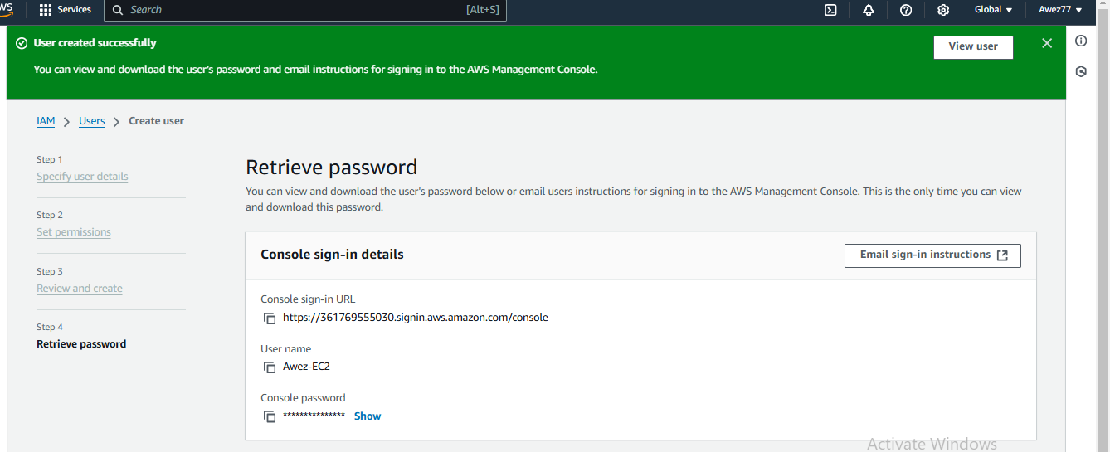

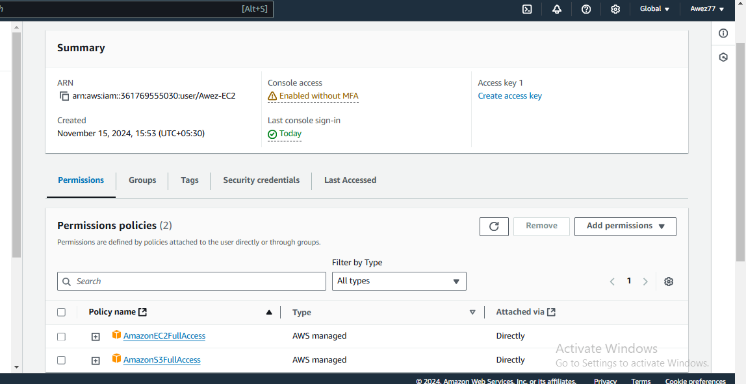

**2) Create one Group in IAM and Assign Read access for ec2.**

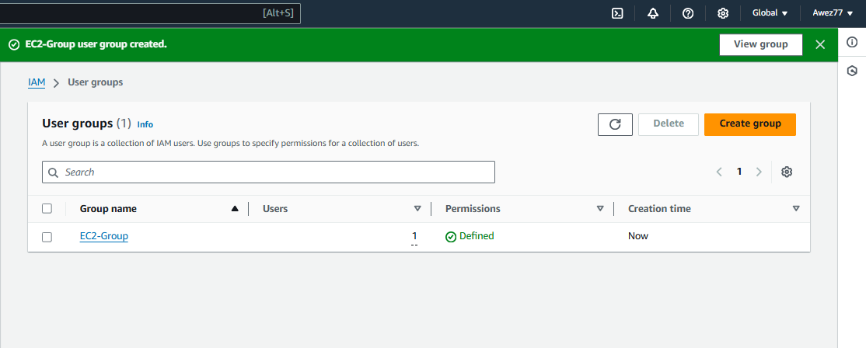

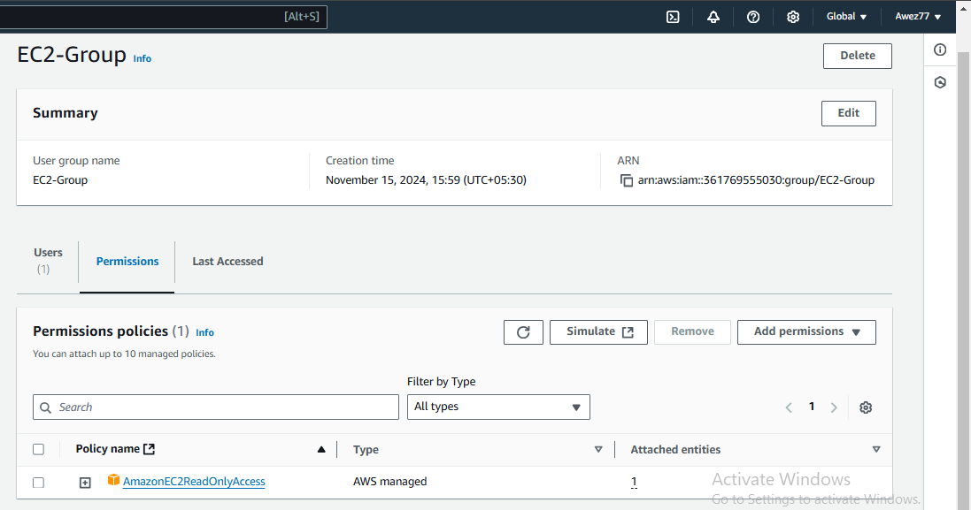

**3) Create a new user with name Devops and add to the group created in task2.**

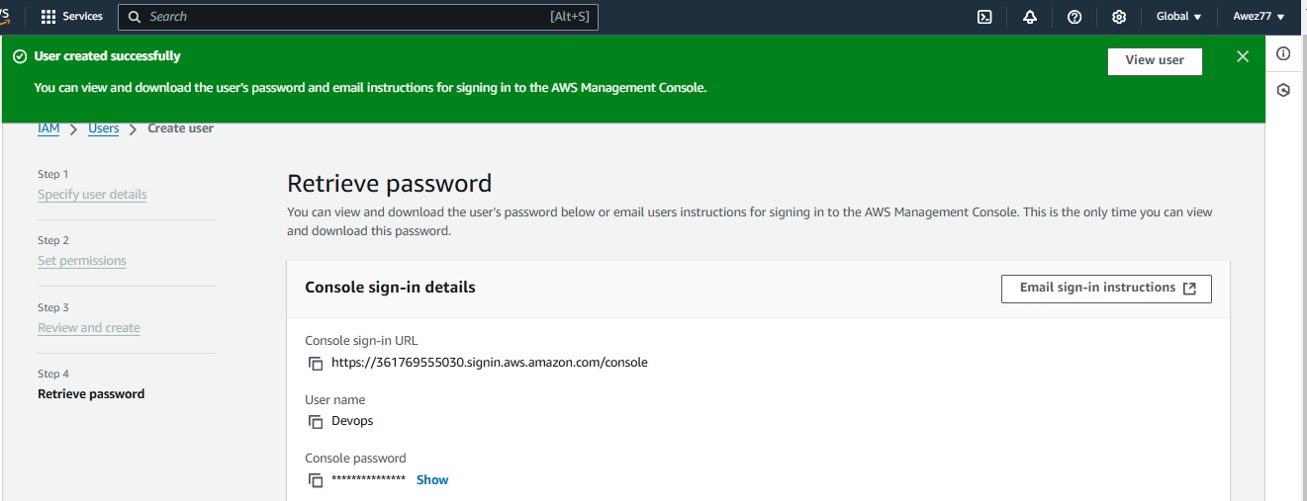

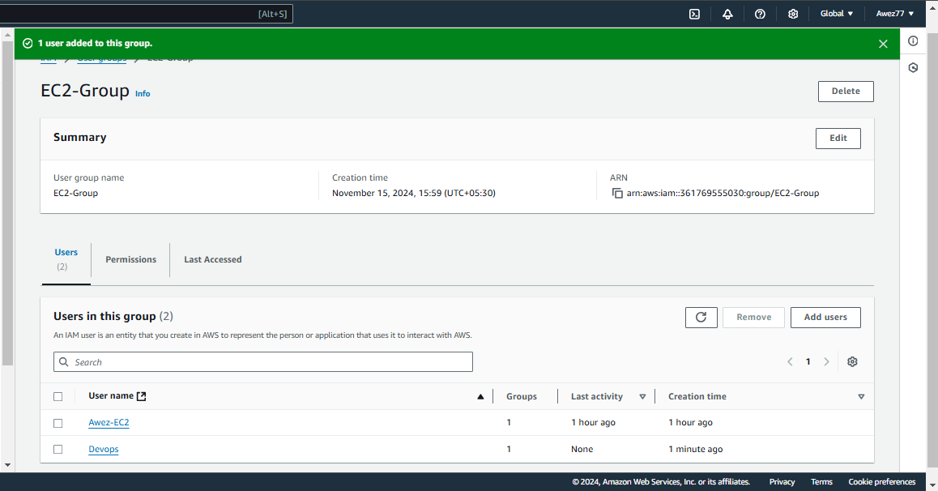

**4) Write a bash script to create a IAM user with VPC full access.**

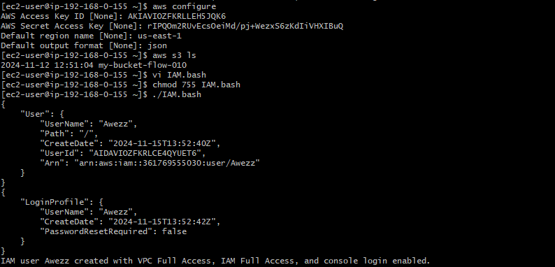

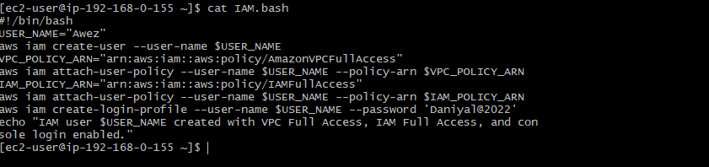

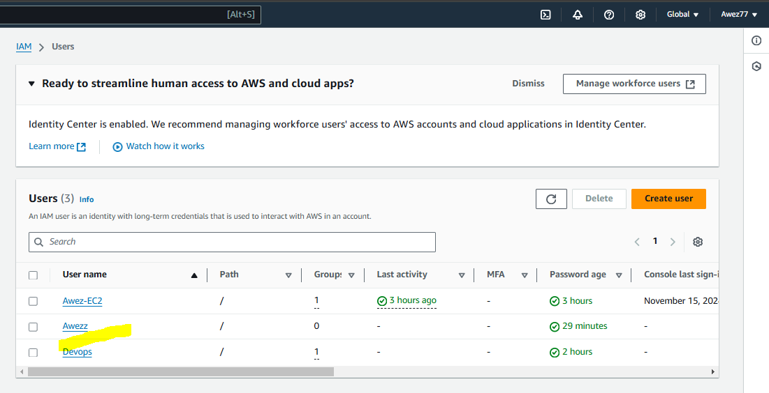

**5) Create a IAM policy to access ec2 for a specific user in specific regions only.**

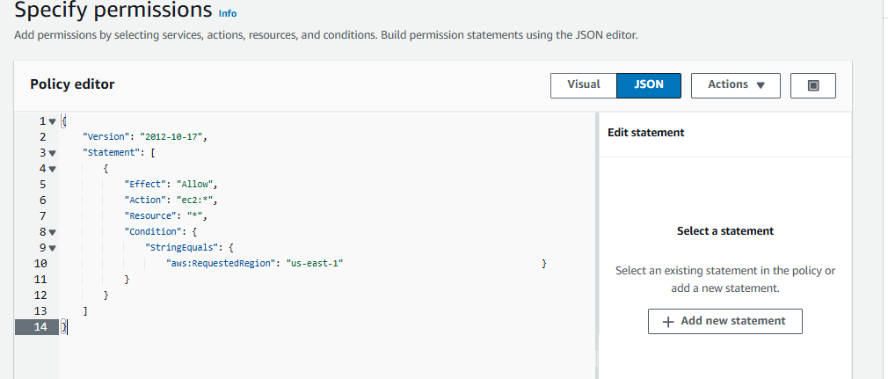

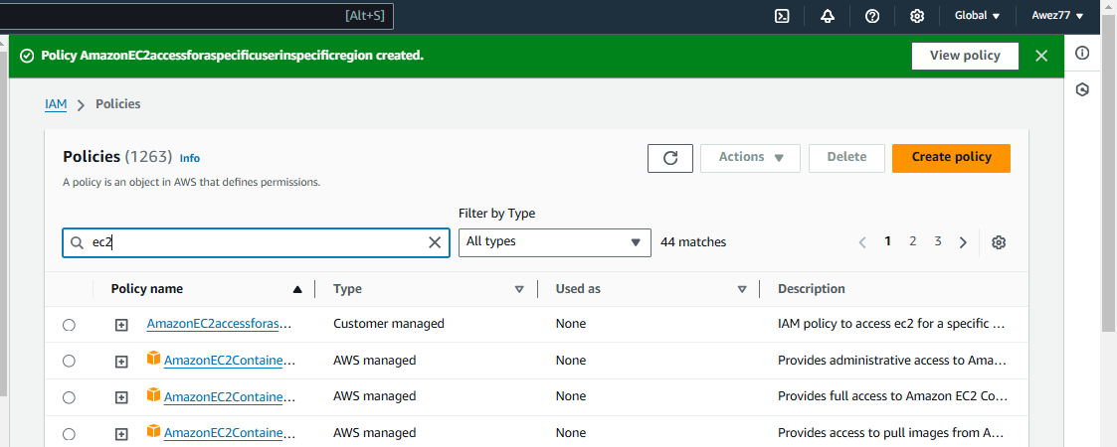

**6) We have two accounts Account A and Account B, Account A user should access s3 bucket in Account B.**