1. **Install jenkins and run jenkins on port number 8081.**

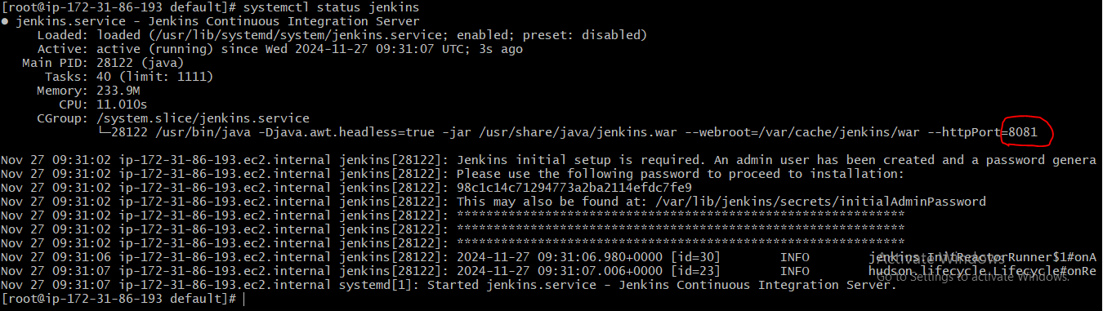

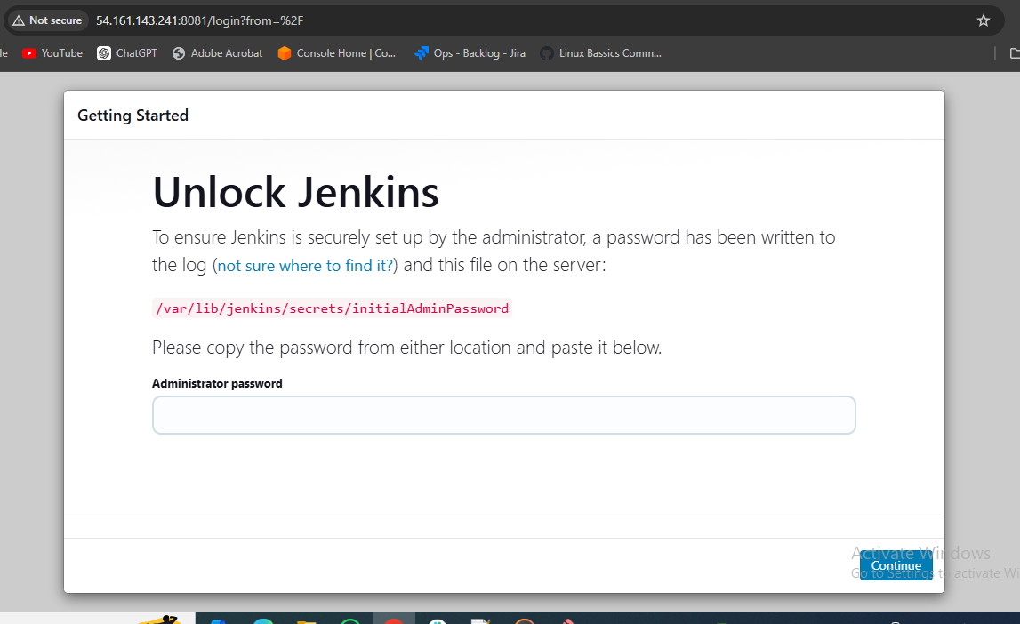

1. **Secure Jenkins server**

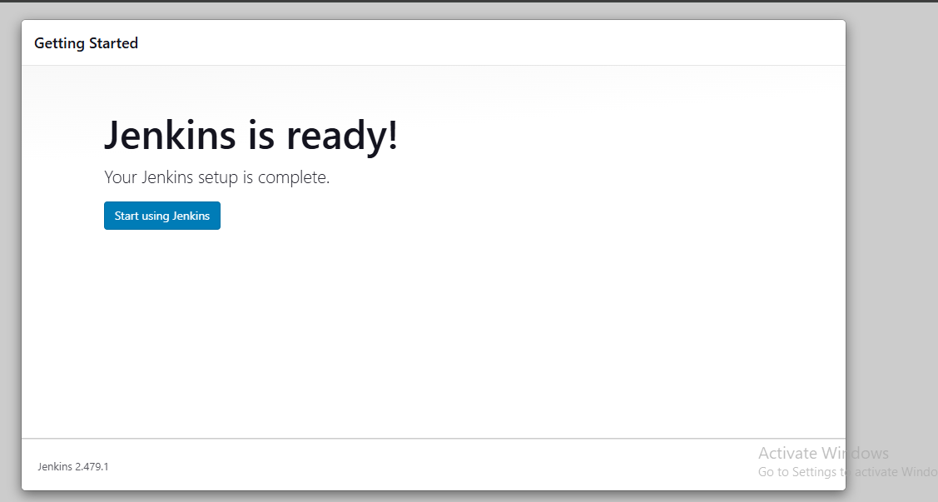

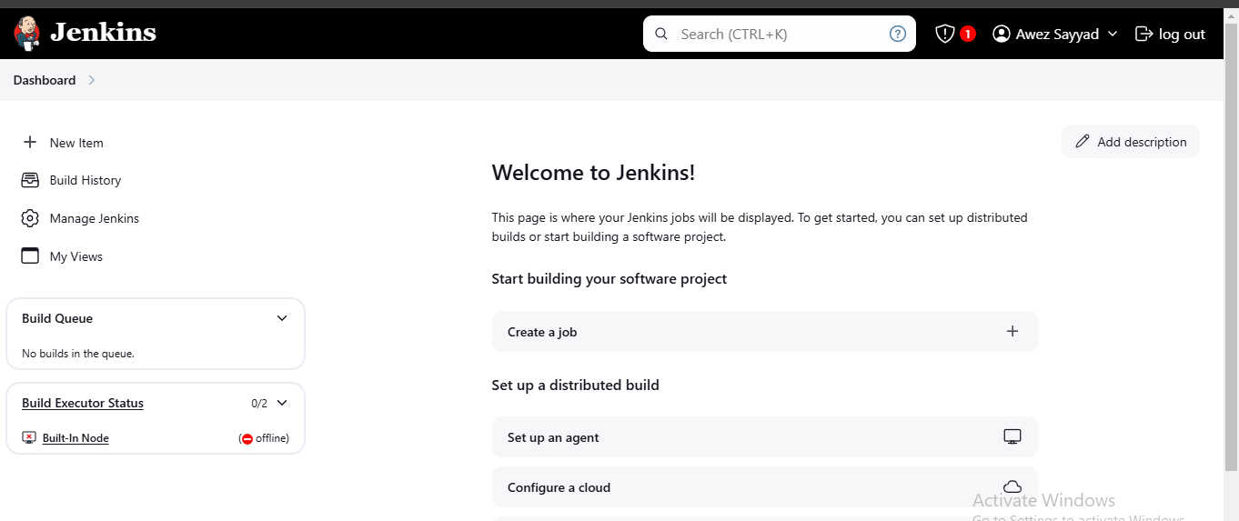

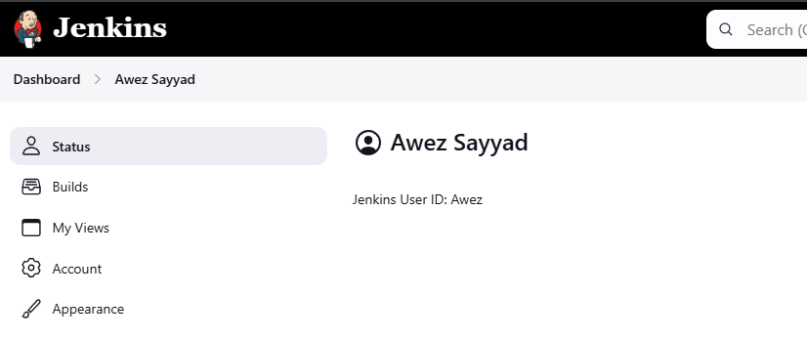

1. **Create users called Devops, Testing in Jenkins with Limited access.**

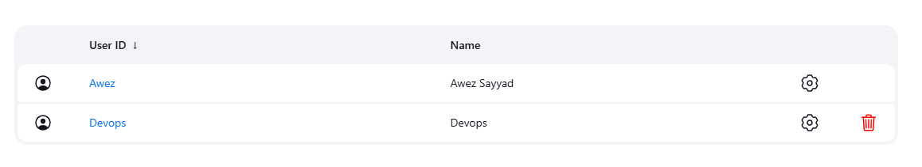

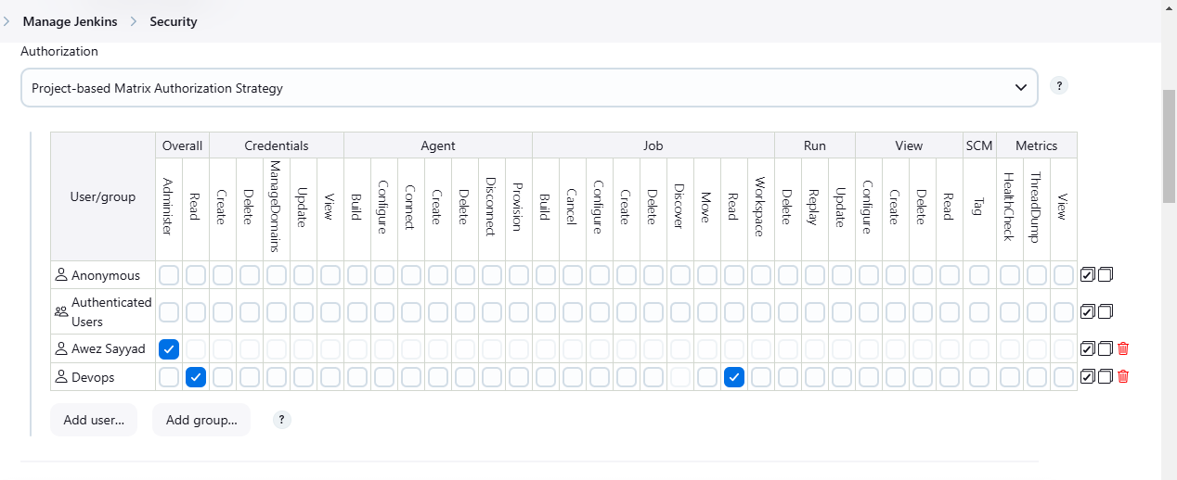

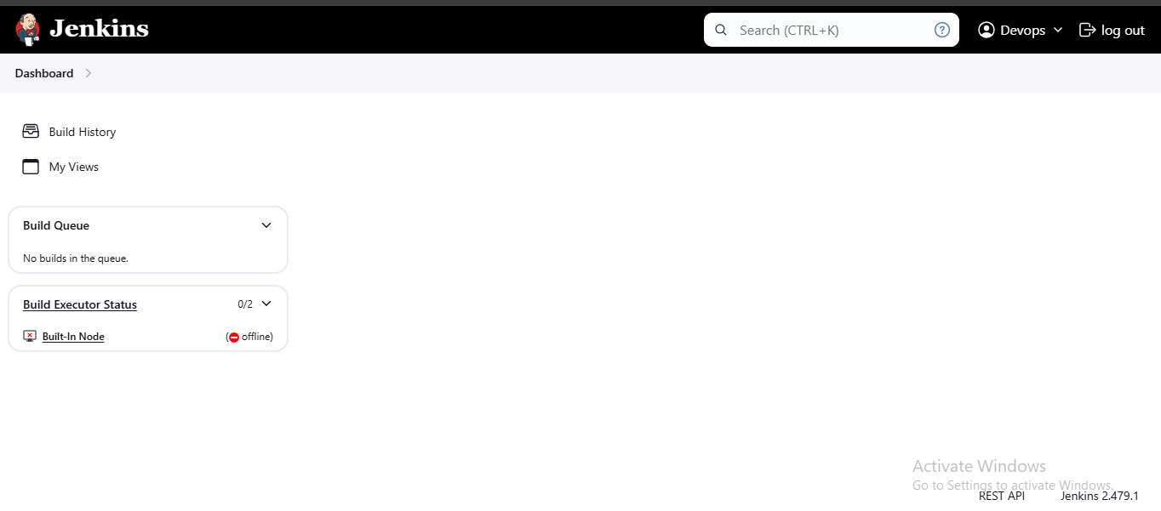

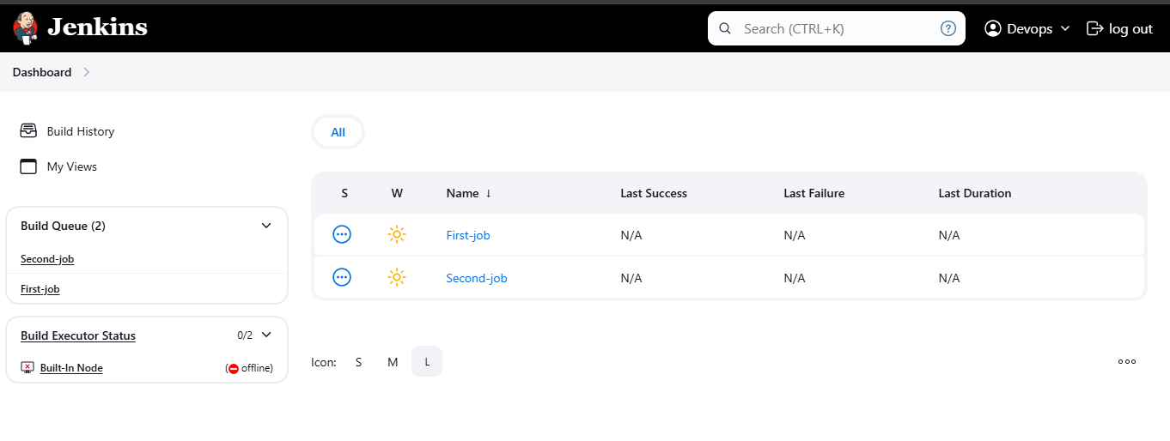

1. **Configure labels and restrict the jobs to execute based on label only.**

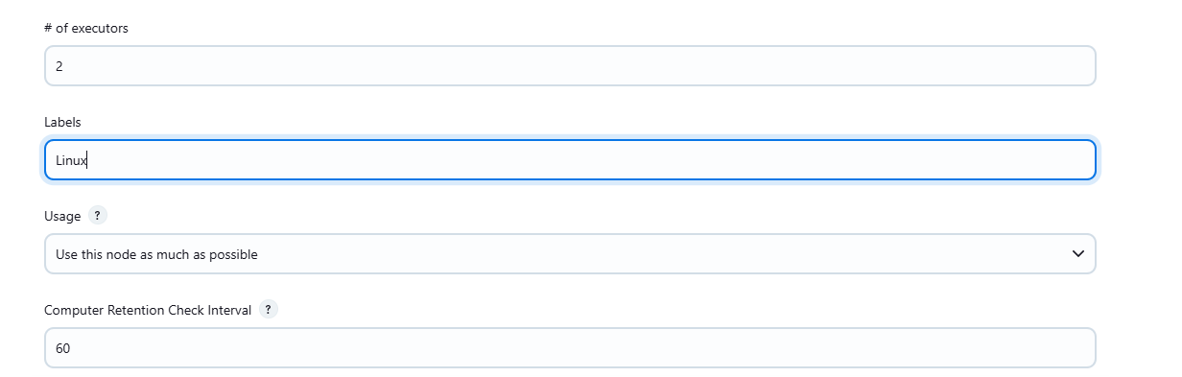

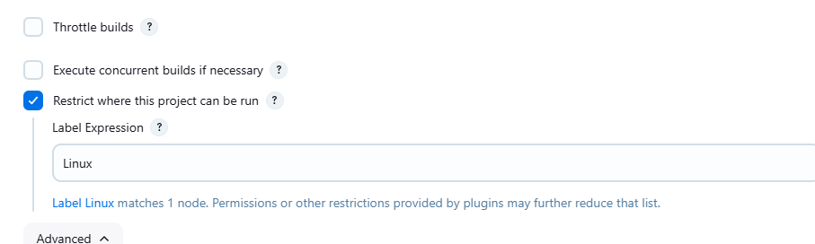

1. **Create Three sample jobs using the below URL.** [**https://github.com/betawins/Techie_horizon_Login_app.git**](https://github.com/betawins/Techie_horizon_Login_app.git)

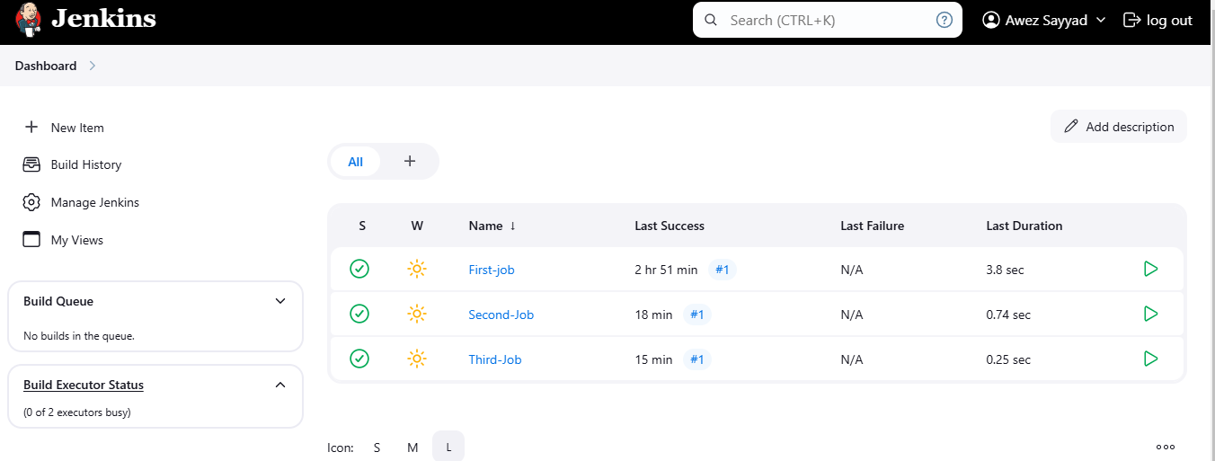

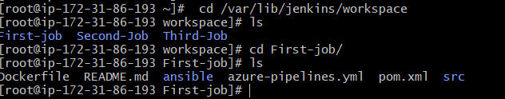

1. **Create one jenkins job using git hub Private repository.**

