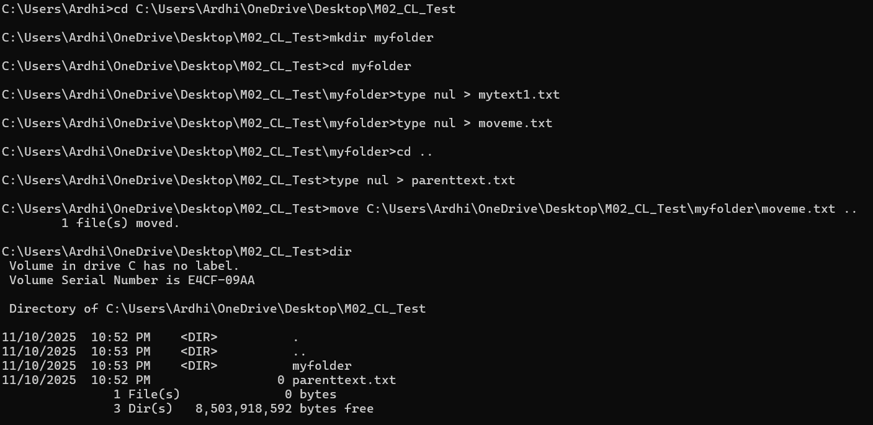
Initially everything went smoothly, however when I attempted to move the moveme.txt file up into it’s parent directory the file seemingly disappeared. The command may not have worked as I intended it to, so I went back and created another moveme.txt file and repeated the process with a properly specified destination.
