DATA ANALYTICS PORTFOLIO
Chicago Traffic Safety Analytics
A Data Story on Crash Patterns, Risk Factors, and Evidence-Based Safety Priorities
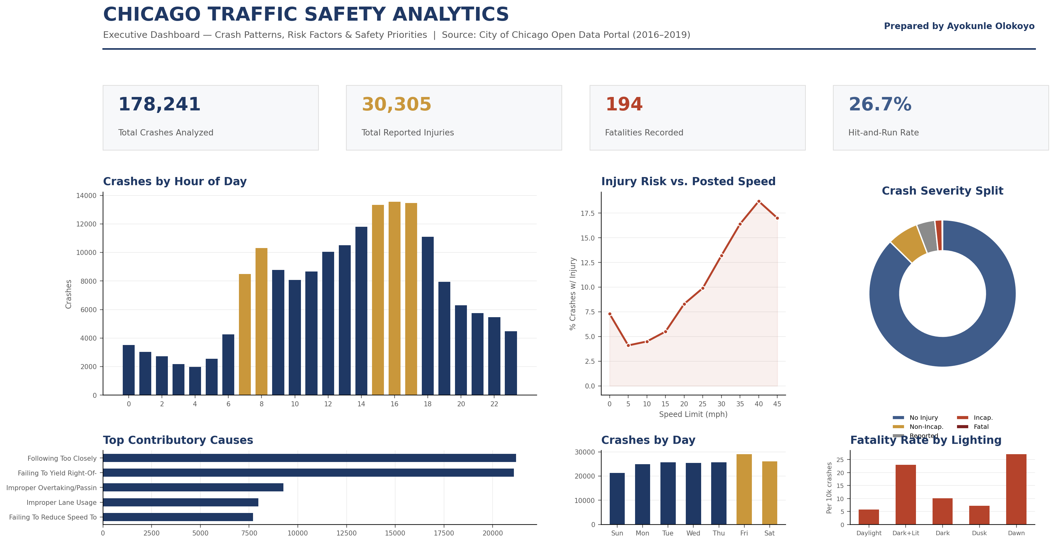
Executive dashboard built from 178,241 real Chicago Police Department crash records (2016–2019), sourced from the City of Chicago Open Data Portal.
AYOKUNLE OLOKOYO
Senior Data Analyst | Advanced Analytics, Dashboards & Predictive Modeling
+234 805 315 7634 | awisespirit@gmail.com
LinkedIn | GitHub Portfolio

The Question
Traffic safety agencies sit on enormous volumes of crash data, but volume alone doesn't create insight. The real question is always the same one a policy team actually needs answered: where should limited safety resources go first, and what does the data say will make the biggest difference? For this project, I set out to answer three specific questions using real, publicly available Chicago Police Department crash data: When do crashes happen, and does that match where enforcement and public-awareness resources are currently focused? What role does posted speed actually play in whether a crash results in injury? And which conditions — lighting, weather, contributing driver behavior — carry the highest real risk, as opposed to simply the highest raw crash count?
Data & Method
This analysis uses 178,241 individual crash records from the City of Chicago's public Traffic Crashes dataset, covering incidents reported by the Chicago Police Department between 2016 and 2019. Each record includes the date, time, location, weather and lighting conditions, posted speed limit, primary contributing cause, and injury severity outcome of a single crash.
I used Python (pandas) to clean, structure, and aggregate the dataset — grouping crashes by hour, day of week, month, and year; calculating injury rates as a share of crashes rather than raw counts, to separate genuine risk from simple traffic volume; and cross-referencing severity outcomes against posted speed limit and lighting condition to isolate the factors most associated with harm, not just frequency. Visualizations were built in Python (matplotlib) and structured into a single executive dashboard view, in the same spirit as the Power BI dashboards and KPI scorecards I have built throughout my career for government and enterprise stakeholders.
The Dashboard

Figure 1. Executive dashboard summarizing crash volume, timing, severity, and risk factors across the full dataset.

Key Findings
1. Crash timing closely tracks the commute, not chaos
Crashes are not evenly or randomly distributed across the day. Two sharp peaks emerge: a morning cluster around 7–8 AM and a much larger afternoon/evening cluster from 3–6 PM, together accounting for roughly a third of all crashes. This is squarely commute-pattern behavior — congestion, fatigue, and driver volume compounding at predictable hours — which means enforcement, signal-timing review, and public messaging campaigns have an obvious, evidence-backed window to target rather than spreading resources evenly across the clock.
2. Posted speed limit is one of the strongest predictors of injury severity in this dataset
The relationship is striking and almost perfectly monotonic above 10 mph: crashes on roads posted at 5 mph carry roughly a 4% chance of injury, while crashes on roads posted at 40 mph carry closer to 19% — nearly a five-fold increase in injury likelihood. This is exactly the kind of finding that turns into a defensible policy recommendation: speed-limit review and traffic-calming investment on higher-speed corridors is not a guess, it is where the data says injury risk concentrates.
3. Darkness with street lighting, not full darkness, carries the highest fatality rate
Intuition might suggest that crashes in complete darkness are the most dangerous. The data says otherwise: crashes occurring in darkness on a lighted road show a meaningfully higher fatality rate per 10,000 crashes than crashes in full darkness. One plausible explanation is that higher-speed arterial roads are the ones more likely to be lit at night, meaning the lighting itself is a marker for road type and traffic speed rather than a protective factor on its own — a nuance that matters when designing an intervention, since 'add more lighting' would not be the correct response to this particular finding.
4. "Unable to determine" and following-too-closely dominate identified causes
After excluding cases where the contributing cause could not be determined, following too closely and failing to yield right-of-way are, by a wide margin, the two most frequently identified contributing causes — together outweighing the next several causes combined. Both are behavioral, not environmental, which points toward driver-education and targeted enforcement campaigns as having a plausible, evidence-based case for impact.
5. Weekends shift the risk profile, not just the volume
Friday and Saturday post the highest raw crash counts of the week, consistent with increased weekend travel. Combined with the weather-conditioned injury-rate finding — where rain and overcast conditions show meaningfully higher injury rates than clear conditions — this suggests weekend-evening, adverse-weather driving is a compounding risk window worth flagging specifically in any seasonal safety campaign.

Recommendations
- Target enforcement and awareness campaigns to the 7–8 AM and 3–6 PM windows, where crash density is highest and driver fatigue/congestion factors are most active.
- Prioritize traffic-calming and speed-limit review on higher-posted-speed corridors, given the near-linear relationship between posted speed and injury likelihood identified in this analysis.
- Investigate the lit-darkness fatality finding further at the corridor level, to distinguish whether lighting, road classification, or speed is the true driver before recommending infrastructure changes.
- Pair any speed or lighting-focused engineering response with a behavioral campaign, since following-too-closely and right-of-way violations remain the leading identified human causes.
- Extend this analysis with a predictive model, using the same logistic regression and simulation-based forecasting approach I have applied in prior work, to estimate crash-risk scores by corridor and time window rather than relying on historical counts alone.
Tools & Methodology Note
This project was completed end-to-end using Python (pandas for data cleaning and aggregation, matplotlib for visualization) and structured using the same KPI-dashboard design principles I've applied throughout my career in Power BI — clear hierarchy, one message per panel, and headline KPIs that orient the viewer before the detail. The underlying dataset is public and unmodified from the City of Chicago Open Data Portal; all analysis, aggregation, and visualization choices are my own. This piece was built specifically to demonstrate applied data-analysis and dashboard-design capability using a real, verifiable public dataset, since prior professional dashboard work was built on data that remains confidential to its originating organization.

Full code, notebook, and additional portfolio pieces available at github.com/awisespirit

