Cloud Storage and Management

Dakshindaya V S,

21BIT010

LAB – 3

I Hosted a sample website from the available formats and hosted it using the aws S3 Instance.

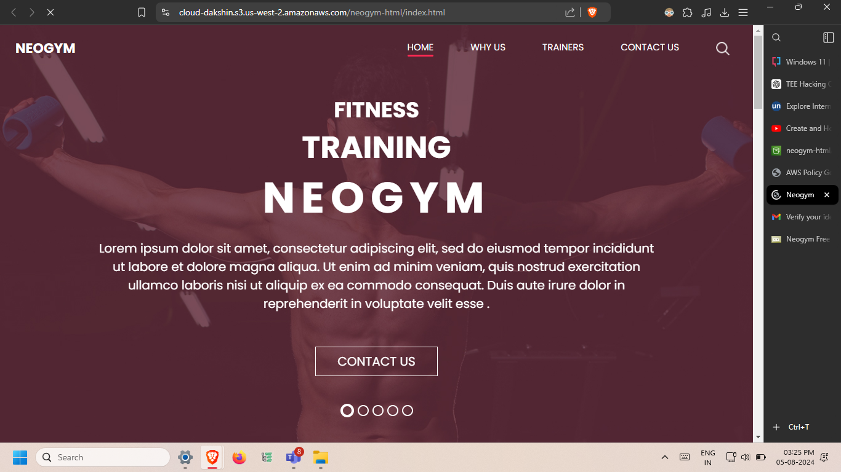

I modified the Policy to include only the IP that are coming from the indian subcontinent and not from some other countries, this has become effective immediately, when I tried to login via a different vpn I was not able to login.

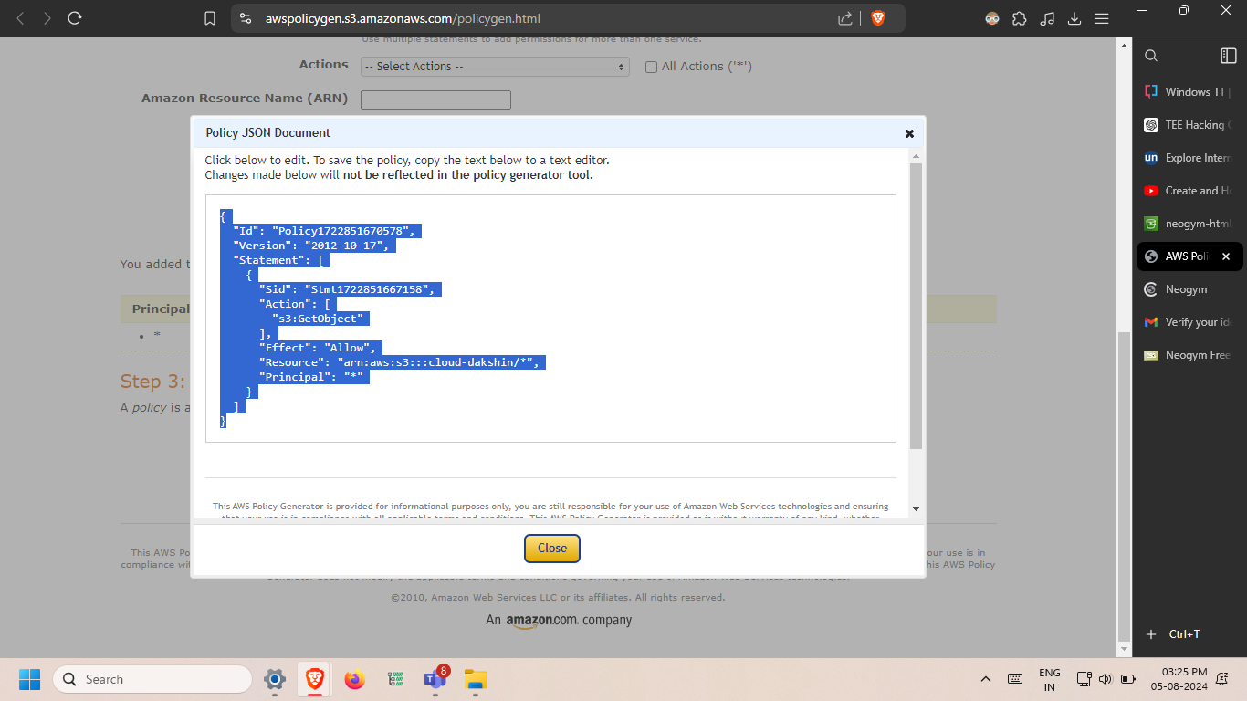

This the location of the index.html page, where the landing page of the webiste is available and the public ip address that is there.

