Statistical Investigation of a Simulated Salmonella Outbreak Using Logistic Regression in R

A Data Analysis Project
Prepared by: Awowole Uthman Boluwatife

Tools Used:
• R
• RStudio

July 2026
Table of content

- Title Page
- Abstract
- Introduction
- Objectives
- Methodology
- Results
- Conclusion

Abstract
Salmonella is one of the leading causes of foodborne illness worldwide and poses a significant public health challenge. This study investigated the factors associated with a simulated Salmonella outbreak using statistical analysis in R. A simulated cross-sectional dataset comprising 1,000 participants was generated, containing demographic characteristics (age, gender, and state of residence), food consumption variables (seafood, meat, fish, eggs, and raw vegetables), and infection status. Descriptive statistics and exploratory data analysis were used to summarize the data. Pearson's Chi-square test was employed to assess associations between categorical variables and infection status, while an independent samples t-test compared the mean age of infected and non-infected participants. A multiple logistic regression model was fitted to identify independent predictors of Salmonella infection. The results showed that seafood consumption was the only statistically significant predictor of infection (p < 0.001), with individuals who consumed seafood having substantially higher odds of infection than those who did not. Age, gender, state of residence, meat, fish, egg, and raw vegetable consumption were not significantly associated with infection (p > 0.05). The findings suggest that contaminated seafood was the most likely source of the simulated outbreak. This project demonstrates the application of statistical methods in outbreak investigation and highlights the usefulness of logistic regression for identifying risk factors associated with infectious disease outbreaks.
Keywords: Salmonella, foodborne disease, outbreak investigation, logistic regression, hypothesis testing, R programming, epidemiology, statistical analysis

Introduction
Salmonella is one of the most common causes of foodborne illness worldwide and remains a major public health concern. The infection is caused by bacteria of the genus Salmonella, which are commonly transmitted through the consumption of contaminated food or water. Foods such as undercooked poultry, eggs, seafood, meat, unpasteurized dairy products, and contaminated fruits and vegetables have been identified as common sources of infection. Individuals infected with Salmonella often experience symptoms including diarrhea, fever, abdominal cramps, nausea, and vomiting, with symptoms typically appearing between 6 and 72 hours after exposure. Although most infections are self-limiting, severe cases may require hospitalization, particularly among young children, older adults, pregnant women, and individuals with weakened immune systems.
Foodborne disease outbreaks continue to pose significant challenges to public health systems across the world. Rapid identification of the source of an outbreak is essential to prevent further transmission, reduce morbidity, and guide appropriate public health interventions. Epidemiological investigations rely heavily on statistical methods to identify potential risk factors associated with disease occurrence. By comparing infected and non-infected individuals, researchers can determine whether demographic characteristics, environmental exposures, or food consumption behaviors are significantly associated with infection.
Statistical techniques such as descriptive statistics, exploratory data analysis, hypothesis testing, and regression modeling are widely used in outbreak investigations. Descriptive statistics provide an overview of the characteristics of the affected population, while inferential statistical methods help determine whether observed associations are statistically significant. Logistic regression is particularly useful when the outcome variable is binary, such as infected versus non-infected, because it estimates the probability of infection while simultaneously accounting for multiple predictor variables. The resulting odds ratios provide valuable measures of the strength of association between potential risk factors and disease occurrence.
In many educational and research settings, simulated datasets are used to demonstrate statistical techniques when real outbreak data are unavailable due to privacy, ethical, or accessibility constraints. Simulated data allow researchers and students to develop practical skills in data management, statistical analysis, and interpretation while following the same analytical procedures used in real-world epidemiological investigations.
This project presents a statistical investigation of a simulated Salmonella outbreak involving 1,000 participants. The analysis examines whether demographic characteristics (age, gender, and state of residence) and selected food consumption variables (seafood, meat, fish, eggs, and raw vegetable consumption) are associated with Salmonella infection. Descriptive statistics, Pearson's Chi-square tests, independent samples t-tests, and multiple logistic regression were employed using R to identify the major predictors of infection and demonstrate the application of statistical methods in outbreak investigation.

Objective

General Objective
To investigate the factors associated with Salmonella infection using a simulated outbreak dataset through statistical analysis in R.

Specific Objectives
- To describe the demographic characteristics of participants using descriptive statistics.
- To examine the distribution of selected food consumption variables among participants.
- To determine the association between demographic characteristics, food consumption variables, and Salmonella infection using appropriate statistical tests.
- To compare the mean age of infected and non-infected participants using an independent samples t-test.
- To identify independent predictors of Salmonella infection using multiple logistic regression.
- To estimate and interpret the odds ratios of the identified risk factors associated with Salmonella infection.

Methodology
This study employed a simulated cross-sectional outbreak investigation to identify factors associated with Salmonella infection. A simulated dataset was developed to mimic data that could be collected during a foodborne disease outbreak investigation. The dataset was created for educational and analytical purposes to demonstrate the application of statistical techniques commonly used in epidemiological research.
The study consisted of 1,000 simulated participants representing individuals who were potentially exposed during the outbreak. Each participant was assigned demographic characteristics, dietary exposure variables, and an infection status based on predefined probabilities to produce a realistic outbreak scenario suitable for statistical analysis.
The outcome (dependent) variable in this study was Infection Status, which was categorized as Yes (infected) or No (not infected). The explanatory (independent) variables included Age (years), Gender, State of residence, Seafood consumption, Meat consumption, Fish consumption, Egg consumption, and Raw vegetable consumption. All food consumption variables were recorded as binary variables (Yes/No).
The outbreak dataset was generated using the R programming language through random sampling techniques. Continuous variables such as age were simulated to approximate a normal distribution, while categorical variables were generated using predefined probabilities to represent realistic demographic characteristics and food consumption patterns. Infection status was simulated such that participants who consumed seafood had a substantially higher probability of infection than those who did not consume seafood, thereby reflecting a plausible Salmonella outbreak originating from contaminated seafood.
Data were analyzed using R and RStudio. Descriptive statistics were used to summarize the characteristics of the study participants. Frequency distributions and percentages were computed for categorical variables, while the mean and standard deviation were calculated for continuous variables. Exploratory Data Analysis (EDA) was conducted using graphical methods, including histograms and bar charts, to visualize the distribution of participant characteristics and food consumption patterns.
Pearson's Chi-square test of independence was employed to examine the association between categorical variables and Salmonella infection status. An independent samples t-test was used to compare the mean age of infected and non-infected participants. To identify independent predictors of Salmonella infection, a multiple logistic regression model was fitted with infection status as the binary outcome variable and demographic and food consumption variables as explanatory variables. Adjusted Odds Ratios (AORs) with corresponding 95% confidence intervals and p-values were estimated to measure the strength and direction of the associations between predictor variables and infection status.
All statistical analyses were performed at a 5% level of significance (α = 0.05). Variables with p-values less than 0.05 were considered statistically significant, while variables with p-values greater than or equal to 0.05 were considered not statistically significant. The findings were presented using tables, charts, and appropriate statistical interpretations to support the conclusions of the study.

Results

Descriptive Statistics:

A total of 1,000 participants were included in the simulated outbreak investigation. The mean age of the participants was 46.40 years (SD = 26.29498).
The study population consisted of male and female participants from different states. The distributions of infection status and food consumption variables were summarized using frequency tables and graphical presentations

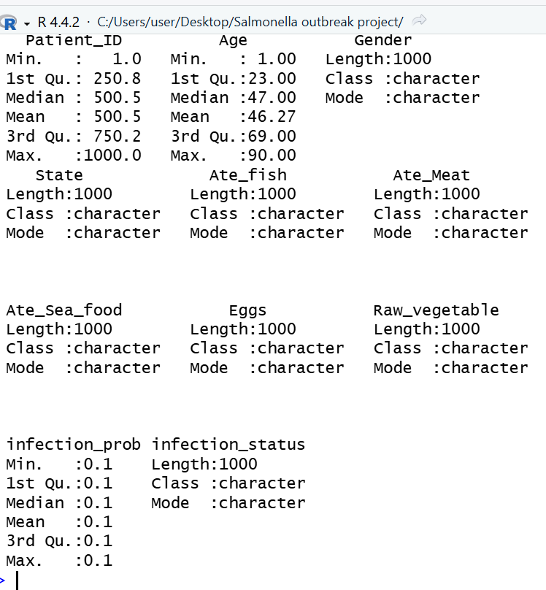
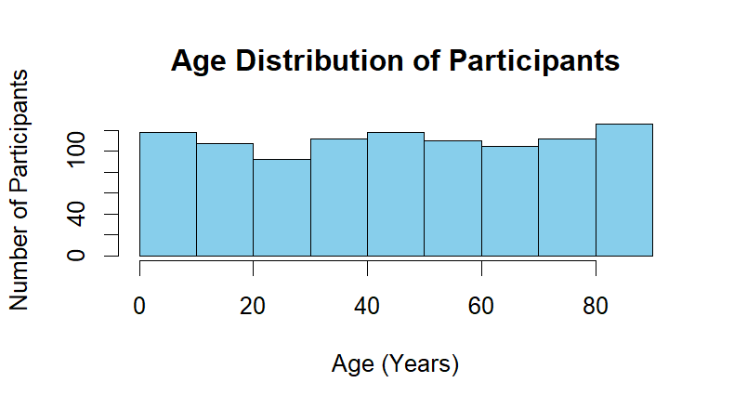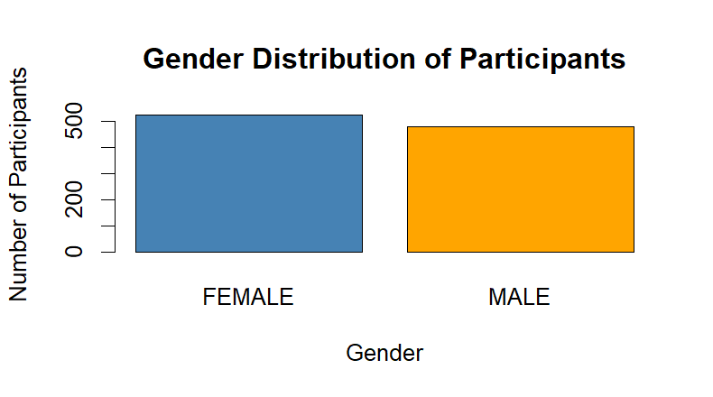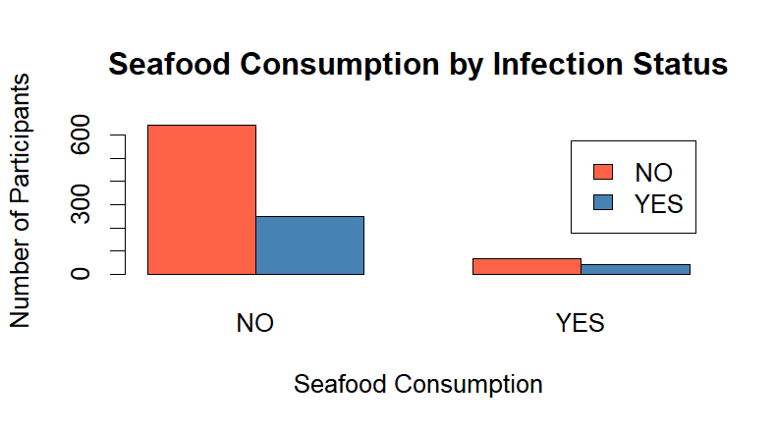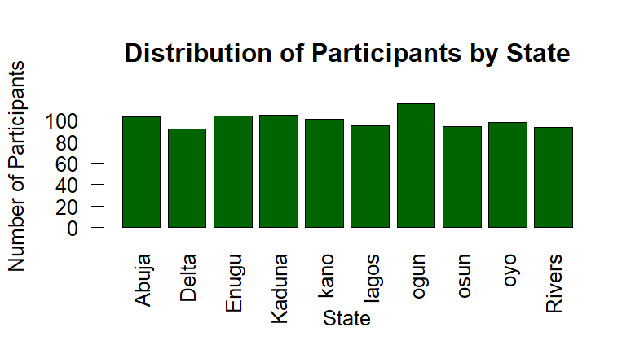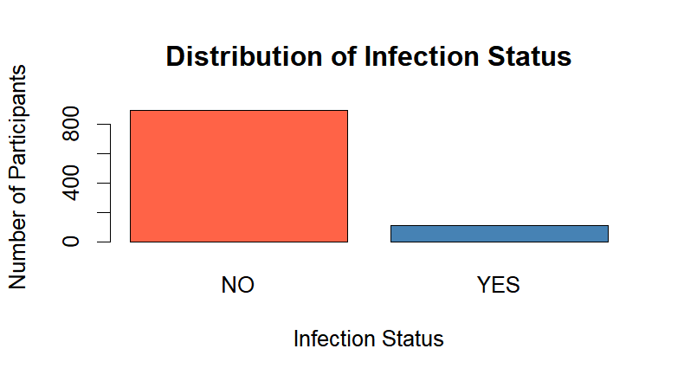
MULTIVARIATE ANALYSIS:
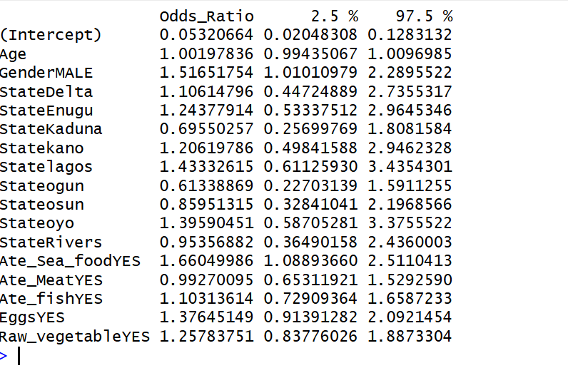

Conclusion:
This study investigated the factors associated with a simulated Salmonella outbreak using statistical methods in R. Descriptive statistics, exploratory data analysis, Pearson's Chi-square tests, an independent samples t-test, and multiple logistic regression were employed to examine the relationship between demographic characteristics, food consumption variables, and Salmonella infection.
The findings revealed that seafood consumption was the only statistically significant predictor of Salmonella infection. Participants who consumed seafood had substantially higher odds of infection than those who did not consume seafood. In contrast, age, gender, state of residence, meat consumption, fish consumption, egg consumption, and raw vegetable consumption were not significantly associated with infection.
The results demonstrate the usefulness of statistical methods, particularly logistic regression, in identifying potential risk factors during disease outbreak investigations. Although the dataset was simulated, the analytical approach reflects standard epidemiological practices and illustrates how statistical evidence can be used to identify likely sources of infection and support public health decision-making.
Overall, this project highlights the importance of data-driven approaches in outbreak investigation and demonstrates the practical application of statistical analysis using R for solving real-world public health problems.

