**Assignment -2**

**Slave1 deploy war in tomcat**

**JM war built**

**GIT**

**Slave2 deploy war in tomcat**

**Step 1:** Launch 3 Instance 🡪 1-JM, 2-slaves

**Step 2:**

Connect & Configure Jenkins master instance

Connect to slaves and install java

yum install java-1.8.0-openjdk-devel.x86_64 –y

Create directory for Tomcat server mkdir /mnt/server 🡪 in both slaves

cd /mnt/server/

wget <https://dlcdn.apache.org/tomcat/tomcat-9/v9.0.65/bin/apache-tomcat-9.0.65.zip>

unzip apache-tomcat-9.0.65.zip

rm –rf apache-tomcat-9.0.65.zip

chmod –R 777 apache-tomcat-9.0.65

sh apache-tomcat-9.0.65.zip/bin/startup.sh 🡪 starting tomcat in slaves

chmod –R 777 /mnt 🡪 giving access to ec2-user in slaves

**Step 3**: Create nodes/agents

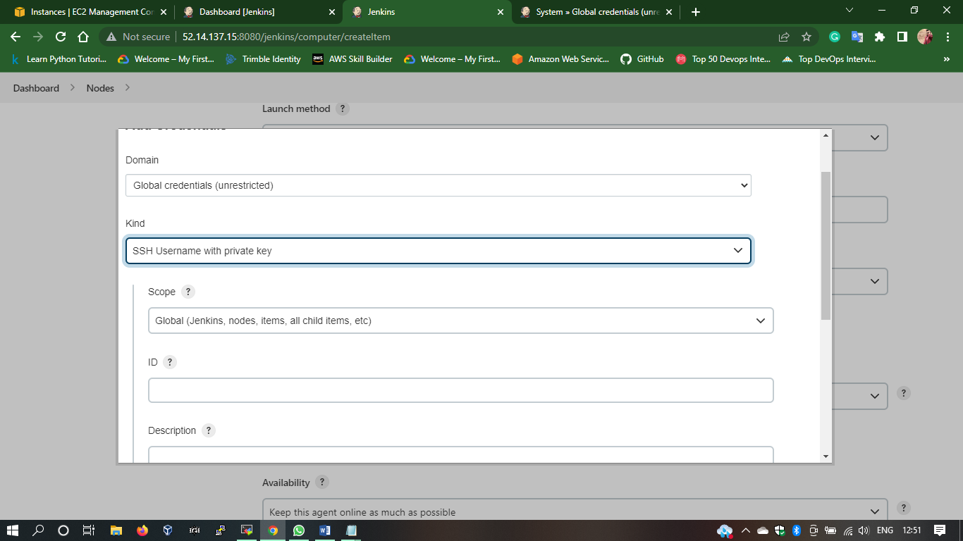

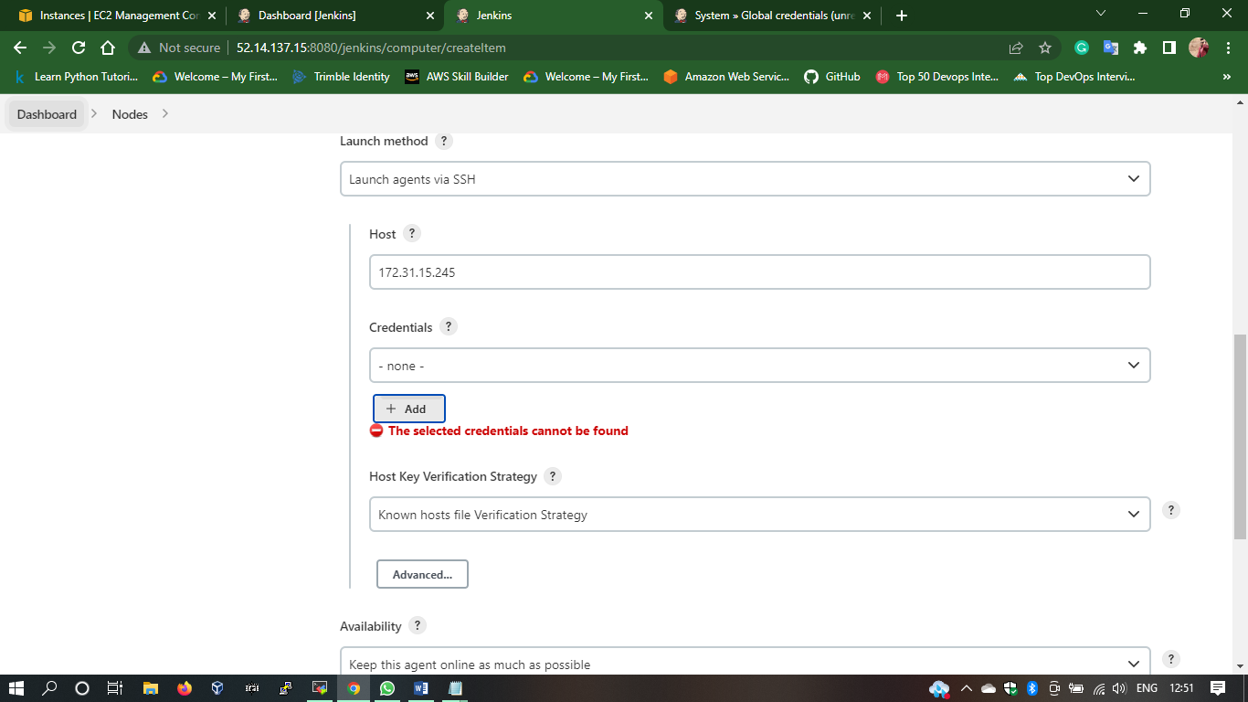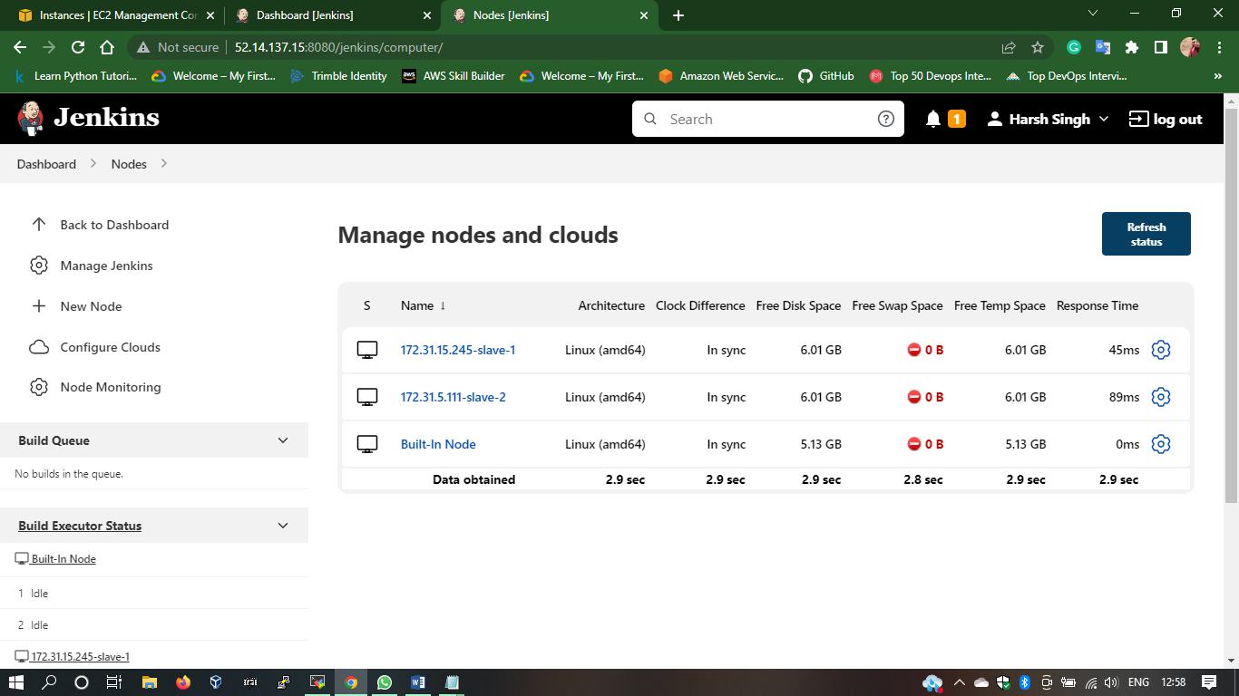

**Step 4:** Configure Pipeline job

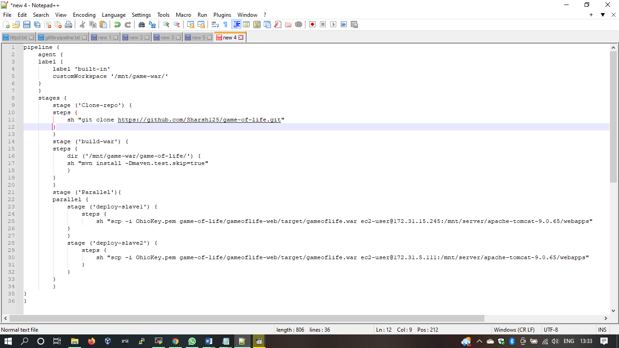

**Step 5: Build JOB**

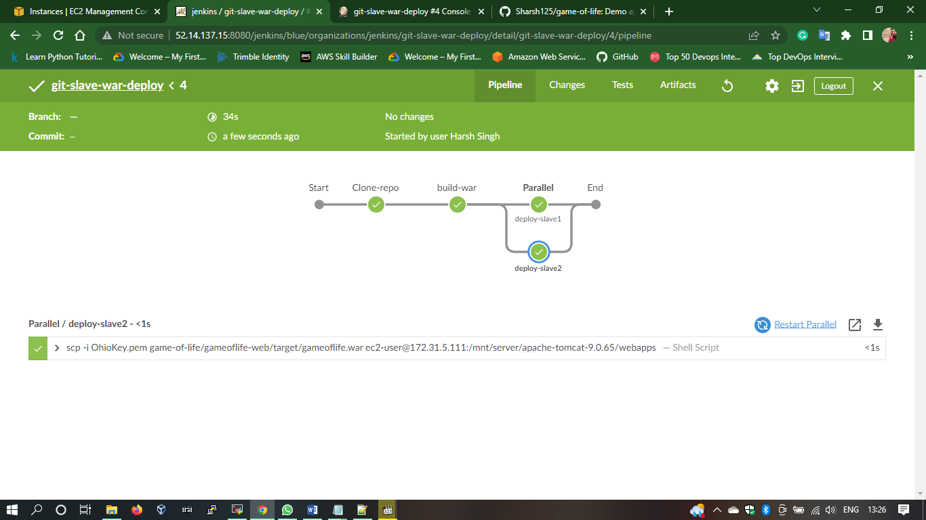

**Step 6: Check Slaves Tomcat directory & servers**

