**Assignment-3**

Job1 Build war & Deploy

On Slave1

Job2-Build war & Deploy

On Slave2

**Jenkins Master**

**Step 1: Launch 2 instances & Connect**

**Yum install git –y**

**yum install java-1.8.0-openjdk-devel.x86_64 –y**

**Install tomcat & configure**

**mkdir /mnt/{server,build} 🡪 cd /mnt/server**

**wget** [**https://dlcdn.apache.org/tomcat/tomcat-9/v9.0.65/bin/apache-tomcat-9.0.65.zip**](https://dlcdn.apache.org/tomcat/tomcat-9/v9.0.65/bin/apache-tomcat-9.0.65.zip)

**unzip apache-tomcat-9.0.65.zip**

**rm –rf apache-tomcat-9.0.65.zip**

**Install maven & configure**

**cd /mnt**

**wget** [**https://dlcdn.apache.org/maven/maven-3/3.8.6/binaries/apache-maven-3.8.6-bin.zip**](https://dlcdn.apache.org/maven/maven-3/3.8.6/binaries/apache-maven-3.8.6-bin.zip)

**Go to ec2-user home dir**

**Set env for maven**

**Cd /home/ec2-user**

**cd ~**

**Vi .bash_profile**

**export Maven_home=/mnt/build/apache-maven-3.8.6/bin**

**export PATH=$Maven_home:$PATH**

**save and exit**

**load file 🡪 source ~/.bash_profile**

**chmod –R 777 /mnt**

**Step 2: Creates nodes/agent 🡪 Slave1, Slave2 & Connect**

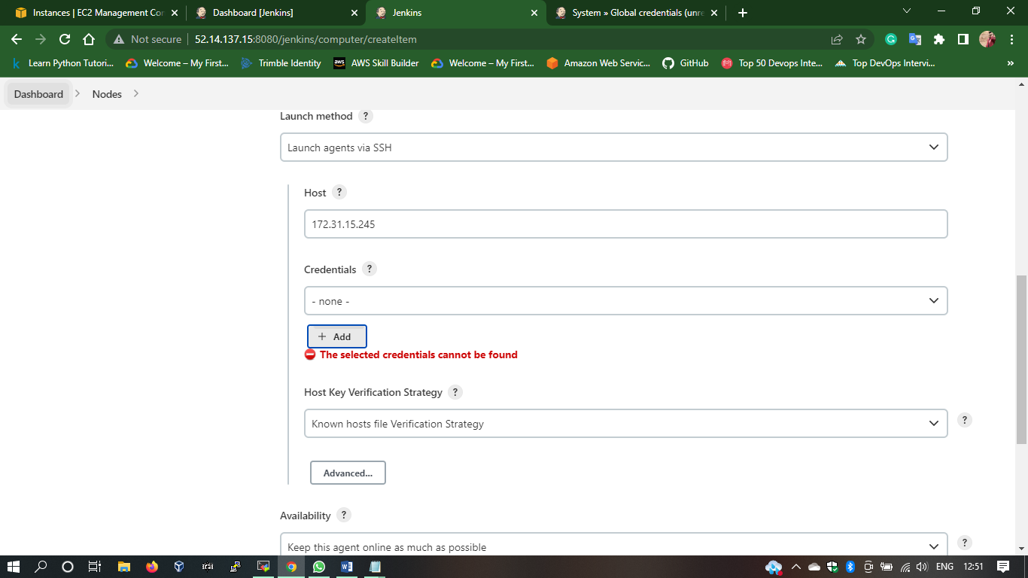

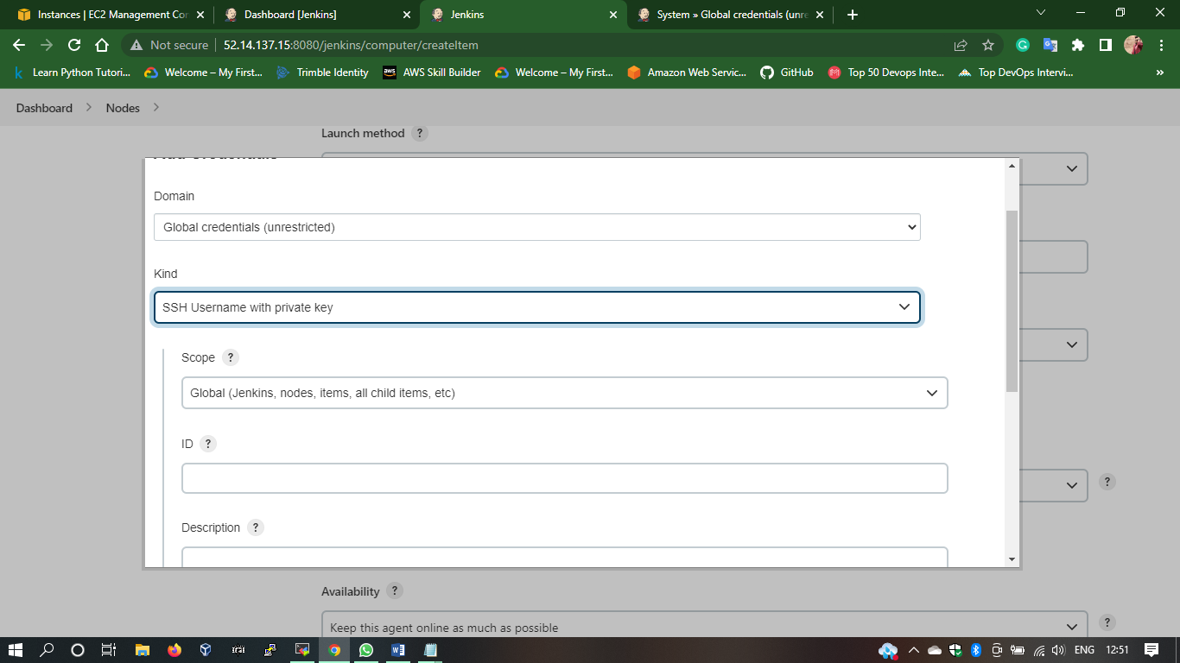

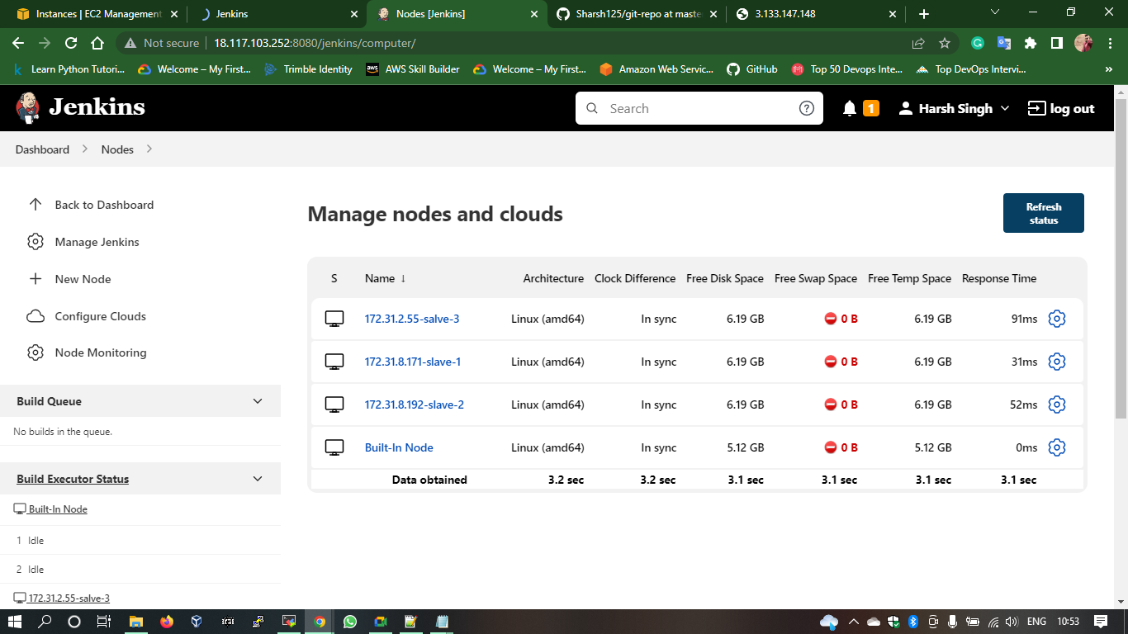

**Step 3: Create pipeline job for slave 1 & 2**

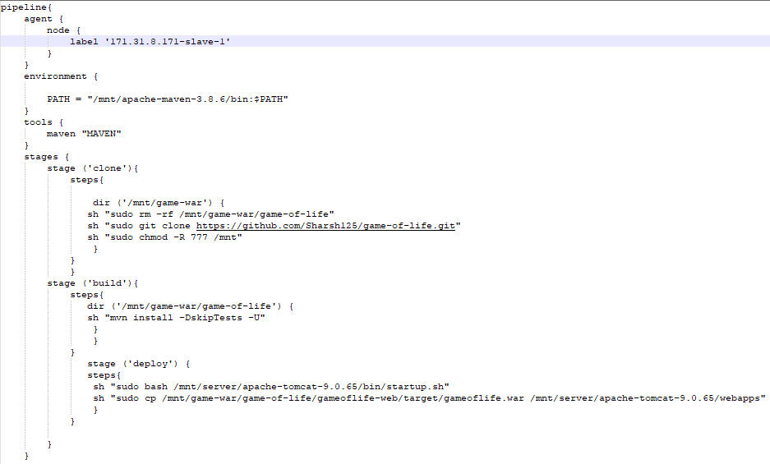

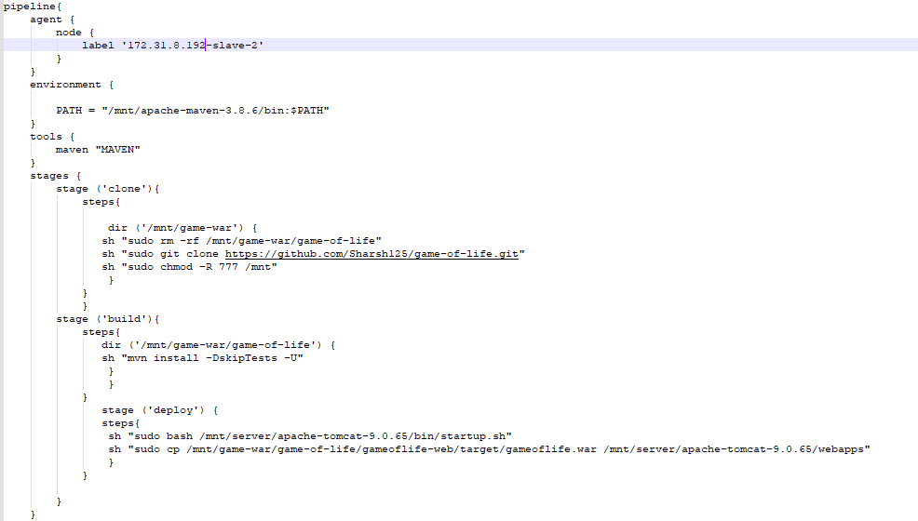

**Step 4: Build job**

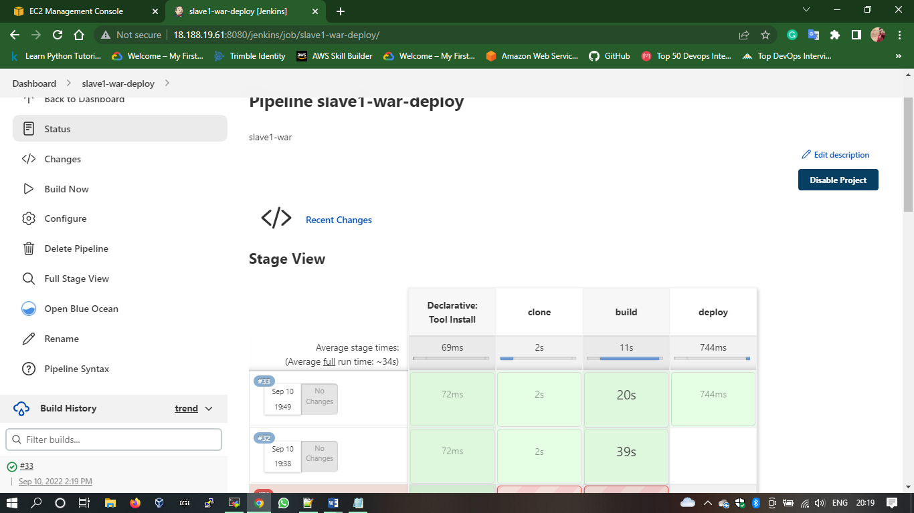

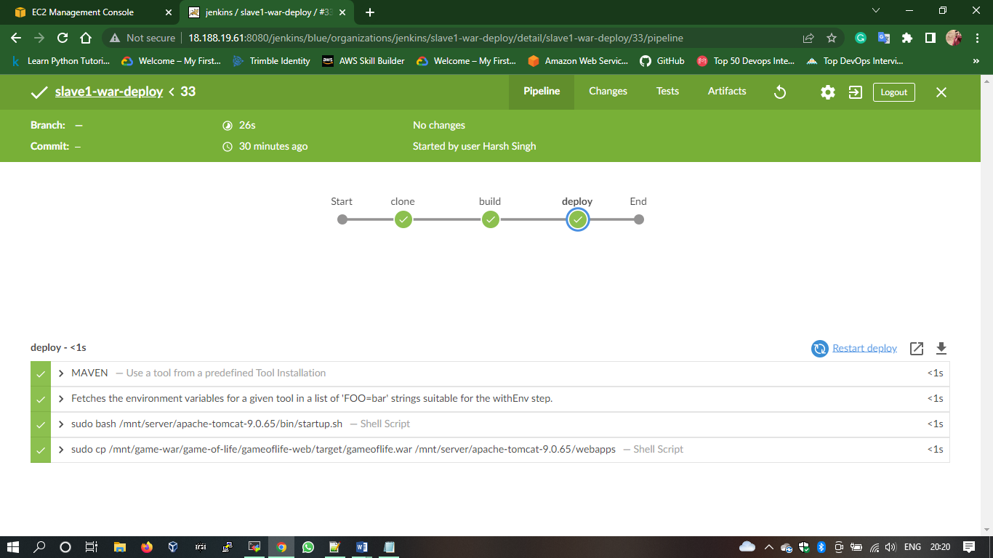

**Results :**

