**Assignment**

Slave1 – Dockerfile

Tomcat Container

War deploy

**Jenkins Master**

**Build game of life war 🡪 deploy on slaves**

**GIT HUB**

**Jenkins File**

Slave2 – Dockerfile

Tomcat Container

War deploy

**Game of Life War**

**Step 1: Step 1:** Launch & connect 2 slaves instances 🡪 slave1, slave2

**Sudo chmod –R 777 /mnt**

**sudo yum install java-1.8.0-openjdk-devel.x86_64 –y 🡪 for Jenkins slaves**

**sudo yum install docker -y**

**sudo systemctl start docker**

**step 2: Create Nodes/agent**

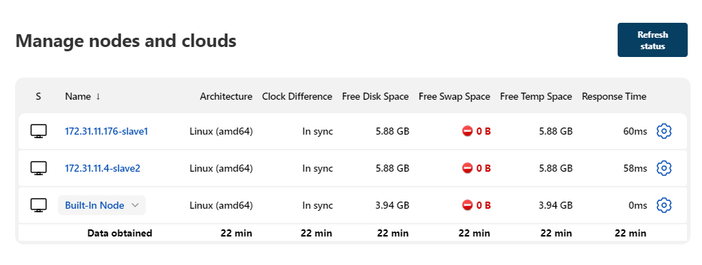

**Step 3: Create 2 pipeline jobs 🡪 1 for Jnekins master with Jenkins file,**

**🡪 2nd for Slaves**

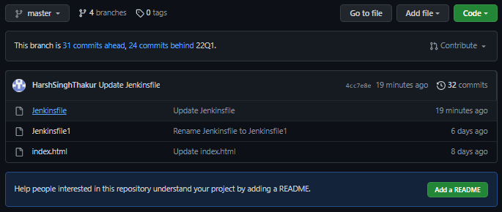

**Docker file configuration 🡪 copy via SCP Command in Jenkins file**

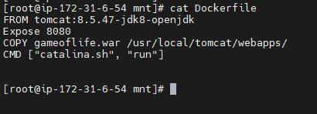

**JenkinsFile 🡪 1st job**

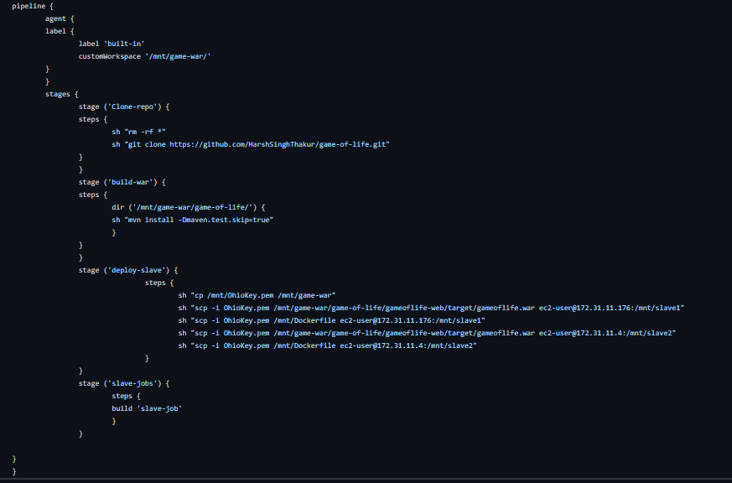

**Slave-job 🡪 2nd job**

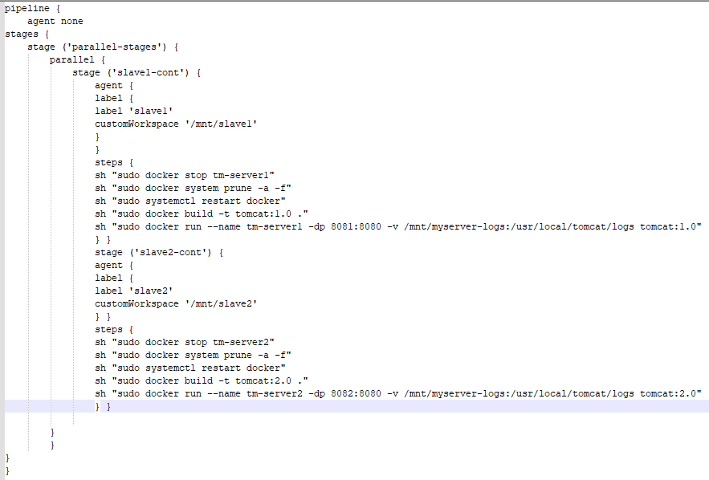

**Build Result**

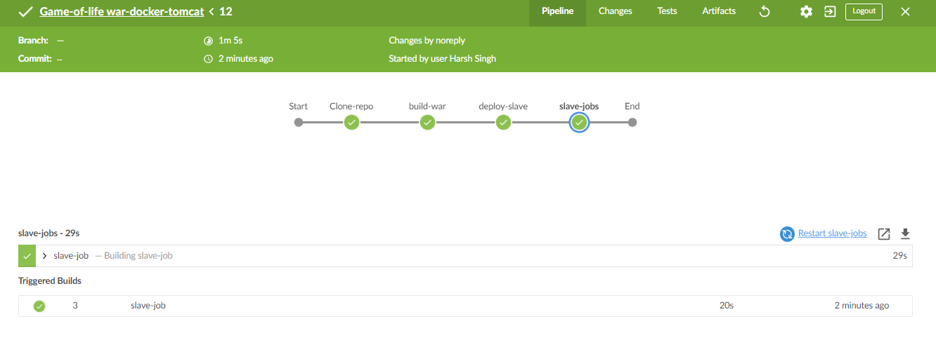

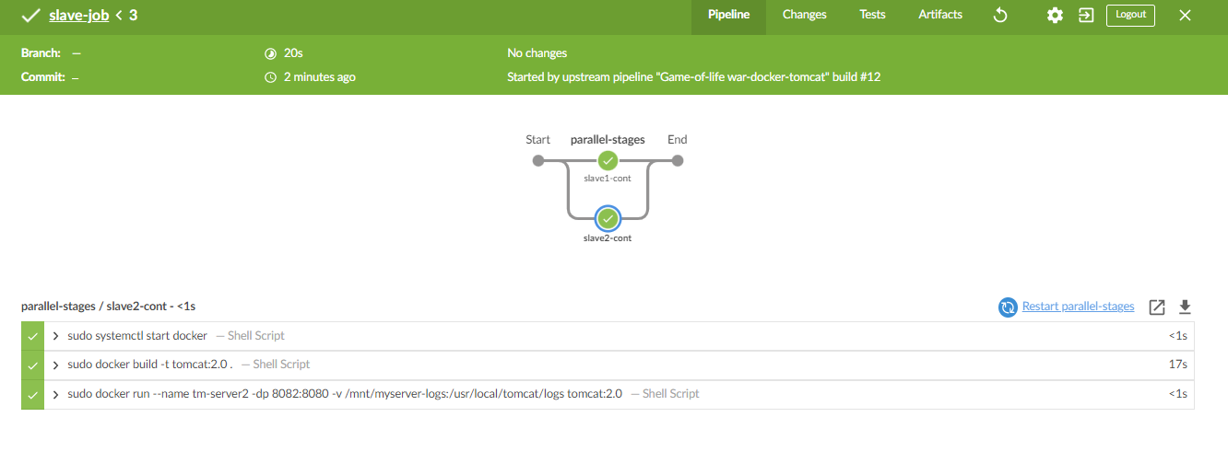

**Final Result**

