CHANGES DONE TILL NOW

1. Removed Passenger Id
2. Made new survived coloumn
3. Removed Name
4. If male then 1 female -1

Sum all = 21205.17/567

1. Replacing AGE BY 37
2. S =1 , c = 2 , q= 3
3. 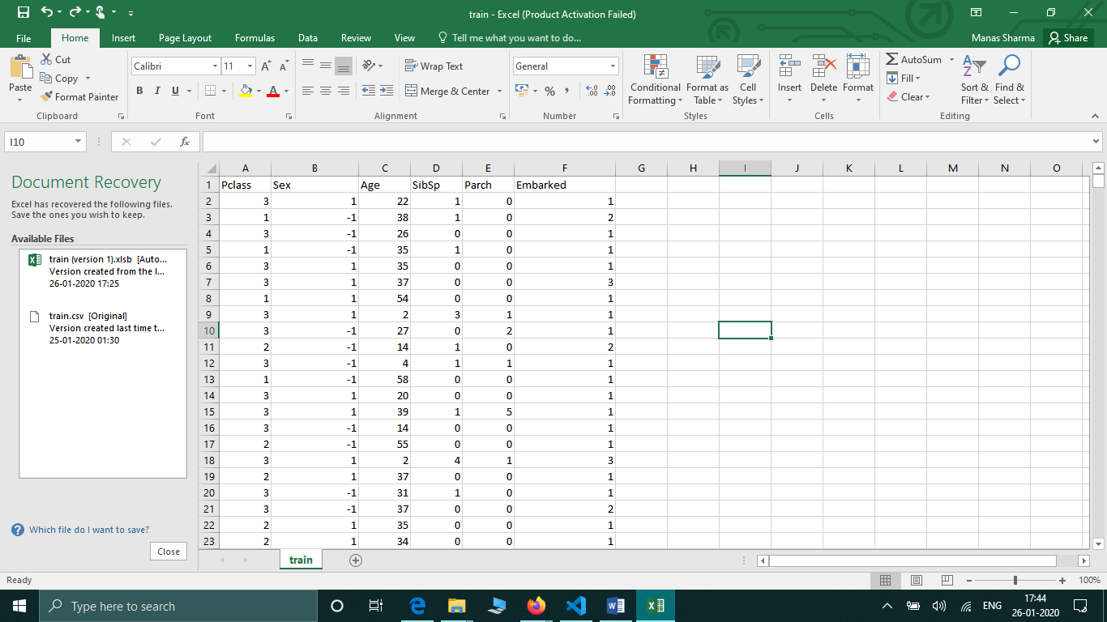
4. [a,b,c,d] = textread("iris2.txt", "%f %f %f %f", \
5. 'delimiter', '\t', "endofline", "\n", 'headerlines', 1);
6. X = [a, b, c, d];
7. disp(X);