1. **Introduction**
   1. **Purpose**

This module will describe how the software will be designed providing the specific information about the expected classes and functionality. This software will be an Online Recipe Book System for home cooks. This system will be designed to maximize the user’s interest by providing a huge number of recipes to choose from. It will offer easy and simple Instructions, along with specific ingredients for every recipe. Additionally, the Online Recipe Book will allow the user to easily generate a list of available ingredients from popular e-stores with lowest prices. They can then use this list to purchase from those specific stores manually. Moreover, the user will find suggestions of recipes based on popular ratings and nutrition value. The system also contains a relational database containing a list of Ingredient price and all recipes.

1. **Document Conventions**

Not Applicable

1. **Description of Design Components**
   1. **Server Side:** The backend coding will be done in Django Framework. The database of recipe and Ingredients price list will be stored using PostgreSQL
   2. **Client Side:** The frontend coding will be done with the help of HTML, Bootstrap and JavaScript to make the webpages responsive, simple and easy to use with friendly user interface.
   3. **Mobile**: The webapp will be mobile friendly. It will also be developed as an Android application using Java.
2. **High-Level Component Design**
3. **Class diagrams**
   1. **Detailed Class Diagram**

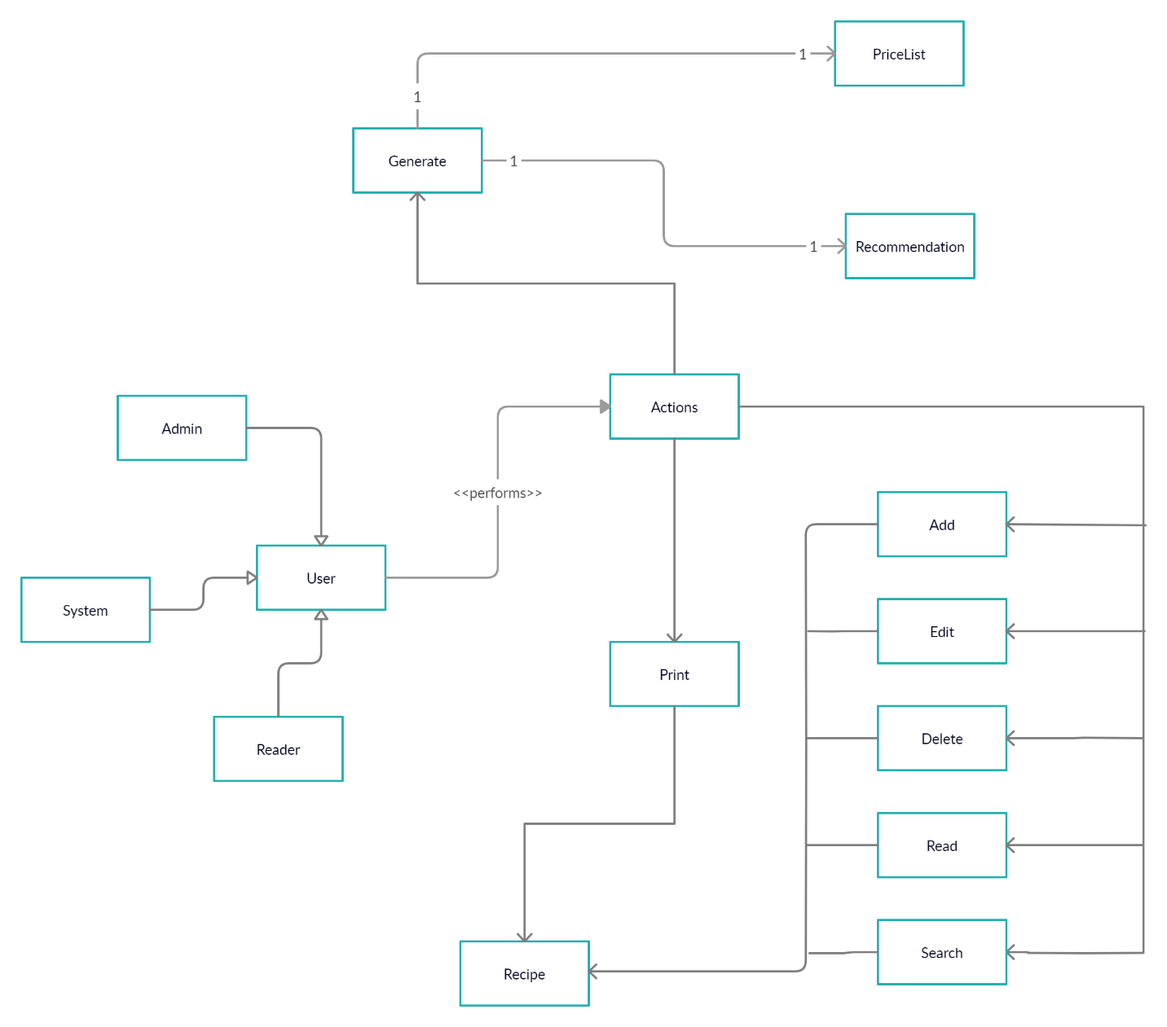

Figure: Class Diagram

* 1. Detailed Class Description
     1. **Name: Recipe**

Purpose: To Store all information related to Recipe Book

Attribute 1

Name: Title

Type: String

Purpose: To Identify Recipe by name/title

Attribute 2

Name: ID

Type: Int

Purpose: To identify and search recipe by id

Attribute 3

Name: Directions

Type: Dictionary

Purpose: To store Instructions as values with each step as key.

Attribute 4

Name: Nutrition

Type: Dictionary

Purpose: To store nutrition values of each recipe to be used as reference for machine learning model.

Attribute 5

Name: Ingredients

Type: List

Purpose: To store a list of Ingredients of recipe

Attribute 6

Name: Rating

Type: Float

Purpose: to store original ratings that was scraped

Method 1

Name: suggest_recipe

Parameters: int ID

Return Type: List

Purpose: Method to invoke Recommendation System to return a number of suggestions

* + 1. **Name: Recommendation**

Purpose:

Attribute 1

Name: Formula

Type: String

Purpose: To store name of Algorithm to be used, like Cosine, Euclidean

Attribute 2

Name: count

Type: Int

Purpose: To store Number of recommendations to return

Attribute 3

Name: recipe_id

Type: int

Purpose: To store id of recipe to base on suggestion.

Method 1

Name: nutrition_recommender

Parameter: int id, string formula, int count

Return Type: List

Purpose: method to calculate similarity and distance between items and return list of recipe id.

* + 1. **Name: IngredientPriceList**

Purpose: To store all price of ingredients scraped from various websites.

Attribute 1

Name: name

Type: String

Purpose: To store name of ingredient.

Attribute 2

Name: price

Type: float

Purpose: To store price of ingredient.

Attribute 3

Name: type

Type: string

Purpose: To store type of Ingredient, like fish, meat, vegetables.

Attribute 4

Name: scraped_from

Type: string

Purpose: To stored website name data was scraped from.

1. **Database Design**
   1. **ER Diagram**

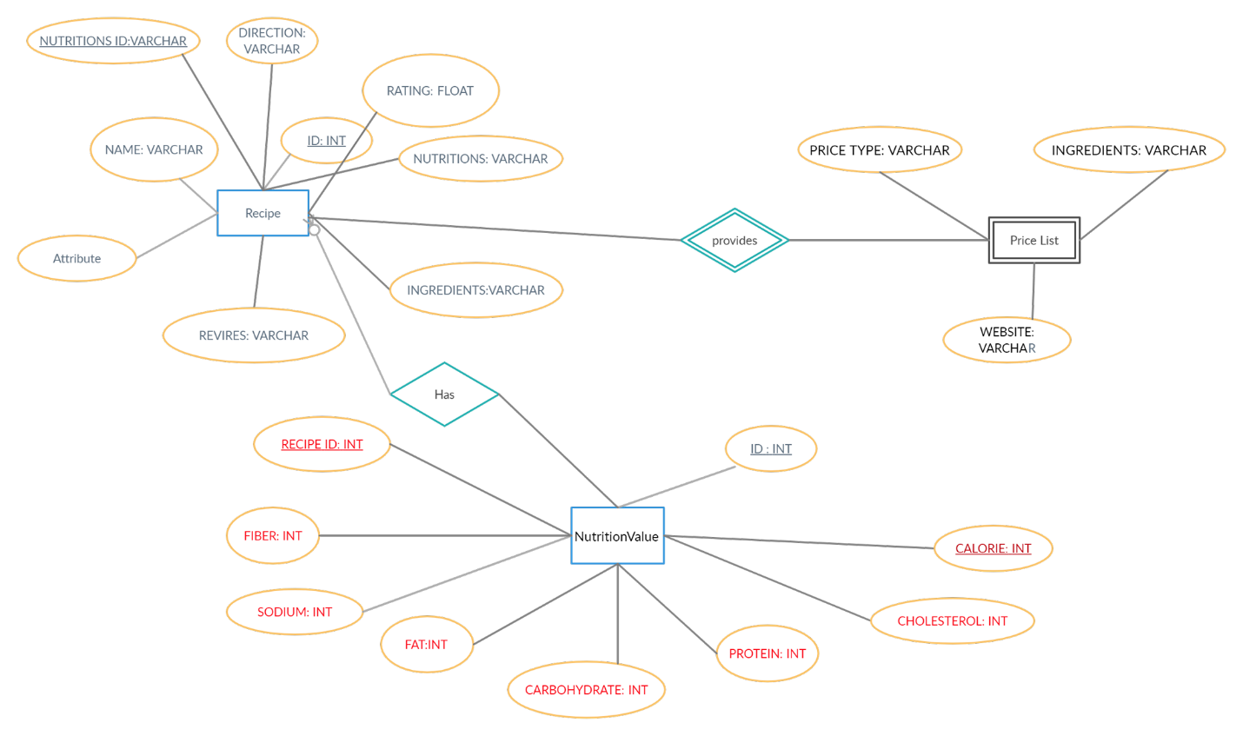

Figure: Entity Relation Diagram

* 1. **ER Description**
     1. **Table Name: Recipe**

Purpose: To Store all information related to Recipe Book

Attribute 1

Name: Name

Type: Varchar

Purpose: To Identify Recipe by name/title

Attribute 2

Name: ID

Type: Int

Purpose: To identify and search recipe by id

Attribute 3

Name: Directions

Type: Varchar

Purpose: To store Instructions as values with each step as key.

Attribute 4

Name: Nutrition

Type: Varchar

Purpose: To store nutrition values of each recipe to be used as reference for machine learning model.

Attribute 5

Name: Ingredients

Type: Varchar

Purpose: To show the ingredients list of each recipe to be used as reference for machine learning model.

Attribute 6

Name: Rating

Type: Float

Purpose: It can show a rating so that one can understand how Helpful the specific recipe is.

Attribute 7:

Name: Reviews

Type: Varchar

Purpose: write opinion about recipes.

Attribute 8:

Name: nutrition’s id

Type: int

Purpose: for identification.

* + 1. **Table Name: Price List**

Purpose: Shows Prices of all ingredients.

Attribute 1

Name: price type.

Type: varchar

Purpose: Show payment method.

Attribute 2

Name: Ingredients.

Type: Varchar.

Purpose: Price List also shows all ingredients of a recipe.

Attribute 3

Name: Website

Type: Varchar

Purpose: Websites are work for generating all ingredient prices.

* + 1. **Table Name: Nutrition Value**

Purpose: You can check out ingredient prices that we will generate for you.

Attribute 1

Name: Id

Type: int

Purpose: specify unique id of all recipe.

Attribute 2

Name: calorie

Type: int

Purpose: shows the amount of calorie remains in a recipe.

Attribute 3

Name: cholesterol

Type: int

Purpose: shows the amount of cholesterol remains in a recipe.

Attribute 4

Name: protein

Type: int

Purpose: shows the amount of protein remains in a recipe.

Attribute 5

Name: fat

Type: int

Purpose: shows the amount of fat remains in a recipe.

Attribute 6

Name: fiber

Type: int

Purpose: shows the amount of fiber remains in a recipe.

Attribute 7

Name: sodium

Type: int

Purpose: shows the amount of sodium remains in a recipe.

Attribute 8

Name: cholesterol

Type: int

Purpose: shows the amount of cholesterol remains in a recipe.

1. **Implementation Plan**

First, we will set up our Django framework and all the backend coding, connecting to the database and outputting required management system.   
Then we will build the recommendation model.

Finally, we will complete our frontend coding and user testing.