AWS Project

PART 2

Route53 configuration for VPC internal communication(with host names)

Created private hosted zone called “sample.project.com”.

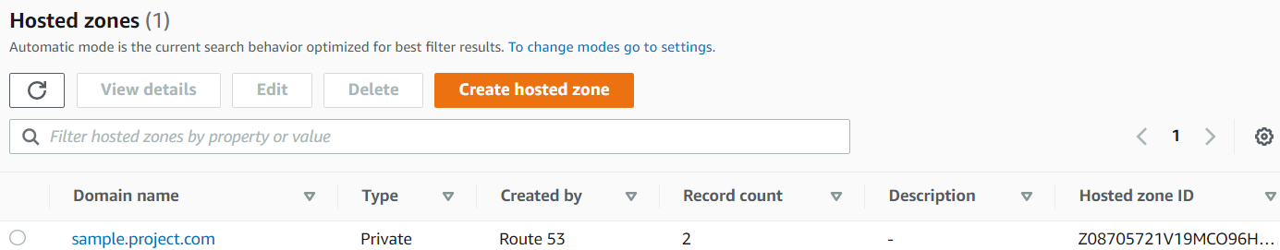

Created CNAME record for all the public and private instances which were created through automation

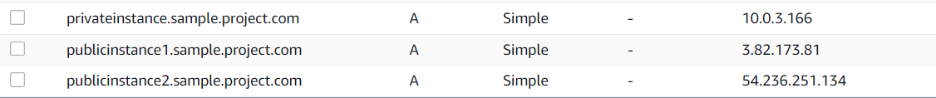

Connectivity check from publicinstance1 (10.0.1.176)

publicinstance1.sample.project.com -> 3.82.173.81

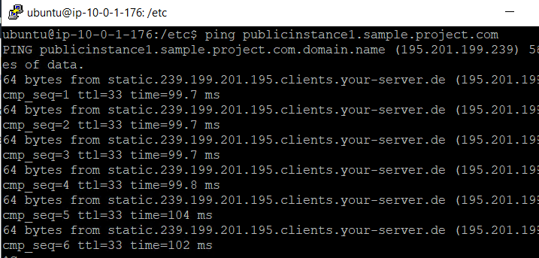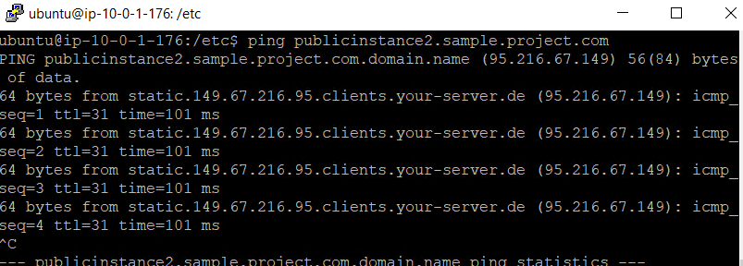

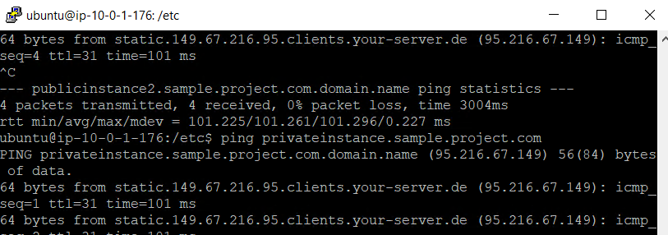

Connectivity check from publicinstance2(10.0.2.42)

publicinstance2.sample.project.com 🡪 54.236.251.134

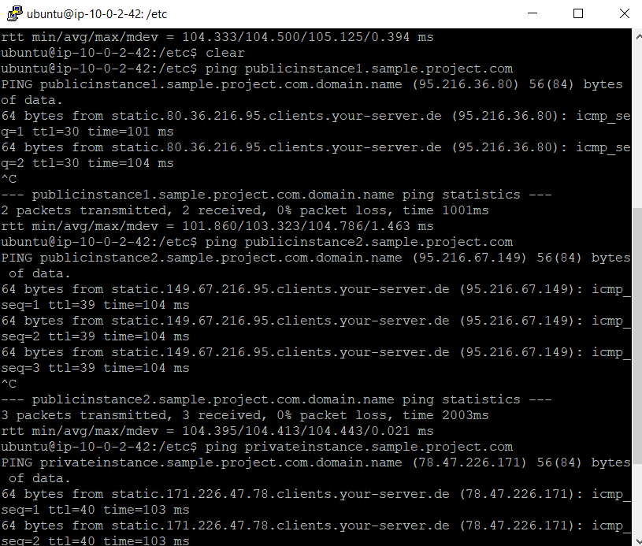

Connectivity check from

privateinstance.sample.project.com -> 10.0.3.166

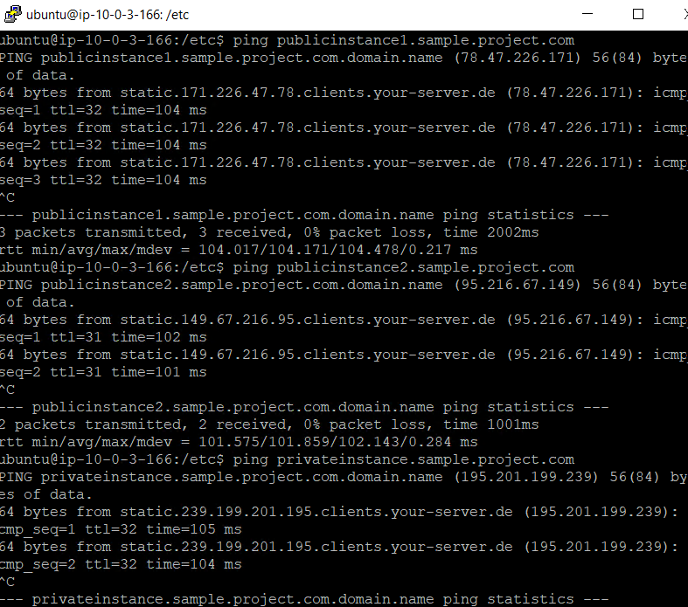

Mysql DB should be accessible only from ASG EC2 instances (hint:SG)

Created SG “type” as mysql to allow the mysql connection and to limit the connection from specific ASG instances, added the IP address of those instances.

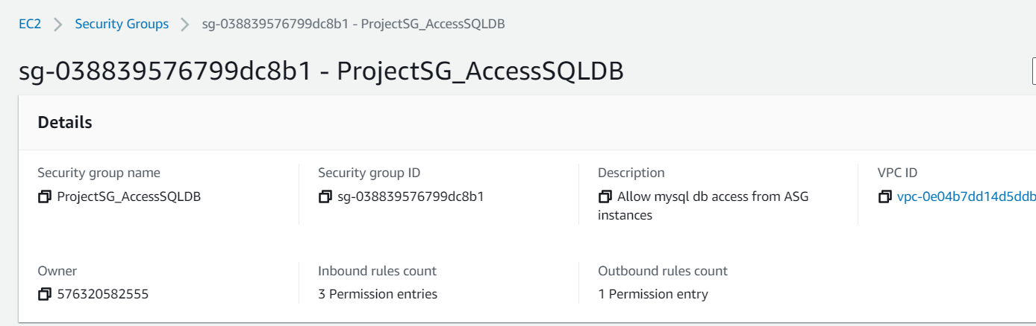

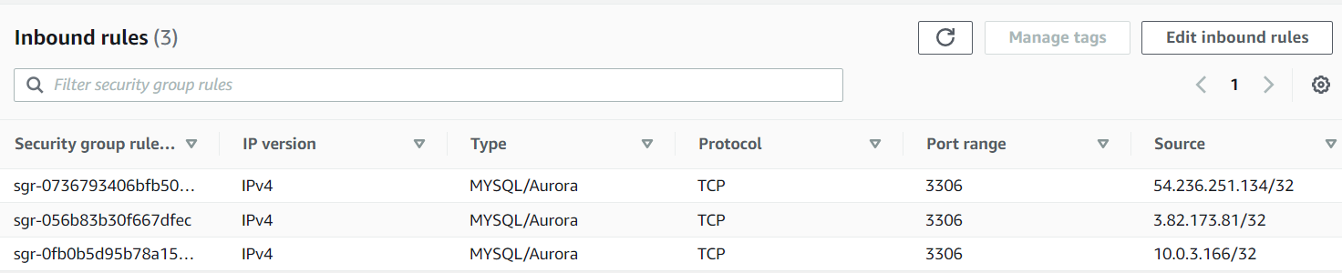

DB instance connectivity from ASG EC2 working fine

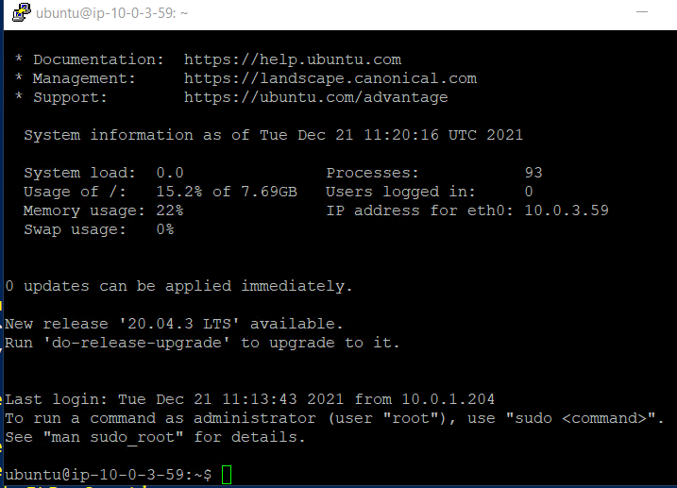

The connection fails when try to connect from the instance which is not part of ASG

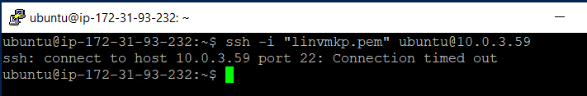

Created a user called testproject_user



Assigned policies to testproject_user to access EC2,VPC,Route53

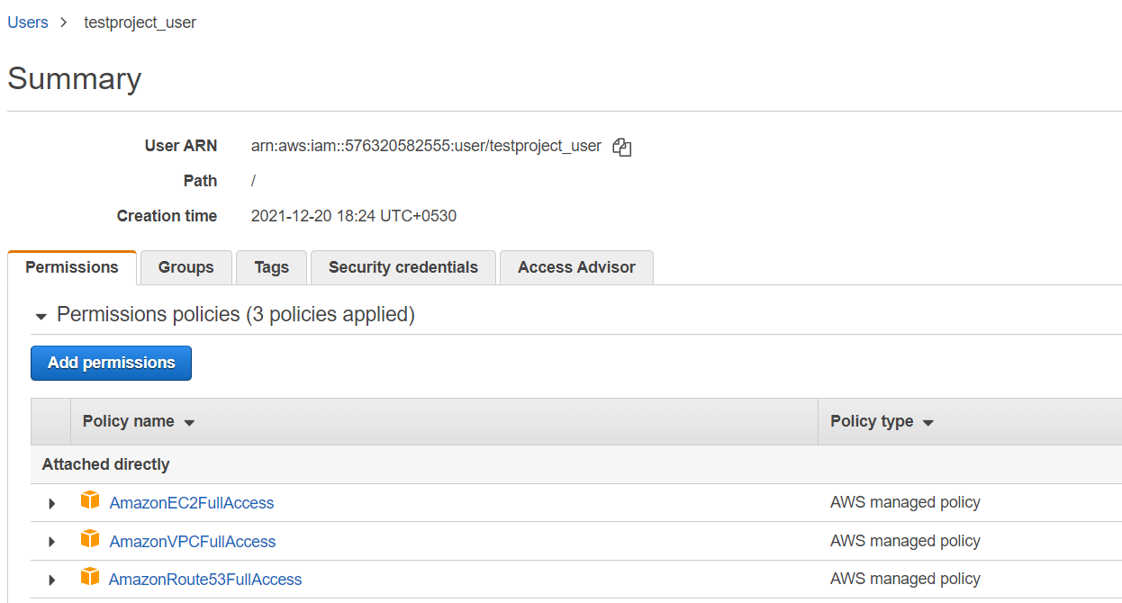

EC2 is accessible

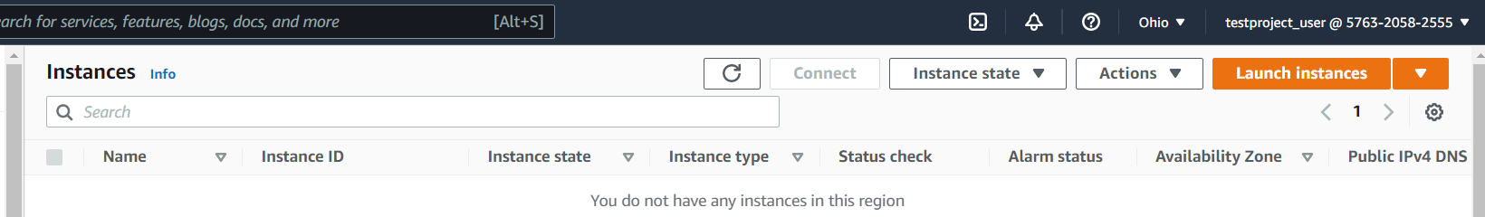

Given above permissions S3 will not be able to access

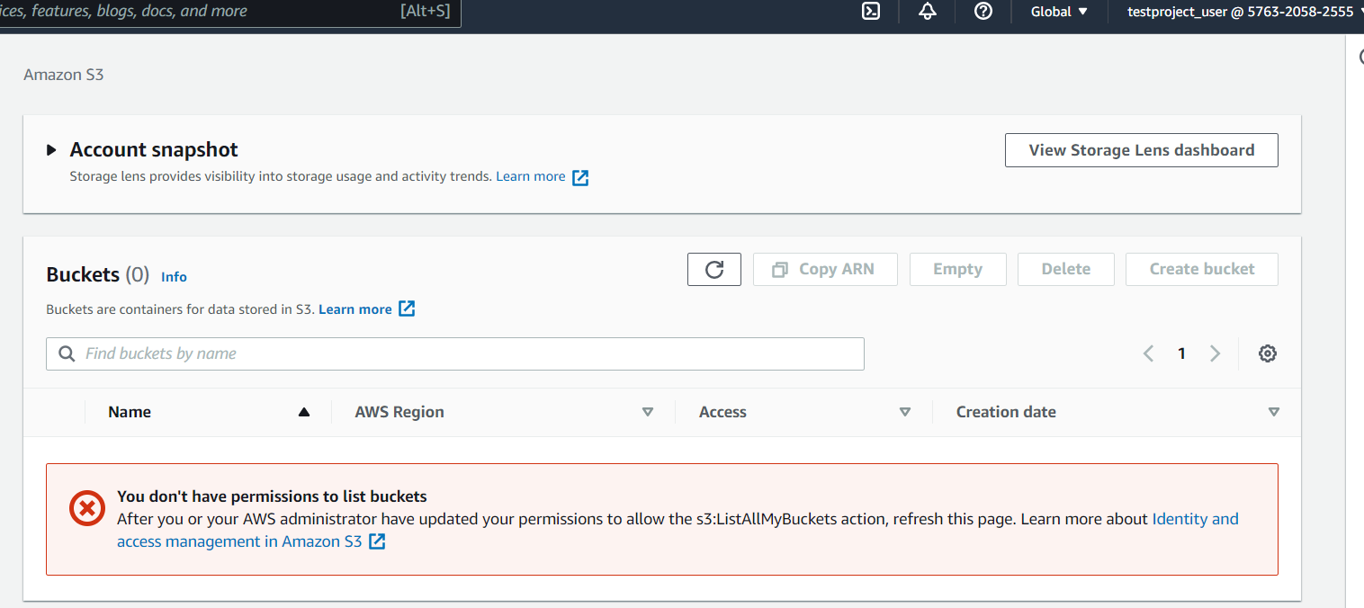

Create S3 bucket to store logs:

Created s3 bucket called “awsprojecttestbucket”  
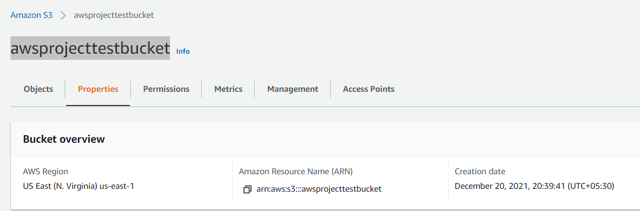

Enabled logging system and chosen another s3 as destination to store the resources

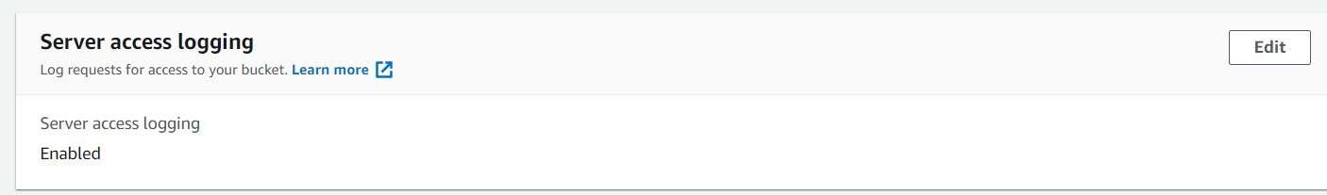

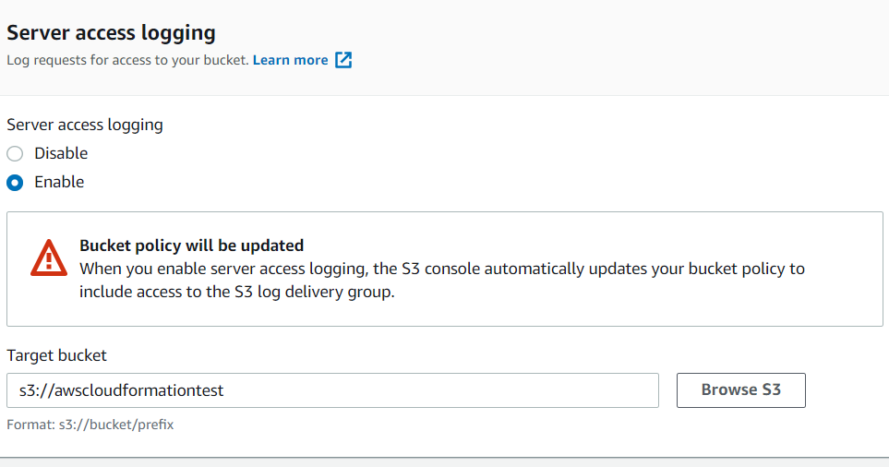

All EC2 instances should have access to S3

Created role called “aws-ec2-s3-access” and added policy to access the s3 from ec2 instances.

