AWS_PROJECT  
PART-3

1)Cloud watch dashboard for monitoring

Created resource group to add the required EC2 instances.

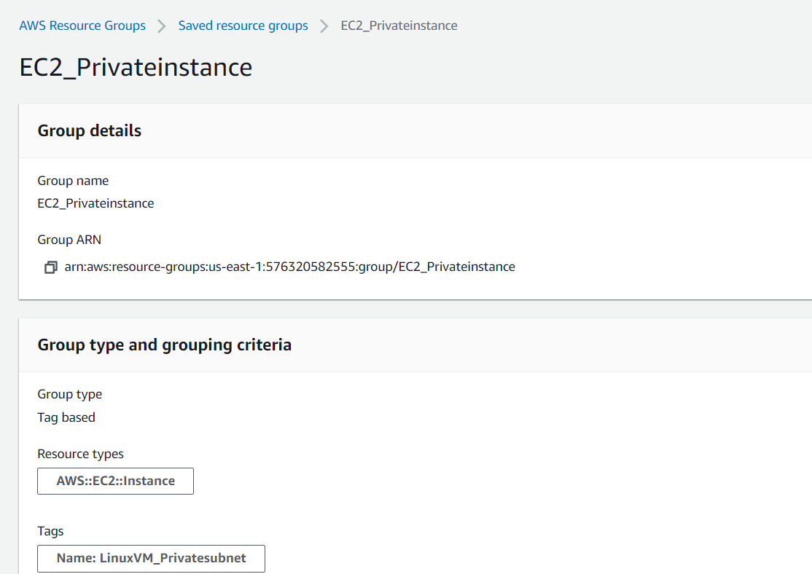

In the cloud watch dashboard selected the required resource group to view the monitoring details.

CPU  
  
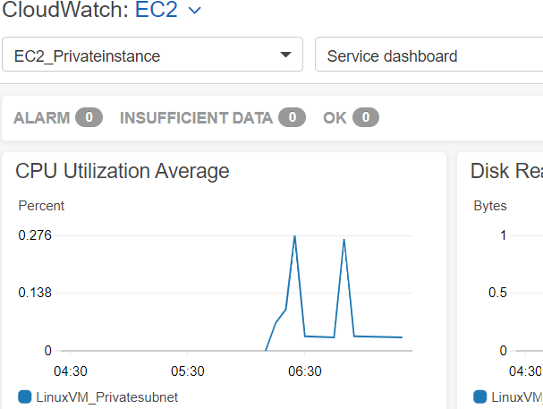

Network  
  
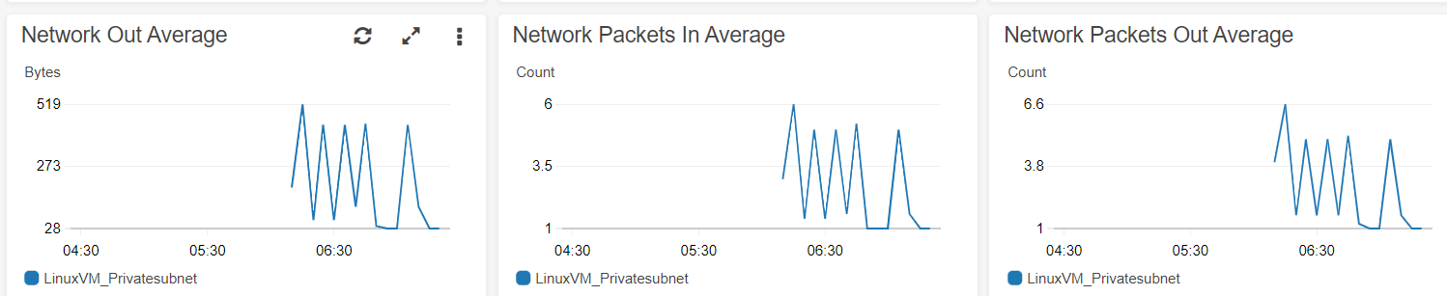

Disk

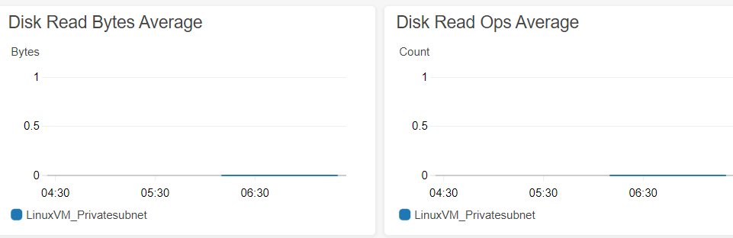

ELB Traffic

