AWS Project

PART 1-Cloudformation

VPC



Public & Private Subnet

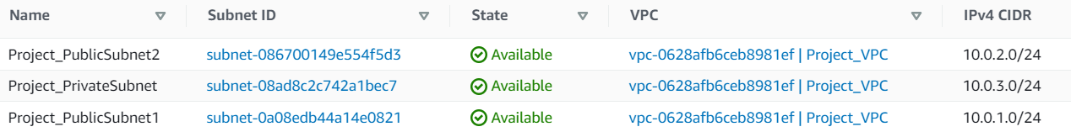

Public - Route table, route and association

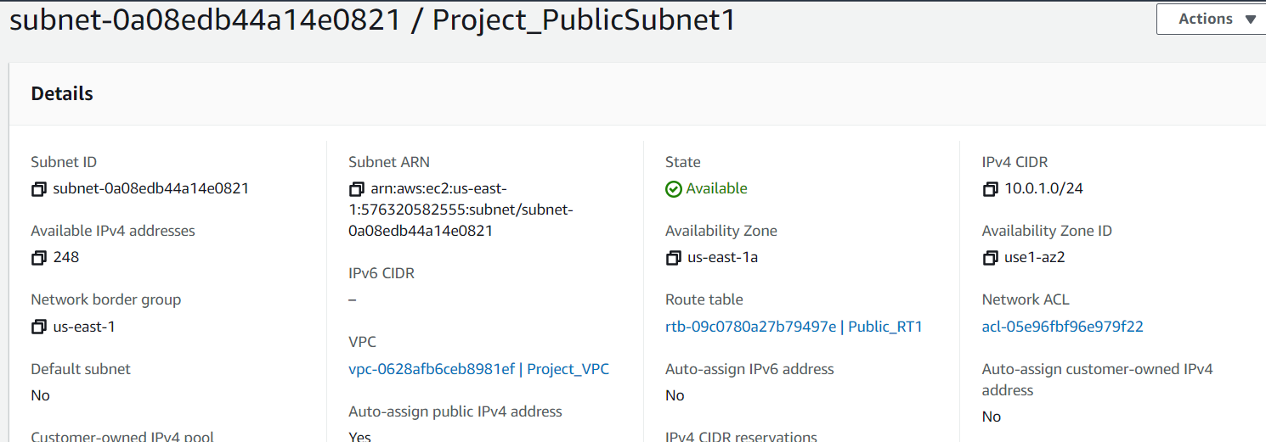

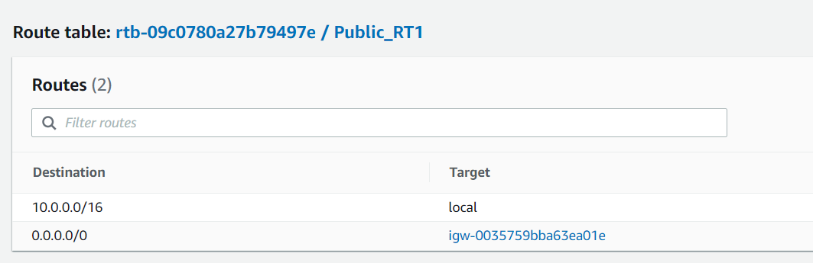

Internet Gateway & public subnet attached



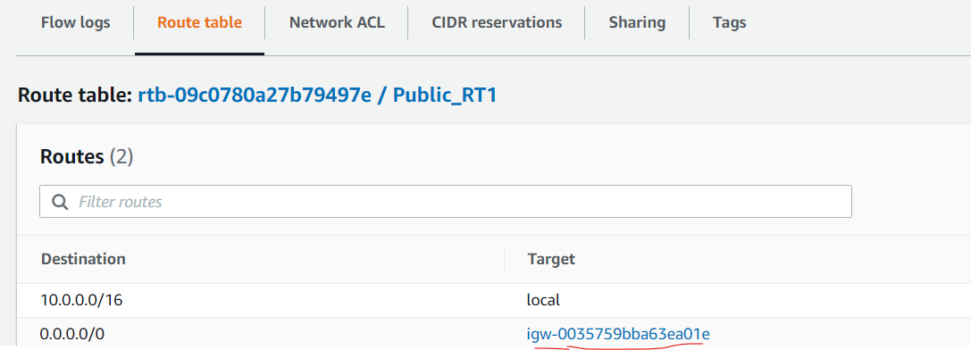

Private - Route table, route and association of route table

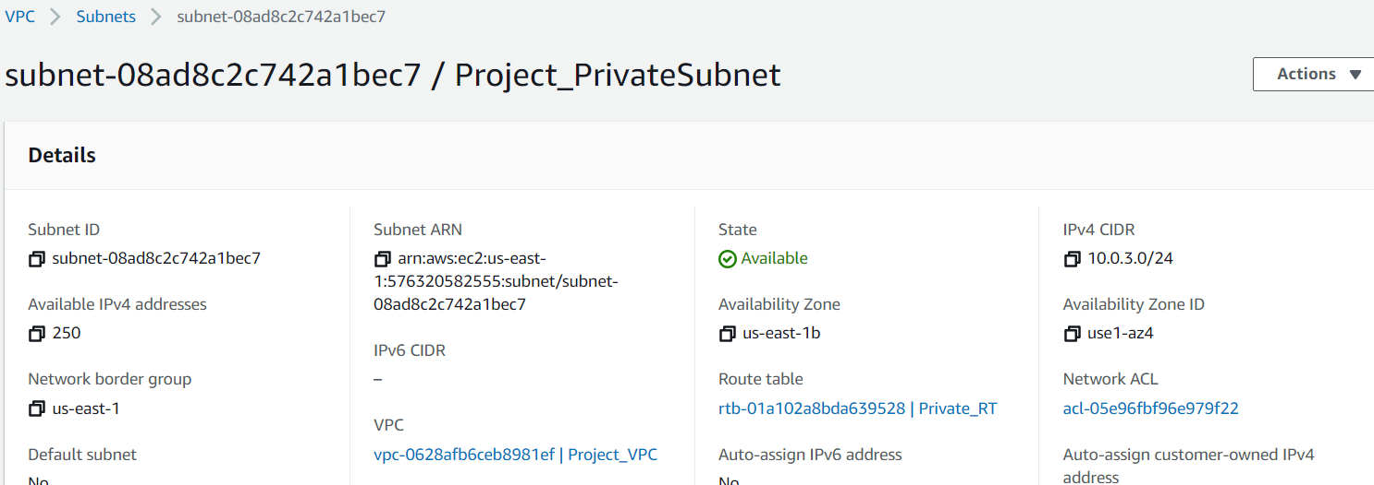

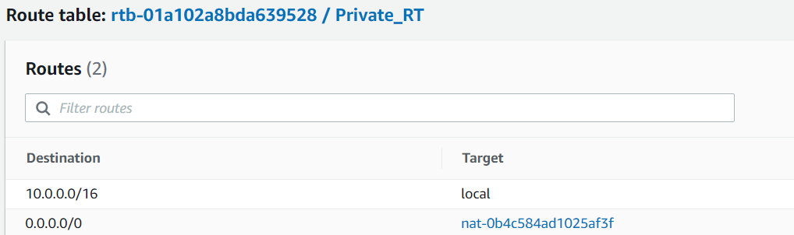

NAT Gateway creation and altered private route table to attach to it



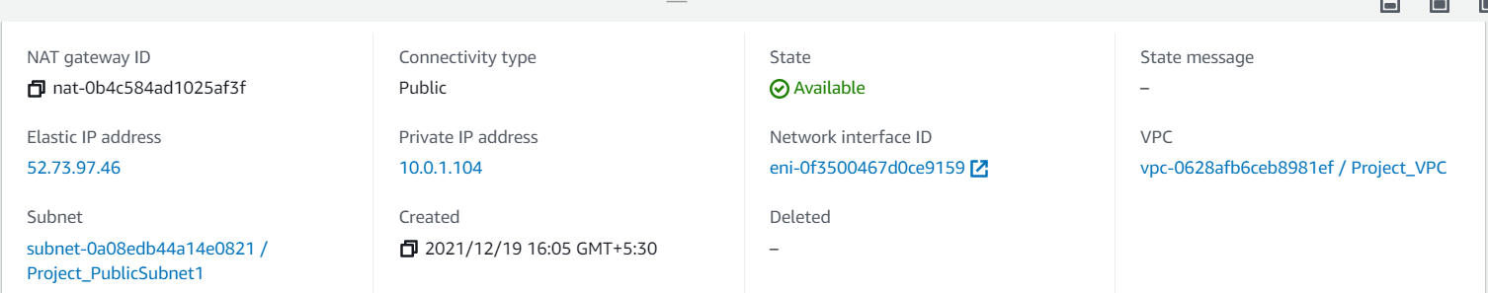

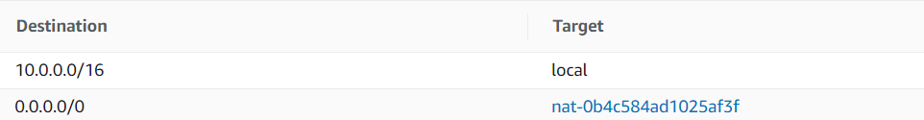

Cloud formation stack creation for the script execution

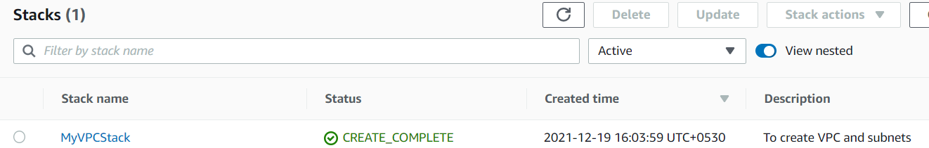

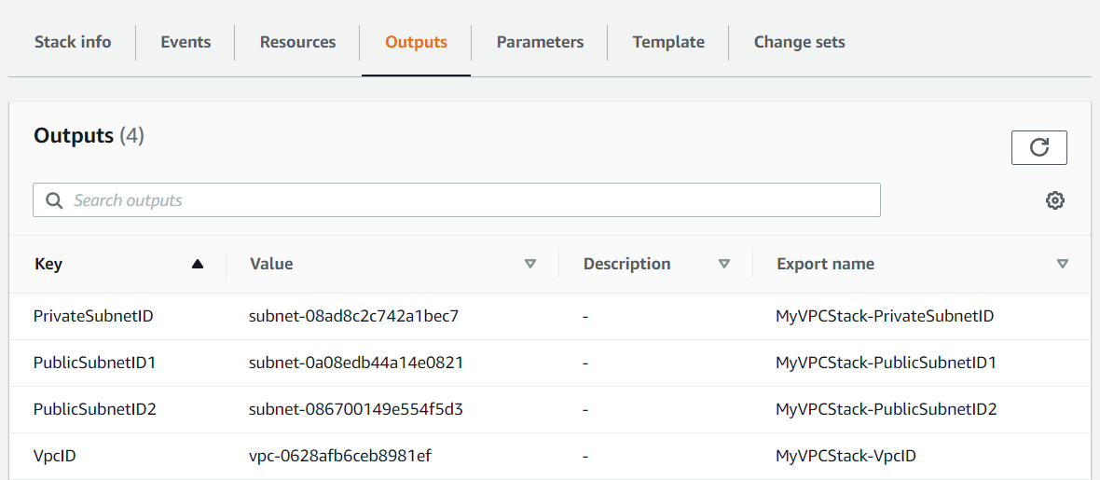

PART 1-Terraform

Auto Scaling group creation for public subnet EC2:

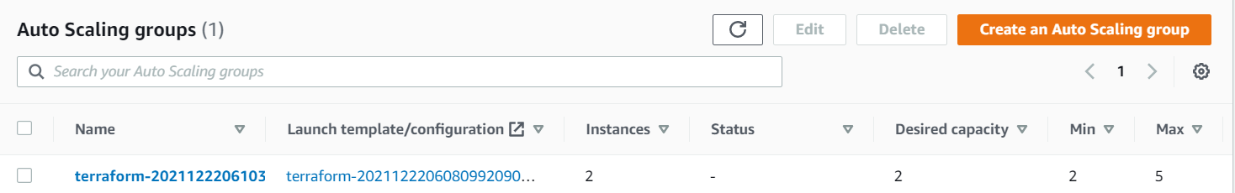

Launch configuration for the instance launch

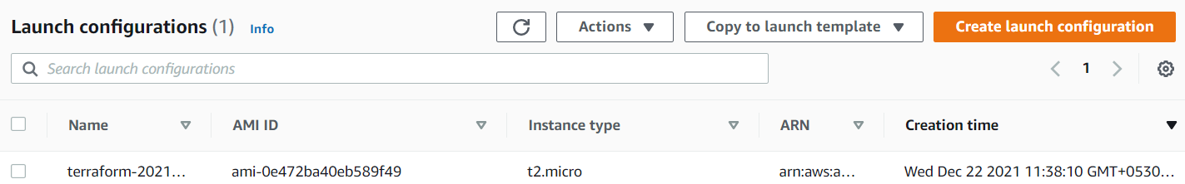

NLB creation for the ASG instances



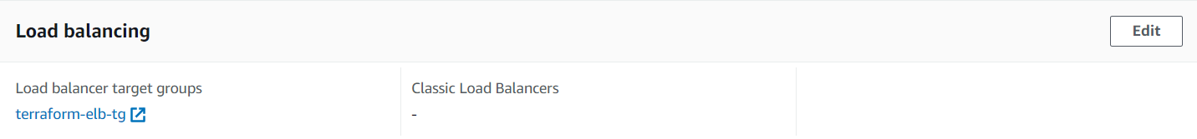

Target group for the NLB

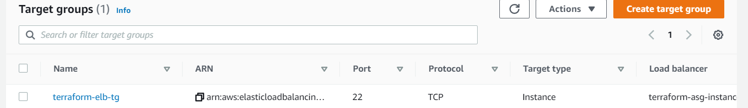

Public subnet EC2 instances



In Private subnet EC2 instance creation using terraform



Apache installation:

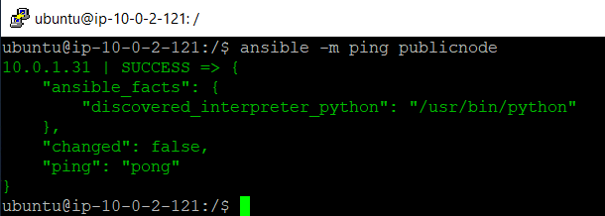

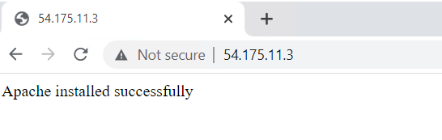

Installation of MySQL on the private node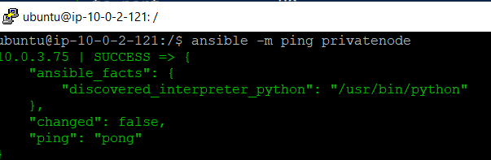

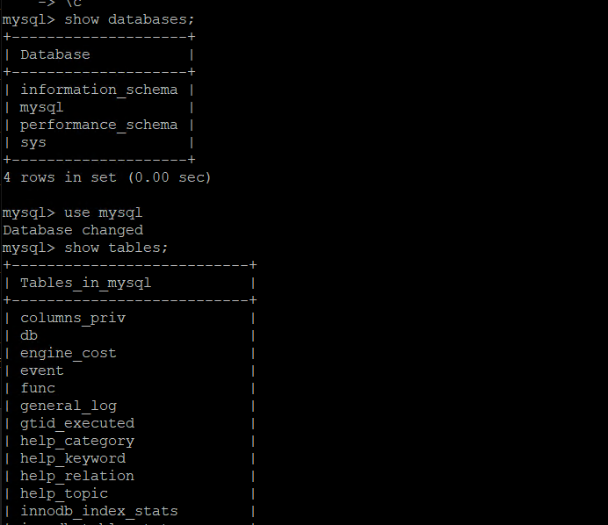

Route53:

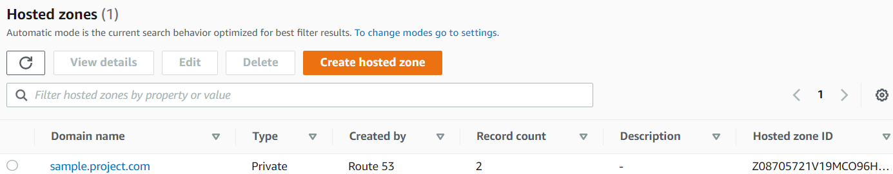

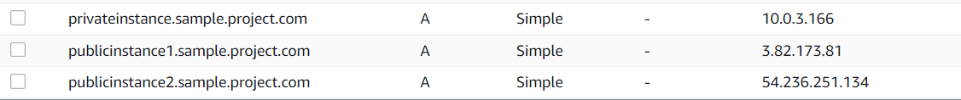

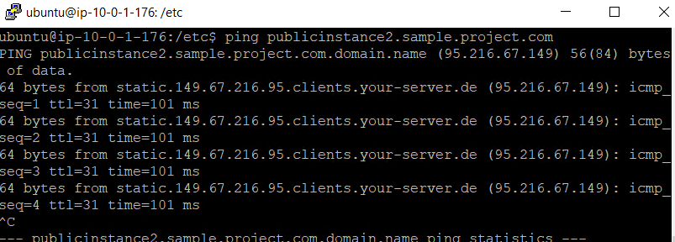

Mysql connectivity only from ASG

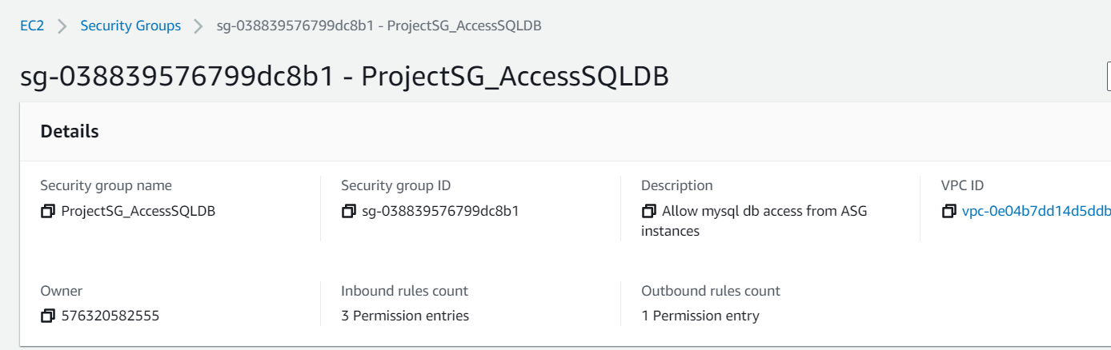

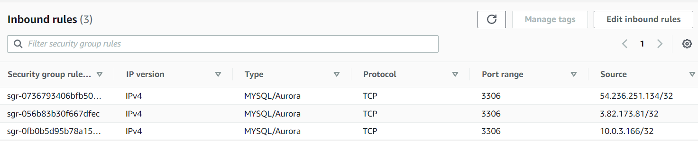

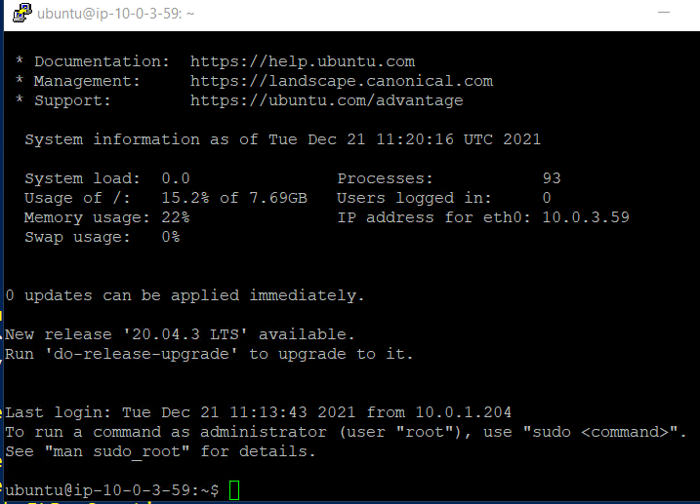

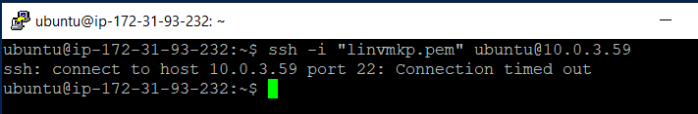

Assign access to ec2, vpc, route53

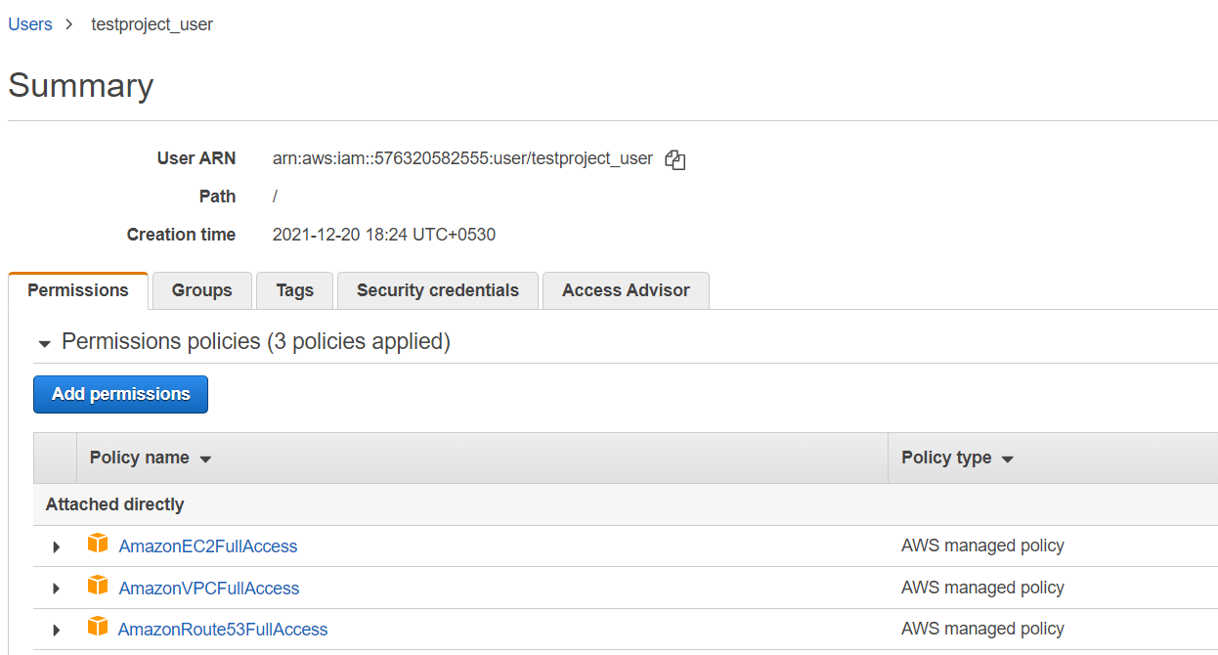

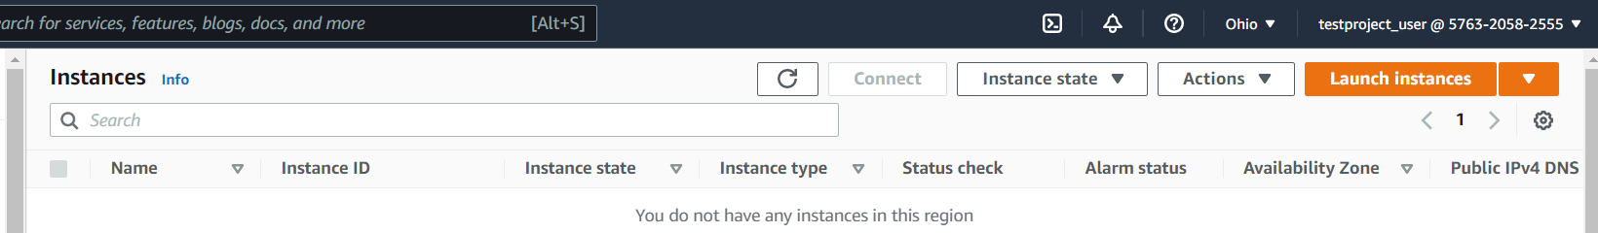

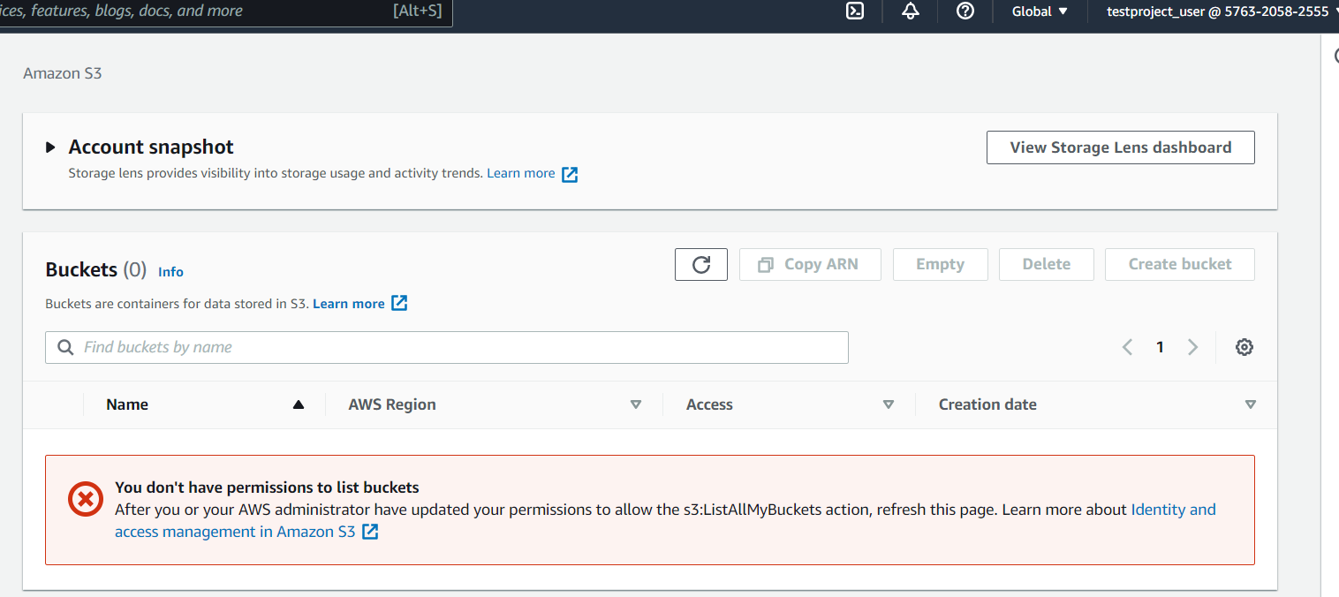

S3 bucket

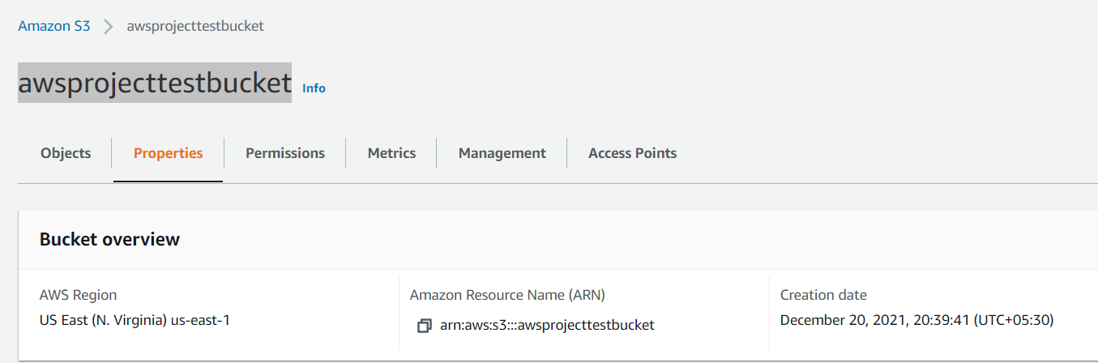

EC2 instances access to s3

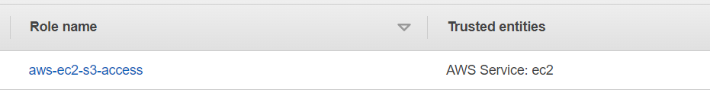

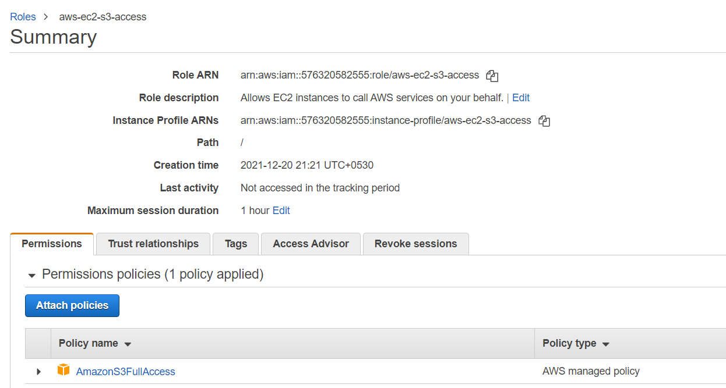

Part3 monitoring

