**Question 2 (b.i):** See code implementation file “CSCE_633_HW_1_KNN.ipynb”

**Question 2 (b.ii):**

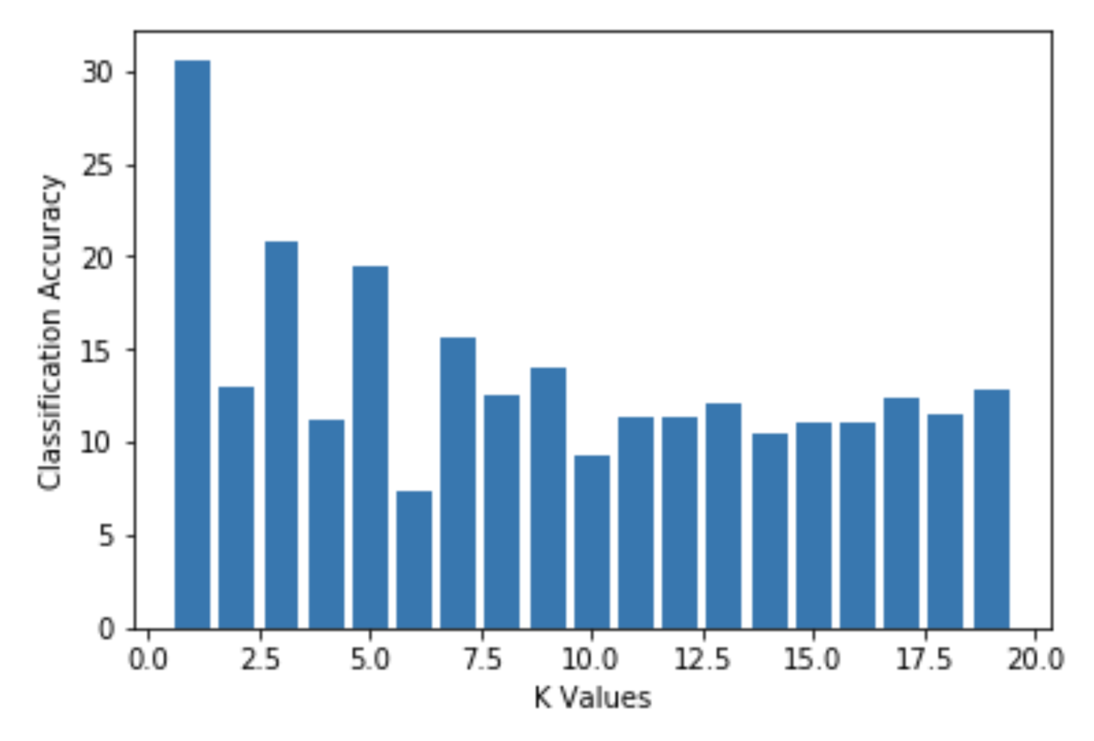

**Question 2 (b.iii):** The implemented knn classifier achieved a 20% accuracy on the test set, using 1 neighbor as the K-neighbor value.

**Question 2 (c.ii):** See code implementation file “CSCE_633_HW1_LinReg.ipynb”

**Question 2 (c.iii):**

Implementation RSS: 103859.81915729915

Correlation between actual and predicted value: 0.1651764113320483