**Question 1:**

See CSCE_633_HW_3_Q1.ipynb

(a.i) (0.5 points) Calculate the convolution of F with filter W1 = [1 1 1], i.e., F1 = F ?W1.

What is the operation that filter W1 performs?

Operation: High pass filter

(a.ii) (0.5 points) Calculate the convolution of F with filter W2 = [1 0 −1], i.e., F2 = F ?W2.

What is the operation that filter W2 performs?

Operation: Low pass filter

**(b.i) (2 points) Implement a 2-d convolution between the image and the filter. Note: You**

**can ignore the edge pixels and only compute the convolution for those pixels which have all**

**neighbors.**

See python file “question_1_b_ii.py”

**Question 2: Image processing for human faces**

1. **(2 points) Implement Principal Component Analysis (PCA)**

**See CSCE_633_HW_3_Q2.ipynb**

**(b) (0.5 points) Plot a curve displaying the first k eigenvalues:**

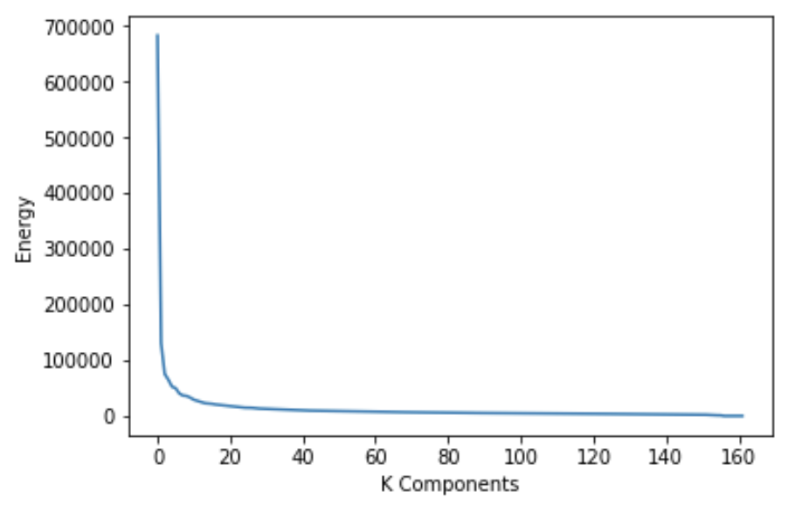

**It appears we need 5 components to capture 50% of energy.**

1. **(0.5 points) Plot the top 10 eigenfaces.**

**See images in folder, “eigenFaces”**