# Problem 1:

a) The following was plotted from “106.txt” at sample 83.

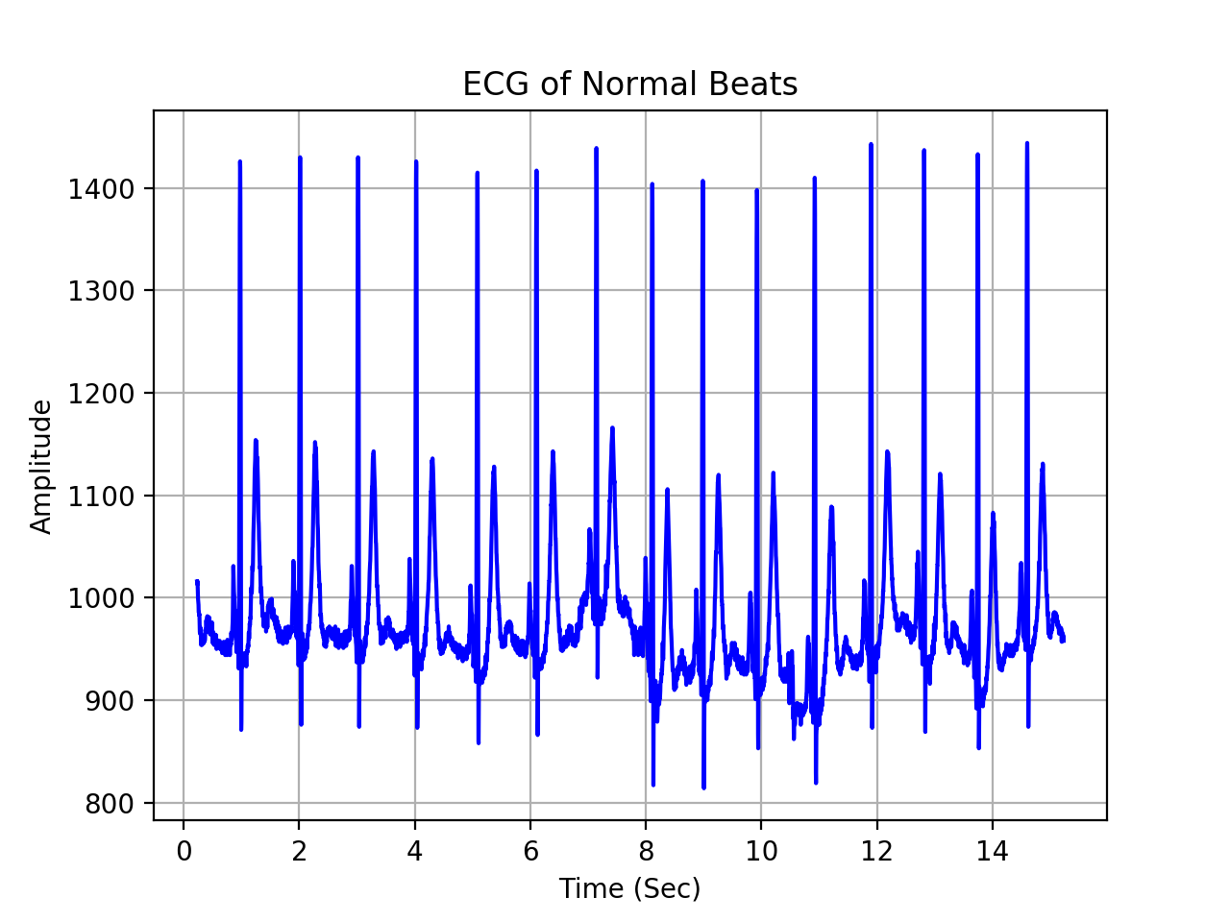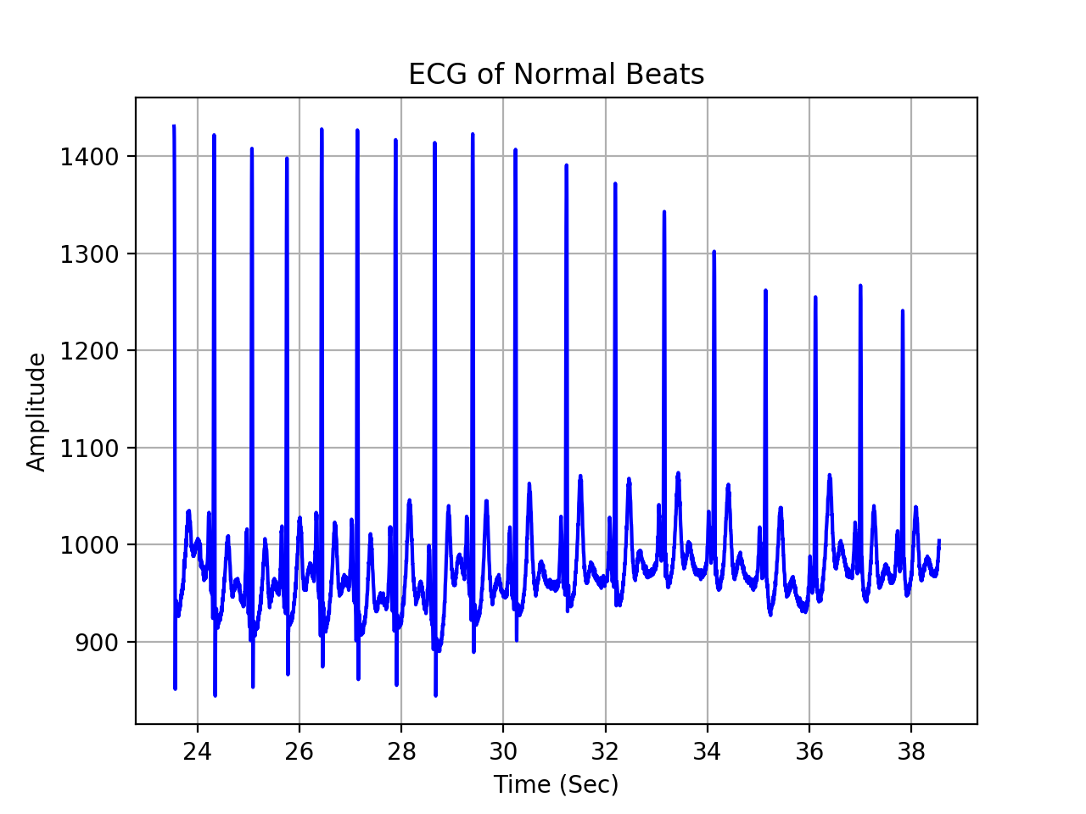

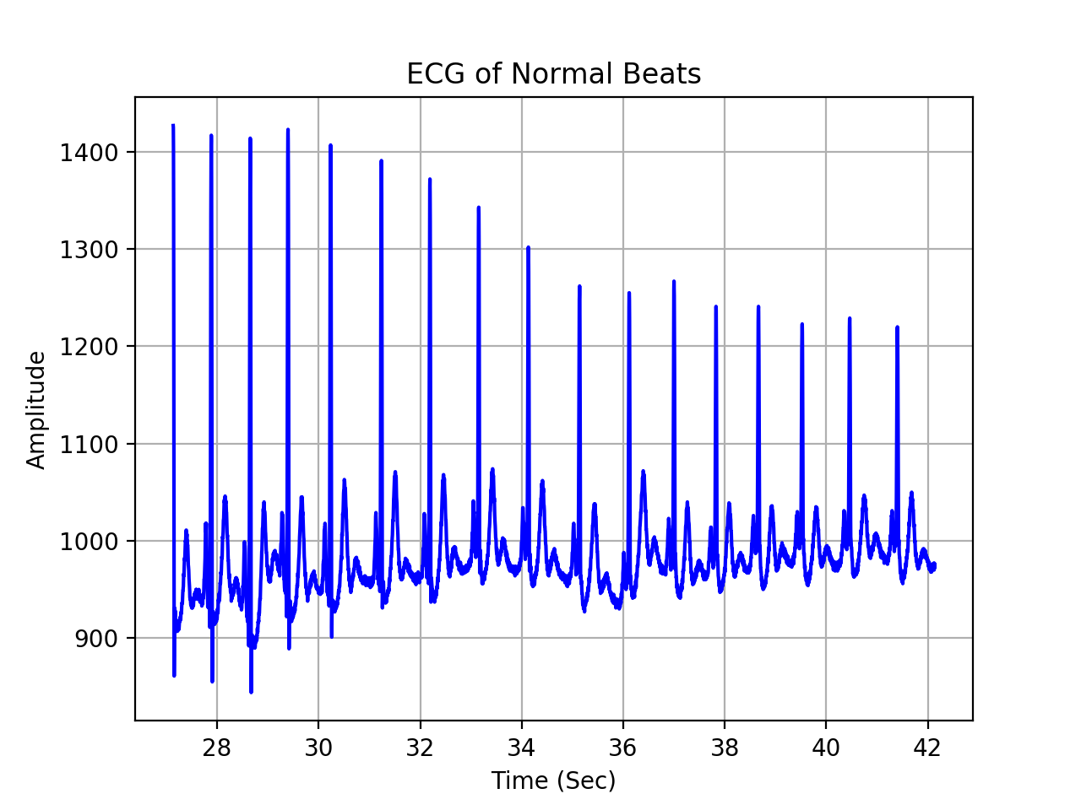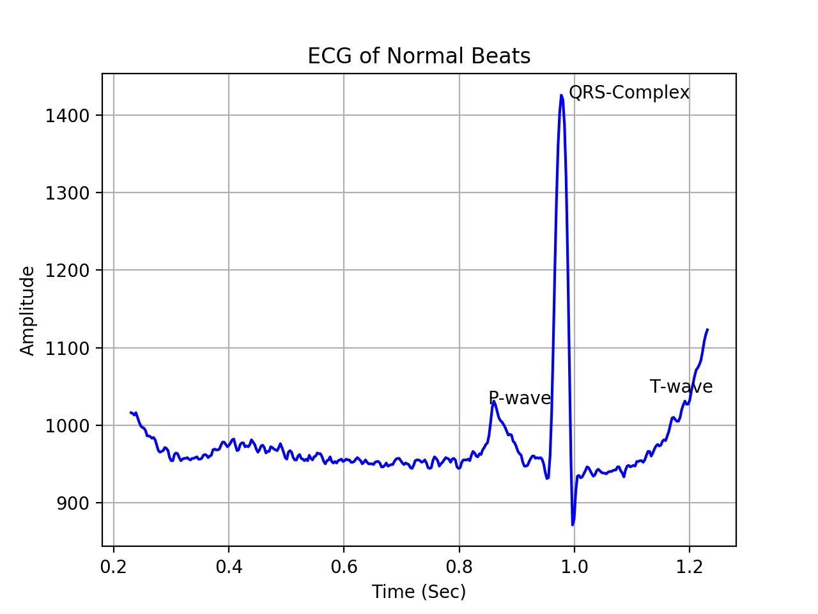

b) The following was plotted from “106.txt” at sample 32867.

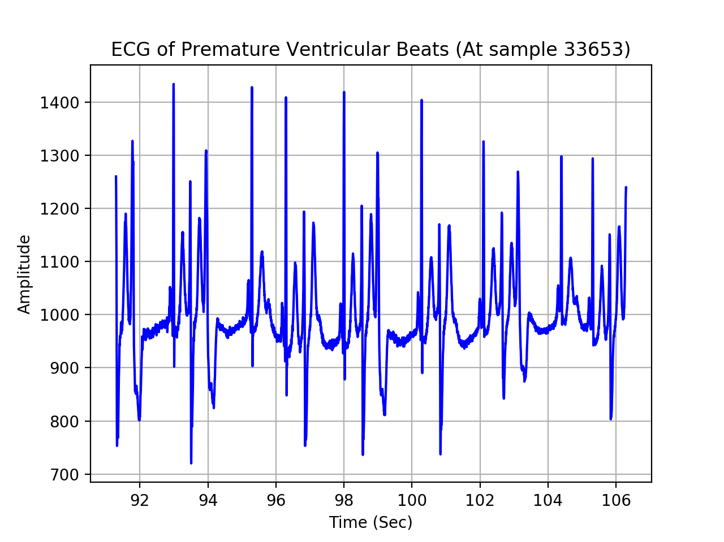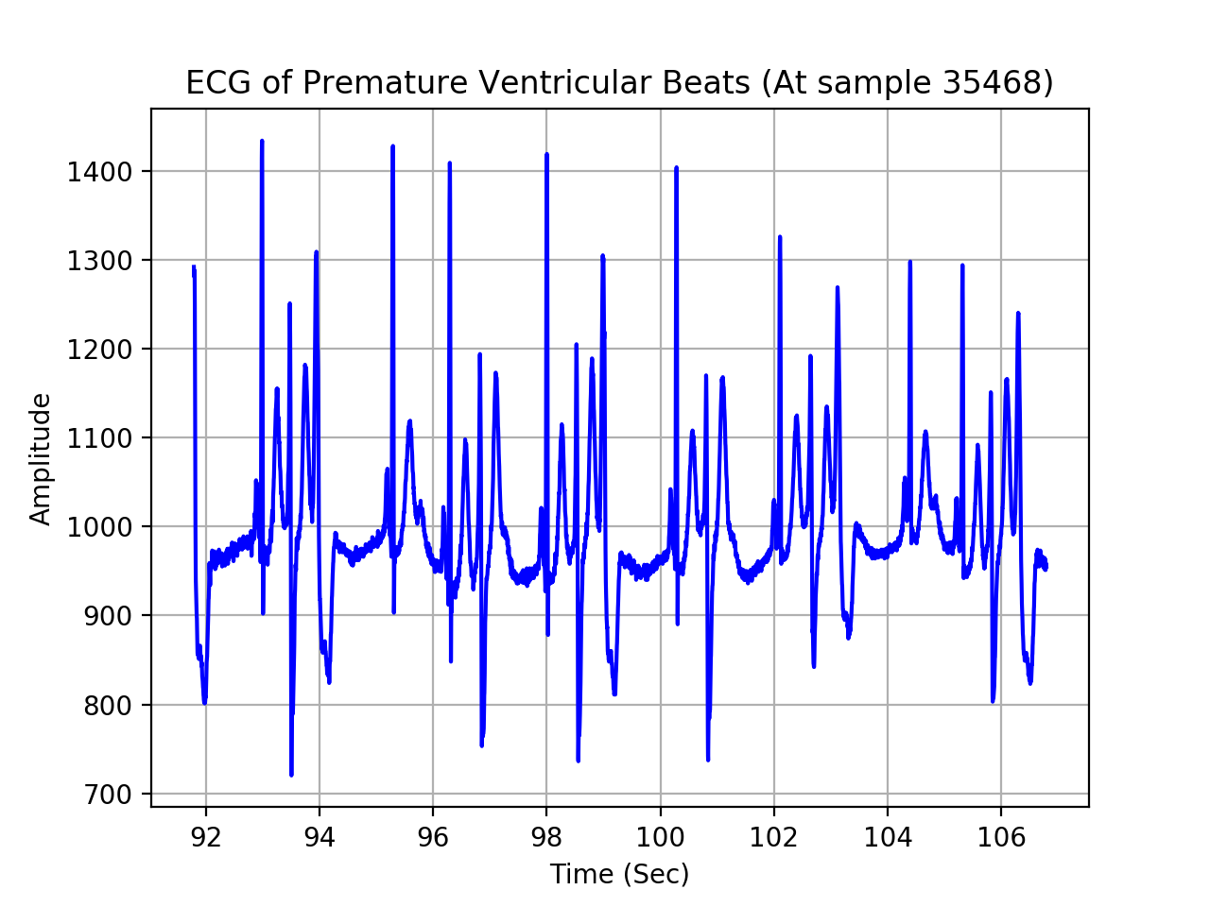

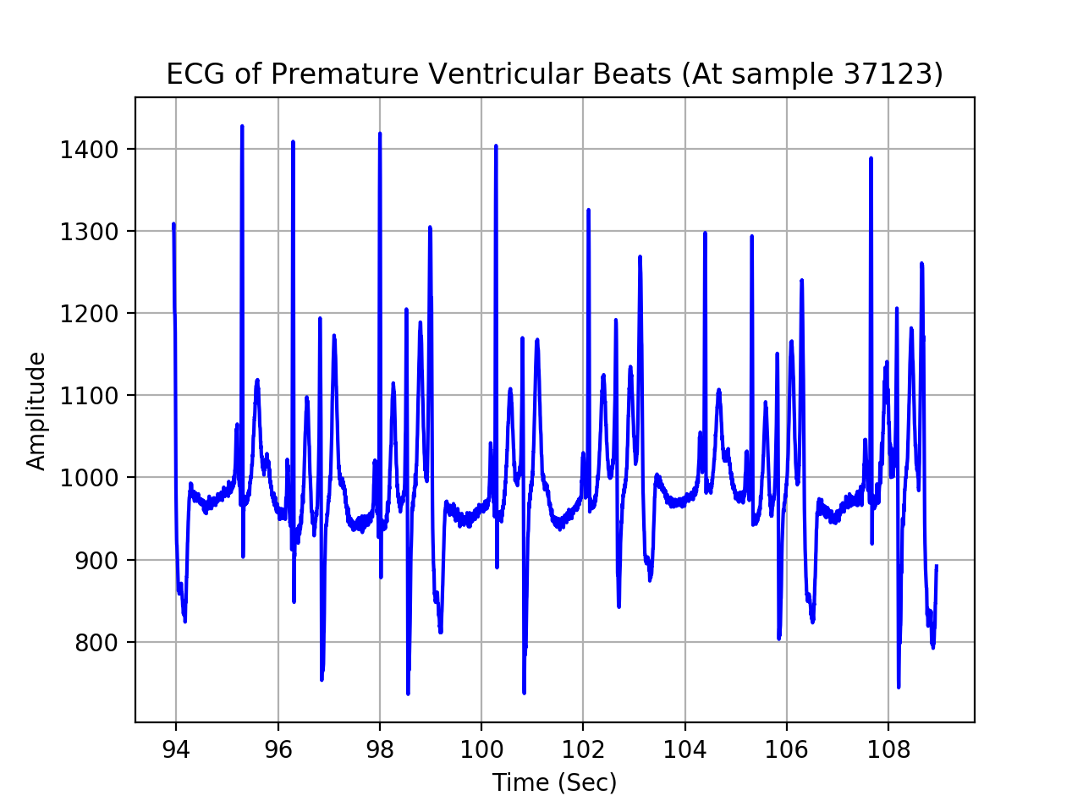

c) Associated graphics can be found in folder, “HW2_1_c”. Subfolders, “1_c_83”,”1_c_8475”,”1_c_9679” are based on samples with normal heart beats. Subfolders, “1_c_32867”,”1_c_33045”,”1_c_33820” are based on samples with abnormal heart beats.

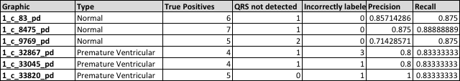

Normal samples appeared to have accurate readings of QRS complexes, with the occasional instance of 1 or 2 complexes not identified. Normal samples, in addition, showed no instances of incorrectly labeled QRS complexes on either the P or T waves. With respect to abnormal heartbeat samples, there were less instances of correctly identified QRS complexes. Incorrectly identified QRS complexes can be attributed to extended T-wave sections in the studied time sample.

d)

# Problem 2:

a) Data from trial 1 of participant ‘S01’ was used. Frequencies used included 50,150,360,1000, and 1500. It appears that increasing the cutoff frequency produced more pronounced peaks with each frequency iteration.

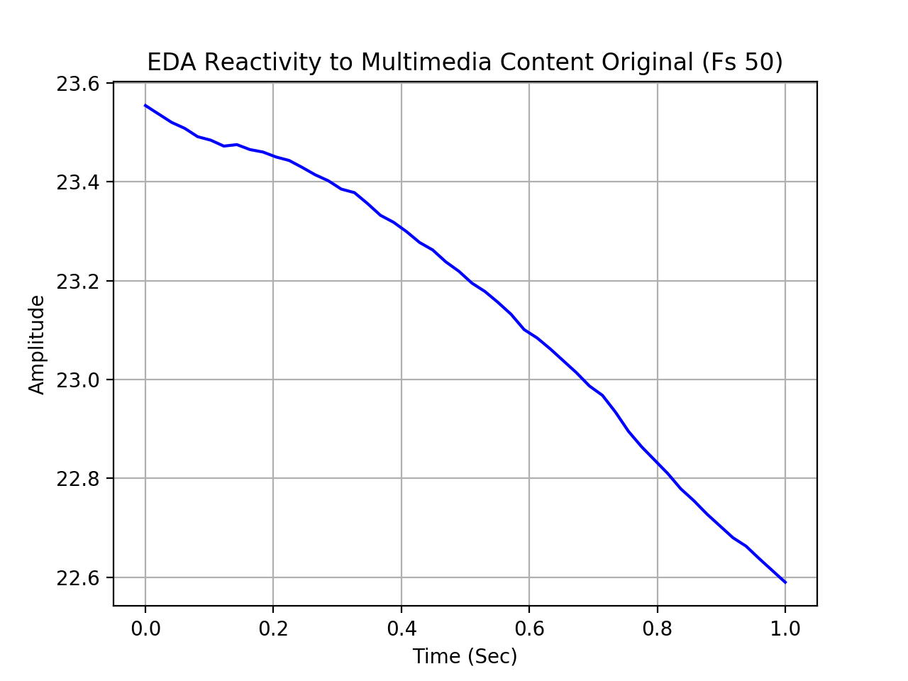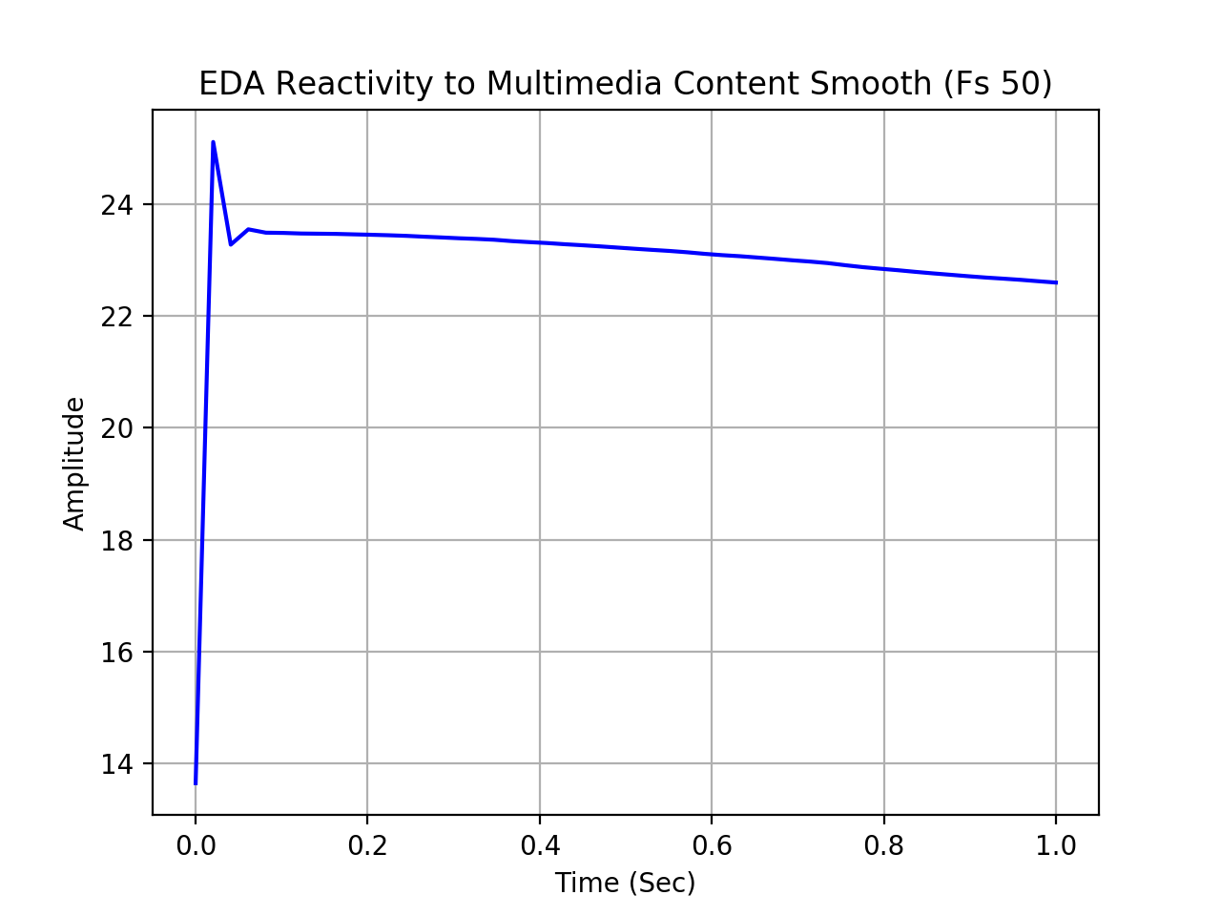

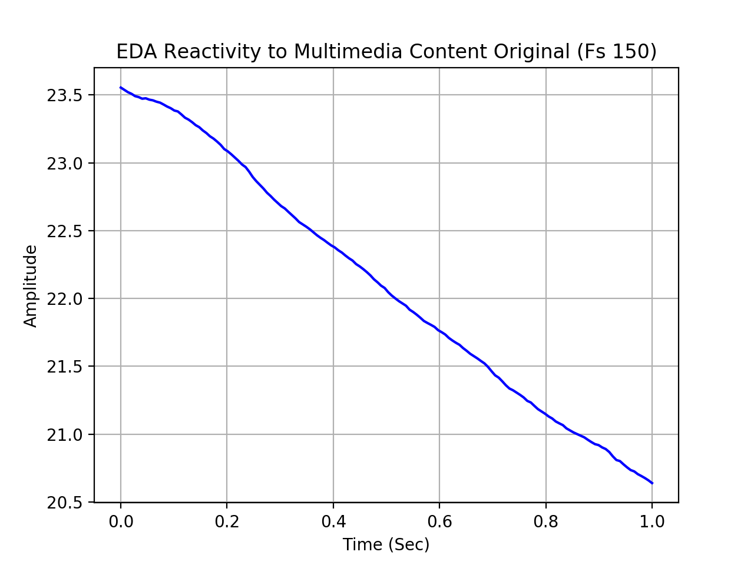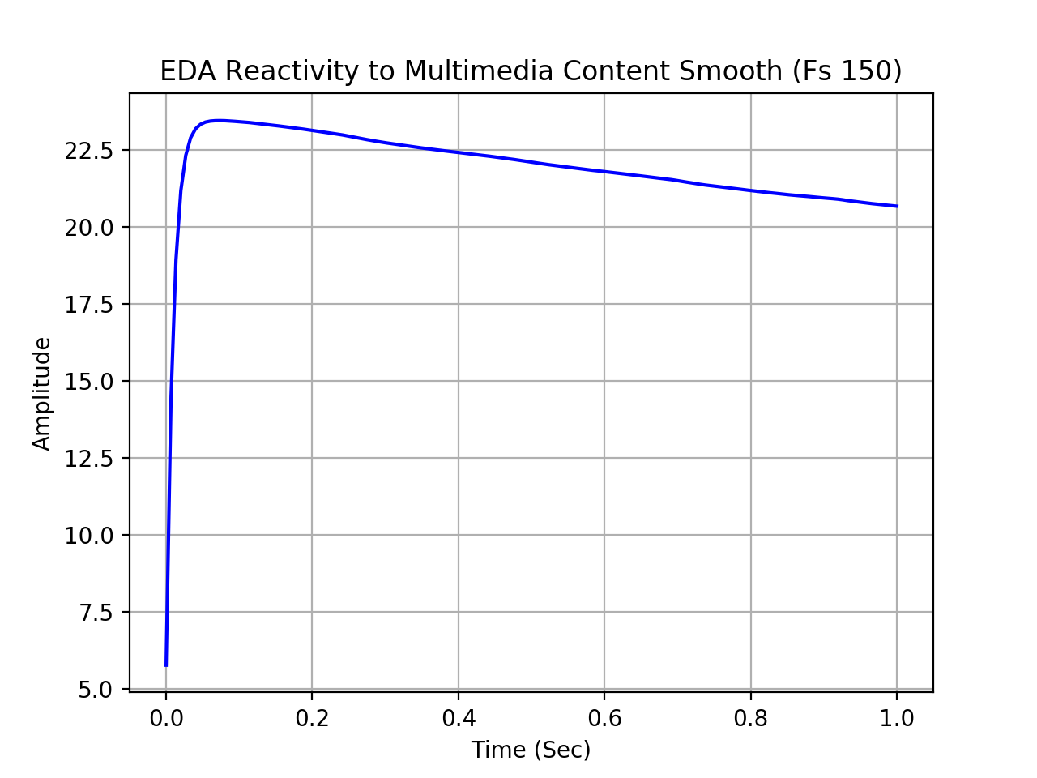

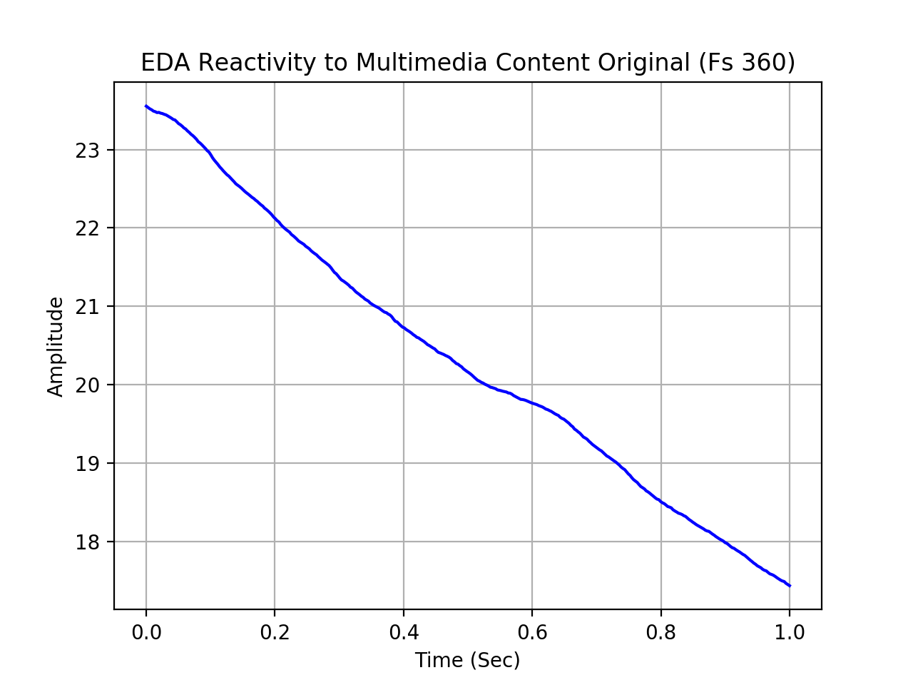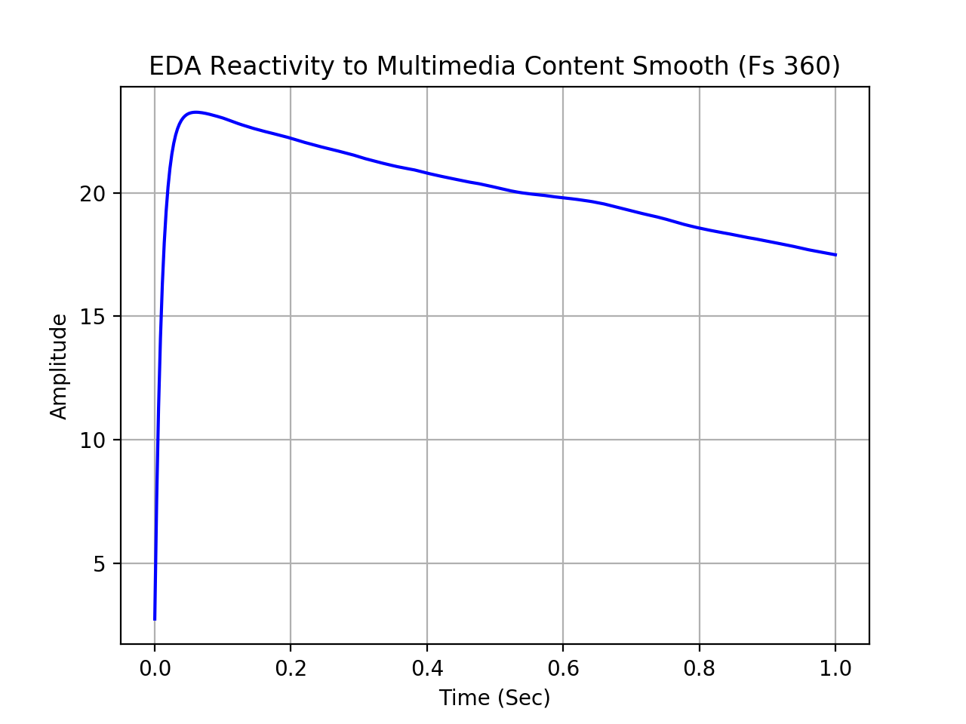

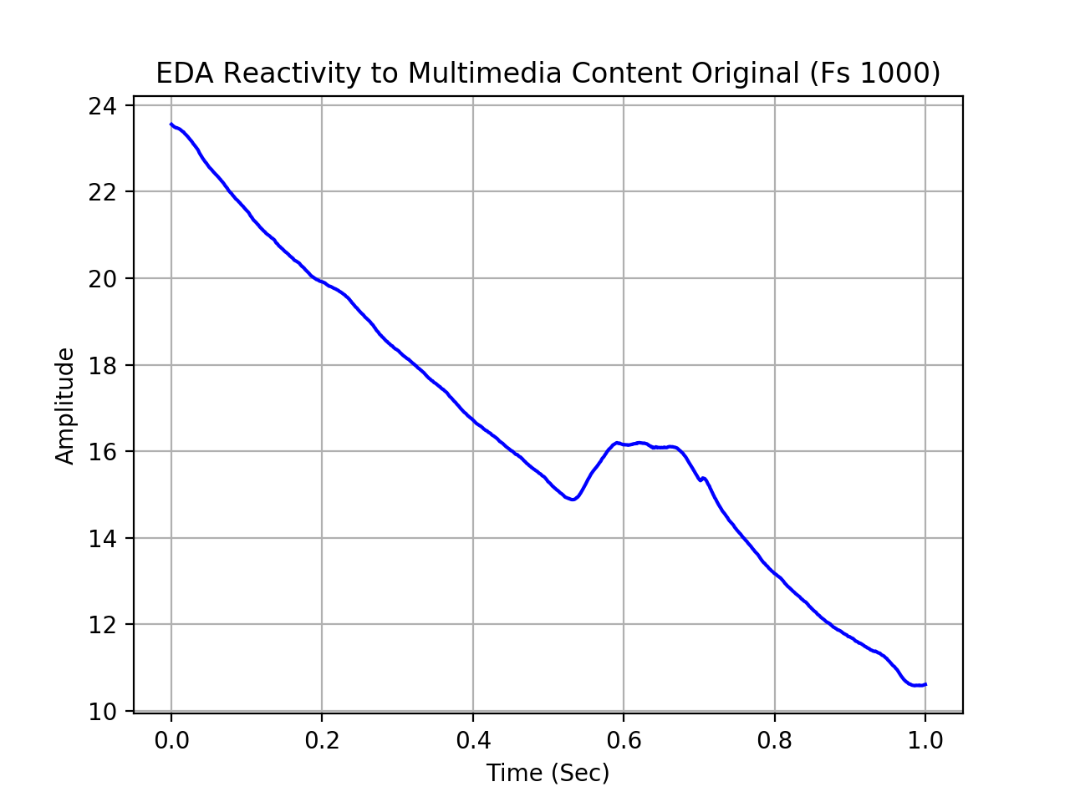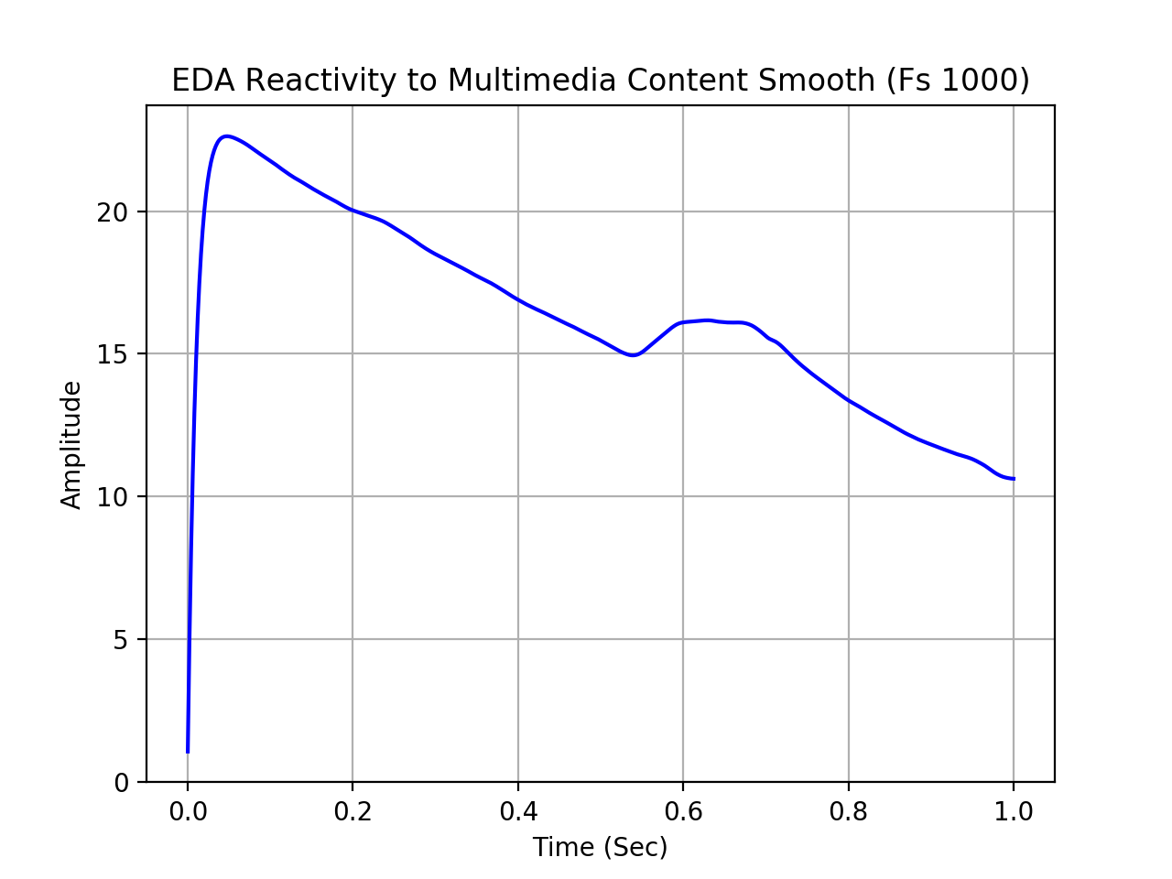

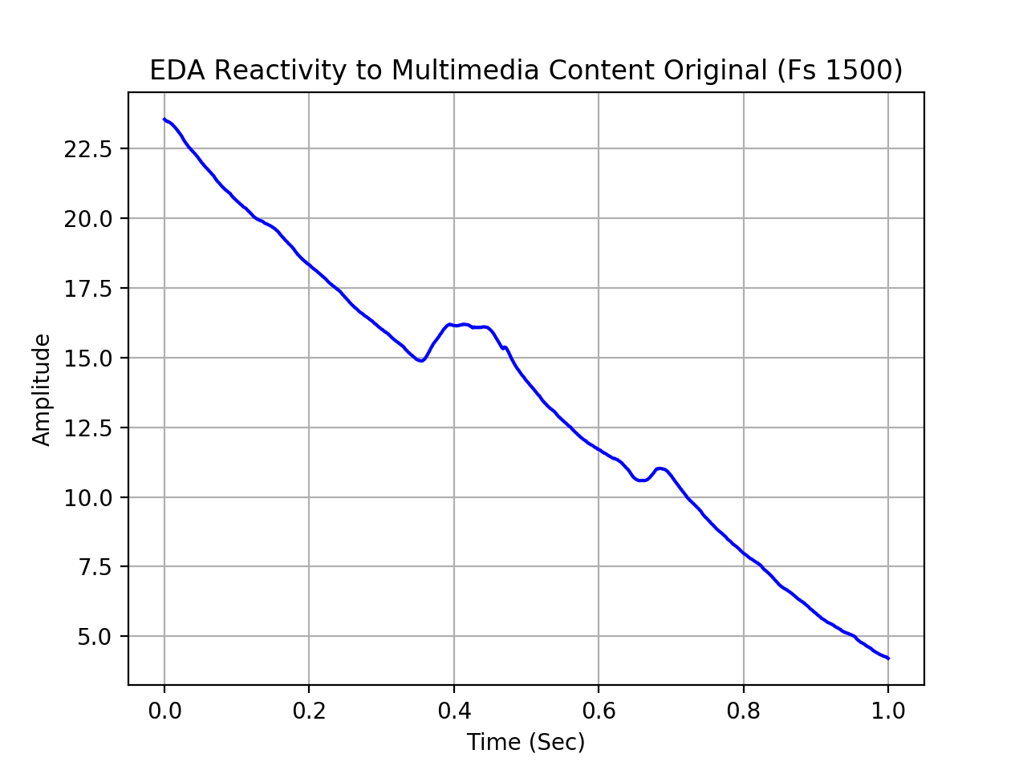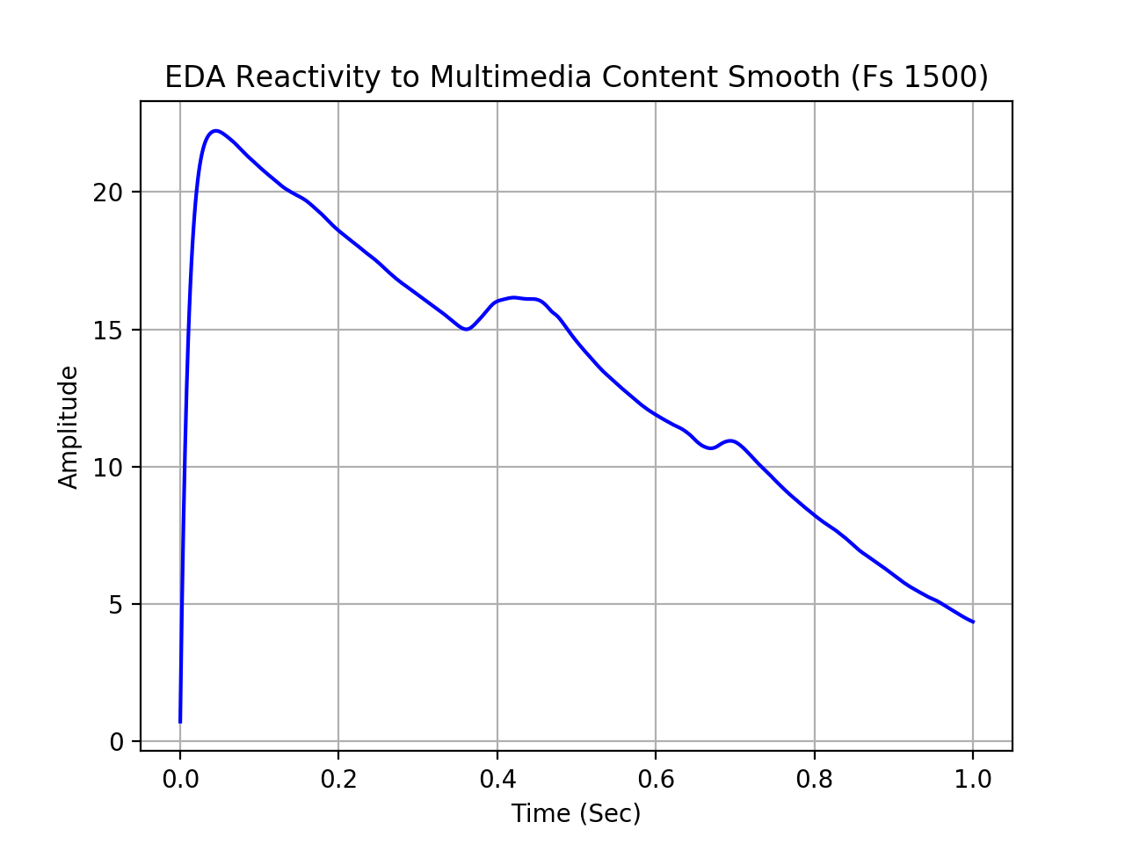

b)

Presented are the EDA plots of participants, S01 through S06 in trial 1. The plots suggest variation in each participants’ response to multimedia content. This can be seen in the range of EDA responses and peaks within the 1 second window. (Refer to folder 2_b)

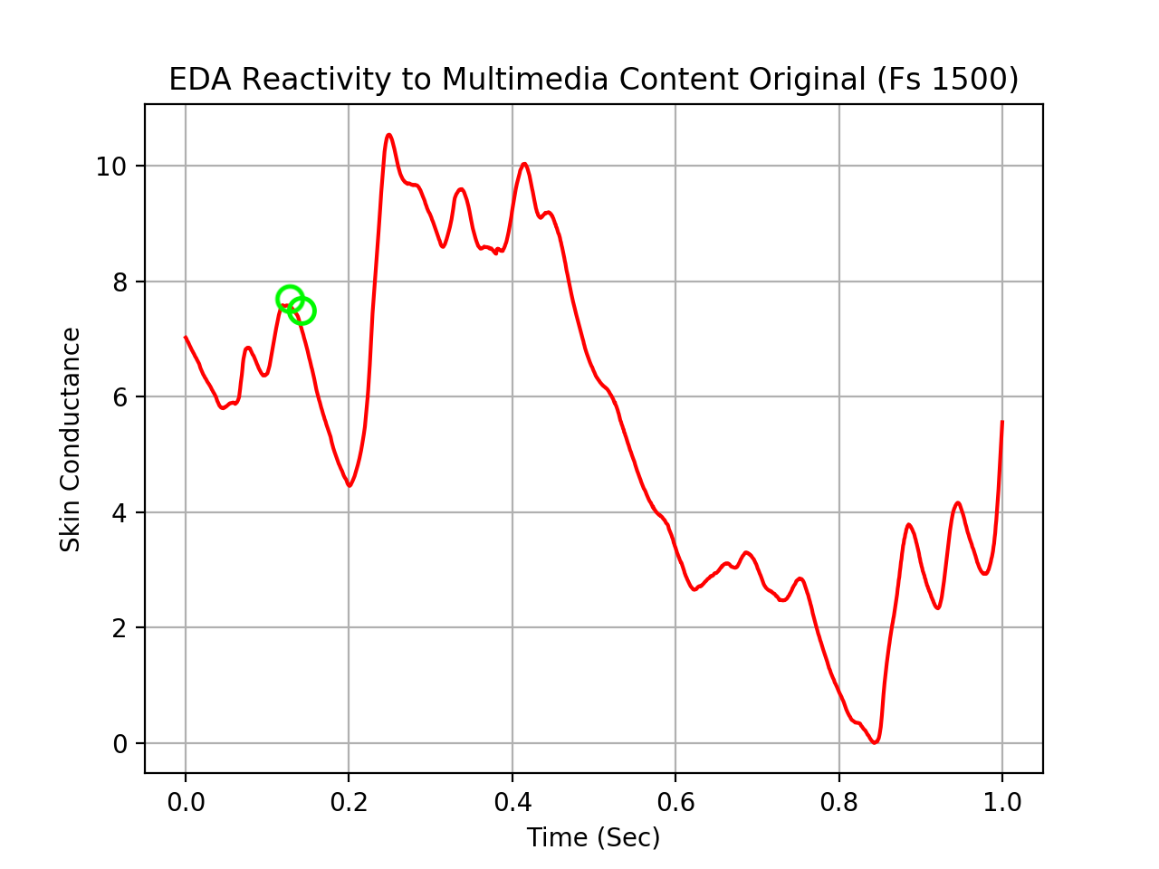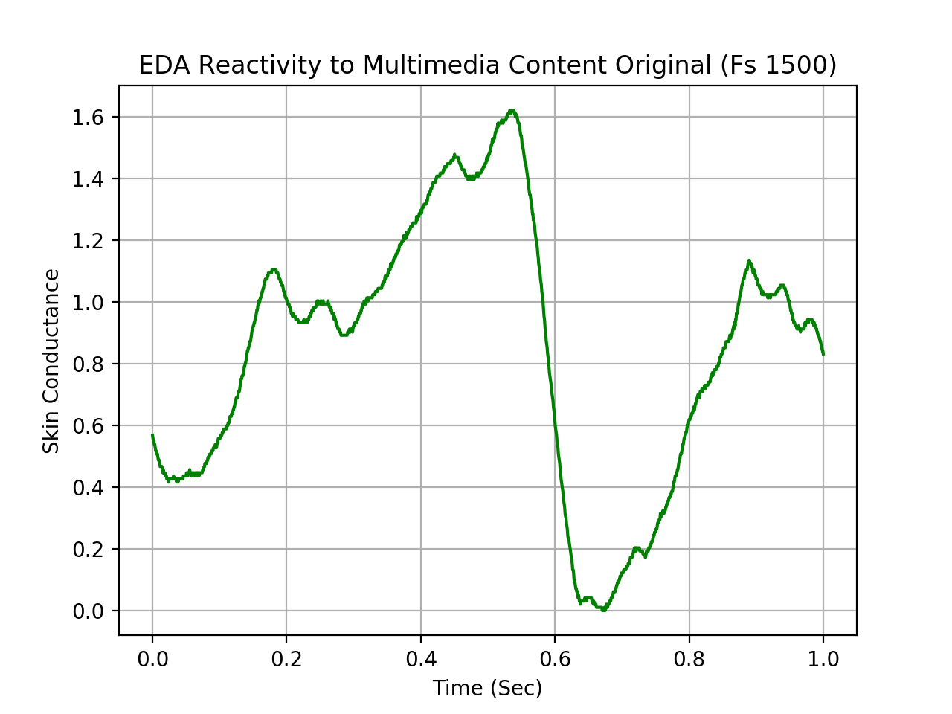

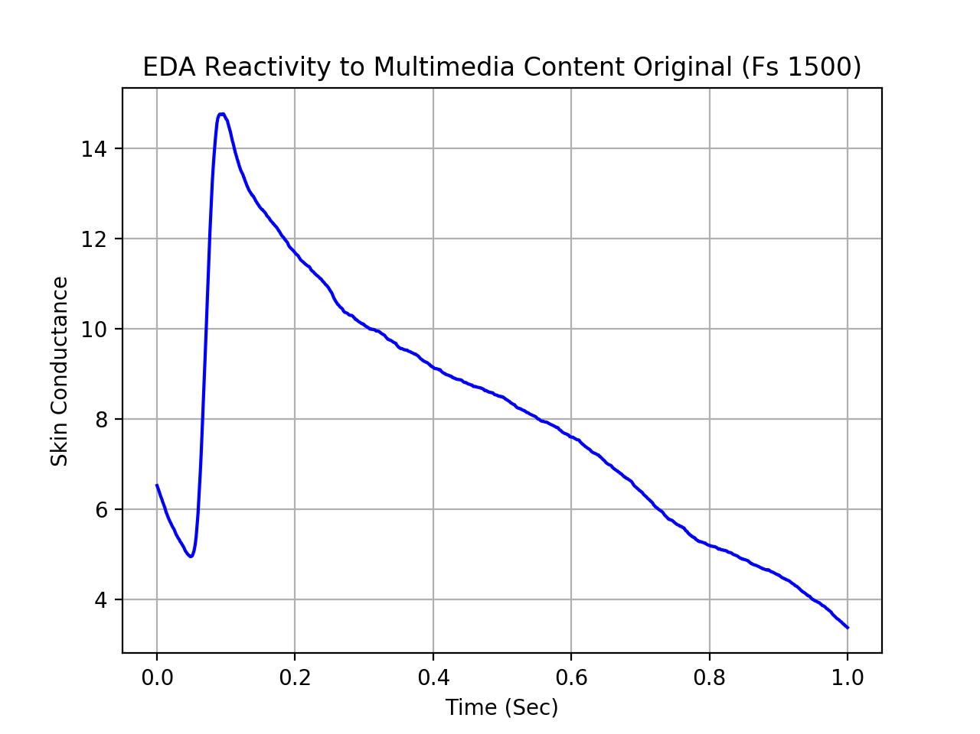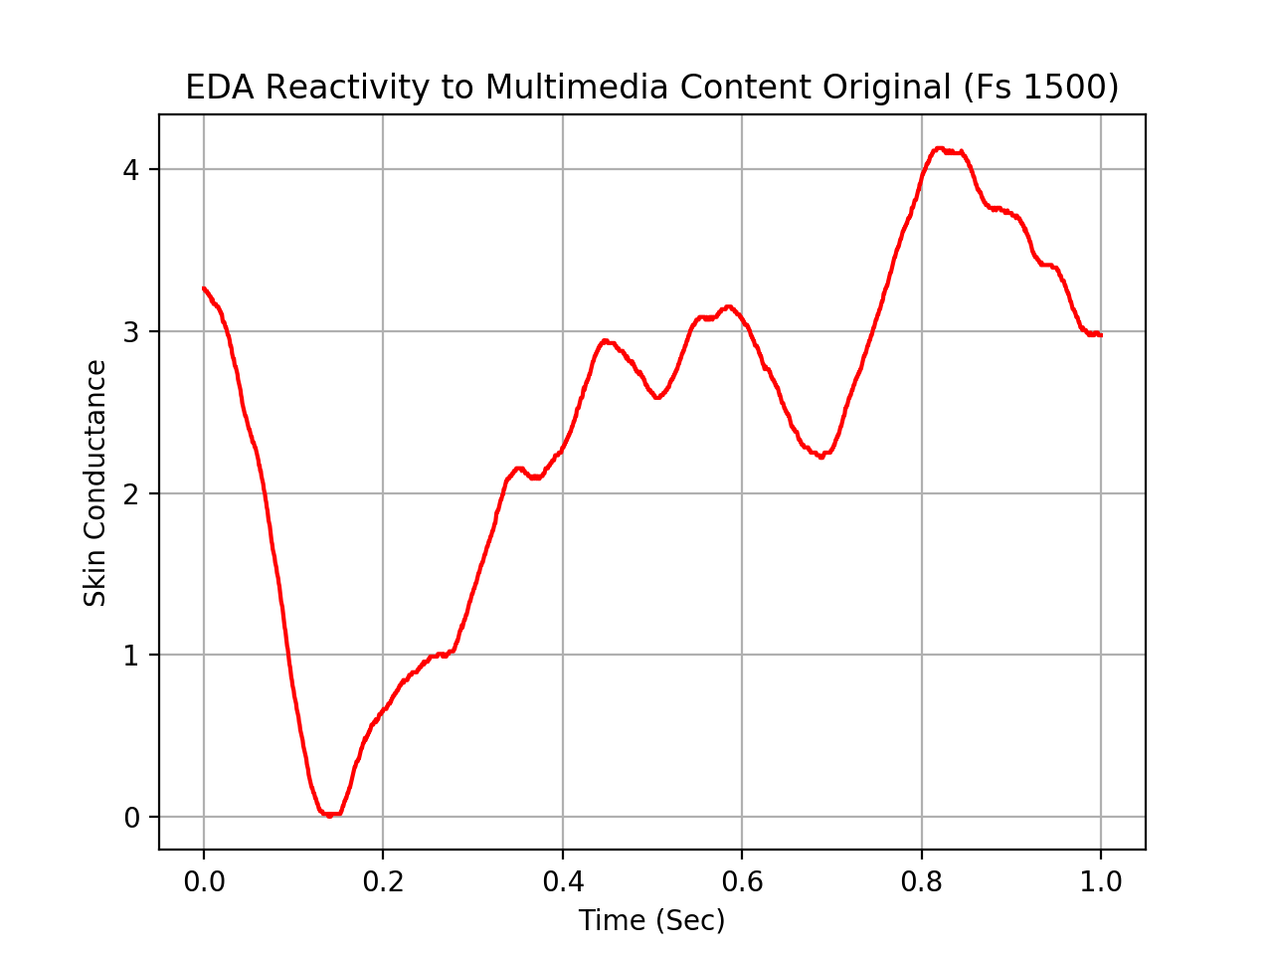

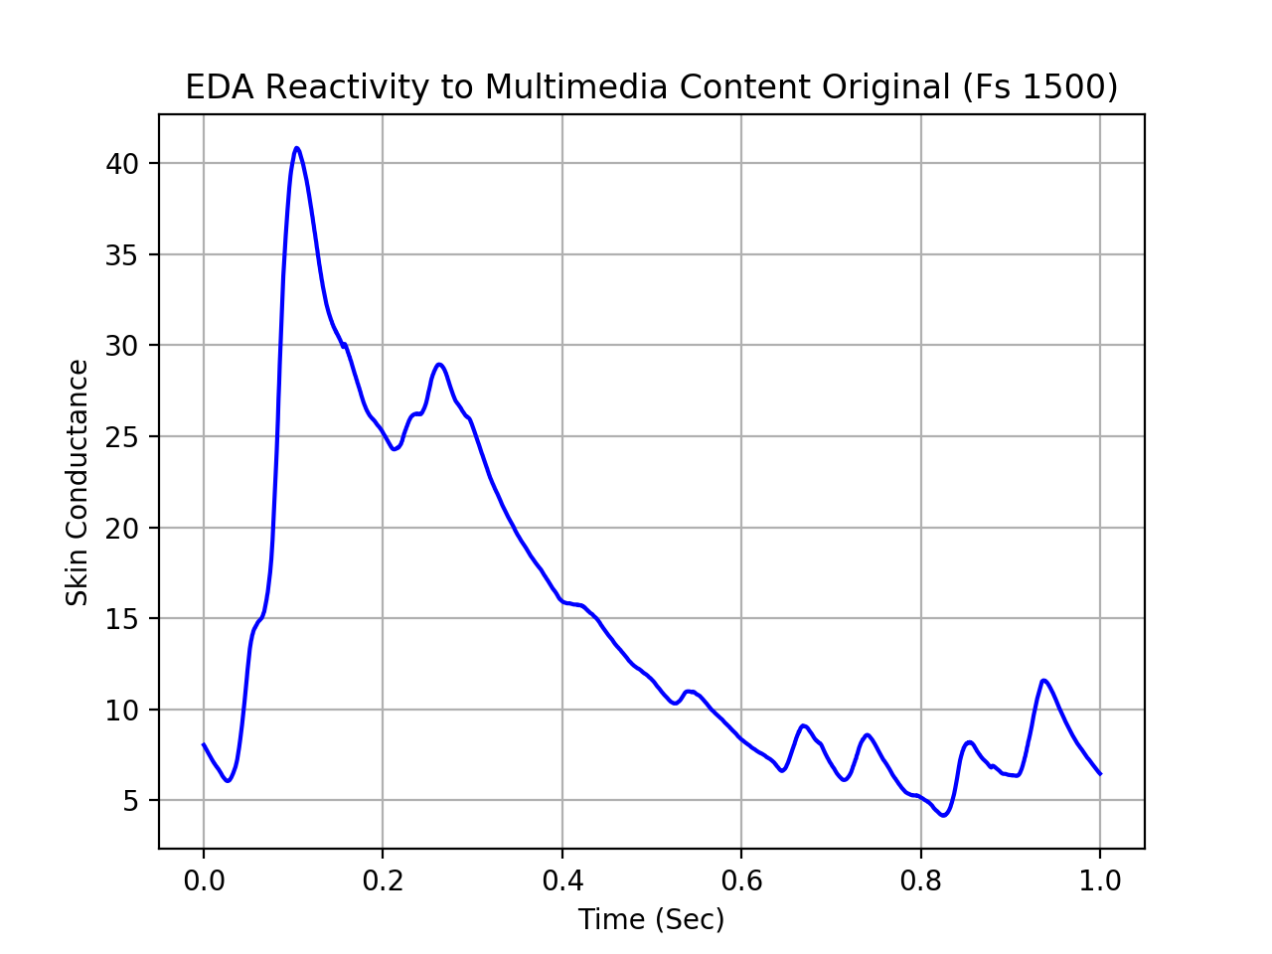 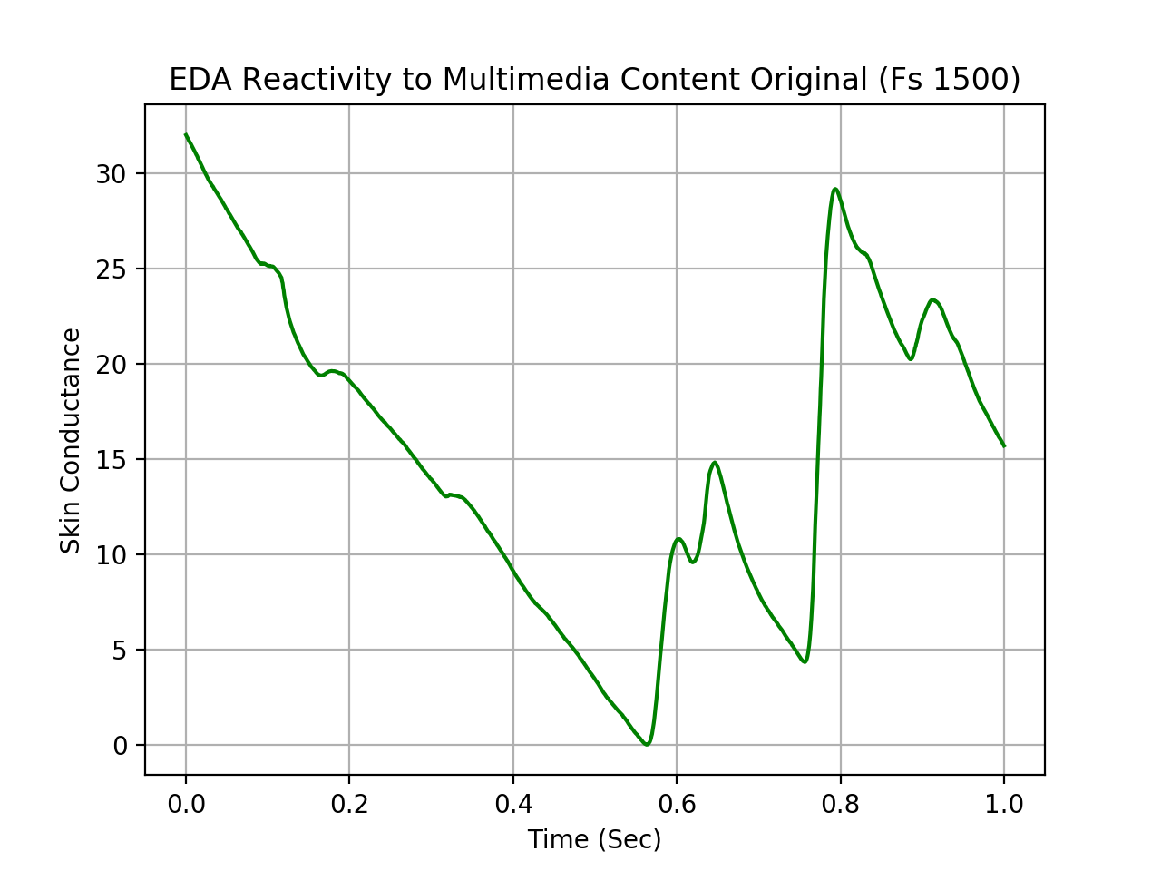

c)

The following values are based off of plots from folder, “2_b”.

|  |  |  |  |  |  |
| --- | --- | --- | --- | --- | --- |
|  | **Mean Level** | **SCR Frequency** | **Mean SCR Amplitude** | **Valence** | **Arousal** |
| s01_Trial1 | 5.3536 | 11 | 1.706 | 6.96 | 3.92 |
| s02_Trial1 | 0.8414 | 9 | 0.243333333 | 4.96 | 5.01 |
| s03_Trial1 | 7.991 | 1 | 9.8 | 7.15 | 4.37 |
| s04_Trial1 | 2.4144 | 5 | 0.948 | 8.17 | 8.05 |
| s05_Trial1 | 15.379 | 5 | 8.694 | 7 | 6.96 |
| s06_Trial1 | 14.7012 | 7 | 4.75375 | 3.65 | 3.49 |

d) Correlation values were computed for ‘valence’ (‘Valence and Mean Level’, ‘Valence and SCR Frequency’, ‘Valence x SCR Amplitude’) and ‘arousal’ (‘Arousal and Mean Level’, ‘Arousal and SCR Frequency’, ‘Arousal x SCR Amplitude’). Results of the correlation tests appears to be statistically non-significant (p > 0.05). My approach could be improved by either including either more participant trials in the tests, expanding the time window of EDA reactivity, or the combination of the previously mentioned two.

|  |  |  |  |  |  |
| --- | --- | --- | --- | --- | --- |
| **Valence x Mean Level** | **Valence x SCR Frequency** | **Valence x Mean SCR Amplitude** | **Arousal x Mean Level** | **Arousal x SCR Frequency** | **Arousal x Mean SCR Amplitude** |
| -0.295888424 | -0.349246999 | 0.116653942 | -0.170681119 | -0.2940677 | -0.083429374 |