PART B
(PART B: TO BE COMPLETED BY STUDENTS)
(Students must submit the soft copy as per following segments within two hours of the practical. The soft copy must be uploaded on the Blackboard or emailed to the concerned lab in charge faculties at the end of the practical in case the there is no Black board access available)
Roll No. : A073 | Name: Aryan Srivastava
Class : MCA | Batch : B3
Date of Experiment : | Date/Time of Submission :
Grade :

B.1 Code:
Index.html
<!DOCTYPE html>
<html lang="en">

<head>
<meta charset="UTF-8">
<meta name="viewport" content="width=device-width, initial-scale=1.0">
<title>Document</title>
<script defer src="scripts.js"></script>
</head>

<body>
<!-- Question 1 -->
<h2>1. Area of a Triangle</h2>
<p>Area of the triangle with sides 5, 6, 7: <span id="triangleArea"></span></p>

<!-- Question 2 -->
<h2>2. Sum of Two Integers</h2>
<input type="number" id="num1" placeholder="Enter first number">
<input type="number" id="num2" placeholder="Enter second number">
<button onclick="computeSum()">Compute Sum</button>
<p id="sumResult"></p>

<!-- Question 3 -->
<h2>3. Reverse a Number</h2>
<input type="number" id="numberToReverse" placeholder="Enter a number">
<button onclick="reverseNumber()">Reverse</button>
<p>Reversed Number: <span id="reversedNumber"></span></p>

<!-- Question 4 -->
<h2>4. Convert First Letter to Upper Case</h2>
<input type="text" id="inputString" placeholder="Enter a string">
<button onclick="convertToUpperCase()">Convert</button>
<p>Converted String: <span id="convertedString"></span></p>

<!-- Question 5 -->
<h2>5. Find Largest Number</h2>
<p id="largestNumberResult"></p>

<!-- Question 6 -->
<h2>6. Compute Average Marks and Grade</h2>
<p id="averageMarks"></p>
<p id="computedGrade"></p>

<!-- Question 7 -->
<h2>7. Pattern</h2>
<pre id="pattern"></pre>
</body>

</html>
scripts.js
// q 1: Area of a Triangle
function calculateAreaOfTriangle() {
const a = 5,
b = 6,
c = 7;
const s = (a + b + c) / 2;
const area = Math.sqrt(s * (s - a) * (s - b) * (s - c));
document.getElementById("triangleArea").innerText = area.toFixed(2);
}

// q 2: Sum of Two Integers
function computeSum() {
const num1 = parseInt(document.getElementById("num1").value);
const num2 = parseInt(document.getElementById("num2").value);
let sum;
if (num1 === num2) {
sum = 3 * (num1 + num2);
} else {
sum = num1 + num2;
}
document.getElementById("sumResult").innerText = `Result: ${sum}`;
}

// q 3: Reverse a Number
function reverseNumber() {
const num = document.getElementById("numberToReverse").value;
const reversed = num.split('').reverse().join('');
document.getElementById("reversedNumber").innerText = reversed;
}

// q 4: Convert First Letter of Each Word to Upper Case
function convertToUpperCase() {
const str = document.getElementById("inputString").value;
const result = str.split(' ').map(word => word.charAt(0).toUpperCase() + word.slice(1)).join(' ');
document.getElementById("convertedString").innerText = result;
}

// q 5: Find Largest of Five Numbers
function findLargest() {
const numbers = [80, 77, 88, 95, 68]; // As in the table
const largest = Math.max(...numbers);
alert(`The largest number is ${largest}`);
document.getElementById("largestNumberResult").innerText = `The largest number is ${largest}`;
}

// q 6: Compute Average Marks and Grade
function computeAverageAndGrade() {
const marks = [80, 77, 88, 95, 68];
const total = marks.reduce((acc, mark) => acc + mark, 0);
const average = total / marks.length;
let grade;

if (average < 60) grade = 'F';
else if (average < 70) grade = 'D';
else if (average < 80) grade = 'C';
else if (average < 90) grade = 'B';
else grade = 'A';

document.getElementById("averageMarks").innerText = `Average Marks: ${average.toFixed(2)}`;
document.getElementById("computedGrade").innerText = `Grade: ${grade}`;
}

// q 7: Construct Pattern
function constructPattern() {
let pattern = '';
for (let i = 1; i <= 5; i++) {
pattern += '*'.repeat(i) + '\n';
}
document.getElementById("pattern").innerText = pattern;
}

calculateAreaOfTriangle();
findLargest();
computeAverageAndGrade();a
constructPattern();

B.2 Output
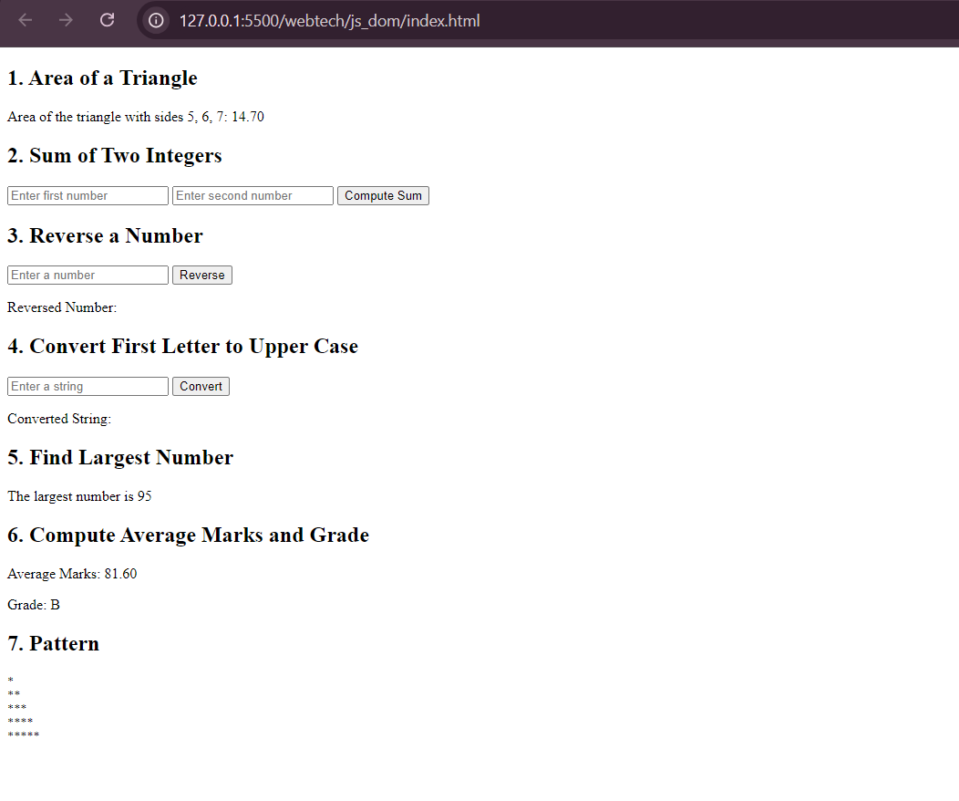
B.3 Conclusion:
Performed and leant about DOM Js
B.3 Observations and Learning:
Successfully completed JS programs

