PART A
(PART A: TO BE REFFERED BY STUDENTS) Experiment - 9

A.1—Aim:
To configure an FTP Server in Packet Tracer

A.2--- Prerequisite:
Working of FTP Protocol

A.3--- Outcome:
After successful completion of this experiment students will be able to:
To configure an FTP server in Packet Tracer.
- Create client and FTP server
- Make new file and upload to FTP server
- Check FTP server directory

Theory:
The File Transfer Protocol (FTP) is a standard network protocol used for the transfer of computer files between a client and server on a computer network.
FTP employs a client-server architecture whereby the client machine has an FTP client installed and establishes a connection to an FTP server running on a remote machine. After the connection has been established and the user is successfully authenticated, the data transfer phase can begin. Although FTP does support user authentication, all data is sent in clear text, including usernames and passwords. For secure transmission that protects the username and password, and encrypts the content, FTP is often secured with SSL(Secure Sockets Layer)/TLS (Transport Layer Security), FTPS (File Transfer Protocol Secure) or replaced with SSH (Secure Shell Protocol), SFTP (Secure File Transfer Protocol).
A.4--- Tasks:
1. Build the network topology.
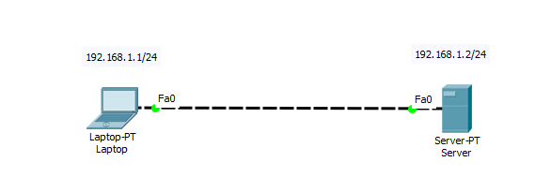

2. Configure static IP addresses on the Laptop and the server.
Laptop: IP address: 192.168.1.1 Subnet Mask: 255.255.255.0
Server: IP address: 192.168.1.2 Subnet Mask: 255.255.255.0
3. Now try using an FTP client built in the Laptop to send files to an FTP server configured in the Server. From the Laptop’s command prompt, FTP the server using the server IP address by typing:
ftp 192.168.1.2
Provide the username(cisco) and password(cisco) [which are the defaults] for ftp login.
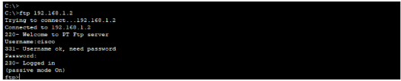
You are now in the FTP prompt .

PC0 has an FTP client which can be used to read, write, delete and rename files present in the FTP server. The FTP server can be used to read and write configuration files as well as IOS images. Additionally, the FTP server also supports file operations such rename, delete and listing directory.
4. Create a file in the Laptop then upload it to the server using FTP. To do this, open the Text Editor in the Laptop, create a file and give it your name of choice. Type any text in the editor then save your file. e.g. myFile.txt.
5. Now upload the file from the Laptop to the server using FTP. (An FTP connection has to be started first. But this is what we’ve done in step 3)
So to do an FTP upload, we’ll type:
put MyFile.txt

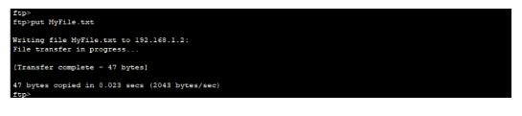
6. Once file upload is successful, go to the Server FTP directory to verify if the file sent has been received. To do this, go to Server-> Services->FTP. Here look for MyFile.txt sent from the laptop.
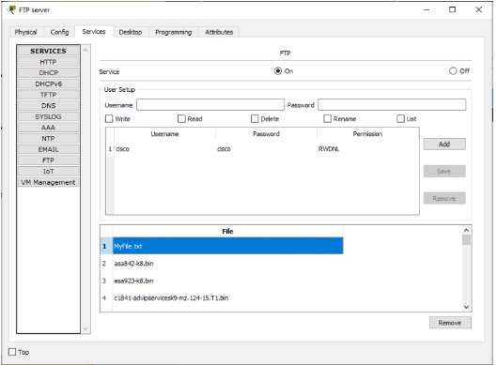
Save the file and name it as CN_EXP9_your Roll no_Batch No.

(PART - B)

Roll.No. : A073 | Name: Aryan Srivastava
Sem/Year : SEM 1 | Batch: B3
Date of Experiment : | Date of Submission:
Grade --

B.1: Procedure of performed experiment

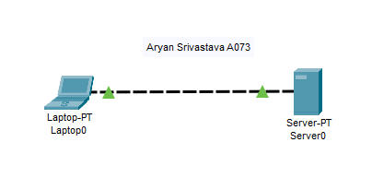
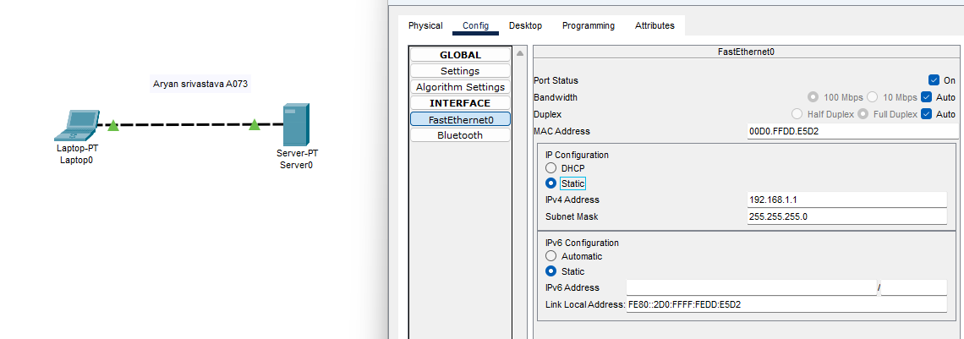
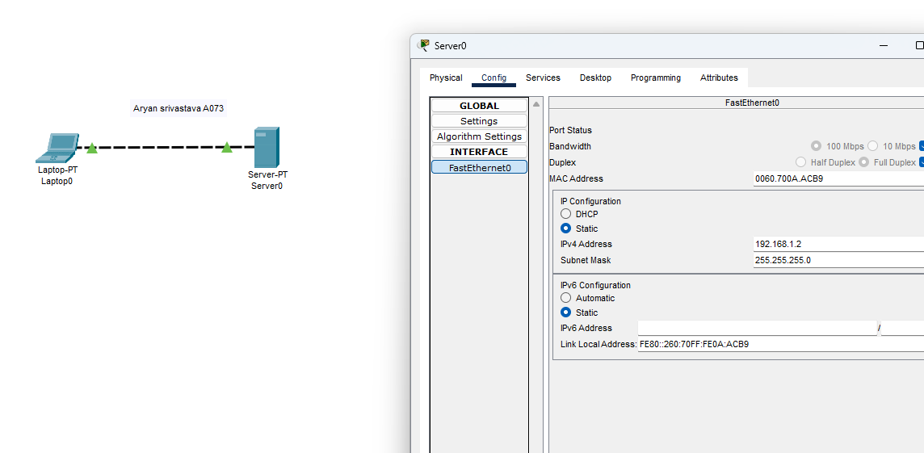
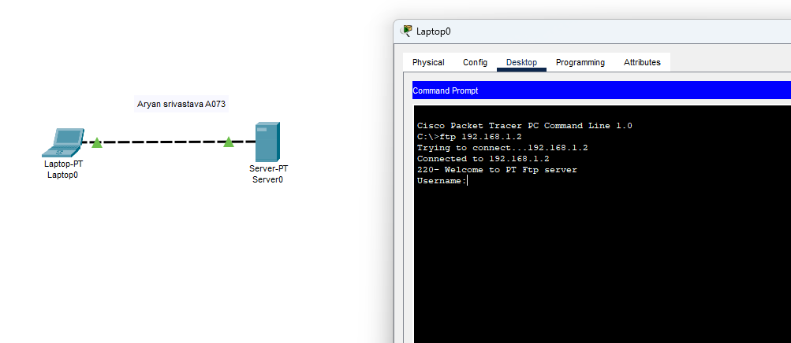

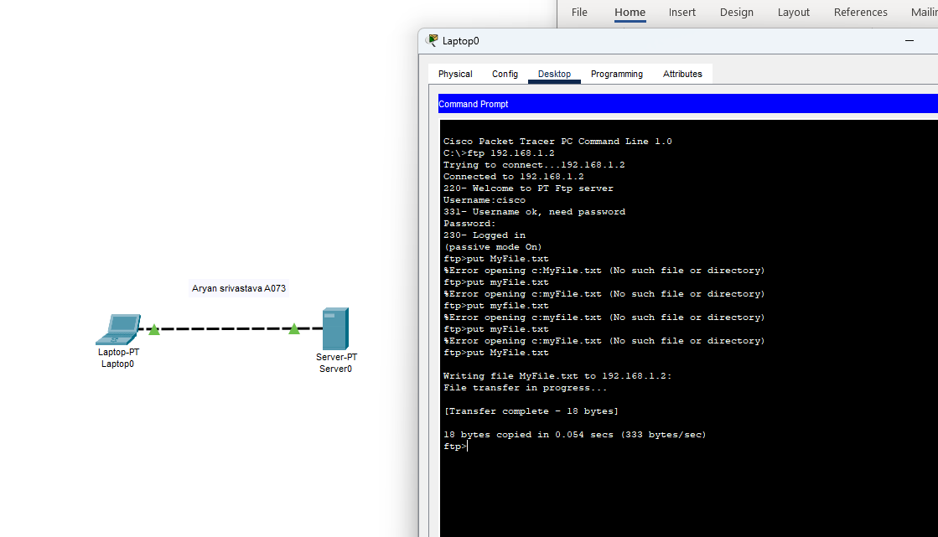
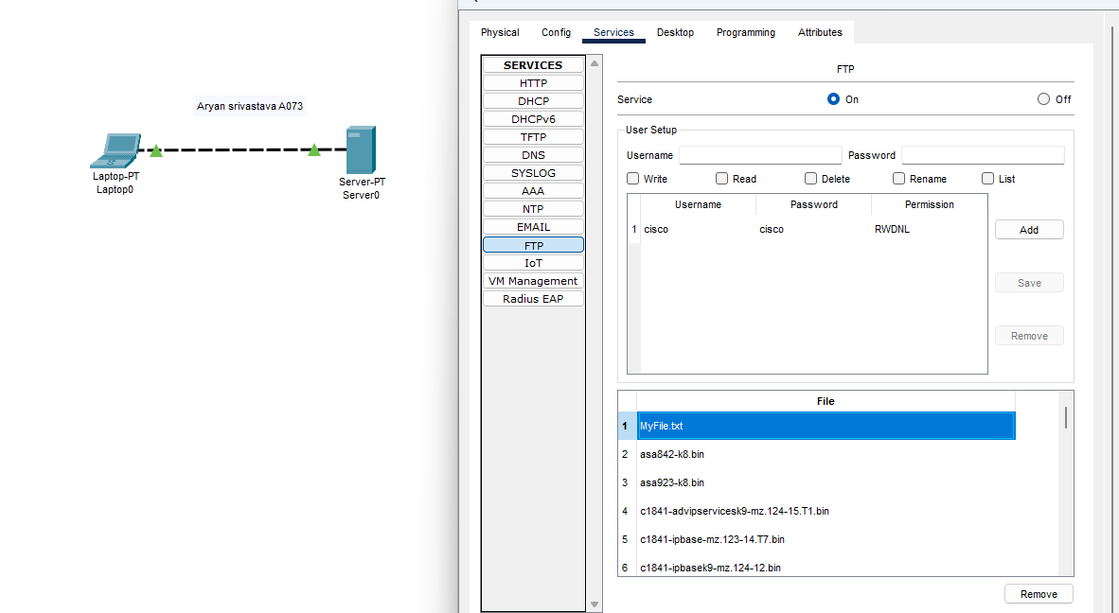

B.2: Observations and Learning’s:

Configured an FTP Server in Packet Tracer Successfully

B.3: Conclusion:

Configured an FTP Server in Packet Tracer Successfully

References

https://computernetworking747640215.wordpress.com/2019/11/22/how-to-configure-an-ftp-server-in-packet-tracer/

