**SVKM’s NMIMS**

**Mukesh Patel School of Technology Management & Engineering**

**Computer Engineering Department**

Program: MCA, Semester I

**Course: Java Programming**

**Experiment No.11**

PART A

**Aim:** To implement Java-Database connectivity using JDBC connector.

**Programs:**

**Task 1:** Modify JavaFx application of “User Registration” implemented In Exp-10. On the click of “Verify” button fetch username and password from the database and compare with username and password entered by the user at GUI interface. In case of valid details, display message “User Authorized” and if details are invalid, display message “User Unauthorized”.

**Task 2:** Implement a JavaFx application of “Loan Calculator”, add button “Save”, which saves the details of loan with future value into the database.

**Part B (to be completed by students)**

**(Students must submit the soft copy as per the following segments. The soft copy must be uploaded on the Blackboard within two hours of your practical session.)**

|  |  |
| --- | --- |
| **Roll no.: A073** | **Name: Aryan Srivastava** |
| **Class: MCA SEM – I** | **Batch: 3** |
| **Date of Experiment: 24-10-2024** | **Date of Submission:** |
| **Grade:** |  |

1. **Program scenario and Program code: (**Paste you program code )

**Code 1 –**

**import javafx.application.Application;  
import javafx.geometry.Insets;  
import javafx.scene.Scene;  
import javafx.scene.control.Button;  
import javafx.scene.control.Label;  
import javafx.scene.control.PasswordField;  
import javafx.scene.control.TextField;  
import javafx.scene.layout.VBox;  
import javafx.stage.Stage;  
  
import java.sql.Connection;  
import java.sql.DriverManager;  
import java.sql.PreparedStatement;  
import java.sql.ResultSet;  
import java.sql.SQLException;  
  
public class UserRegistrationVerification extends Application {  
  
 private TextField usernameField;  
 private PasswordField passwordField;  
 private Label messageLabel;  
  
 @Override  
 public void start(Stage primaryStage) {  
 primaryStage.setTitle("User Registration Verification");  
  
 usernameField = new TextField();  
 usernameField.setPromptText("Username");  
  
 passwordField = new PasswordField();  
 passwordField.setPromptText("Password");  
  
 Button verifyButton = new Button("Verify");  
 verifyButton.setOnAction(e -> verifyUser());  
  
 messageLabel = new Label();  
  
 VBox layout = new VBox(10);  
 layout.setPadding(new Insets(20));  
 layout.getChildren().addAll(usernameField, passwordField, verifyButton, messageLabel);  
  
 Scene scene = new Scene(layout, 300, 200);  
 primaryStage.setScene(scene);  
 primaryStage.show();  
 }  
  
 private void verifyUser() {  
 String inputUsername = usernameField.getText();  
 String inputPassword = passwordField.getText();  
  
 String url = "jdbc:mysql://localhost:3306/prac11"; // replace with your database  
 String user = "root"; // replace with your MySQL username  
 String password = "root"; // replace with your MySQL password  
  
 try (Connection conn = DriverManager.getConnection(url, user, password)) {  
 String sql = "SELECT * FROM Users WHERE username = ? AND password = ?";  
 PreparedStatement stmt = conn.prepareStatement(sql);  
 stmt.setString(1, inputUsername);  
 stmt.setString(2, inputPassword);  
  
 ResultSet rs = stmt.executeQuery();  
  
 if (rs.next()) {  
 messageLabel.setText("User Authorized");  
 } else {  
 messageLabel.setText("User Unauthorized");  
 }  
 } catch (SQLException ex) {  
 ex.printStackTrace();  
 }  
 }  
  
 public static void main(String[] args) {  
 launch(args);  
 }  
}**

**code 2 –**

**import javafx.application.Application;  
import javafx.geometry.Insets;  
import javafx.scene.Scene;  
import javafx.scene.control.Button;  
import javafx.scene.control.Label;  
import javafx.scene.control.TextField;  
import javafx.scene.layout.VBox;  
import javafx.stage.Stage;  
  
import java.sql.Connection;  
import java.sql.DriverManager;  
import java.sql.PreparedStatement;  
import java.sql.SQLException;  
  
public class LoanCalculator extends Application {  
  
 private TextField loanAmountField;  
 private TextField interestRateField;  
 private TextField periodField;  
 private Label messageLabel;  
  
 @Override  
 public void start(Stage primaryStage) {  
 primaryStage.setTitle("Loan Calculator");  
  
 loanAmountField = new TextField();  
 loanAmountField.setPromptText("Loan Amount");  
  
 interestRateField = new TextField();  
 interestRateField.setPromptText("Interest Rate (%)");  
  
 periodField = new TextField();  
 periodField.setPromptText("Period (Years)");  
  
 Button saveButton = new Button("Save");  
 saveButton.setOnAction(e -> saveLoanDetails());  
  
 messageLabel = new Label();  
  
 VBox layout = new VBox(10);  
 layout.setPadding(new Insets(20));  
 layout.getChildren().addAll(loanAmountField, interestRateField, periodField, saveButton, messageLabel);  
  
 Scene scene = new Scene(layout, 300, 250);  
 primaryStage.setScene(scene);  
 primaryStage.show();  
 }  
  
 private void saveLoanDetails() {  
 double loanAmount = Double.parseDouble(loanAmountField.getText());  
 double interestRate = Double.parseDouble(interestRateField.getText());  
 int period = Integer.parseInt(periodField.getText());  
  
 // Calculate Future Value  
 double futureValue = loanAmount * Math.pow(1 + (interestRate / 100), period);  
  
 String url = "jdbc:mysql://localhost:3306/prac11"; // replace with your database  
 String user = "root"; // replace with your MySQL username  
 String password = "root"; // replace with your MySQL password  
  
 try (Connection conn = DriverManager.getConnection(url, user, password)) {  
 String sql = "INSERT INTO Loans (loanAmount, interestRate, period, futureValue) VALUES (?, ?, ?, ?)";  
 PreparedStatement stmt = conn.prepareStatement(sql);  
 stmt.setDouble(1, loanAmount);  
 stmt.setDouble(2, interestRate);  
 stmt.setInt(3, period);  
 stmt.setDouble(4, futureValue);  
  
 stmt.executeUpdate();  
 messageLabel.setText("Loan details saved successfully.");  
 } catch (SQLException ex) {  
 ex.printStackTrace();  
 messageLabel.setText("Error saving loan details.");  
 }  
 }  
  
 public static void main(String[] args) {  
 launch(args);  
 }  
}**

1. **Output:**

**Output 1 –**

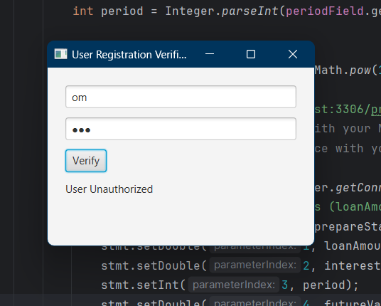

**Output 2 –**

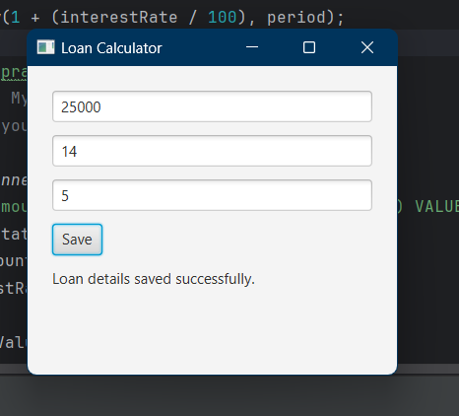

1. **Observation learning and conclusion:** mention what learning you got out of practical

**Learnt about java FX**

**Conclusion**

Successfully implemented Java FX