**SVKM’s NMIMS**

**Mukesh Patel School of Technology Management & Engineering**

**Computer Engineering Department**

Program: MCA, Semester I

**Course: Java Programming**

**Experiment No.01**

PART A

(PART A : TO BE REFFERED BY STUDENTS)

**A.1 Aim:** To understand and implement basic concepts like Data types, Variables and Operators in Java.

**TASK 1: Write a Java program to take input for two integer numbers from the user and add them.**

**Task 2: The straight-line method of computing the yearly logical depreciation of the value of an item is given by**

**Depreciation = (purchase-price –Salvage Value)/years_of_service**

**Write a program to determine the salvage value of an item when the purchase price, years of service, and the annual depreciation are given.**

**Task 3: The total distance travelled by a vehicle in t seconds is given by**

**Distance = ut + (at2)/2**

**Where u is the initial velocity (meters per second), a is the acceleration (meters per second2). Write a program to evaluate the distance travelled at regular intervals of time, given the values of u and a.**

**Task 4: Write a Java program to reverse the number entered by the user.**

**TASK 5: Consider the scenario of processing marks of a student John for a course as part of a student management system. The assumption is that John takes exams in five different subjects. Find the total marks and average marks scored by John.**

**Task 6: Write a Java program to perform basic calculator operations.**

**Task 7: Write a Java program to swap two numbers.**

**Task 8: Write a Java program to check if entered number is odd or even.**

**Task 9: Write a Java program to find largest of three numbers entered by the user.**

**Task 10: Write a Java program to check whether a number is positive, negative or zero.**

**Task 11: Write a Java program to check if two of three Boolean variables are true.**

**Task 12: Write a Java program to check whether an alphabet is vowel or consonant.**

**Task 13: Write a Java program whether entered year is leap year or not.**

**Task 14: Write a Java program that calculates and displays the amount of money you would have if you invested 10000 Rs at 5% interest for one year. Use the formula:**

**Future Amount = Principal*Rate*Time.**

**A.2 Prerequisite:**

1. Fundamental concepts of C\C++.

**A.3 Outcome:**

**After successful completion of this experiment, students will be able to**

1. Implement concept of Data types, variables in Java

**A.4 Theory:**

**A.4.1.**

Java Variables

A variable is a container which holds the value while the [Java program](https://www.javatpoint.com/simple-program-of-java) is executed. A variable is assigned with a data type.

Variable is a name of memory location. There are three types of variables in java: local, instance and static. There are two types of data types in Java: primitive and non-primitive.

Variable

A variable is the name of a reserved area allocated in memory. In other words, it is a name of the memory location. It is a combination of "vary + able" which means its value can be changed.

**int** data=50;//Here data is variable

There are three types of variables in Java

* local variable
* instance variable
* static variable

Data Types in Java

Data types specify the different sizes and values that can be stored in the variable. There are two types of data types in Java:

1. **Primitive data types:** The primitive data types include boolean, char, byte, short, int, long, float and double.
2. **Non-primitive data types:** The non-primitive data types include Classes, Interfaces, and Arrays.

Java Primitive Data Types

In Java language, primitive data types are the building blocks of data manipulation. These are the most basic data types available in Java language.

Java is a statically-typed programming language. It means, all variables must be declared before its use. That is why we need to declare variable's type and name.

There are 8 types of primitive data types:

* boolean data type
* byte data type
* char data type
* short data type
* int data type
* long data type
* float data type
* double data type

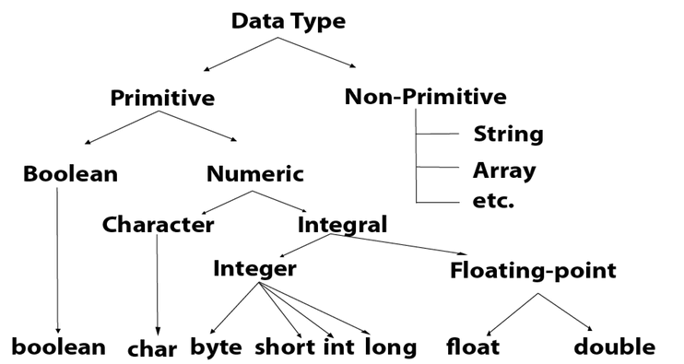

PART B

(PART B : TO BE COMPLETED BY STUDENTS)

Students must submit the soft copy as per following segments within two hours of the practical. The soft copy must be uploaded on the portal at the end of the practical. The filename should be **MCA_JP_rollno_experimentno Example : MCA_JP_C001_Exp1**

|  |  |
| --- | --- |
| Roll No. A073 | Name: Aryan Srivastava |
| Class : FY MCA | Batch : B3 |
| Date of Experiment: 23-07-2024 | Date of Submission: 24-07-2024 |
| Grade : |  |

**B.1 Software Code written by student:**

***(Paste your code completed during the 2 hours of practical in the lab here)***

**Task 1:**

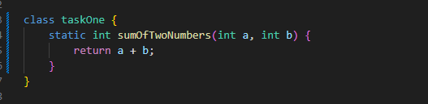

**Task 2:**

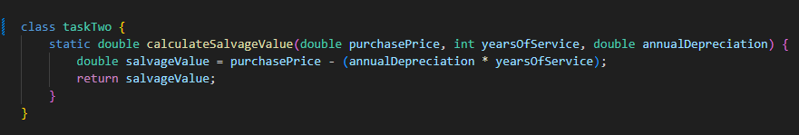

**Task 3:**

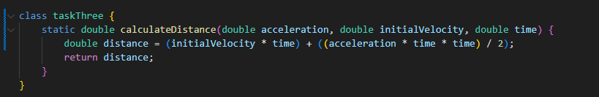

**Task 4:**

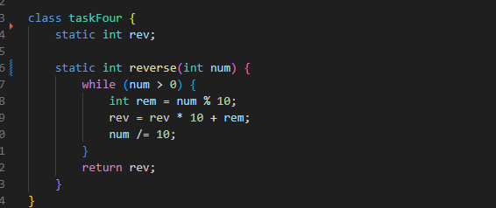

**Task 5:**

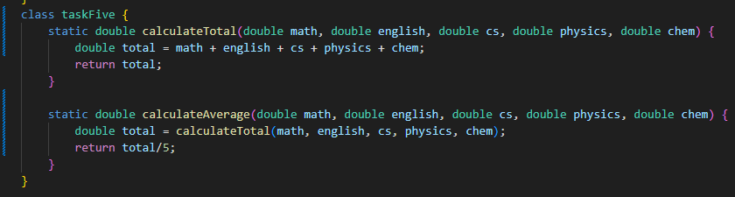

**Task 6:**

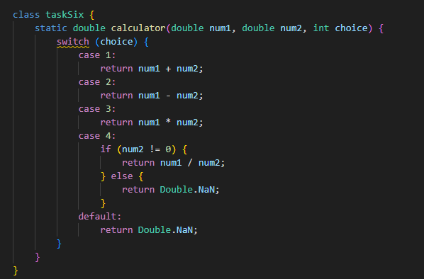

**Task 7:**

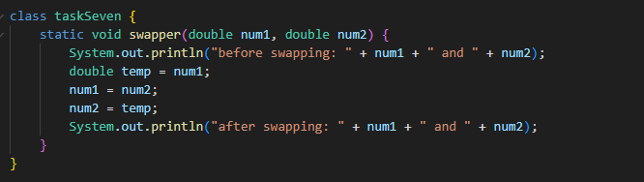

**Task 8:**

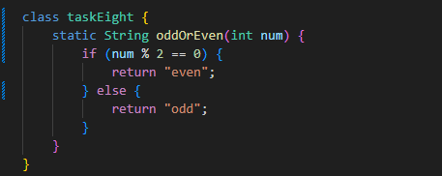

**Task 9:**

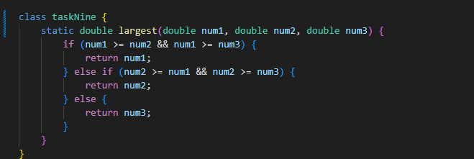

**Task 10:**

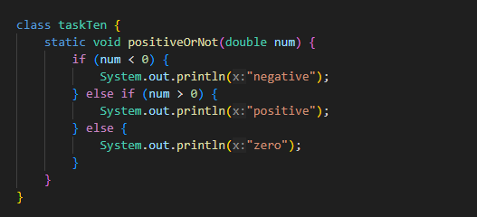

**Task 11:**

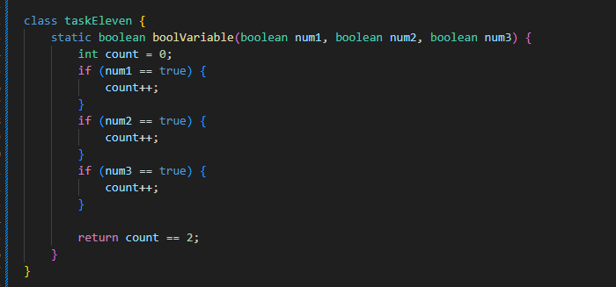

**Task 12:**

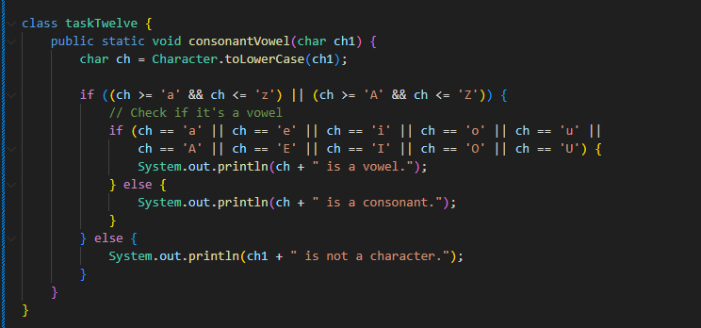

**Task 13:**

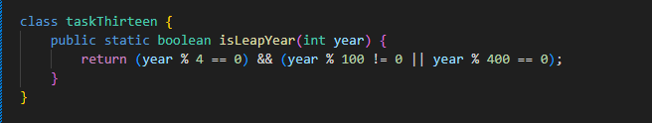

**Task 14:**

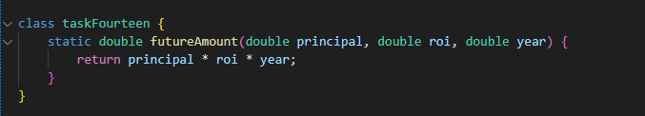

**B.2 Input and Output:**

***(Paste your program input and output in following format, If there is error then paste the specific error in the output part. In case of error with due permission of the faculty extension can be given to submit the error free code with output in due course of time. Students will be graded accordingly.)***

**Task 1:**

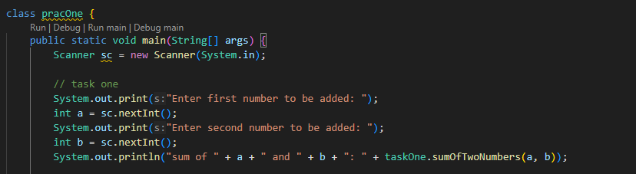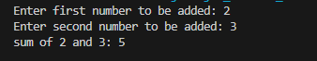

**Task 2:**

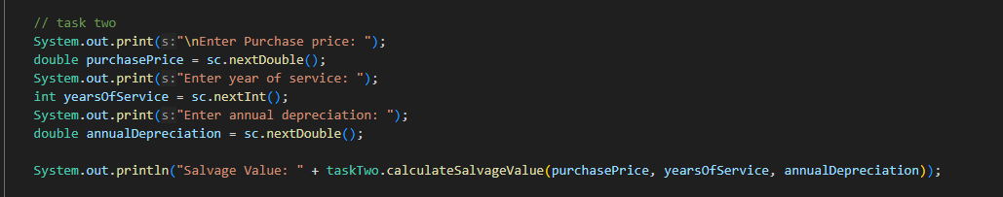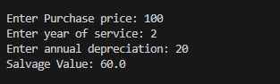

**Task 3:**

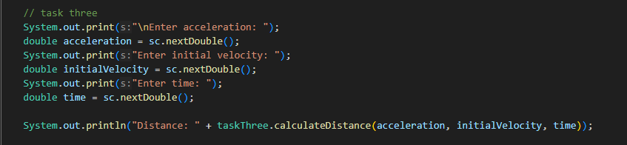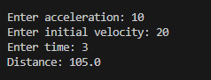

**Task 4:**

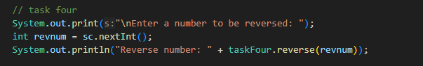

**Task 5:**

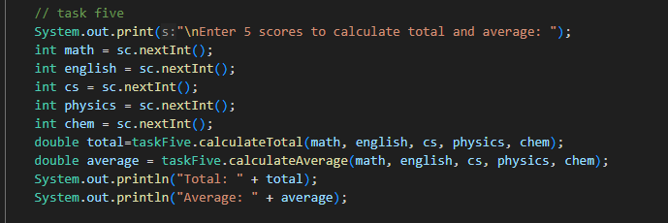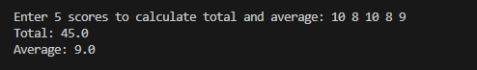

**Task 6:**

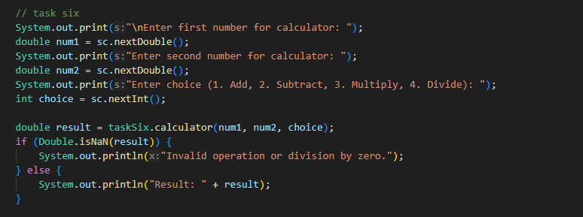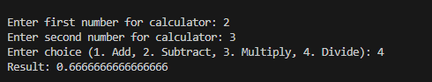

**Task 7:**

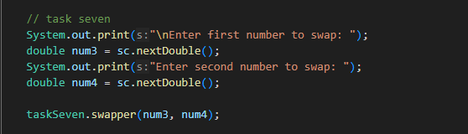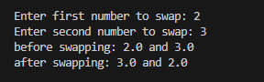

**Task 8:**

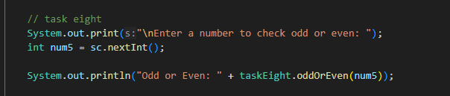

**Task 9:**

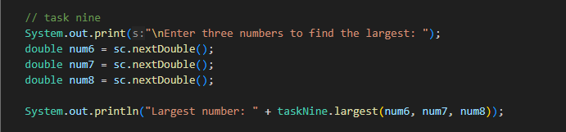

**Task 10:**

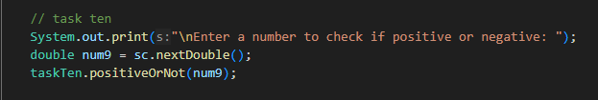

**Task 11:**

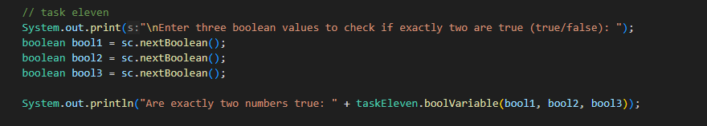

**Task 12:**

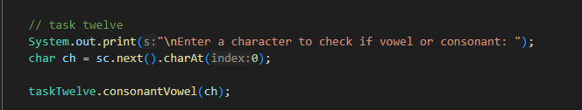

**Task 13:**

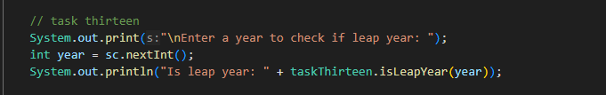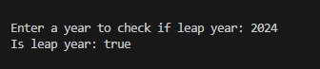

**Task 14:** 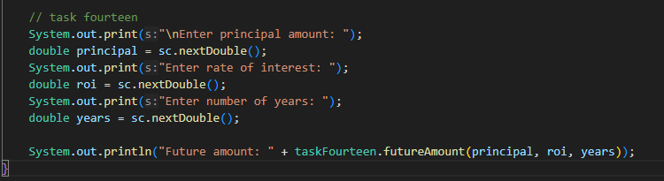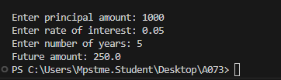

**B.3 Question of Curiosity:**

**1. Define Datatype, Variable and keywords.**

Data Type: A data type in Java specifies the size and type of values that can be stored in an identifier (variable). Java has two categories of data types:   
Primitive Data Types: These are predefined by the language and are named by a reserved keyword. Examples include int, boolean, char, etc.   
Non-primitive Data Types: Also known as reference types, these include classes, interfaces, and arrays.

Variable: A variable is a named memory location that stores data temporarily during program execution. It is characterized by its data type and can hold different values as the program runs.

Keywords: Keywords are reserved words in Java that have special meanings and cannot be used as identifiers (like variable names or function names). Examples include class, public, static, etc.

**2. Explain different types of operators available in Java**

Arithmetic Operators: Used for basic mathematical operations like addition, subtraction, multiplication, division, etc.

Relational Operators: Used to establish relationships between operands. Examples include equality, inequality, greater than, less than, etc.

Logical Operators: Used to combine multiple conditions. Examples include &&, || and !

Bitwise Operators: Perform bit-level operations on operands. Examples include bitwise AND, bitwise OR, bitwise XOR, etc.

Assignment Operators: Used to assign values to variables. Examples include =, +=, -= etc.

Conditional (Ternary) Operator: ? : - Used for decision making based on a condition.

Instanceof Operator: instanceof - Used to test whether an object is an instance of a specific class or interface.

**3. Explain different types of data types available in Java.**

Primitive Data Types: These are basic types provided by the language and are not objects. They include boolean, char, byte, short, int, long, float, and double.

Non-primitive Data Types: Also called reference types, these include classes, interfaces, and arrays. They are derived from primitive types and are used to create objects.

**4. Explain basic blocks of Java program.**

Package Declaration: Specifies the package to which the class belongs.

Import Statements: Import other Java classes or entire packages for use in the current program.

Class Definition: Contains fields, methods, constructors, etc.

Fields (Variables): Declare variables to store data.

Constructors: Special methods used for initializing objects.

Methods: Contains code that performs tasks when invoked.

Statements & Expressions: Actual code that performs operations and tasks.

Comments: Non-executable statements used for documentation.

**5. What is Java Virtual Machine?**

Java Virtual Machine (JVM) is an abstract computing machine that enables Java bytecode to be executed on different hardware platforms without the need for recompilation. It interprets compiled Java bytecode into machine-specific instructions and manages memory, security, and other system resources during program execution. JVM forms the heart of the Java Runtime Environment (JRE), which is required to run Java applications.

**B.3 Conclusion:**

In completing these tasks, I've successfully navigated fundamental concepts in Java programming. From handling data types, variables, and operators to implementing calculations, user input, and decision-making logic, each task has deepened my understanding of Java's core functionalities. These exercises have equipped me with essential skills in writing structured programs, manipulating data, and solving practical problems. Moving forward, I aim to build upon this foundation to tackle more complex challenges in Java development, leveraging these fundamentals to enhance my programming proficiency.

************************