**SVKM’s NMIMS**

**Mukesh Patel School of Technology Management & Engineering**

**Computer Engineering Department**

Program: MCA, Semester I

**Course: Java Programming**

PART B

|  |  |
| --- | --- |
| Roll No. A073 | Name: Aryan Srivastava |
| Class : MCA FY | Batch : B3 |
| Date of Experiment: 05-08-2024 | Date of Submission |
| Grade : |  |

**B.1 Software Code written by student:**

**Task 1: a. data**

**Task 2: c. reference**

**Task 3: b. Data**

**Task 4: OP: 1**

**Task 5:**

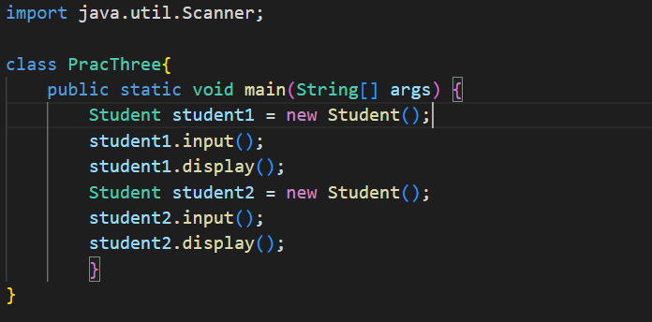 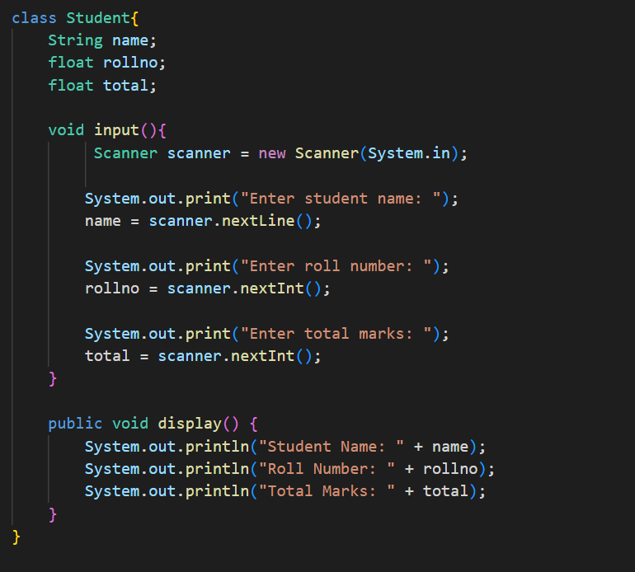

**Task 6:**

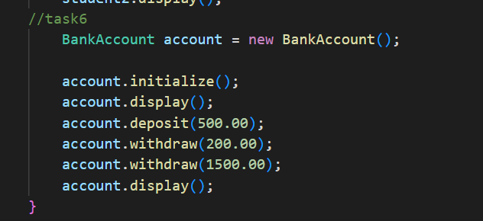 ---------->main()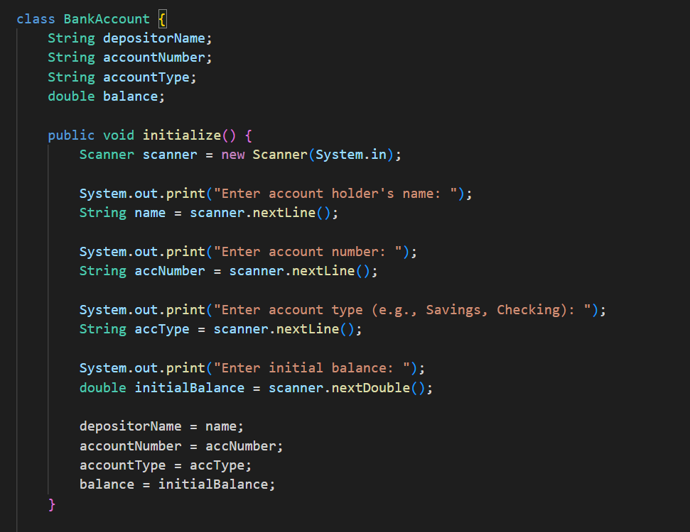 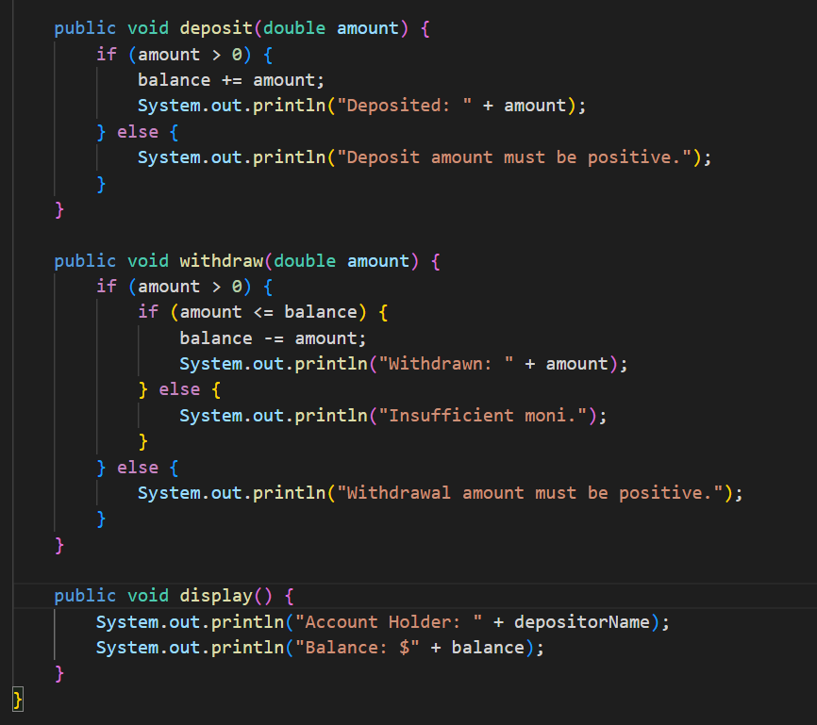

**Task 7:**

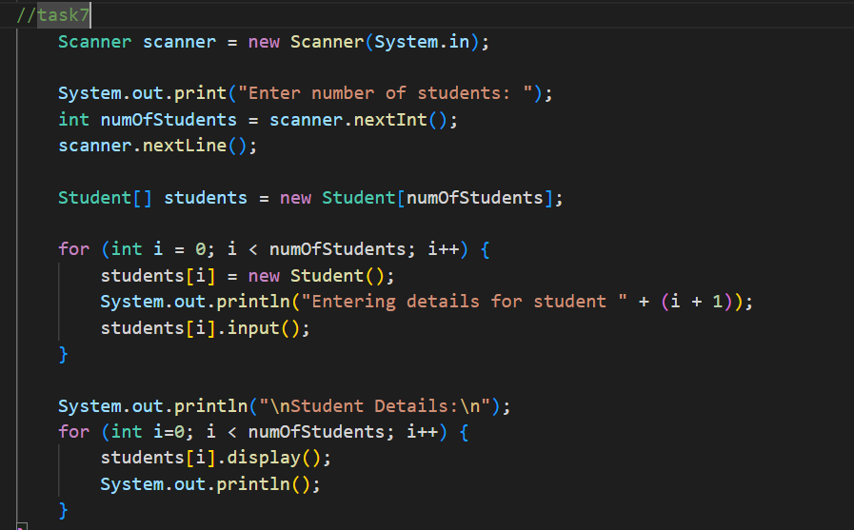

**Task 8: 12**

**Task 9:**

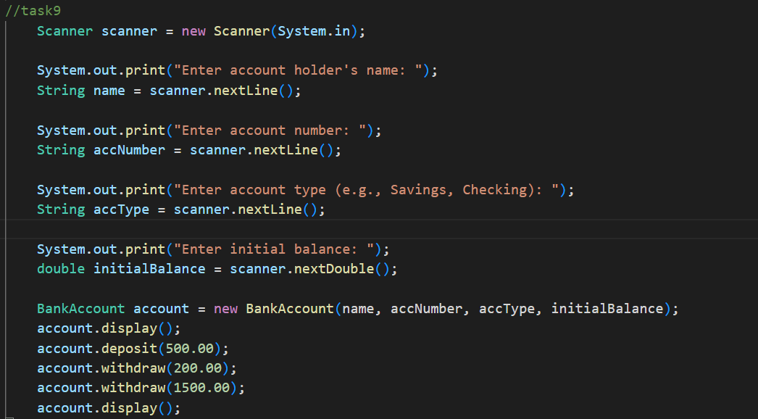 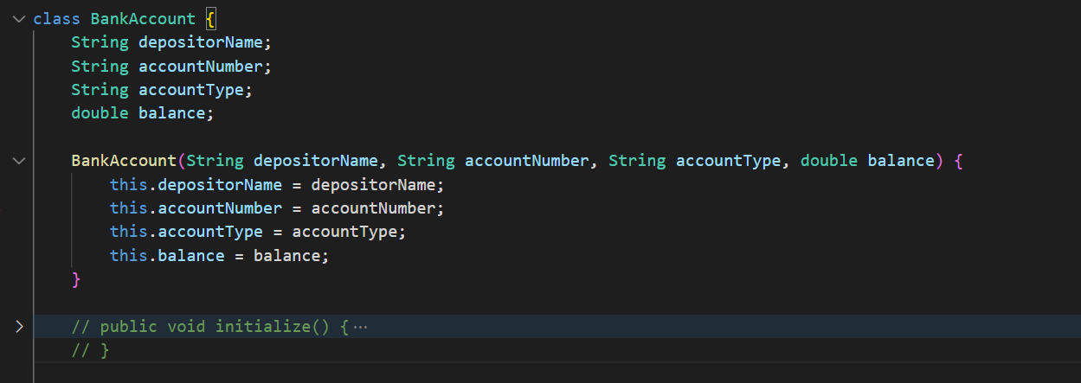 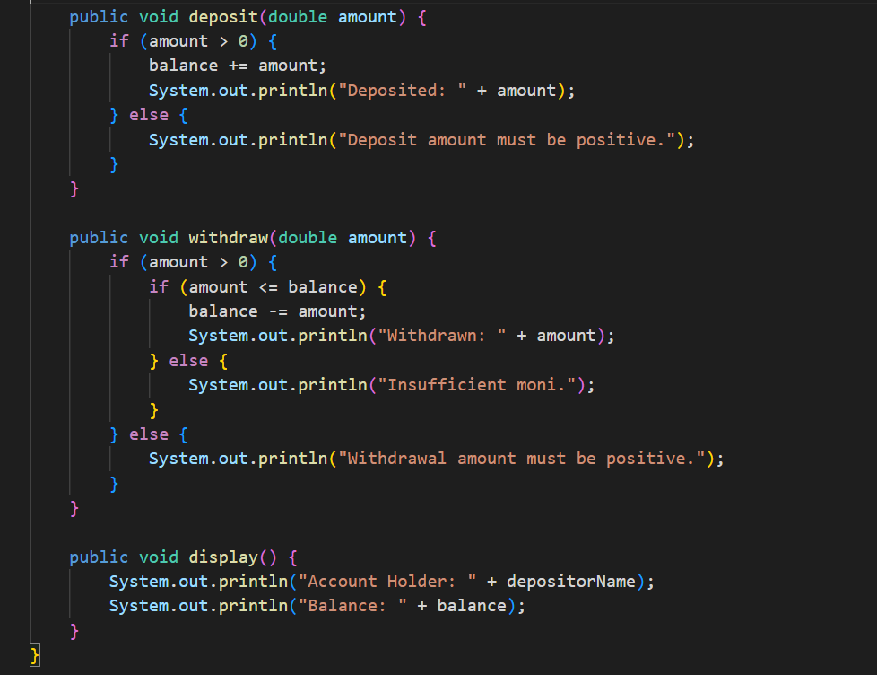

**Task 10:**

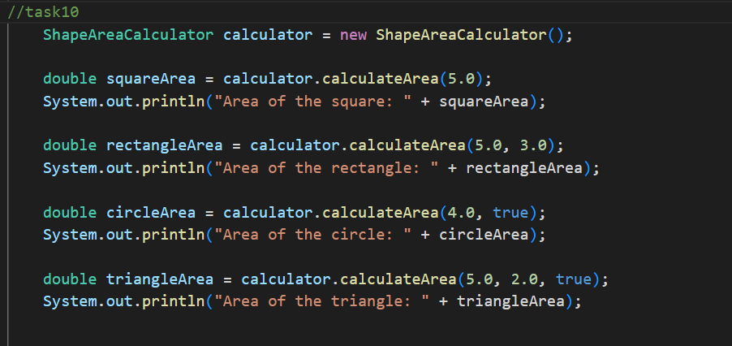 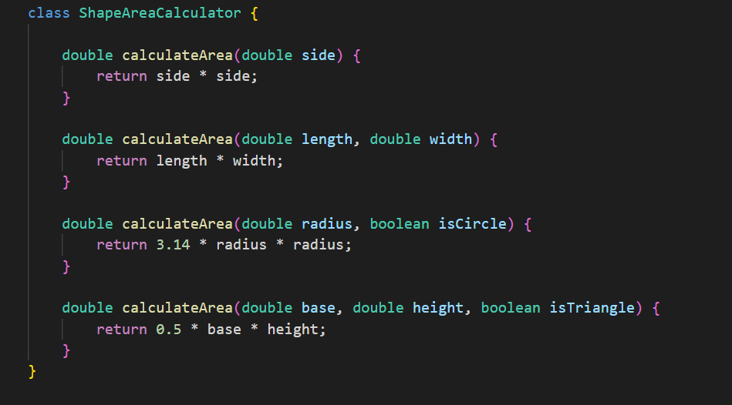

**B.2 Input and Output:**

**Task 5:**

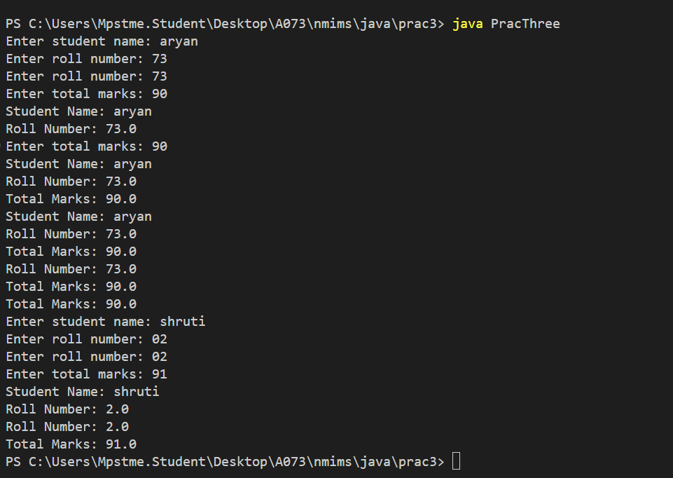

**Task 6:** 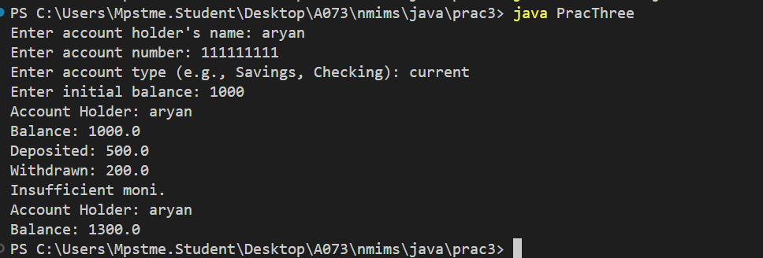

**Task 7:**

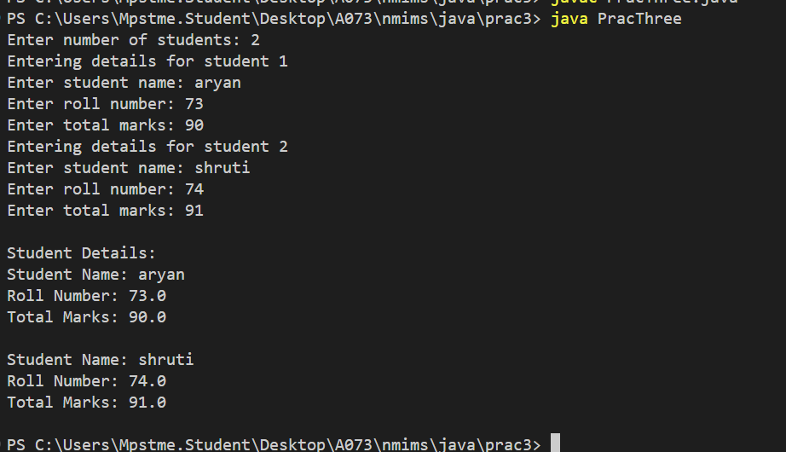

**Task 9:**

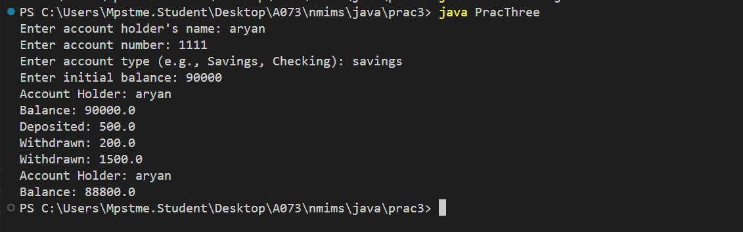

**Task 10:**

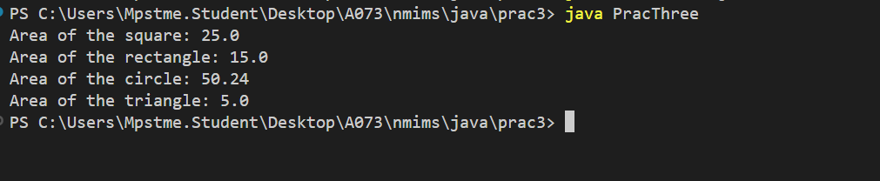

**B.3 Question of Curiosity:**

**Q.1 How do classes help us to organize our programs?**

Classes in Java act as blueprints from which individual objects are created. They help in organizing programs by encapsulating data and methods that operate on that data into a single unit. This organization allows for better modularity, reusability, and maintainability of code. By defining classes, we can create multiple instances (objects) that share the same structure and behavior but maintain their own state. Classes can contain local variables, instance variables, and class variables, each serving different purposes and scopes, further enhancing the organization of code.

**Q.2 What is a constructor? What are its special properties?**

A constructor is a special type of method in a class that is called when an object of the class is instantiated. The key properties of constructors are:

* They have the same name as the class.
* They do not have a return type, not even void.
* They are invoked automatically when an object is created.
* Constructors can be overloaded, meaning a class can have more than one constructor with different parameter lists.
* If no constructor is explicitly defined in a class, the Java compiler provides a default constructor

**Q.3 How do we invoke constructor?**

Constructors are invoked automatically when a new object is created using the new keyword. For example, if we have a class named Dog, we can create an object of this class and invoke its constructor as follows: Dog myDog = new Dog();  
Here, Dog() is the constructor being invoked to initialize the myDog object.

**B.3 Conclusion:**

Classes and constructors in Java play a crucial role in structuring and organizing code. Classes serve as blueprints for creating objects, encapsulating data and behaviors to promote modularity and reusability. They contain local, instance, and class variables, each with specific scopes and uses. Constructors, essential for object instantiation, initialize new objects and share the class name without a return type. They ensure objects are set up with initial values and can be overloaded for flexibility. Together, classes and constructors enable robust software development by providing clear, organized, and reusable code structures.

************************