**SVKM’s NMIMS**

**Mukesh Patel School of Technology Management & Engineering**

**Computer Engineering Department**

Program: BTech Integrated, Semester IV

**Course: Java Programming**

Students must submit the soft copy as per following segments within two hours of the practical. The soft copy must be uploaded on the portal at the end of the practical. The filename should be B**DS_batch_rollno_experimentno Example: BTI_BDS_C1_C001_Exp4**

|  |  |
| --- | --- |
| Roll No. A073 | Name: Aryan Srivastava |
| Class : MCA | Batch : B3 |
| Date of Experiment: 12-08-2024 | Date of Submission |
| Grade |  |

**B.1 Software Code written by student:**

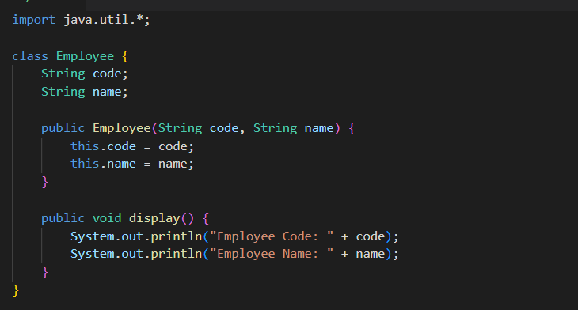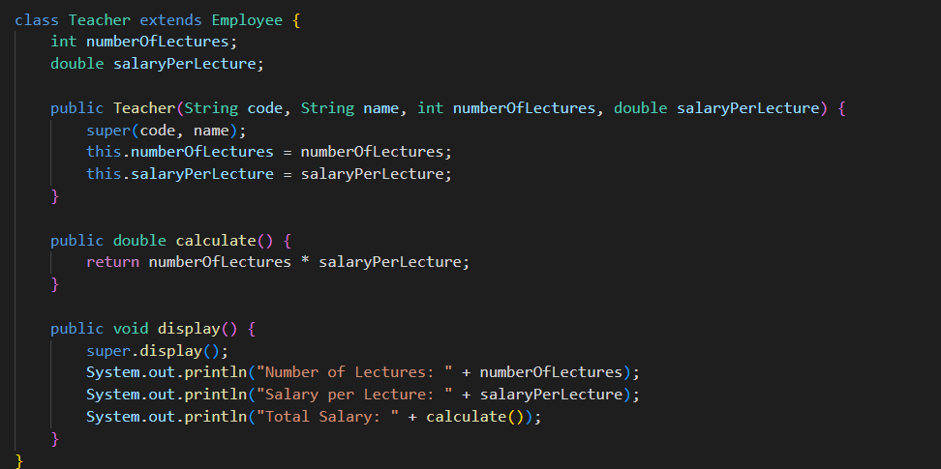

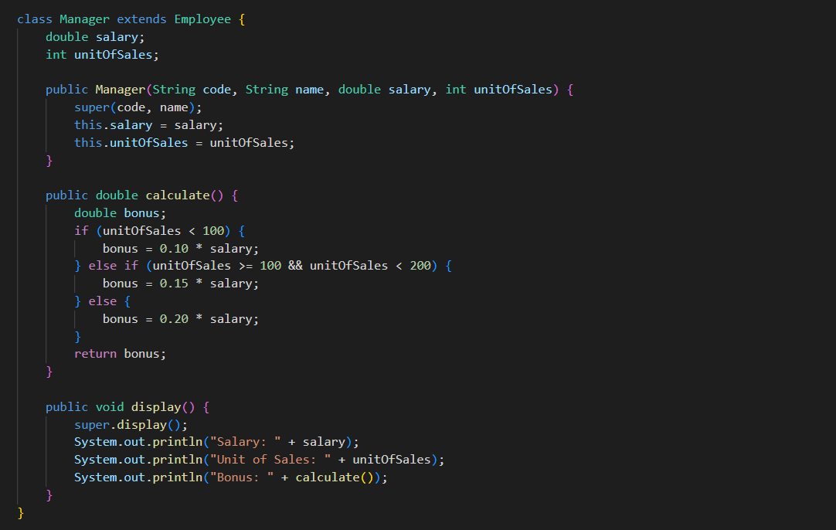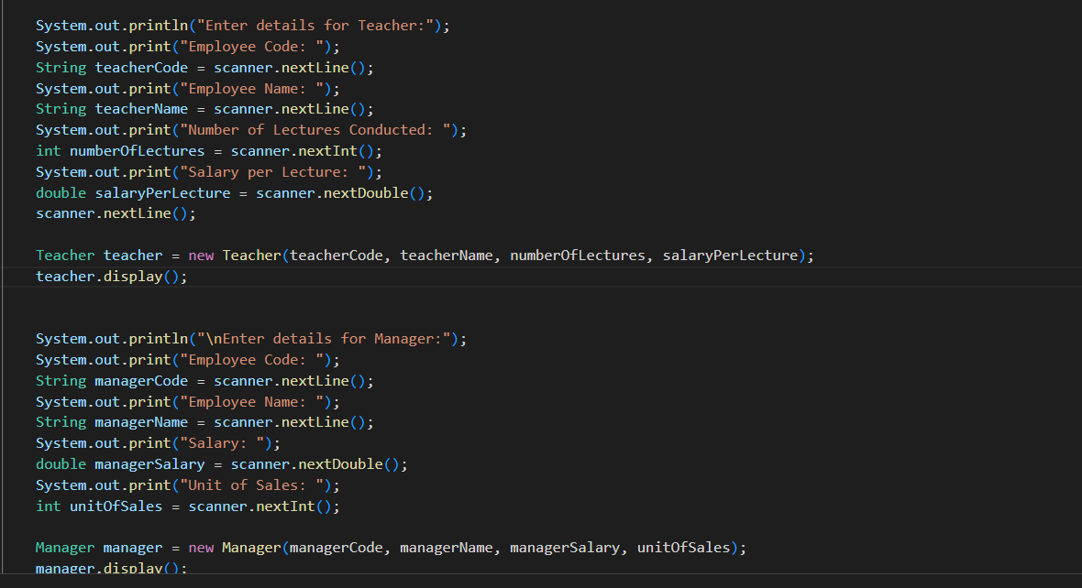

**2**

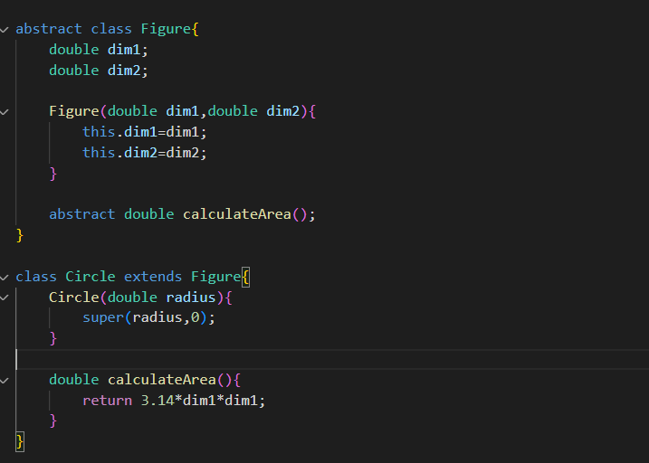

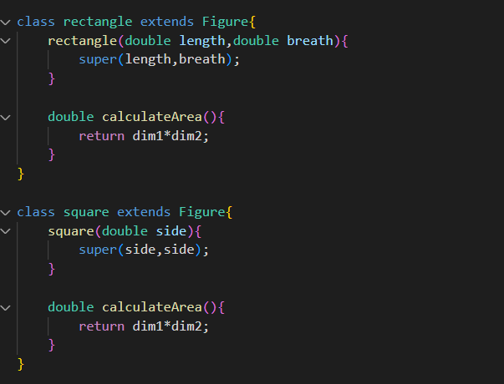

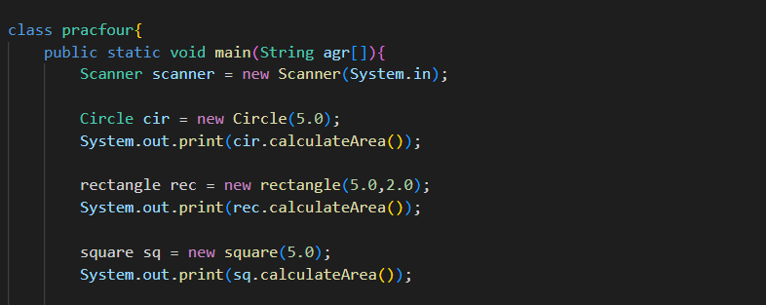

**B.2 Input and Output:**

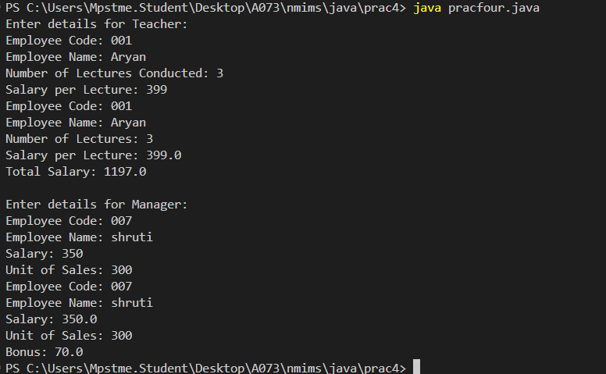

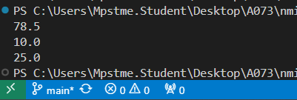

**B.4 Conclusion:**

We demonstrated how to use abstract classes and polymorphism

************************