**SVKM’s NMIMS**

**Mukesh Patel School of Technology Management & Engineering**

**Computer Engineering Department**

Program: BTech Integrated, Semester IV

**Course: Java Programming**

**Experiment No.07**

PART A

(PART A : TO BE REFFERED BY STUDENTS)

**Aim:** To implement various String operations.

**Prerequisite: Concept of Java Basic.**

**Outcome: After successful completion of this practical students will be able to**

1. Understand how to use String and StringBuffer class for string operations.

**Theory:**

**String Class**

* The string class implements immutable character string, which are read-only after the string has been created and initialized.
* If an altered version of an existing string is needed , a new string object is created that contains the modifications.
* Eg String str=“This is java program”;
* **String Methods:**
* Here is the list of methods supported by String class:

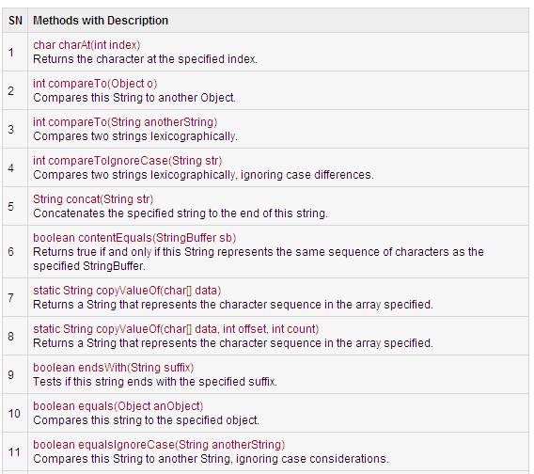

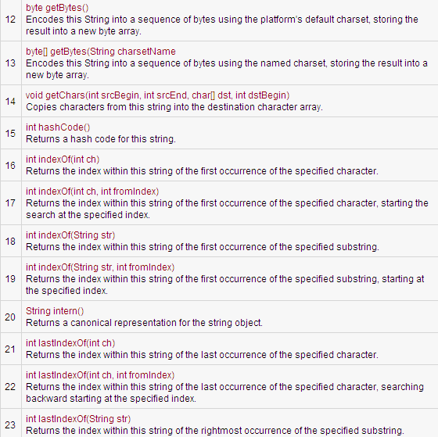

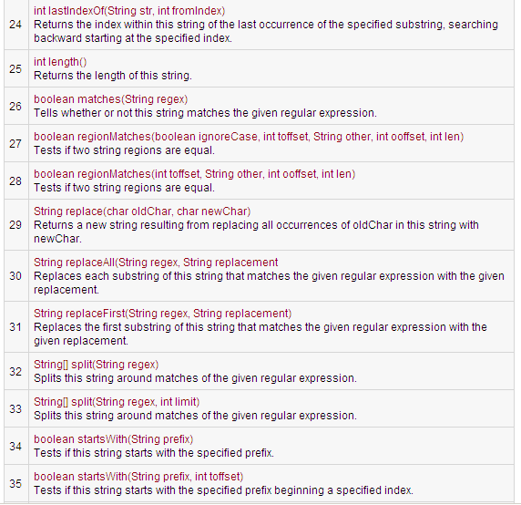

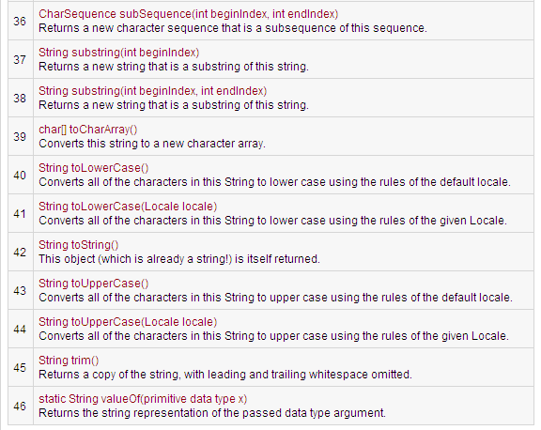

**StringBuffer class**

* It represents grow-able and writeable character sequence.
* It has methods for modifying the contents of the StringBuffer.
* Constructors
* StringBuffer()
  + The default constructor (the one with no parameters) reserves room for 16 characters without reallocation.
* StringBuffer(int size)
  + accepts an integer argument that explicitly sets the size of the buffer.
* StringBuffer(String str)
  + accepts a String argument that
  + sets the initial contents of the StringBuffer object and reserves room for 16 more characters without reallocation.

**StringBuffer Class Methods**

Here is the list of important methods supported by StringBuffer class:

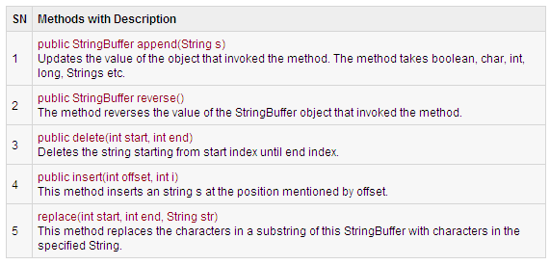

Here is the list of other methods (Except set methods ) which are very similar to String class:

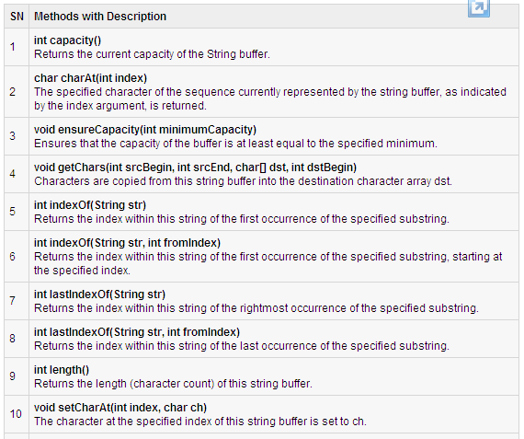

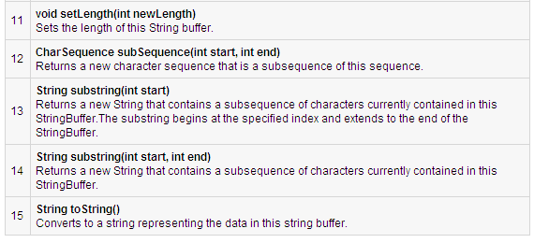

**Programs:**

1. Write a program which will perform following operations on string (String class object)
   1. will count all occurrence of a particular character in a given string
   2. To reverse a string
   3. Concatenate two string
   4. Find string is palindrome or not

Test the class using menu driven program.

1. Create a class, which perform following operations on string (StringBuffer class object)
   1. To compare two strings
   2. Find string is palindrome or not
   3. Find number of occurrences of a substring within a string
   4. To replace substring with other string
   5. To append a new string at the end of existing string
   6. To insert a new string at the position given by the user.
   7. To delete substring
   8. To sort 4 strings.

Test the class using menu driven program.

1. WAP to check if a user entered string is palindrome or not.
2. WAP to reverse a user entered string without using built-in reverse() method.

**Part B**

|  |  |
| --- | --- |
| **Roll no.:** | **Name:** |
| **Class:** | **Batch:** |
| **Date of Experiment:** | **Date of Submission:** |
| **Grade:** |  |

1. **Program scenario and Program code:**

**1.**

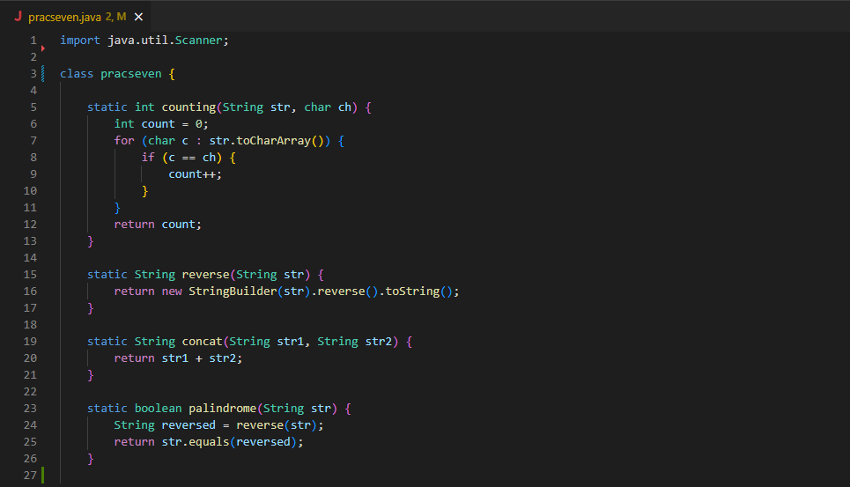 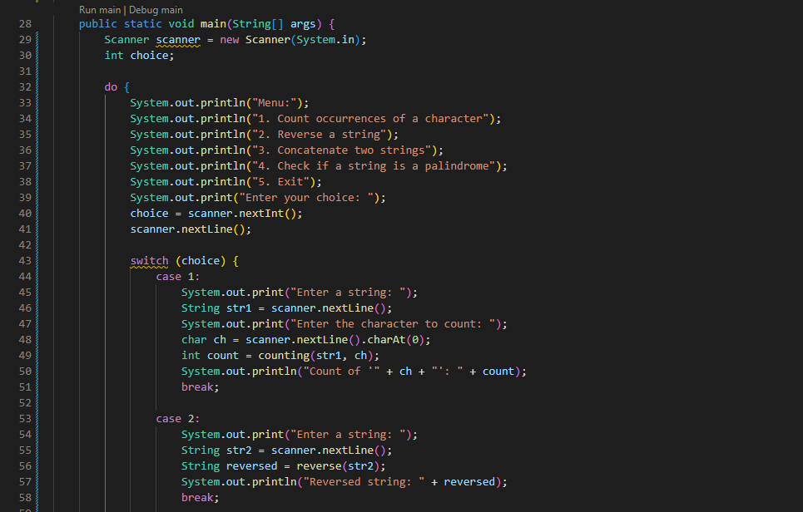

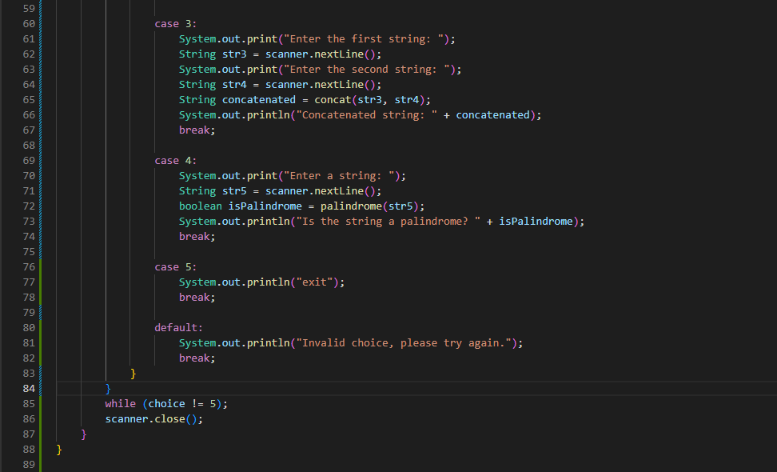**2.**

**3.**

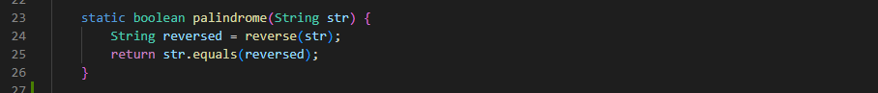

**4.**

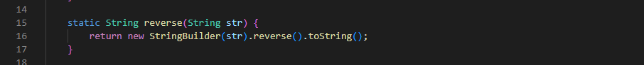

1. **Output:**

**1.**

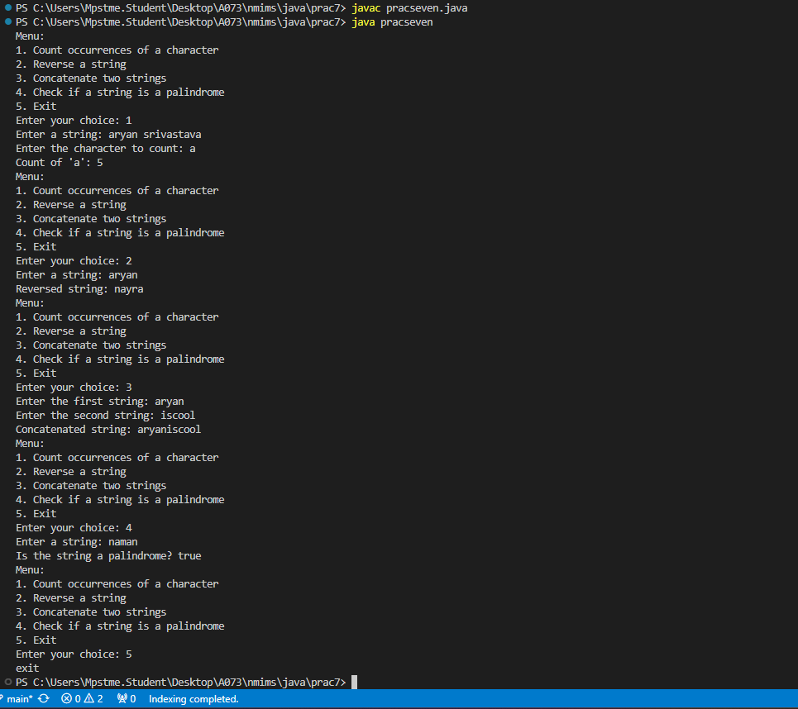

**2.**

**3.**

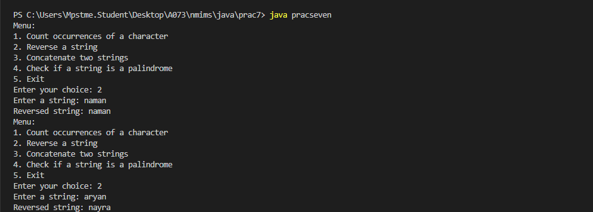

**4.**

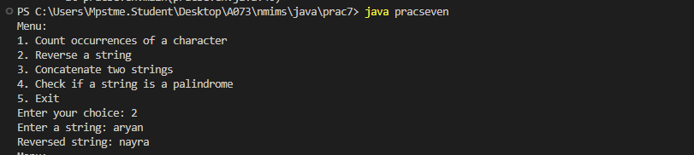

1. **Observation learning and conclusion:** mention what learning you got out of practical
2. **Questions of Curiosity:**

* **Explain the difference between String, StringBuffer and StringBuilder class in Java.**
* **Explain “strings are immutable in java”.**