**(PART - B)**

| Roll.No. : A073 | Name: Aryan Srivastava |
| --- | --- |
| Sem/Year : 1 | Batch: B3 |
| Date of Experiment : | Date of Submission: 30-07-2024 |
| Grade -- |  |

# **B.1: Procedure of performed experiment**

Students can include the output/observations as per each of tasks given in Part A

**A4.2.**

**A. Coaxial Cable**

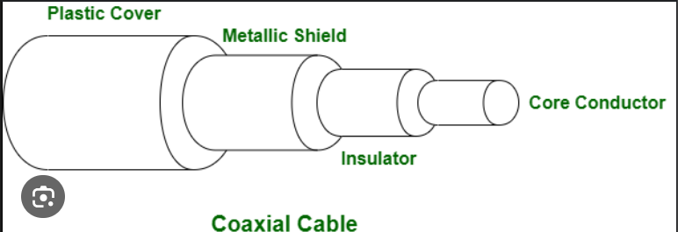

Coaxial cable, commonly referred to as coax, consists of a central copper conductor surrounded by an insulating layer, a metallic shield, and an outer insulating layer. The metallic shield helps prevent interference from external electromagnetic fields, making it ideal for transmitting high-frequency signals. Coaxial cables are widely used in cable television systems, broadband internet connections, and other data communication networks. They come in different grades, such as RG-6 and RG-59, with RG-6 being more suitable for high-frequency applications. The design of coaxial cables allows for reliable data transmission over longer distances compared to twisted pair cables.

### B. Twisted Pair Cable

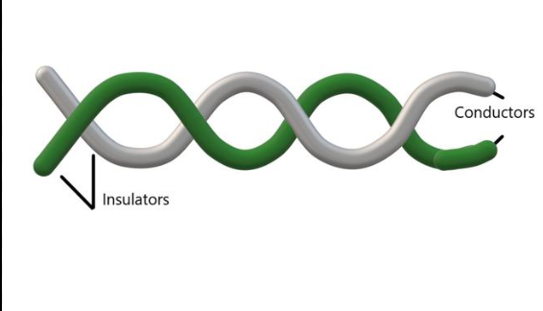

Twisted pair cables consist of pairs of insulated copper wires twisted together. The twisting helps to reduce electromagnetic interference (EMI) from external sources and crosstalk between adjacent pairs. These cables are commonly used in telephone lines and Ethernet networks. There are two main types: Unshielded Twisted Pair (UTP) and Shielded Twisted Pair (STP). UTP is more common and cost-effective, while STP provides additional shielding for environments with high EMI. Twisted pair cables are categorized based on their performance characteristics, such as Cat5e, Cat6, and Cat7, with higher categories offering greater bandwidth and data transmission speeds.

### 

### B1. Unshielded Twisted Pair (UTP)

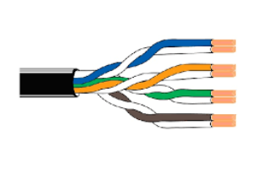

Unshielded Twisted Pair (UTP) cables are a type of twisted pair cable that lacks additional shielding around the twisted wire pairs. UTP cables are widely used in Ethernet networks, telephone systems, and various data communications applications. They are favored for their low cost, flexibility, and ease of installation. UTP cables come in various categories, such as Cat5e, Cat6, and Cat6a, each offering different levels of performance in terms of bandwidth and signal quality. Despite their lack of shielding, UTP cables can effectively resist electromagnetic interference (EMI) due to the twisting of the wire pairs.

### B2. Shielded Twisted Pair (STP)

Shielded Twisted Pair (STP) cables include additional shielding, such as a metal foil or braided mesh, around the twisted pairs of wires. This shielding provides better protection against electromagnetic interference (EMI) and crosstalk compared to Unshielded Twisted Pair (UTP) cables. STP cables are commonly used in environments with high levels of EMI, such as industrial settings or data centers. The extra shielding makes STP cables more robust and capable of maintaining signal integrity over longer distances. However, they are generally more expensive and less flexible than UTP cables, making them less commonly used in standard office or residential networks.

### 

### C. Fiber Optic Cable

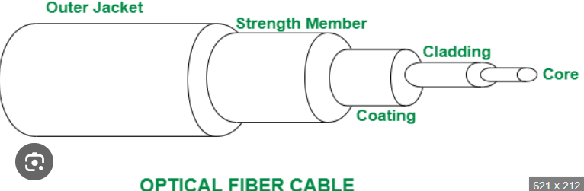

Fiber optic cables use light to transmit data, offering high-speed communication over long distances with minimal signal loss. They consist of a core made of glass or plastic fibers, surrounded by a cladding that reflects light back into the core, and an outer protective layer. Fiber optic cables are immune to electromagnetic interference and provide higher bandwidth compared to copper cables, making them ideal for backbone networks, internet infrastructure, and high-demand applications. There are two main types: Single-mode fibers, which are used for long-distance communication, and Multi-mode fibers, which are suitable for shorter distances.

**A4.3.**

**hostname-Returns the name of the current computer.**

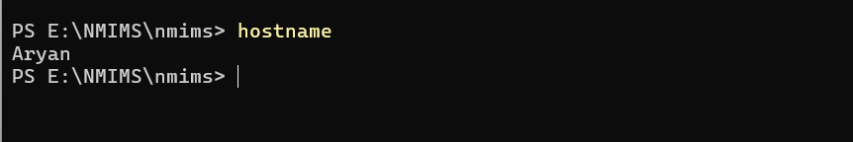

**ping-Tests the reachability of a host on a network and measures the round-trip time.**

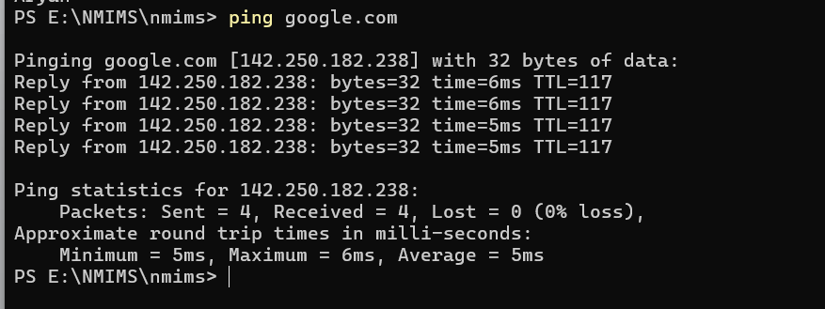

**ipconfig-Displays the network configuration of the current system.**

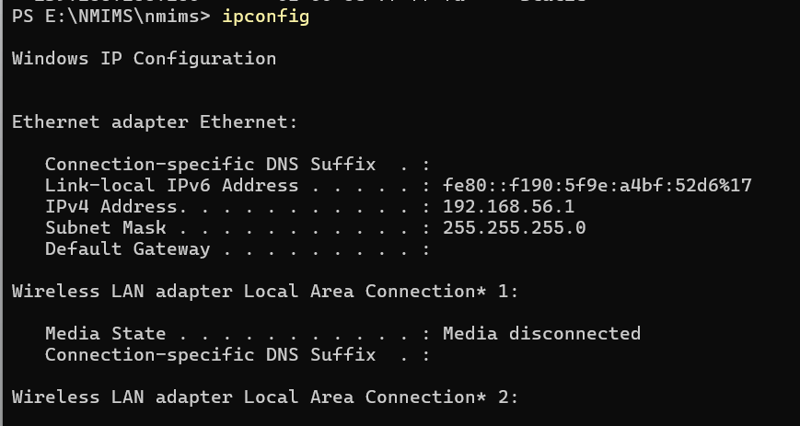

**netstat-Provides information about network connections, routing tables, and interface statistics.**

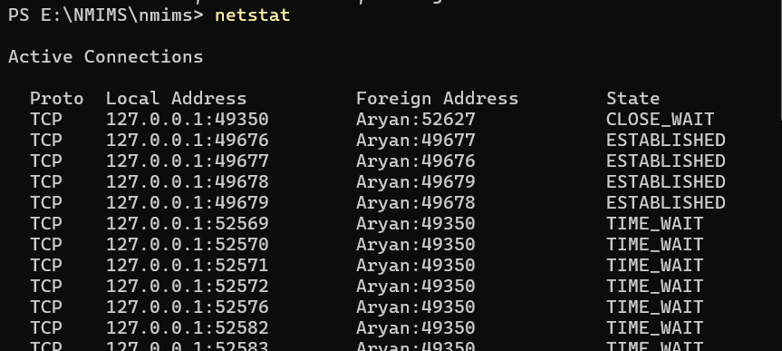

**netstat -a-Displays all active connections and listening ports on the system.**

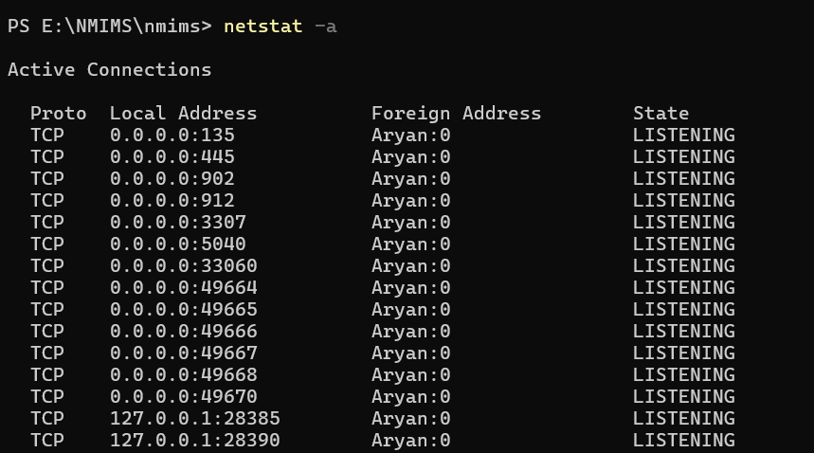

**netstat -i -Shows network interface statistics, including received and transmitted packets.**

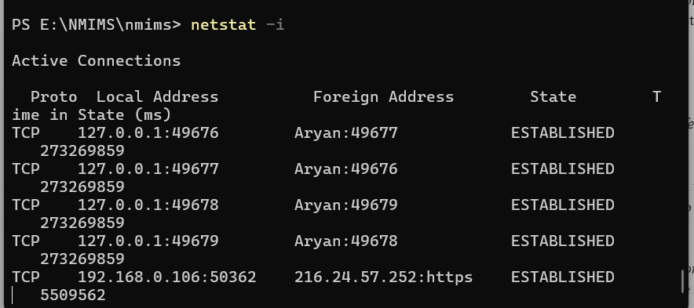

**netstat -r -Displays the routing table, which shows the paths data takes to reach different network destinations.**

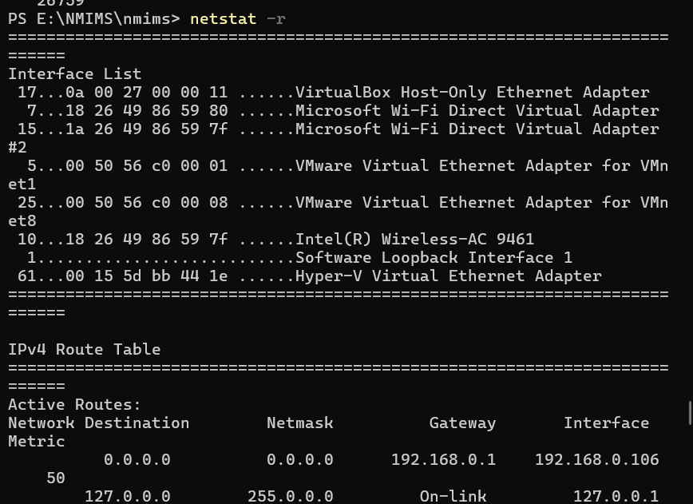

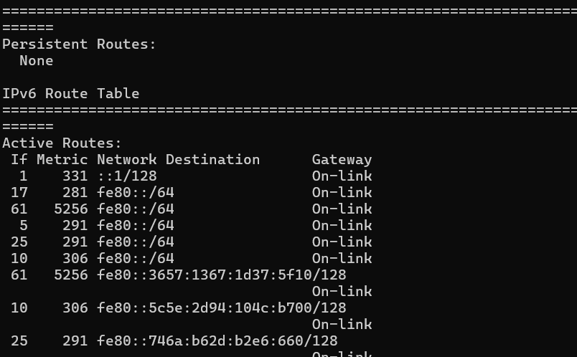

**nslookup-Queries DNS to find the IP address associated with a domain name or vice versa.**

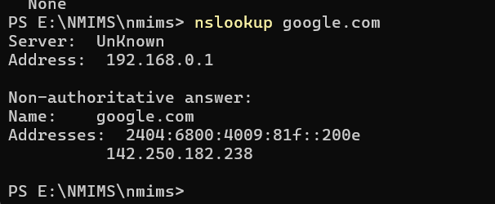**tracert-Traces the path packets take to reach a network host.**

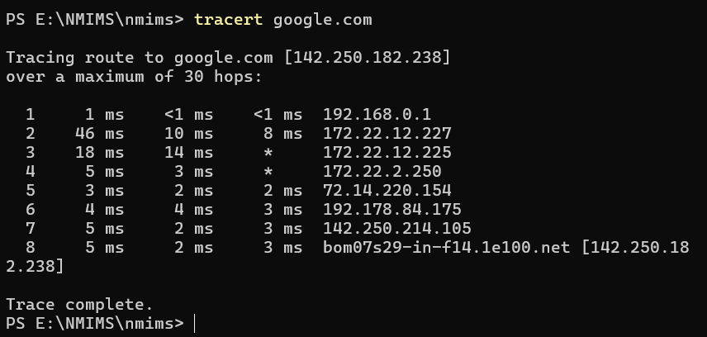

**getmac-Displays the MAC address of the network interfaces on the system**

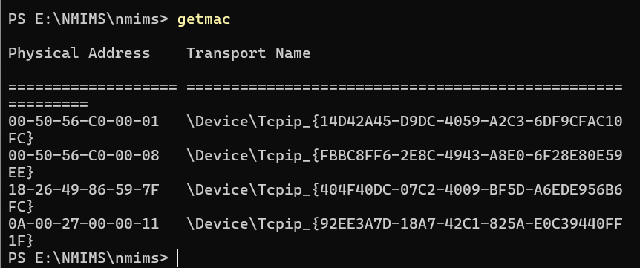

**arp -a -Shows the Address Resolution Protocol (ARP) table, mapping IP addresses to MAC addresses.**

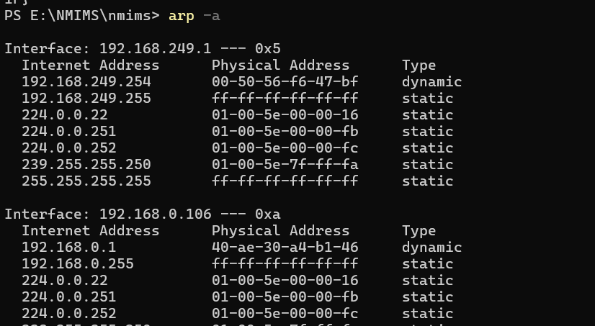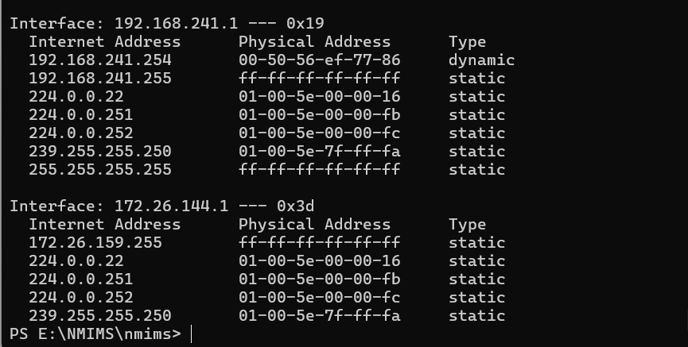

# **B.2: Observations and Learning’s:**

I made detailed observations and shared what I've learned. For example, using the ping command, I observed the latency and packet loss, which taught me how to assess network connectivity. With ipconfig, I explored the IP address configuration and understood how different network interfaces are set up. The netstat -a command showed all active connections, revealing the importance of monitoring network traffic. The netstat -i command provided interface statistics, helping me learn about data transmission and errors. Lastly, netstat -r displayed the routing table, giving insights into how data is routed across the network. These observations helped me understand the practical aspects of network management and diagnostics.

Regarding network media, examining coaxial cables helped me understand their robust design and shielding against interference, while the comparison between Unshielded Twisted Pair (UTP) and Shielded Twisted Pair (STP) cables highlighted the impact of shielding on signal quality. Observing fiber optic cables, I learned about their superior speed and distance capabilities, which are essential for high-demand applications. These observations provided a comprehensive understanding of different networking components and their practical applications.

# **B.3: Conclusion:**

In conclusion, this exercise provided valuable hands-on experience with various network commands and media, enhancing our understanding of networking principles. By using commands like `ping`, `ipconfig`, and `netstat`, we gained practical insights into network diagnostics, connectivity assessment, and traffic monitoring. Observing the different properties of coaxial cables, twisted pair cables (UTP and STP), and fiber optic cables allowed us to appreciate their respective advantages and limitations in real-world applications. The experiment highlighted the importance of choosing the appropriate network media and tools based on specific needs and environmental factors. Overall, these tasks deepened our technical knowledge and practical skills in managing and troubleshooting computer networks, preparing us for more complex networking challenges.