**(PART - B)**

|  |  |
| --- | --- |
| Roll.No. : A073 | Name: Aryan Srivastava |
| Sem/Year : 1 | Batch: B3 |
| Date of Experiment : 30-07-2024 | Date of Submission: 30-07-2024 |
| Grade -- |  |

# B.1: Procedure of performed experiment

Students can include the output/observations as per each of tasks given in Part A

I. STAR TOPOLOGY

**1. Placed switch 2960 from [network devices] 🡪 [switches]🡪 switch 2960**

**Placed PC from [end devices]🡪[end devices]🡪PC**

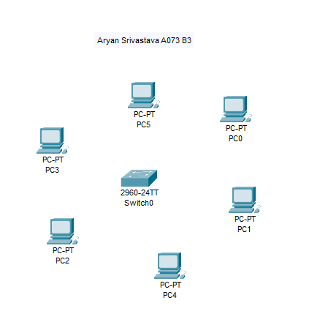

**2. Connect the switch to PC using [Connections]🡪[Connections]🡪Copper Straight Through with Ethernet ports**

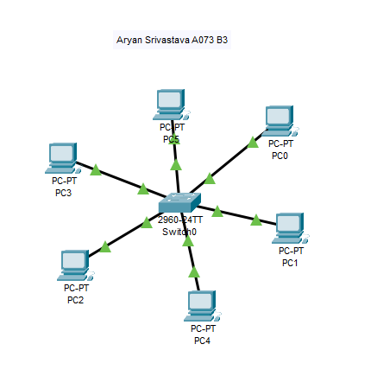

**3. Configure Each PC with the IP address and Subnet mask from PC🡪Config🡪INTERFACE🡪FastEthernet0🡪IP 4 Address**

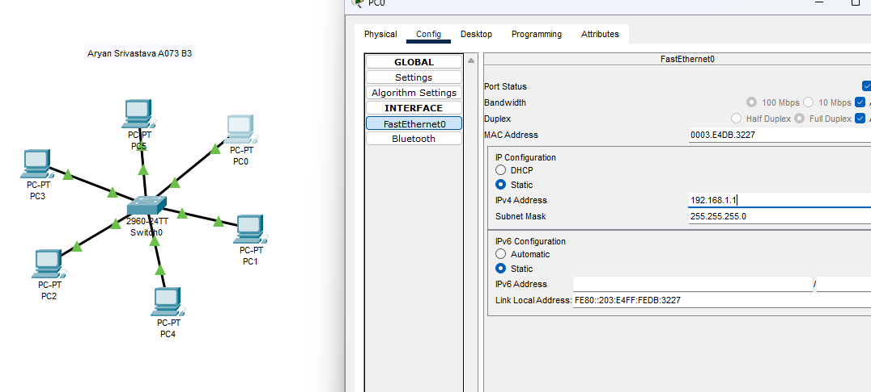

**4. Pinging the PCs**

**Real time panel**

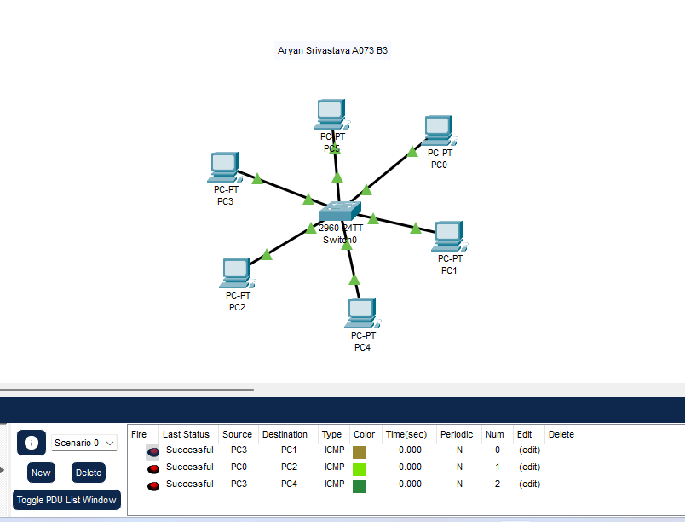

**Simulation panel**

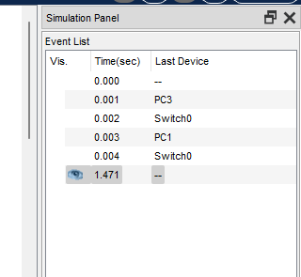 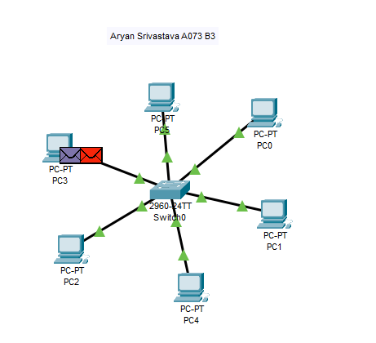

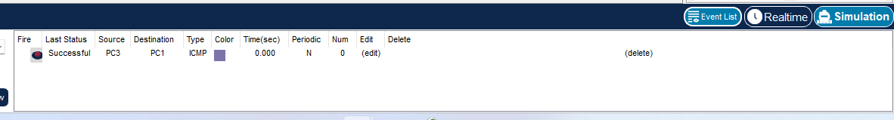

**Pinging via command line**

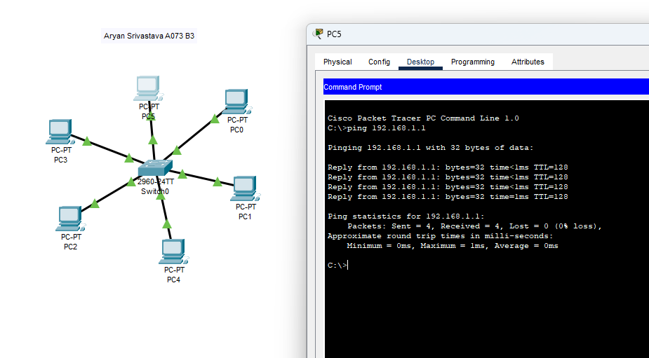

II. MESH TOPOLOGY

**1. Place five switch 2960s from [network devices] 🡪 [switches]🡪 switch 2960, and Place five PCs from [end devices]🡪[end devices]🡪PC**

**2. Connect the switch to switch using [Connections]🡪[Connections]🡪Copper Cross over with Ethernet ports**

**Connect the switch to PC using [Connections]🡪[Connections]🡪Copper Straight Through with Ethernet ports**

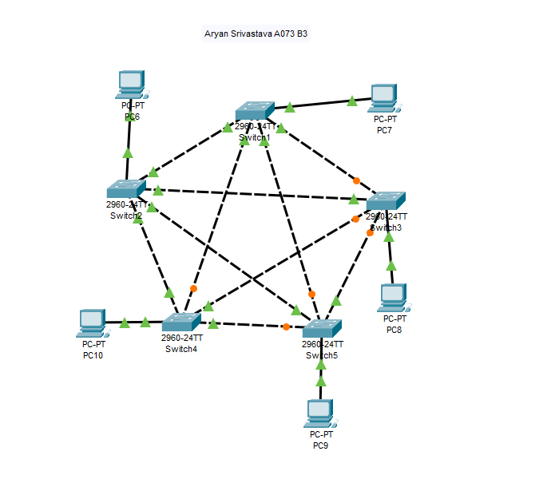

**3. Configure Each PC with the IP address and Subnet mask from PC🡪Config🡪INTERFACE🡪FastEthernet0🡪IP 4 Address**

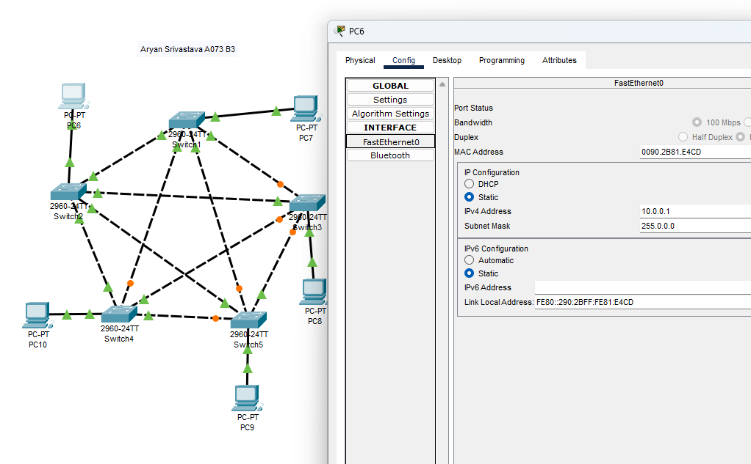

**4. Pinging the PCs**

**Real time panel**

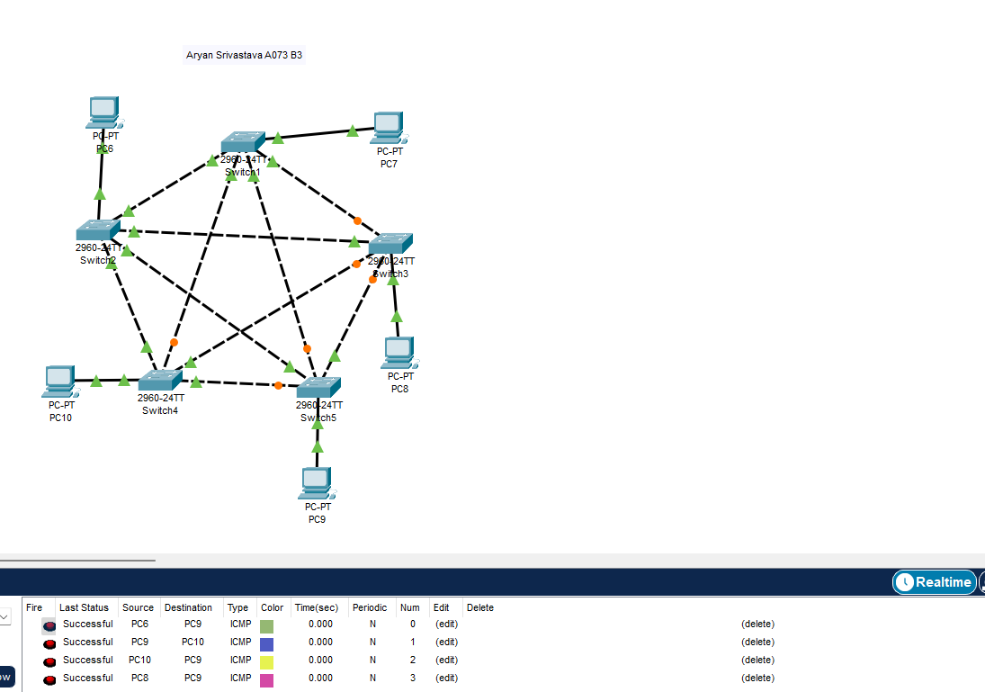

**Simulation panel**

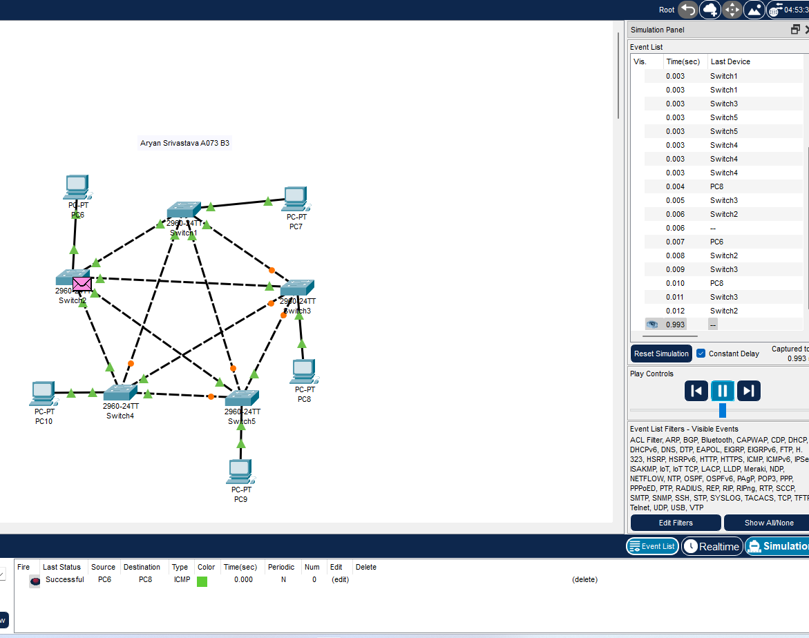

Command Line

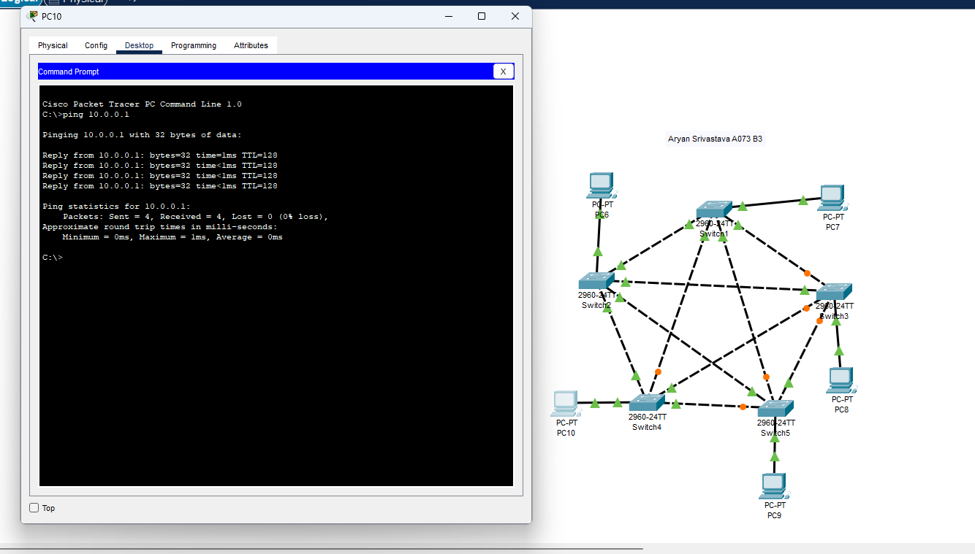

**B2. Questions of Curiosity:**

* In what types of environments is a star topology most commonly implemented?
  + **Office Networks**: Star topology is often used in office environments where there is a central hub (such as a switch or router) that connects multiple devices, providing ease of management and troubleshooting.
  + **Home Networks**: Many home networks use a star topology, where a router serves as the central hub for devices like computers, smartphones, and smart home devices.
  + **Small to Medium-sized Enterprises (SMEs)**: Star topology is popular in SMEs due to its simplicity and ease of expansion.
  + **Educational Institutions**: Schools and universities may use star topology to connect classrooms, laboratories, and administrative offices.
* How does the scalability of a star topology compare to other topologies like bus or ring?
  + **Scalability**: Star topology is generally more scalable than bus or ring topologies. In a star topology, adding new devices is straightforward: simply connect them to the central hub. This can be done without disrupting the entire network.
  + **Bus Topology**: Adding devices to a bus topology can lead to network congestion and may require the entire network to be taken offline for reconfiguration. The more devices connected, the more potential there is for signal degradation.
  + **Ring Topology**: In a ring topology, adding or removing devices can disrupt the network. Scalability is limited, and the network may require reconfiguration to add new devices.
* What considerations should be considered when expanding a star topology network?
  + **Hub Capacity**: Ensure the central hub (e.g., switch or router) has enough ports and processing power to handle additional devices.
  + **Cabling**: Consider the type and length of cabling needed to connect new devices to the hub. Longer distances may require higher quality cables or signal boosters.
  + **Power Supply**: Make sure the central hub and connected devices have adequate power supply, especially if using Power over Ethernet (PoE) devices.
  + **Network Performance**: Evaluate the network's bandwidth and performance to ensure it can handle additional traffic without degradation.
  + **Security**: Implement security measures like firewalls and access controls to protect the network as it expands.
* In what scenarios would a full mesh topology be preferred over a star topology?
  + **High Availability**: Full mesh topology is preferred when high availability and fault tolerance are critical, as each device is connected to every other device, providing multiple paths for data transmission.
  + **Critical Applications**: In scenarios where network downtime can have severe consequences, such as in financial institutions, healthcare, or military applications, a full mesh topology is advantageous.
  + **High Traffic Volume**: If the network needs to handle high traffic volumes and provide low-latency communication between devices, a full mesh topology can be beneficial.
  + **Decentralized Networks**: Full mesh topology is suitable for decentralized networks where there is no single point of failure and communication needs to be reliable and fast.
* How does mesh topology handle high traffic volumes and potential network congestion?
  + **Redundant Paths**: Mesh topology provides multiple paths between devices, which helps distribute traffic and reduce congestion. If one path is congested or fails, data can be rerouted through another path.
  + **Load Balancing**: Advanced routing protocols can be used to balance the load across different paths, optimizing network performance and reducing the likelihood of congestion.
  + **Resilience**: The redundancy in a mesh topology ensures that the network remains operational even if some connections fail, providing resilience against congestion-related issues.
* What are the cost implications of deploying a mesh topology in a large-scale network?
  + **Higher Equipment Costs**: Mesh topology requires more networking equipment (switches, routers, cables) compared to other topologies, as each device needs to be connected to multiple other devices.
  + **Installation and Maintenance**: The complexity of installation and maintenance is higher, leading to increased labor costs and the need for specialized skills.
  + **Scalability Costs**: As the network grows, the costs of adding new devices and connections increase exponentially, making large-scale deployments expensive.
  + **Power and Cooling**: More equipment means higher power consumption and cooling requirements, adding to operational costs.
  + **Managing and Monitoring**: Managing a full mesh network requires advanced network management tools and monitoring systems, which can be costly to implement and maintain.

# B.3: Observations and Learning’s:

**Star Topology:**

**Observation**

1. **Central Hub Role**: The central hub efficiently managed the communication between devices. All data packets were routed through the hub, acting as the network's communication backbone.
2. **Single Point of Failure**: If the central hub failed, the entire network went down, highlighting the vulnerability of this topology.
3. **Ping Results**: The ping times were consistent and relatively fast, as the data packets only needed to travel through the hub to reach their destination.

**Learnings:**

1. **Easy Troubleshooting**: Identifying network issues was straightforward, as any problem in communication was likely related to the central hub or the direct connection to it.
2. **Scalability**: Adding new devices to the network was simple, requiring only a new connection to the central hub.
3. **Network Load**: The central hub must be powerful enough to handle the total data load, as all traffic passes through it.

**Mesh Topology Simulation**

**Observations:**

1. **Multiple Paths**: The network provided multiple paths between devices, ensuring that even if one connection failed, data could be rerouted through another path.
2. **High Availability**: The network was resilient to failures, as no single point of failure existed.
3. **Ping Results**: Ping times varied depending on the paths used. In some cases, alternative paths resulted in slightly longer ping times.

**Learnings:**

1. **Fault Tolerance**: Mesh topology provides high fault tolerance, making it suitable for critical applications where uptime is crucial.
2. **Complexity and Cost**: Setting up and maintaining a mesh network is more complex and expensive compared to a star topology, due to the need for multiple connections and advanced routing.
3. **Traffic Management**: Effective traffic management and load balancing are crucial in a mesh network to prevent congestion and ensure optimal performance.

# B.4: Conclusion:

The lab experiment on star and mesh topologies provided valuable insights into the strengths and weaknesses of each network configuration. Star topology offers simplicity and ease of expansion but is vulnerable to a single point of failure at the central hub. Mesh topology, while more complex and costly to implement, excels in fault tolerance and high availability due to its multiple redundant paths. Choosing the appropriate topology depends on the specific needs and constraints of the network environment, such as scalability, cost, and criticality of uptime.